Project information
CALL FOR PROPOSALS | 1
MIS-ETC: | 426
PRIORITY AXIS: | 1 Economic and Social Development
MEASURE: | 1.2 Develop the tourism sector, including the strengthening of the regional identity of the border region as a tourist destination
PROJECT TITLE: | Increasing the Tourism Capacities in Banat Region
ACRONYM:
DURATION: | 04.12.2010-03.06.2012
IPA FUNDS CONTRACTED: | 484.665,75
TOTAL FUNDS CONTRACTED: | 570.195,00
ABSORBTION RATE (%): | 80.72
PROJECT OBJECTIVE(S): | Creation, development, modernization and promotion of public cross-border infrastructure for tourism.  Awareness and interest for the Banat region raised.  Completed feasibility studies.  Creation or improvement of the cross-border tourism products, joint marketing approaches and activities coordinated by the existing tourist Info points.
SHORT DESCRIPTION OF THE PROJECT: | The project created the premises for a sustainable development of the tourism products in the targeted area. The feasibility studies and plans created the premises for further development of the region, as a necessary foundation for infrastructural development. This development aimed at strengthening the economy and competitiveness of Banat. 5 new tourism products have been promoted through the project. The project activities contributed to the recognition of the region as a tourist destination.
DEGREE OF ACHIEVEMENT OF INDICATORS: | Indicator value provisioned in the contract Present indicator value % 6= (5)/(3)*100  Output indicators (1) UM (2) Quantity (3) UM (4) Quantity (5)  Improved physical infrastructure in the border area (as a future result) -  Result indicators  New or improved cross-border tourism products, joint marketing approaches/activities Number of new or improved cross-border tourism products, marketing activities 5 Number of new or improved cross-border tourism products, marketing activities 5 100  New or improved cross-border tourism services and increased SME’s capacity Number of activities, actions, initiatives focusing on promoting tourism in the border area and on promoting SME’s activity. 3 Number of activities, actions, initiatives focusing on promoting tourism in the border area and on promoting SME’s activity. 3 100  Project indicators  Feasibility study: Reconstruction of the Main Street (Kanjiza) study 1 study 1 100  Feasibility study: Reconstruction of the Fishermen’s Square (Kanjiza) study 1 study 1 100  Feasibility study: Reconstruction of the camp site (Kanjiza) study 1 study 1 100  Feasibility study: Reconstruction of the building in the town centre (Pancevo) study 1 study 1 100  Feasibility study: Reconstruction of two castles (Novi Knezevac) study 1 study 1 100  Purchase of a mobile stage (Kanjiza) mobile stage 1 mobile stage 1 100  Purchase of a tent (Banat Ripensis) tent 1 tent 1 100  Purchase of new quays (Kanjiza) new quays 3 new quays 3 100
RESULTS ACHIEVED: | 1. Civil organizations were included into the tourist activities.  2. Long term planning and investments were made possible thanks to the feasibility studies and plans. The feasibility studies were placed online and open to view for investors, the private sector and any individual.  3. Marketing has ensured the enhancement of the existing tourist capacities and the development of new ones.  4.The promotional outcomes/indicators were various:  a) promotional documentary DVD on the two touristic study trips in Banat, both in Serbia and in Romanian  b.) printing of trilingual flyers introducing the project  c.) printing of trilingual brochures presenting the tourist offer of Banat in 2012  e.) press conferences  5. Five infrastructural studies in the three Serbian towns.  6. The procured tent helped future cultural and tourist events. The tent has been in constant use since it was procured.  7. The three quays in Kanjiza have changed the general picture of the city. They are very useful equipment especially for the fishers who can easily dock their boats. The tourists and the local inhabitants intensively use the quays for swimming in summertime and for rowing and canoeing too.  8. Ensuring new jobs thanks to the need for new work force that became responsible for the mobile stage. Altogether eight people.  9. The mobile stage serves as a good means for holding festivities, cultural events without the need for the Municipality of Kanjiza to rent equipment. The stage was used by all the towns of the municipality. Up to the point of delivery the Municipality of Kanjiza rented mobile stages for different events at least four, five times, but currently the Municipality can give the stage additionally to other towns from the municipality.  More details regarding the project can be found by accessing:  http://www.kanjiza.rs/ujlap/site/index-sr.html?id=260&fbclid=IwAR0slGXl0w5wqm1NDehlVISSn18F8PWUft4LcESjP6wSL-BRfpHUv7sQ2Q0

Partnership information
 |  | COUNTRY | COUNTY/DISTRICT | BUDGET(EURO) | CONTACT DETAILS
LEAD PARTNER: | Municipality of Kanjiza | Serbia | Northern Banat | 401.495 | Kanjiža, Glavni trg 1  Tel. +381(0)24 /875-166
PARTNER 2: | Banat-Ripensis Micro-Regional Association for Localities' Development | Romania | Timiş | 55.500 | Jimbolia, Tudor Vladimirescu 81  Tel. +40 256 302563
PARTNER 3: | City of Pančevo | Serbia | South Banat | 20.000 | Pančevo, Trg Kralja Petra I, 2-4  Tel. +381 (0) 13 344 422
PARTNER 4: | Municipality of Novi Kneževac | Serbia | Northern Banat | 93.200 | Novi Kneževac, Kralja Petra I Karađorđevića 1  Tel. +381(0)230/ 82 055

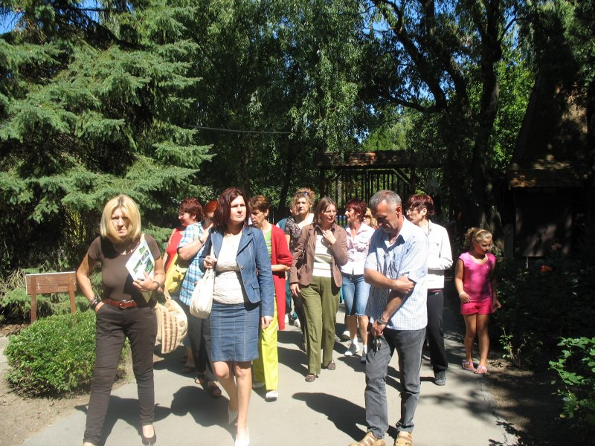
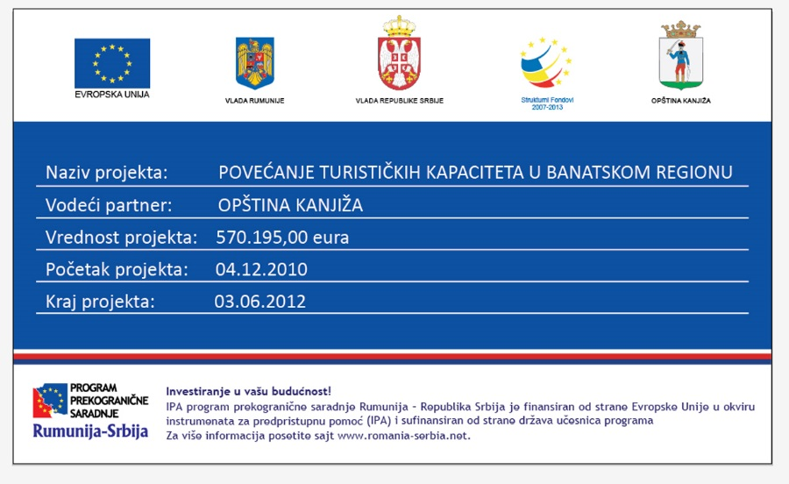

the implementation period (including extensions)
total funds spent/total funds contracted *100
indicators and level of achievement against targets set

