 | Project information
 | CALL FOR PROPOSALS |  | 1
 | MIS-ETC: |  | 424
 | PRIORITY AXIS: |  | 1 Economic and Social Development
 | MEASURE: |  | 1.2 Develop the tourism sector, including the strengthening of the regional identity of the border region as a tourist destination
 | PROJECT TITLE: |  | Improvement of Cross-border Cooperation and Common Tourist Offer of Municipalities of Vrsac and Deta - Application of New Technologies in Illumination
 | ACRONYM: |  | ANTI
 | DURATION: |  | 01.12.2010-30.11.2011
 | IPA FUNDS CONTRACTED: |  | 735.977,02
 | TOTAL FUNDS CONTRACTED: |  | 865.855,32
 | ABSORBTION RATE (%): |  | 65,99
 | PROJECT OBJECTIVE(S): |  | - Improvement of existing objects in order to make them tourist attractions and contribute to the preservation of cultural heritage and confessional diversity of Banat region. This preservation will be performed in full agreement with the European legislation and these attractions will be included in tourist offers of the region applying modern, efficient and user-friendly approach.  - Mutual recognition of local authorities in Vrsac and Deta as natural partners in economic, social and cultural collaboration through different joint investment programs.  - Improvement of inter-confessional and interethnic relations of towns Deta and Vrsac inhabitants leading to the better quality of life for the population in the border area
 | SHORT DESCRIPTION OF THE PROJECT: |  | The partnership between Vrsac and Deta was created in order to implement the architectural illumination of six churches of Orthodox and Catholic faiths, buildings of great historical and cultural importance. Lighting of these churches within the implementation of the project made them more attractive and helped them to acquire another function, apart from the primary one as religious buildings. The illumination process managed to emphasize cultural aspects of these buildings making them attractive for tourists, as well as for locals. The six churches that were illuminated:  - Serbian Orthodox Church in Vrsac, built in 1785 is the biggest Serbian orthodox church in Vojvodina. Interior of the church was painted by many well-known and important Serbian painters giving it great artistic value.  - Roman Catholic Cathedral in Vrsac built in Neogothic style in 1863. It is second largest cathedral in Serbia and is considered to be the most beautiful one.  - Romanian Orthodox Church in Vrsac, built in 1913 is the monument of the Byzantium art. Its appearance makes it one of the most beautiful buildings in Vrsac.  - Romanian Orthodox Church in Deta is a new church built with governmental funds and private donations.  - Roman-Catholic Church in Deta is built in Neogothic style and celebrating its 210 anniversary in 2020.  - Romanian Orthodox Church of Opatita is situated in village Opatita, 4 km from Deta. It is built in 1725 upon old church foundations.  Together with the six churches, Deta Fire Station Tower was architecturally illuminated, too. This building is a historical monument and today it serves as a museum of the Town of Deta.
 | DEGREE OF ACHIEVEMENT OF INDICATORS: |  | Indicator Indicator value provisioned in the contract Present indicator value %  Output indicators (1) UM (2) Quantity (3) UM (4) Quantity (5) 6= (5)/(3)*100  Improved physical infrastructure in the border area  Improved capacity and cross-border contacts of SMEs and in the R&D sector  Result indicators  New or improved cross-border tourism products, joint marketing approaches/activities or joint tourism information services developed Illuminated church 6 Illuminated church 6 100%  Illuminated tower 1 Illuminated tower 1 100%  Brochure 1 Brochure 1(2000) 100%  Tourist catalogue 1 Tourist catalogue 1(1000) 100%  Leaflets 2 Leaflets 2(3000) 100%  Flayer 2 Flayer 2(6000) 100%  Banner 2 Banner 2 100%  Display panels 2 Display panels 2 100%  Billboard 2 Billboard 2 100%  Commemora-tive Plaques 2 Commemora-tive Plaques 2 100%  Information Campaigns 1 Information Campaigns 1 100%  Press releases 20 Press releases 20 100%  Press Conferences 6 Press Conferences 6 100%  Press Visits 2 Press Visits 2 100%  New or improved cross-border tourism services and increased SME’s capacity Tourist info touch screen panel 2 Tourist info touch screen panel 2 100%  Project indicators  Minutes of Meeting Reports 9 Reports 27 300%  Registration of the brands Deta Fire Station Tower and Vrsac Tower regarding local legislation Number of registration document 2 Number of registration document 2 100%
 | RESULTS ACHIEVED: |  | Architectural lighting of 6 churches in Vrsac, Serbia and Deta, Romania and the Fire Station Tower in Deta was achieved, in order to improve the touristic offer of the regions. Diverse activities like workshops, roundtables and press tours were organized for the improvement and promotion of the tourist offer from Vrsac and Deta municipalities. Together, the project partners developed a tourist catalogue. The Vrsac Tower brand and Deta Fire Station Tower brand were registered. Touch screens were installed at appropriate locations.  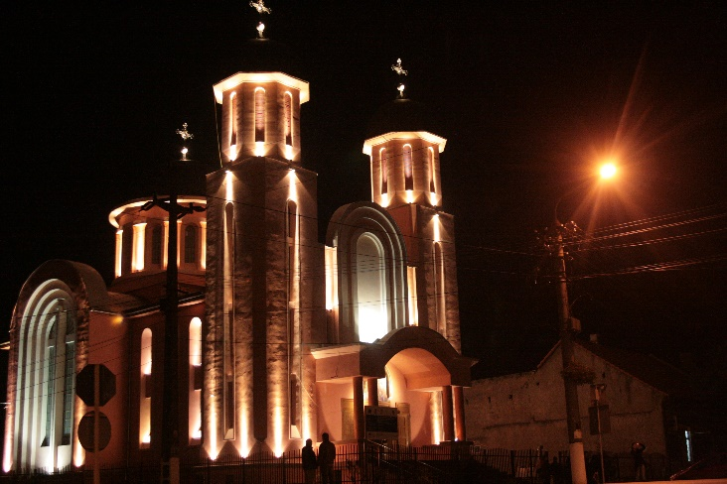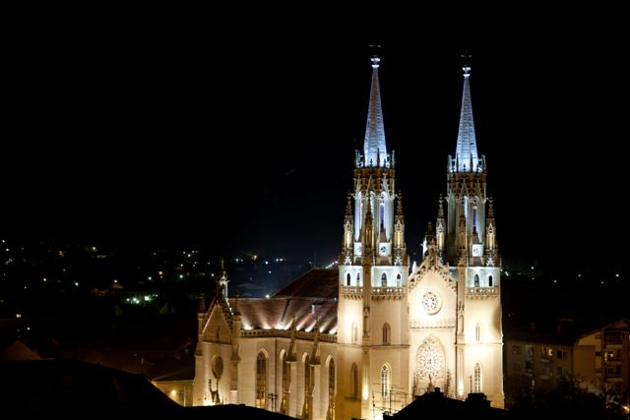  A short video about the project is available at:  https://www.youtube.com/watch?v=2cXOiZs3ADo
Partnership information
 |  |  |  | COUNTRY | COUNTY/DISTRICT | BUDGET(EURO) | CONTACT DETAILS
LEAD PARTNER: |  | Municipality of Vrsac |  | Serbia | South Banat | 172.195,80 | Vrsac, 1, Trg Pobede Street  Tel. +381 (0) 13 800-501
PARTNER 2: |  | DETA MUNICIPALITY |  | Romania | Timis | 116.861,60 | Deta, 1, Victoriei Street  Tel. 40723686786
PARTNER 3: |  | Serbian Orthodox Church Municipality of Vrsac |  | Serbia | South Banat | 52.475,94 | Vrsac, 11, Save Kovacevica Street  Tel. +381 (0) 13 831-862
PARTNER 4: |  | Romanian Orthodox Cathedral Church of Vrsac |  | Serbia | South Banat | 52.475,94 | Vrsac, 13, Dositejeva Street  Tel. +381 (0) 13 831-846
PARTNER 5: |  | Roman-Catholic Church Municipality of Vrsac |  | Serbia | South Banat | 44.464,56 | Vrsac, 31, Zarka Zrenjanina Street  Tel. ++381 (0) 13 831-136
PARTNER 6: |  | Romanian Orthodox Cathedral Church of Deta |  | Romania | Timis | 112.660,95 | Deta, 37, Victoriei Street  Tel. 0040-744829802
PARTNER 7: |  | Roman-Catholic Church of Deta |  | Romania | Timis | 102.974,27 | Deta, 37, Victoriei Street  Tel. 0040-744645467
PARTNER 8: |  | Romanian Orthodox Church of Opatita |  | Romania | Timis | 211.974,26 | Deta, 105, Opatita village  Tel. 0040-723517020

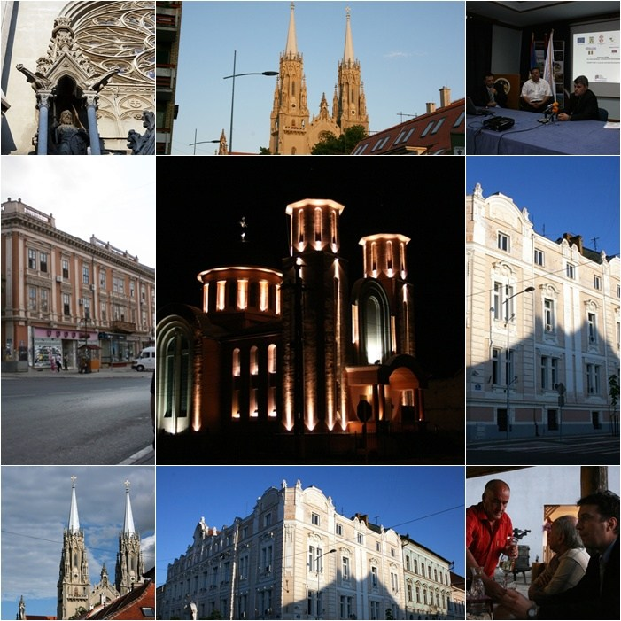

the implementation period (including any extensions) will be filed in, for example 01.01.2015 – 01.01.2017
total funds spent/total funds contracted *100
indicators and level of achievement against targets set

