Project information
CALL FOR PROPOSALS |  | 1
MIS-ETC: |  | 422
PRIORITY AXIS: |  | 2 Environment and Emergency Preparedness
MEASURE: |  | 2.3 More effective systems and approaches to emergency preparedness
PROJECT TITLE: |  | MODERNIZATION AND REHABILITATION CENTER OF REGIONAL FAST INTERVENTIONS AND MONITORING ON EMERGENCY SITUATIONS CIREŞU, MEHEDINTI COUNTY
ACRONYM: |  | RMCRIRMSUCJM
DURATION: |  | 27.11.2010-26.09.2012
IPA FUNDS CONTRACTED: |  | 800.071,09
TOTAL FUNDS CONTRACTED: |  | 941.260,10
ABSORBTION RATE (%): |  | 68,85
PROJECT OBJECTIVE(S): |  | - Strengthening the cross-border cooperation between local authorities from Mehedinti County and District Branicevski and, in emergencies, creating a socio-economic development and balanced development of the region borders Romania – Serbia.  - Encouraging further involvement of local communities in the border zone within the Integral-border cooperation for the establishment of joint partnerships for the benefit of increasing overall competitiveness of the economy.  - Creating the institutional and organizational ethic necessary to provide similar approaches and common services in order to better respond to emergencies and improve the quality of life in border area communities.
SHORT DESCRIPTION OF THE PROJECT: |  | The regional Center for monitoring and rapid intervention in emergency situations Ciresu, from Mehedinti County in Romania has been rehabilitated. The team in charge with monitoring and rapid intervention in emergency situations was equipped up to the latest standards. A survival guide was developed in agreement with the European Union norms, to improve the quality of life in communities in the border area by better responding in emergency situations.
DEGREE OF ACHIEVEMENT OF INDICATORS: |  | Indicator value provisioned in the contract Present indicator value % 6= (5)/(3)*100  Output indicators (1) UM (2) Quantity (3) UM (4) Quantity (5)  Increased institutional capacity and preparedness in reacting to situations of environmental emergency Number 1 Number 1 100  Increased joint technical preparedness to situations of environmental emergency Number 1 Number 1 100  Result indicators:  Increased expertise and exchange of experience in the field of environment protection Number of actions, activities, initiatives increasing expertise or exchange of experience in environment protection topics 10 Number of actions, activities, initiatives increasing expertise or exchange of experience in environment protection topics 10 200  Increased qualification of human resource in reacting to situations of environmental emergency Number of relevant staff and volunteers among local inhabitants gained skills /trained to react effectively in case of environmental emergency 20 Number of relevant staff and volunteers among local inhabitants gained skills /trained to react effectively in case of environmental emergency 20 100  Project indicators:  The Technical Project of the Center Regional of monitoring and rapid intervention in emergency situations Ciresu. Contract of execution, sketches, plans, measurements 1 Contract of execution, sketches, plans, measurements 1 100  The rehabilitation of the Regional Building Center monitoring and rapid intervention in emergency situations Ciresu The execution of contractual construction,invoices, records of teaching - reception 1 The execution of contractual construction,invoices, records of teaching - reception 1 100  Creating the new jobs in SMIRSU Number 7 Number 7 100  The equipment and supplies purchased for the Regional Center of monitoring and rapid intervention in emergency situations Ciresu. Minutes of teaching - the receipt of the equipments, contracts, invoices 1 Minutes of teaching - the receipt of the equipments, contracts, invoices 1 100  Purchased equipment SMIRSU Minutes of teaching - the receipt of the equipments, contracts, invoices 1 Minutes of teaching - the receipt of the equipments, contracts, invoices 1 100  Survival Guide Documentation on the survival guide Number of copies printed 1000 Documentation on the survival guide Number of copies printed 1000 100  Seminar Lists of the participants at the seminar 1 Lists of the participants at the seminar 1 100  Exchange of experience between specialists from both countries and the implementation team Minutes drawn during the exchange of experience 1 Minutes drawn during the exchange of experience 1 100  Promotion Project Articles in the mass - media, posters, paper banners, pens 12 Articles in the mass - media, posters, paper banners, pens 12 100  Audit project Audit Reports 1 Audit Reports 1 100  Meetings of the project Delegations, meeting minutes 3 Delegations, meeting minutes 3 100
RESULTS ACHIEVED: | Efficient management of emergencies at the border between Mehedinţi and Branicevski.  The rehabilitation and modernization of the regional center for monitoring and rapid intervention in emergency situations Ciresu and its equipment: video surveillance system, Internet and data network, furniture, computers, LCD TV, stove with accessories, microwave ovens, refrigerators, medical refrigerator, vacuum cleaners, multi boards, phone / fax, telephony and data network, surveillance and anti-burglary system.  Ensuring the practice of tourism in a civilized and safe framework.  Last generation equipment of SMIRSU: 4x4 car equipped for permanent monitoring equipment for particular situations, land auto-ambulance equipped with medical equipment and first aid, ATV - 4x4 land sites for travel on narrow trails and valleys with trailer, trailer Transport ATV-s, technical intervention equipment, GPS equipment accessories, computers, technical equipment collective, uniform personnel, technical equipment intervention technique, underground machinery, equipment, water, rocks and extrication equipment, rescue equipment, communications equipment, electronic mapping, Individual intervention equipment, ski equipment and winter rescue, camping equipment, equipment maintenance and repair, underwater interventions equipment, mobile phones alerting device, portable computers with accessories for collecting data from the field, video accessories. A short video about the project is available at:  https://www.youtube.com/watch?v=DTHvh8TztY0&t=1s

Partnership information
 |  | COUNTRY | COUNTY/DISTRICT | BUDGET(EURO) | CONTACT DETAILS
LEAD PARTNER: | Mehedinti County Council | Romania | MEHEDINTI | 941.260,10 | DROBETA TURNU SEVERIN, 89,TRAIAN Street  Tel. 0252-311218
PARTNER 2: | MUNICIPALITY GOLUBAC | Serbia | BRANICEVSKI | 0 | GOLUBAC, 15 Cara Lazara Street  Tel. +3981 12 678 128

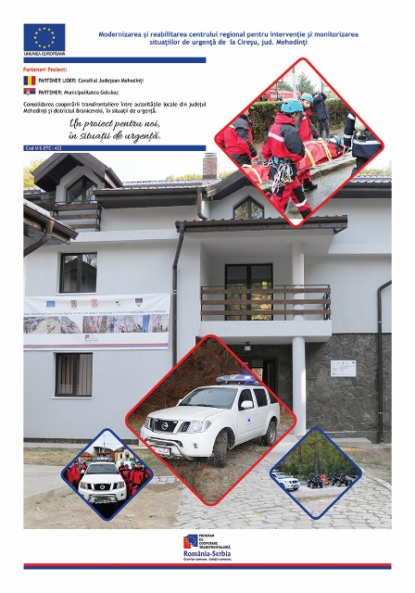

the implementation period (including extensions)
total funds spent/total funds contracted *100
indicators and level of achievement against targets set

