Project information
CALL FOR PROPOSALS | 1
MIS-ETC: | 421
PRIORITY AXIS: | 3 Promoting “people to people” exchanges
MEASURE: | 3.3 Increase educational, cultural and sporting exchange
PROJECT TITLE: | Folklore - The Traditional Item
ACRONYM:
DURATION: | 05.11.2010-04.11.2011
IPA FUNDS CONTRACTED: | 149.795,50 €
TOTAL FUNDS CONTRACTED: | 176.230 €
ABSORBTION RATE (%): | 83,63 %
PROJECT OBJECTIVE(S): | Promotion of common cultural and traditional heritage of Godeanu, Mehedinți and Mosna, Bor areas. Support in creating cross-border partnerships for developing the common cultural and folkloric traditions.
SHORT DESCRIPTION OF THE PROJECT: | As long as both communities have common traditions that survived through centuries, the project partners decided to implement a project which created a cultural partnership between the two Romanian-Serbian cross-border communities, promoting these regions and bringing economic, social and cultural development. The endowments acquired during the project implementation created a more friendly environment for local artists, motivating them to present much better-quality acts of culture and promoting the cultural life of the two communities. The project activities increased the people-to-people exchanges in the field of culture between Godeanu and Mosna Villages and the integration of these Romanian-Cross-border communities.

DEGREE OF ACHIEVEMENT OF INDICATORS: | Indicator value provisioned in the contract Present indicator value % 6= (5)/(3)*100  Output indicators (1) UM (2) Quantity (3) UM (4) Quantity (5)  Increased people-to-people exchange in the fields of culture between Godeanu and Mosna Villages Number 1 Number 1 100%  Increased integration of the border communities Godeanu and Mosna Number 1 Number 1 100%  Result indicators  Increased cultural integration of people in the areas of Godeanu and Mosna Number of participants at all cultural events proposed by the project 50 Number of participants at all cultural events proposed by the project 1400 2800%  Improved quality of life and increased attractiveness of the border communities as a living place Number of activities, actions and initiatives communes in the cultural and folkloric field 6 Number of activities, actions and initiatives communes in the cultural and folkloric field 6 100%  Project indicators  Popularization of Mosna Ensemble, Serbia Number of spectacles 2 Number of spectacles 2 100%  TV apparitions 2 TV apparitions 2 100%  Popularization Godeanu Fanfare, Romania Number of spectacles 2 Number of spectacles 2 100%  TV apparitions 2 TV apparitions 2 100%

RESULTS ACHIEVED: | In the framework of a cross-border partnership between the Godeanu Local Council (Romania), Mehedinți County Council (Romania) and Mosna City Hall (Republic of Serbia) the project "Folklore – The Traditional Element" was implemented under the Romania-Republic of Serbia IPA Cross-border Cooperation Programme and benefiting from a total budget of 176,230 euros, between November 2010 and November 2011.  The overall objective of this cross-border project was to increase the interest in traditional folk elements at the level of the two local communities and at the regional level, thus ensuring a sustainable and balanced cultural development of the Romanian-Serbian cross-border area. The first stage of project consisted in organizing thematic meetings between the representatives of the folk ensembles of Mosna and Godeanu communes in which the common needs for organizing folk festivals on the two banks of the Danube were established. In order to ensure high quality of these festivals, the organizers bought 30 men's folk costumes, specific to the Northern area of ​​Mehedinți County, inspired by the frescoes of the churches within the Commune of Godeanu, musical instruments necessary for the folk-minstrels, including blowing instruments sax, horn, trombone, clarinet, organ, accordion and drums.  In the second phase of the project, two traditional music festivals were held with more than 2,000 people attending, one in Godeanu on 22 May 2011 and one in Mosna on June 2, 2011.  Within these cultural-traditional events, the representatives of the two localities had the opportunity to meet to discover the traditions and customs existing across the Danube, to learn about the way of life, culture and neighbours’ history. Between the guests of the folkloric performances, along with the local folk-minstrels, were also present popular folkloric musicians from the two areas. The festivals were complemented by the organization of crafts exhibitions that included traditional working tools, wooden objects, folk costumes, as well as well-known Șișești ceramics made of clay.  The video recordings of the two folkloric performances will be a testimony for future generations through a DVD that was distributed in Godeanu, Romania and Mosna in the Republic of Serbia.  Within the „Folklore - The Traditional Item” project were purchased the following musical instruments and stage equipment: 1 mobile scene; 1 sound system with boxes and microphones (for voice and for the instruments); 3 saxophones; 4 trumpets; 1 clarinet; 1 tuba; 2 tenor horns; 1 trombone; 1 pipe organ with stops and stand;1 accordion; 1 drum; 2 drum sticks (cymbal); 30 popular costumes for men from North of the Mehedinți area (15 for summer time and 15 for winter period); 3 photo cameras and3 video cameras.  1000 DVDs and CDs were created to present the folkloric groups from Mosna, Serbia and Godeanu, Romania.

Partnership information
 |  | COUNTRY | COUNTY/DISTRICT | BUDGET(EURO) | CONTACT DETAILS
LEAD PARTNER: | Godeanu Local Council | Romania | Mehedinți | 176.230 | Godeanu, Mehedinți  Tel. 0040 252 388 540
PARTNER 2: | Mehedinți County Council | Romania | Mehedinți | 0 | Drobeta Turnu Severin, Traian Str. No. 89  Tel. +40 372 521113
PARTNER 3: | Mosna Mayoralty | Serbia | Bor | 0 | Mosna, Donji Milanovac  Tel. +38163686900

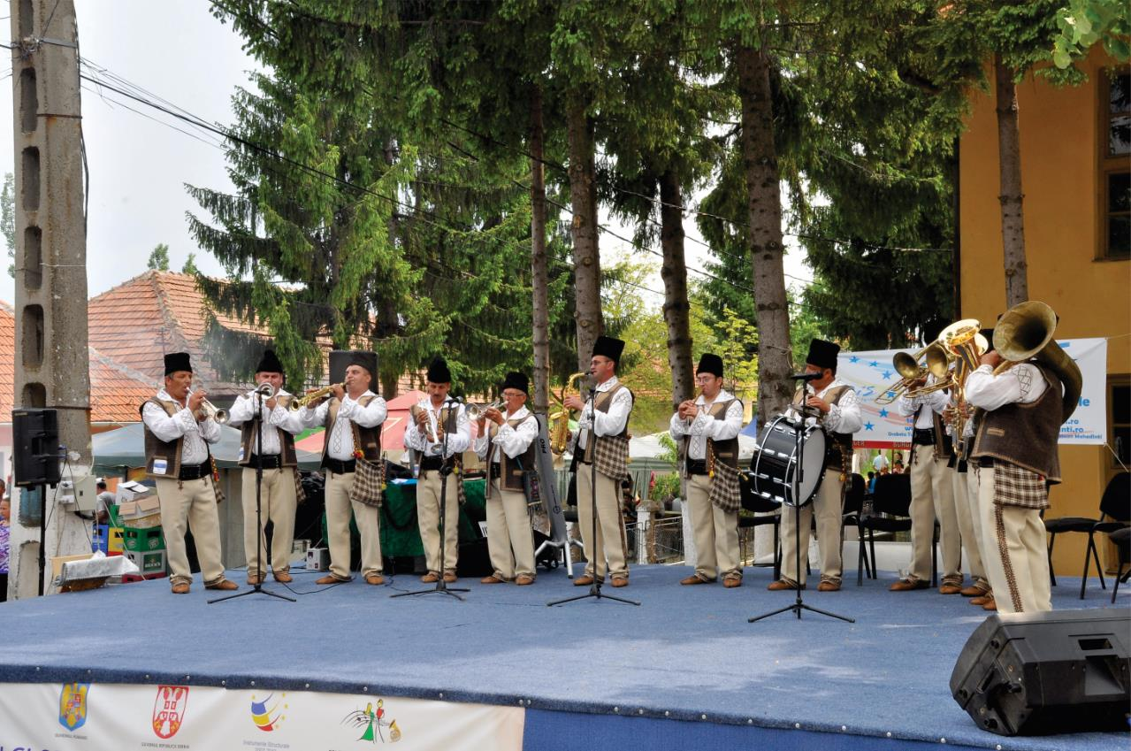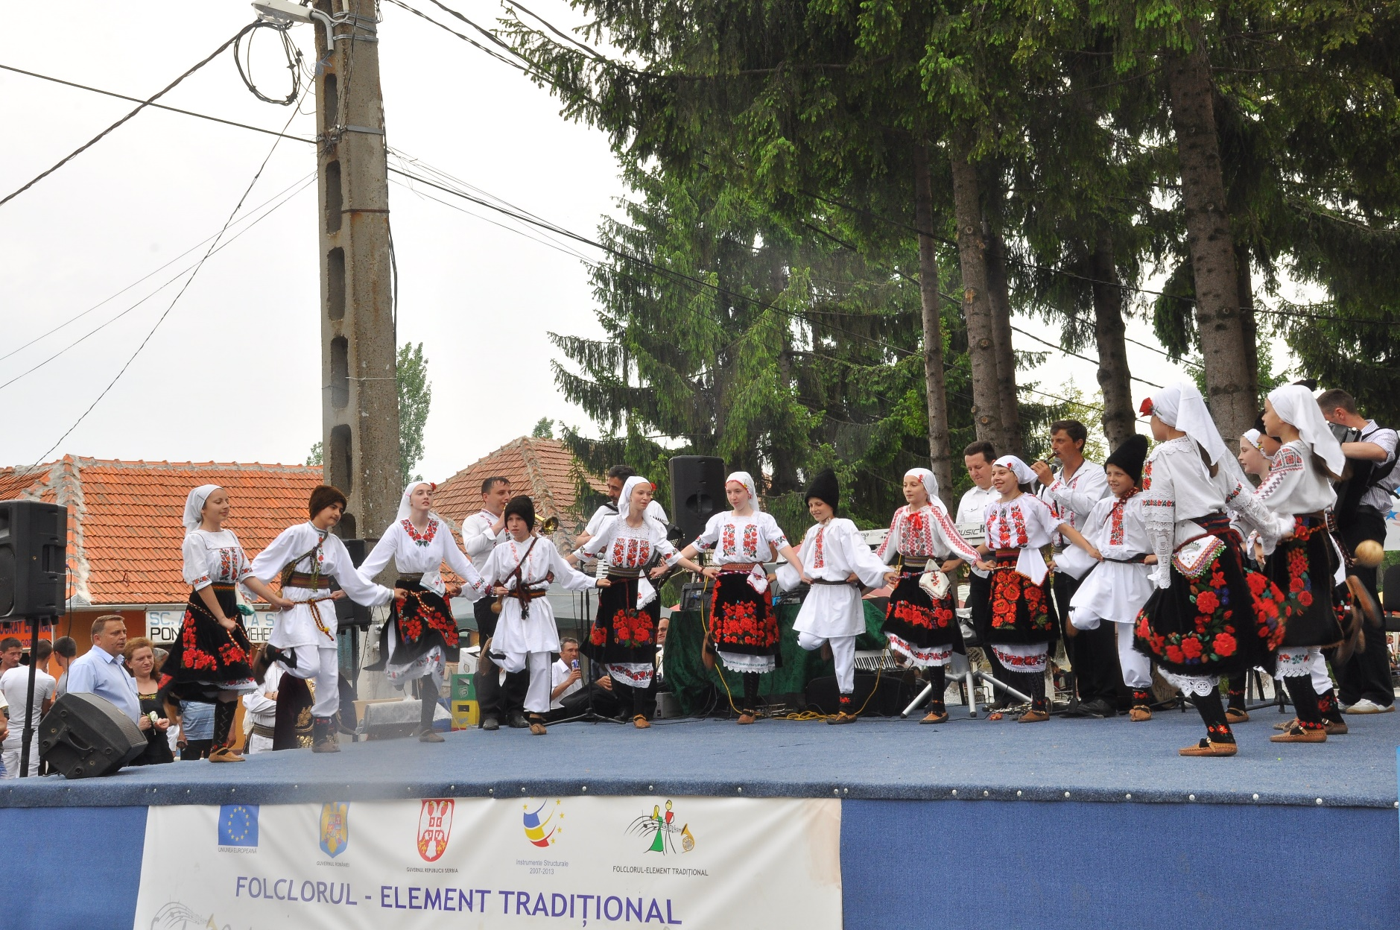
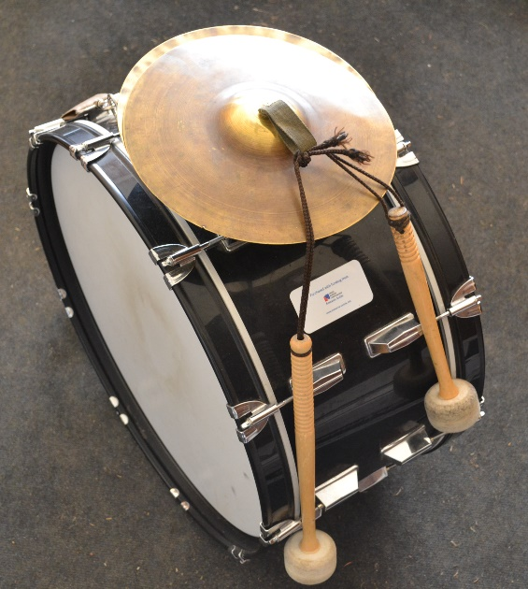
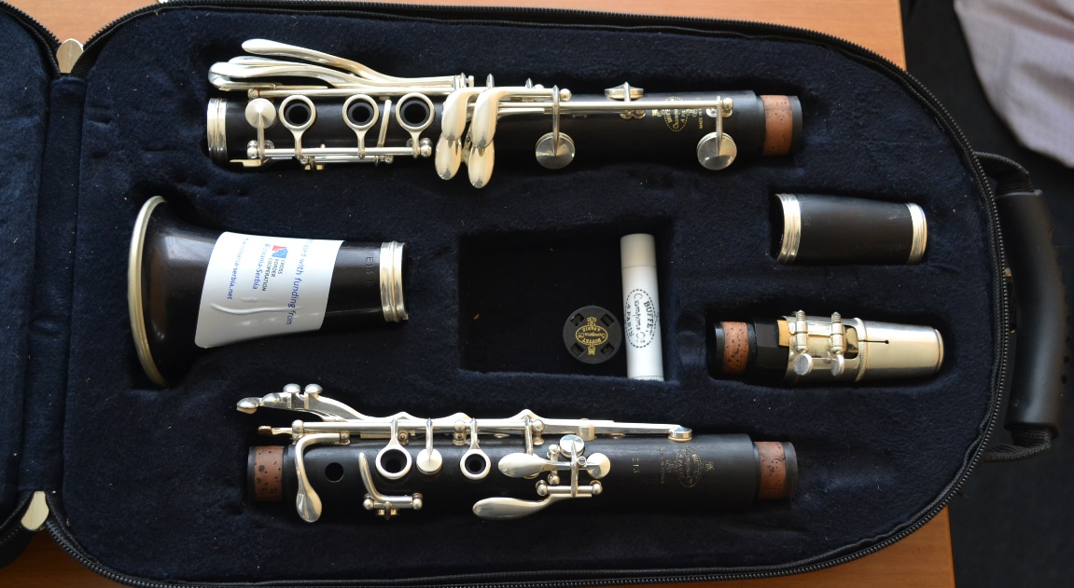
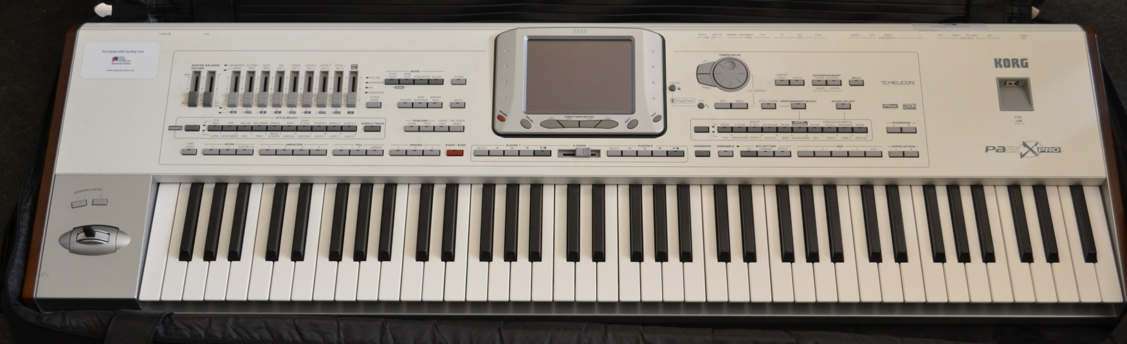
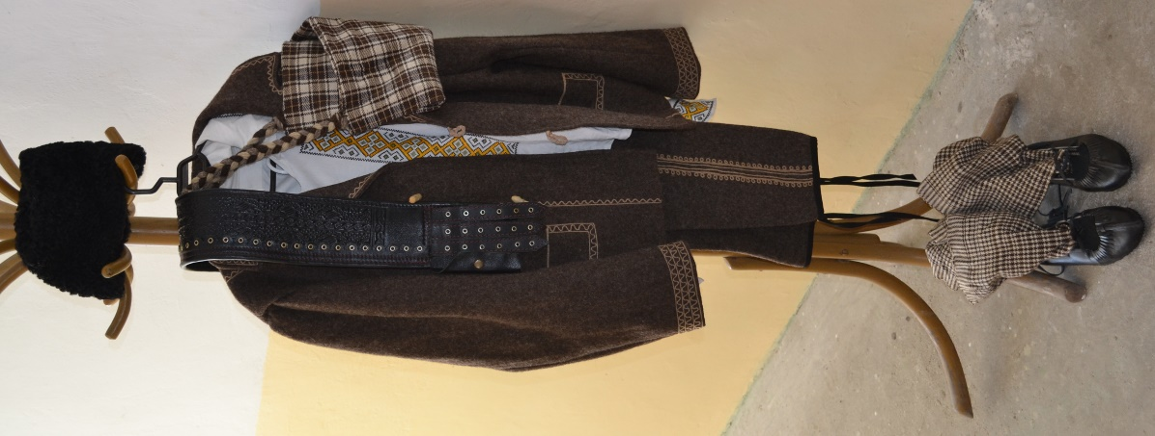

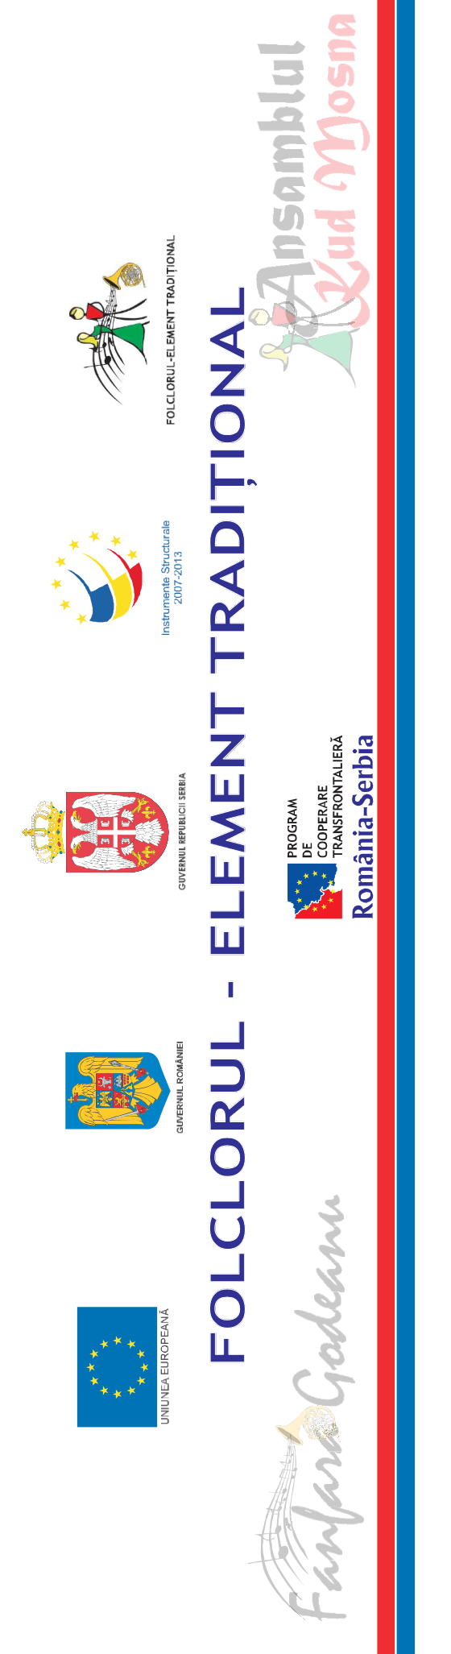

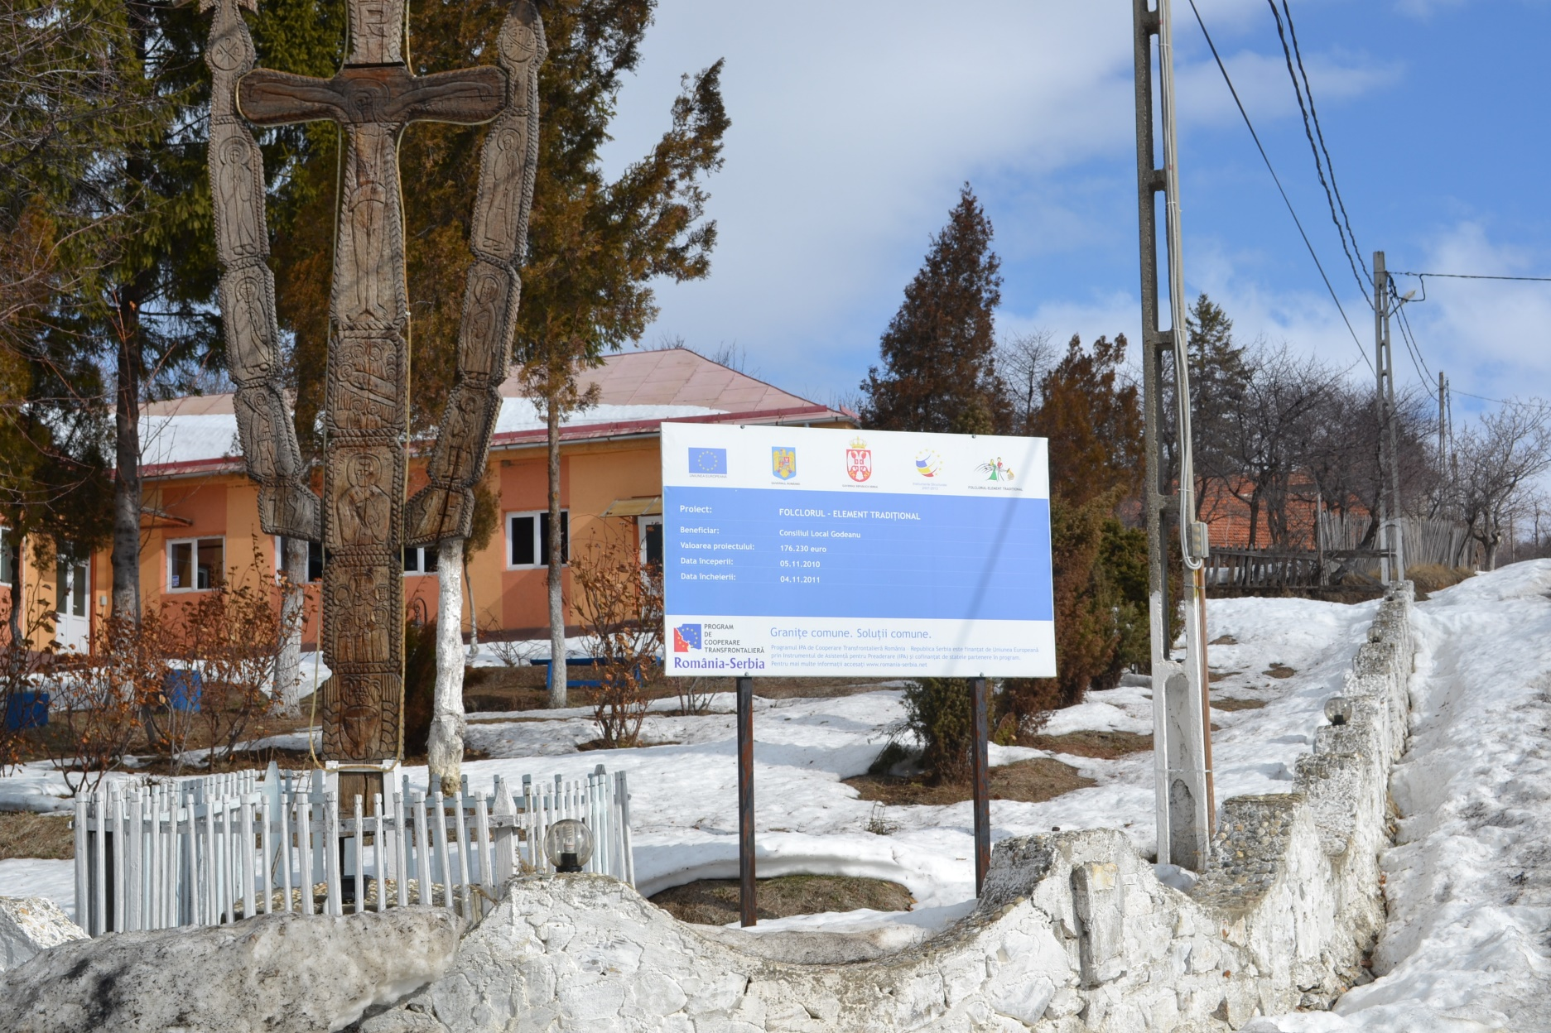

the implementation period (including extensions)
total funds spent/total funds contracted *100
indicators and level of achievement against targets set

