Project information
CALL FOR PROPOSALS |  | 1
MIS-ETC: |  | 417
PRIORITY AXIS: |  | 3 Promoting “people to people” exchanges
MEASURE: |  | 3.3 Increase educational, cultural and sporting exchange
PROJECT TITLE: |  | Find out about life 2
ACRONYM: |  | FOAL
DURATION: |  | 01.12.2010-30.11.2011
IPA FUNDS CONTRACTED: |  | 83.053,62 €
TOTAL FUNDS CONTRACTED: |  | 97.710,74 €
ABSORBTION RATE (%): |  | 80,06%
PROJECT OBJECTIVE(S): | Decreasing poverty of youth in the cross-border area using a strategic document from the field of prevention of risky behaviour of youth in Bor, Požarevac and Resita, based on National Anti-Drug Strategy of Romania and Serbia.  Development of a network of teams educated for common innovative methods in the field of informal education for better life of the youth in Bor, Požarevac and Resita.  Empowerment of healthy mechanisms of the youth to respond actively to the challenges, fight back, refuse and choose healthy behaviour and healthy style of life.  Raising the general awareness of professionals and civil public in Bor and Branicevo Districts (Serbia) and Caraș-Severin County (Romania) regarding the danger of using drugs.

SHORT DESCRIPTION OF THE PROJECT: | This second part of the “Find out about life” project has improved the program regarding the primary prevention of drug abuse in Bor District and spread positive experience of innovative methods onto border communities Požarevac and Resita. Further on, to spread the partnership on the border areas and to develop a joint approach concerning the drug problem, within the project we conducted informal education and youth activities to improve the life quality of youth from the both sides of the Romanian-Serbian border.  The project multiplied positive cross-border effects and contributions, both in Resita and Požarevac, transferring innovative methods and techniques, constructive dialogue of non-violent communication and transformation of conflict in peers’ groups, thematic parents’ meetings and same-age education on drug prevention in order to improve the youth quality of life. The people from the cross-border region cooperated each other to learn about cultural differences, exchanged their experience and improved social activities that contributed to more balanced social and economic development.  After the end of project implementation, the networking teams has continued to sustain joint activities and cooperation with the Anti-Drug Municipality Councils.

DEGREE OF ACHIEVEMENT OF INDICATORS: | Indicator value provisioned in the contract Present indicator value % 6= (5)/(3)*100  Output indicators (1) UM (2) Quantity (3) UM (4) Quantity (5)  1. Stronger civil society in the cross-border area Number of students educated for same-age education drug-prevention 25 25 volunteers attended a 5 days training in Požarevac, being educated for same-age education drug prevention 25 100%  Number of volunteers educated for same-age education drug prevention, who renewed their knowledge 25 25 volunteers renew their knowledge in leading the drug prevention workshops, held for 2 days in Bor. 25 100%  Number of educated volunteers for same-age mediation for promoting constructive dialogue in non-violent communication and during solving conflicts in peer groups 50 Number of educated volunteers for same-age mediation for promoting constructive dialogue in non-violent communication and during solving conflicts in peer groups 50 100%  Number of educated teachers for realization of thematic parents’ meetings in all three communities 26 Number of educated teachers for realization of thematic parents’ meetings in all three communities 36 138%  Indicator value provisioned in the contract Present indicator value % 6= (5)/(3)*100  Output indicators (1) UM (2) Quantity (3) UM (4) Quantity (5)  2. Increased people-to-people exchange in the field of informal Workshops with students from all three communities 240 Workshops with students from all three communities 240 100%  Promotional activities of constructive dialogue on non-violent communication in schools and solving peer conflicts in all three communities 62 Promotional activities of constructive dialogue on non-violent communication in schools and solving peer conflicts in all three communities 62 100%  Thematic parents’ meetings and number of supported parents and panels with teachers in all three communities 44 Thematic parents’ meetings and number of supported parents and panels with teachers in all three communities 44 100%  3. Increased integration of the cross-border communities and improved local service in border area Joint thematic workshops and written agreement on cooperation 3 Joint thematic workshops and written agreement on cooperation 3 100%  Printed and distributed publications from the field comprised by the project with the same content 10600 Printed and distributed publications from the field comprised by the project with the same content 10600 100%  Number of information and thematic radio and TV broadcasts 22 Number of information and thematic radio and TV broadcasts 38 172,7%  Result indicators  Increased social and cultural integration of people in cross-border areas Participants benefiting from social and cultural cross-border events 126 Participants benefiting from social and cultural cross-border events 136 108%  Project indicators  Improved quality of life and increased attractiveness of the border communities as a living space of border communities as places to live in Number of activities, actions, initiatives which develop new or improve already existing educational and social service, or improve local life conditions. 324 - (Realized 240 workshops and supported 4500 students, 22 thematic parents meetings and 22 discussion issues with teachers with 660 supported parents 660 supported teachers and 40 mediations with supported 80 students in all three communities and achieved sustainable drug prevention programme.) Number of activities, actions, initiatives which develop new or improve already existing educational and social service, or improve local life conditions. 324 100%

RESULTS ACHIEVED: | Result 1: Teams educated teams for continuous and long-term activities on prevention of drug abuse and risky behaviour of youth in Bor, Resita and Požarevac.  - Two days training with supervision support for 25 volunteers for peer education through workshop methods on drug prevention was realized in Bor (21 peer educators from Bor and 4 from Resita);  -Four days training for teachers and their associates (36) on thematic parents’ meetings regarding risky behaviour of youth was realized in Bor;  -Five days training for volunteers regarding peer education through workshops methods on drug prevention was realized in Požarevac, 25 pupils from all three communities were educated (15 from Požarevac, 2 from Bor and 8 from two schools in Resita)  -5 days training for 50 pupils realized in Resita to educate the youth for promotion of constructive dialogue and conflict transformation in peer groups. The training was attended by two groups of 25 pupils from primary and secondary schools, 34 pupils were from Resita, 8 pupils were from Bor and 8 from Požarevac;  Result 2: The youth adopted the knowledge and the skills of positive responding to drug—challenges, healthy way of behaviour and healthy way of life.  - 4819 primary school pupils from 20 schools were educated during 240 workshops on drug prevention. 100 workshops were held in Bor, 60 workshops for two schools Resita and 80 workshops in Požarevac. The school pupils were informed about the negative bad effects of drugs and gathered skills to respond positively to challenges reflecting healthy behaviour and healthy life style.  - 660 Parents Committee members supported at 22 thematic parents’ meetings realized in 20 Primary schools, Bor (10), Požarevac (8) and 4 in two schools in Resita.  -660 teachers from 20 Primary schools supported at 22 discussion issues in schools in Bor (10), Požarevac (8) and Resita (4).  - 82 pupils at conflict/problem issue were supported through 40 peer mediations in Primary and Secondary schools in all three communities and 750 pupils and School Parliament members and students were informed on ways of peaceful solving of problems, practicing tolerance and constructive dialogue in peer groups throughout 22 presentations.  - Peer mediators from Secondary schools from Bor conducted a survey among Secondary school pupils on violence perception at schools and risky surrounding and organized public action;  - Organizing 22 discussion issues with students in 20 schools in Bor, Požarevac and Resita - activities on stimulating positive models of behaviour of students.  -within the project it was realized a „Quiz of knowledge” game, broadcasted live on local TV in Požarevac, regarding negative effects of drugs between students from Bor, Resita and Požarevac.  - during the Anti-drug World Day, promotional actions were organized in Bor and Požarevac in order to present healthy life style, alternative/positive models of behaviour of youth, Art and Literature contests were also organized in schools Bor and Požarevac. In Resita both partner schools realized an event celebrating International day of youth.  Result 3: Sustainable cross-border programme of primary prevention of adolescent from drug abuse and improved cooperation of people from both sides of the border covered by the project.  - Three thematic round-tables with 62 participants were realized in Bor, Resita and Požarevac. The participants exchanged experiences regarding the methodology of preventing drug abuse and planning future cooperation activities.  -500 posters, 3000 practicums for parents, 3500 brochures, 1100 promotional flyers and 2500 leaflets were printed and distributed in Bor, Resita and Požarevac.  - Realized 6 thematic one-hour TV broadcasts, on local media (2 in Bor, 2 in Resita and 2 in Požarevac).  - 22 informative broadcasts reporting on all the activities during the report period in Bor (8) and Požarevac (12) and Resita (2). 5 radio broadcasts in Bor (2), Požarevac (2) and Resita (1) and 5 informative radio.

Partnership information
 |  | COUNTRY | COUNTY/DISTRICT | BUDGET(EURO) | CONTACT DETAILS
LEAD PARTNER: | NGO Kokoro Bor | Serbia | Borski | 38.905,04 | Bor, M. Vasića-Perice 4  Tel. 00381 30 296 760
PARTNER 2: | "Mircea Eliade" Theoretical High School Reșița | Romania | Caras-Severin | 18.294,35 | Reșița, Str. Făgărașului Nr.6-8  Tel.+40 255 231074
PARTNER 3: | NGO Youth of Jazas Požarevac | Serbia | Branicevo | 22.669,00 | Požarevac, Bože Dimitrijevića 53  Tel. +381 12 222 946
PARTNER 4: | "Traian Vuia" Theoretical High School Reșița | Romania | Caras-Severin | 17.842,35 | Reșița, 71, Str. Văliugului  Tel. +40-(0)255-254.034

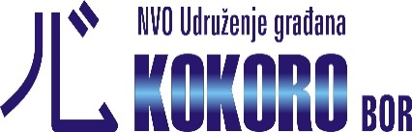

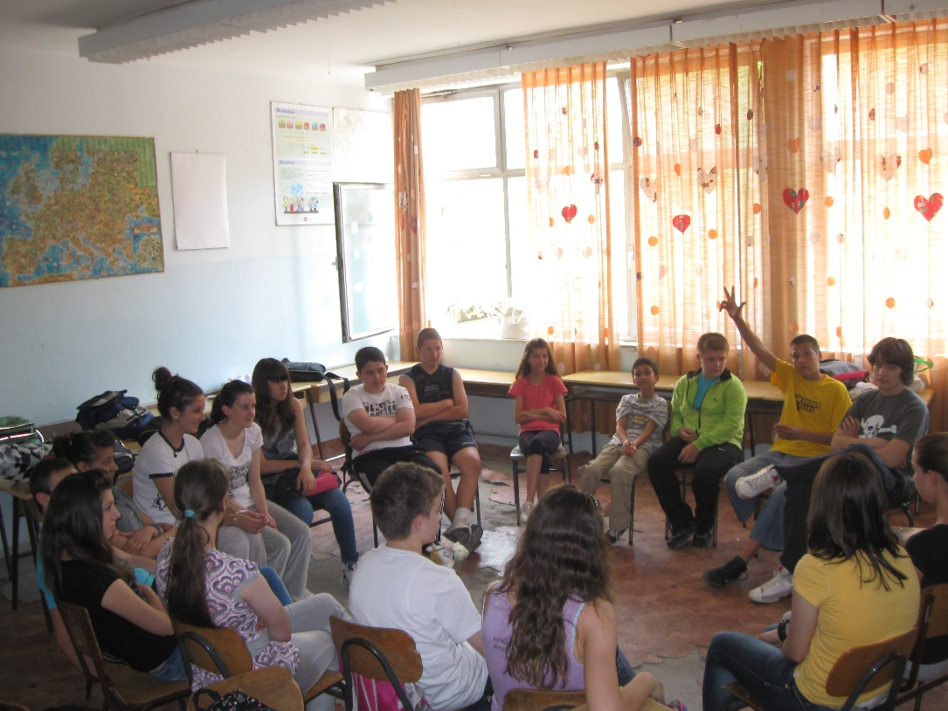
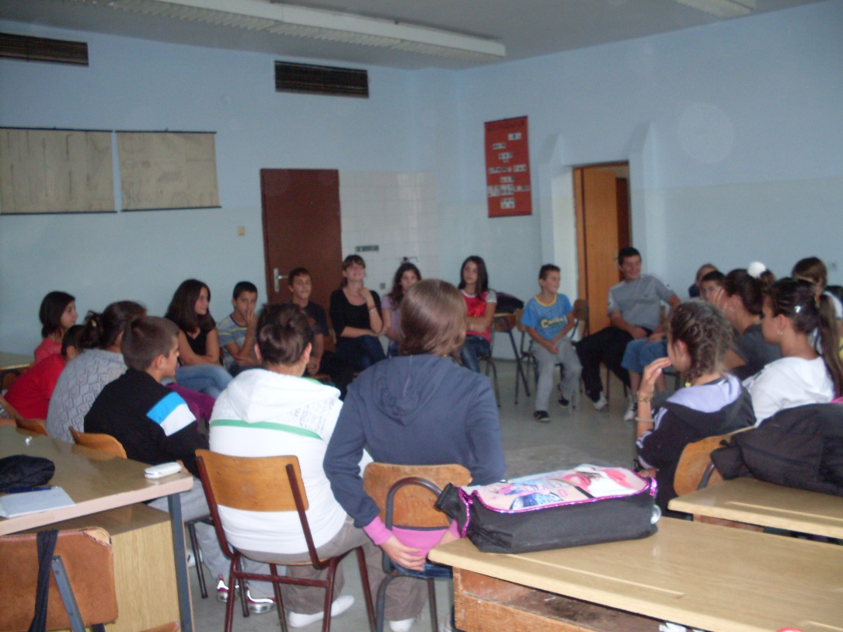

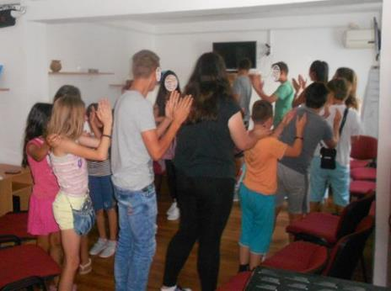
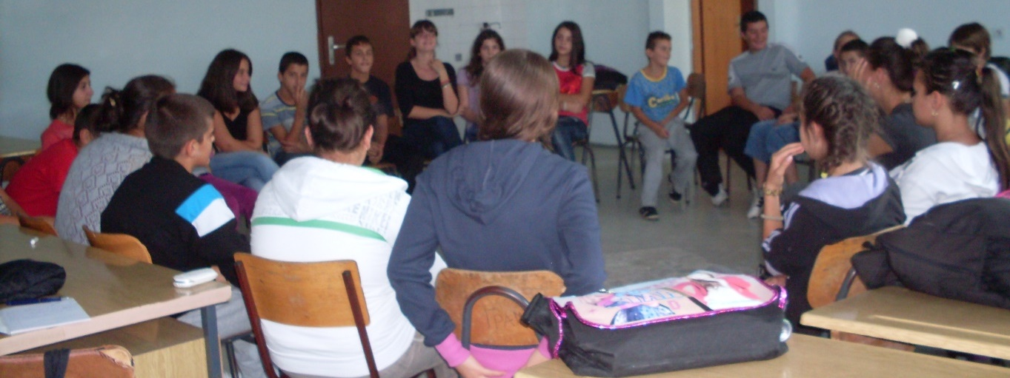
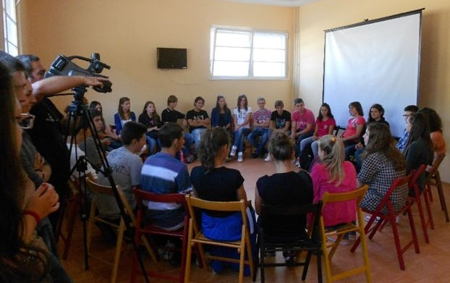
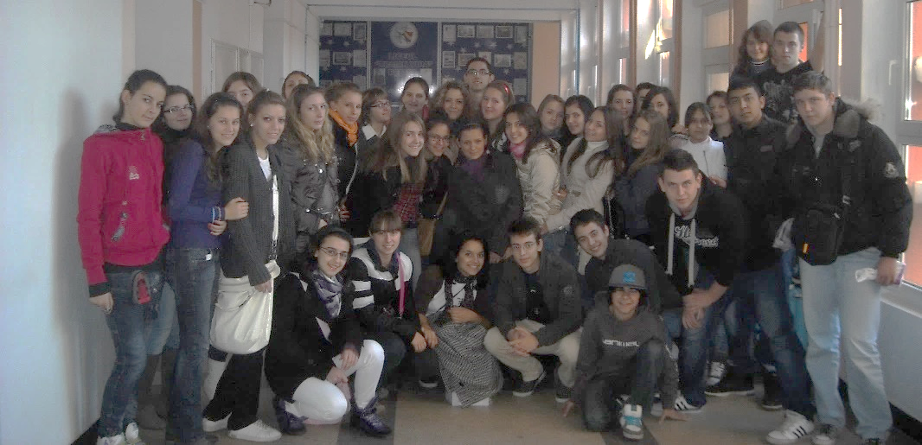
Find About Life II

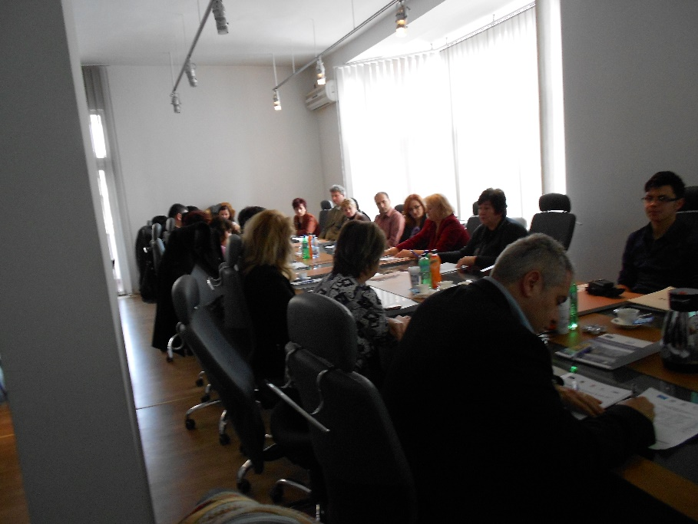
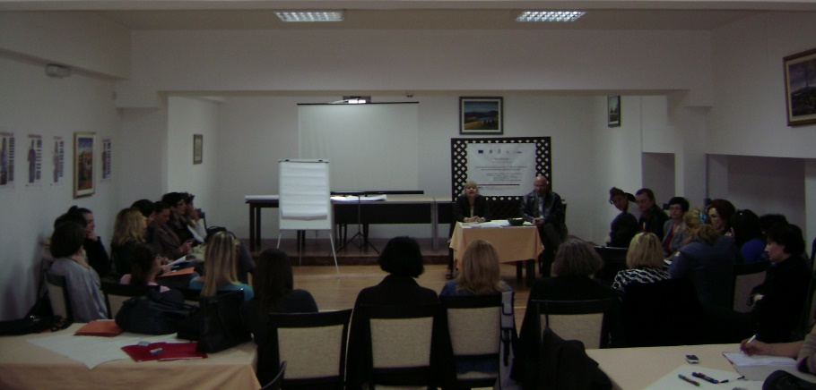
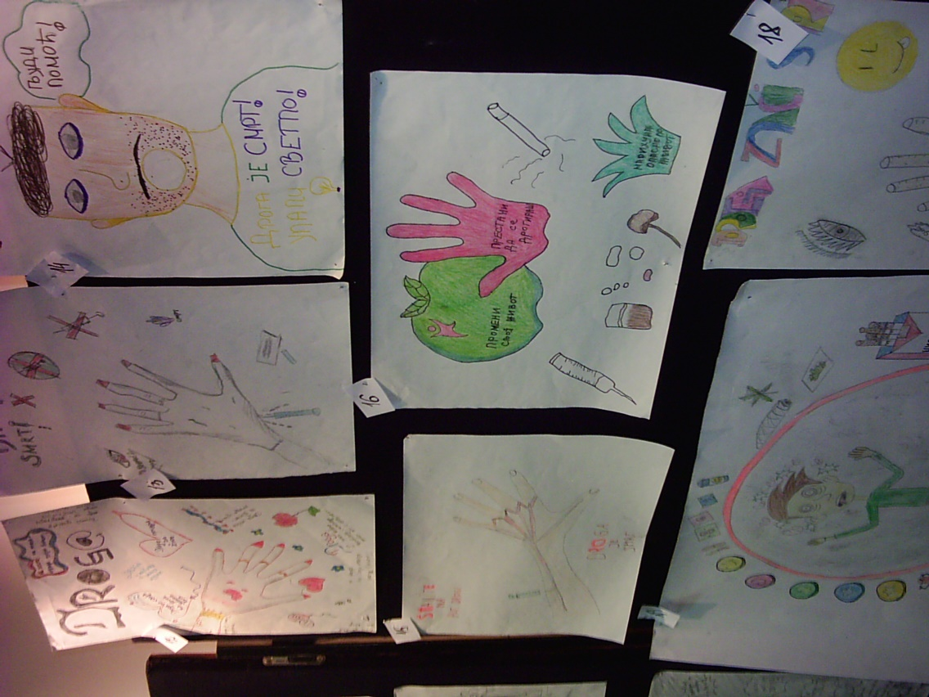
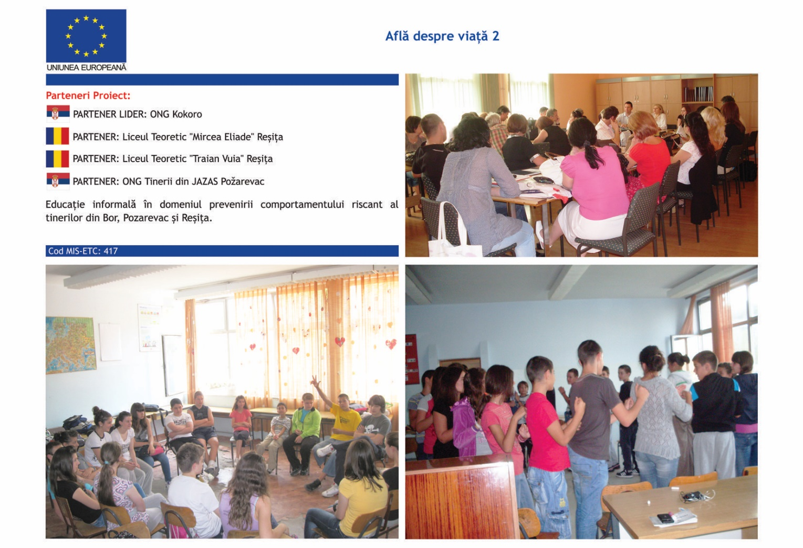
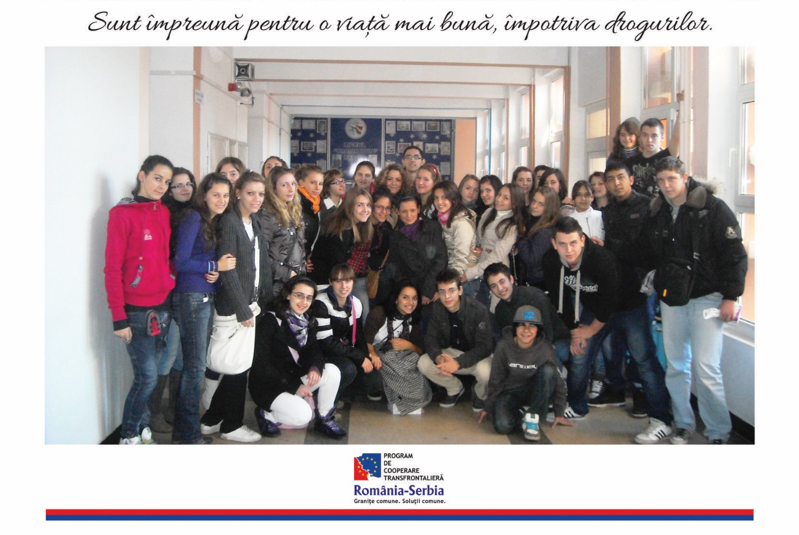

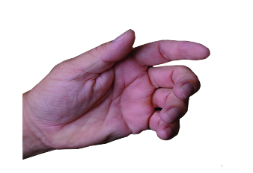
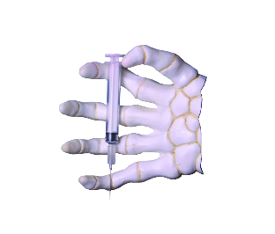
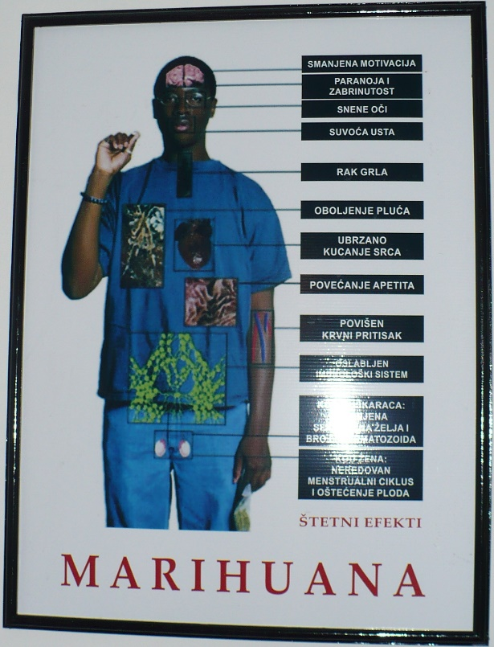
Bor, Požarevac and Reșița
Find About Life II

the implementation period (including extensions)
total funds spent/total funds contracted *100
indicators and level of achievement against targets set

