Project information
CALL FOR PROPOSALS | 1
MIS-ETC: | 414
PRIORITY AXIS: | 2 Environment and Emergency Preparedness
MEASURE: | 2.2 Develop and implement effective strategies for waste and waste water management
PROJECT TITLE: | Waste selective collection to the EU level
ACRONYM:
DURATION: | 27.11.2010-26.05.2012
IPA FUNDS CONTRACTED: | 572.529,40 €
TOTAL FUNDS CONTRACTED: | 673.564,00 €
ABSORBTION RATE (%): | 97,92%
PROJECT OBJECTIVE(S): | Training and informing the citizens about the waste selective collection.  Training the population for selecting the waste in order to recycling it.  Population training for knowing to collect selectively the waste in different containers, labelled properly and placed in special areas accessible for the citizens.  Population awareness on the importance of selective waste collection and implicitly its recycling.
SHORT DESCRIPTION OF THE PROJECT: | Continuing the strong partnership established in the previous cross-border projects implemented, the partners decided to pay closer attention to the environmental issues. The project created a selective waste collection service in 8 villages arranging 60 collection points with the necessary endowments and equipment, trained 20 people from the partner villages in selective waste collection and provided basic information on the benefits of selective waste collection to 1.647 households in the partner villages.
DEGREE OF ACHIEVEMENT OF INDICATORS: | Indicator value provisioned in the contract Present indicator value % 6= (5)/(3)*100  Output indicators (1) UM (2) Quantity (3) UM (4) Quantity (5)  Improved physical infrastructure of waste and wastewater treatment in the border area Number 1 Number 1 100  Increased institutional capacity and preparedness in reacting to situations of environmental emergency (e.g. flooding, bird flu) Number 1 Number 1 100  Increased joint technical preparedness to situations of environmental emergency Number 1 Number 1 100  Result indicators  Increased cross-border cooperation in environment protection Number 1 Number 1 100  Increased expertise and exchange of experience in the field of environment protection Number 1 Number 1 100  Improved knowledge on different environment-friendly approaches and applications in everyday life Number 1 Number 1 100  Project indicators  Number of shared equipment purchased for environmental protection. - 1 waste collecting vehicle (garbage truck); - 60 points to selectively collect the waste; - 240 containers for waste collection; Number 1 Number 1 100  Number 60 Number 60 100  Number 240 Number 240 100  Number of relevant staff and volunteers among local inhabitants gained skills Number 3 Number 3 100  Number of activities, actions, initiatives promoting different environment-friendly solutions. Number 1647 Number 1647 100
RESULTS ACHIEVED, INCLUDING PHOTOS: | - 60 waste selective points;  - 1 waste collecting vehicle;  - 1 small plant used to sort, shred and grind the recycled materials;  - 240 euro-containers;  - 3 working places;  - educated population concerning the waste selective collection.

Partnership information
 |  | COUNTRY | COUNTY/DISTRICT | BUDGET(EURO) | CONTACT DETAILS
LEAD PARTNER: | Sisesti Local Council | Romania | Mehedinti | 673.564,00 | Sisesti Commune, PC 227455  Tel. 0721/ 241 347
PARTNER 2: | Mehedinti County Council | Romania | Mehedinti | 0 | Drobeta Turnu Severin, Traian Str. No. 89  Tel. +40 372 521113
PARTNER 3: | Mosna Mayoralty | Serbia | Bor | 0 | Mosna, Donji Milanovac  Tel. +38163686900

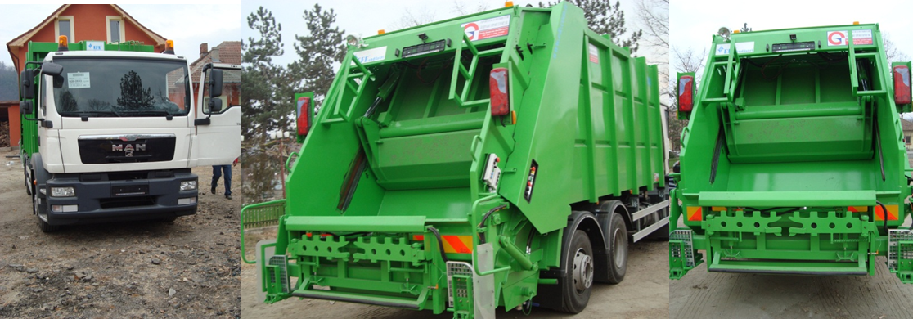

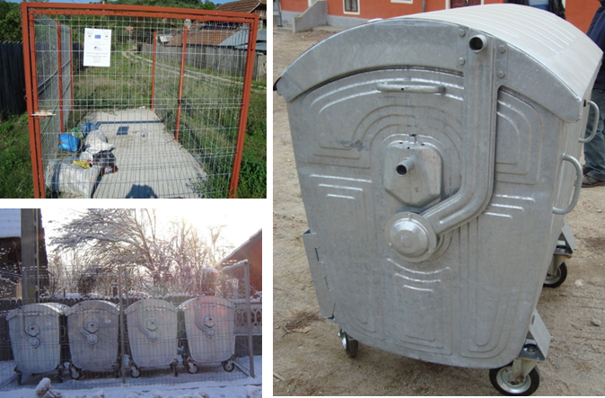

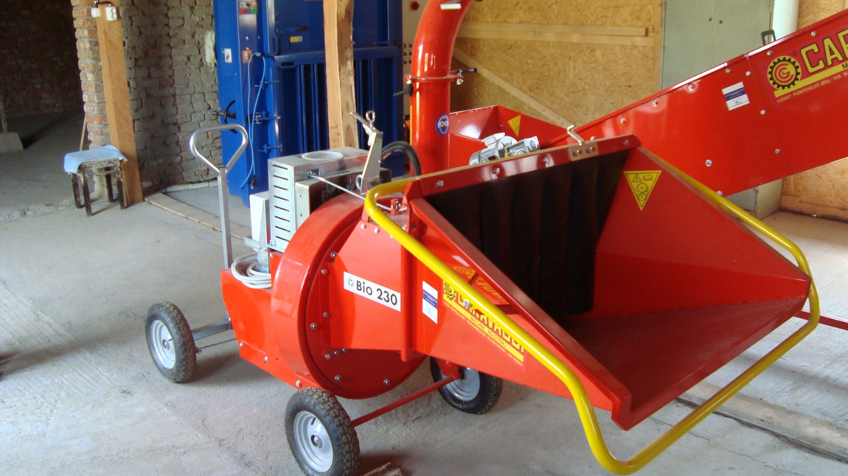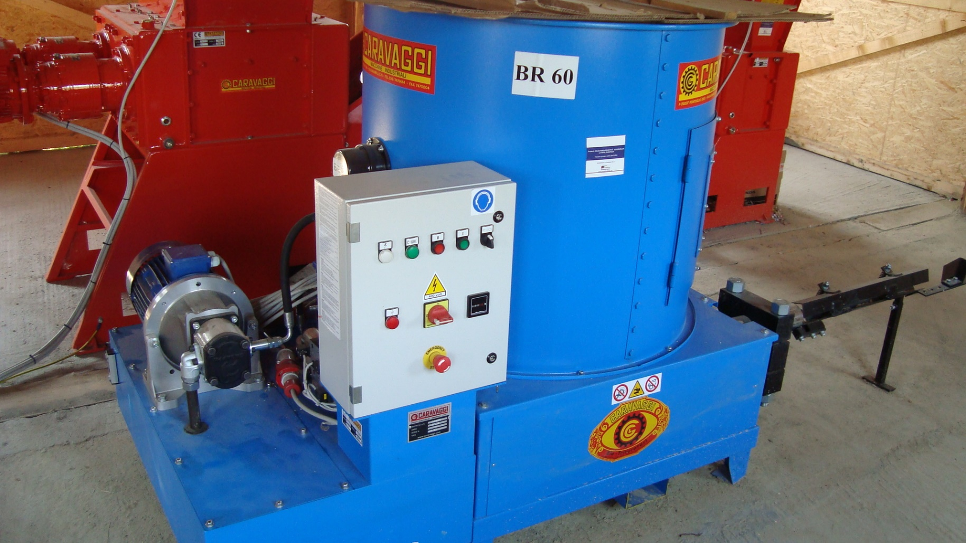

the implementation period (including extensions)
total funds spent/total funds contracted *100
indicators and level of achievement against targets set

