,

|  |  |
| --- | --- |
| **Project information** | |
|  |  |
| CALL FOR PROPOSALS | 1 |
| MIS-ETC: | 411 |
| PRIORITY AXIS: | 2. Environment and Emergency Preparedness |
| MEASURE: | 2.1 Improve systems and approaches to address cross-border environmental challenges, protection and management |
| PROJECT TITLE: | **Measures for protection of the Tamis river – “STEP 2”** |
| ACRONYM: | STEP 2 |
| DURATION[1]: | 01.01.2011 – 30.04.2012 |
| IPA FUNDS CONTRACTED: | 513.455,76 € |
| TOTAL FUNDS CONTRACTED: | 604.065,60 € |
| ABSORBTION RATE (%)[2]: | 56,29% |
| PROJECT OBJECTIVE(S): | One of the project objectives was to improve the quality of human life by upgrading of the eco-status of the Tamis region and creating conditions for a more even, sustainable socio-economic development.  During the project we created the conditions for the improvement of the quality of the Tamis water for the protection of the river in the next years (2010-2020) and raising the eco-awareness in local communities by a coordinated action of cleaning the river and the banks from solid waste.  The project raised the level of responsibility in water management through promotion of best available waste water treatment technologies in the region, by upgrading the communal infrastructure in critical Tamis-related spots in Opovo village and uupgrading the infrastructure for treatment of waste water on the Tamis river banks in Zrenjanin villages. |

|  |  |
| --- | --- |
| SHORT DESCRIPTION OF THE PROJECT: | The project contributed to the environmental protection of Timiș River and raised awareness regarding the cross-border environment along the river.  In order to improve the quality of human life by upgrading of the eco-status of the Tamis region and to clean the Timiș (Tamis) River from the floating and dumped solid waste, during the „ Days of Tamis”, the project in cooperation with the NGO sector, organized a massive ecological action in 22 locations along the Tamis River in Romania and Serbia. Over 120 private boats sailed in these actions and the environmentalist, tourist, sports and recreational associations started long-term cooperation to protect our joint natural resource from further deterioration.  A registry of polluters has been created through the collection of field data regarding all the polluters located on the left and right banks of the Tamis river. |
| DEGREE OF ACHIEVEMENT OF INDICATORS[3]: | |  |  |  |  |  |  | | --- | --- | --- | --- | --- | --- | |  | **Indicator value provisioned in the contract** | | **Present indicator value** | | **% 6= (5)/(3)*100** | | **Output indicators**  **(1)** | **UM**  **(2)** | **Quantity**  **(3)** | **UM**  **(4)** | **Quantity**  **(5)** |  | | **Improved technical capacity of the cross-border monitoring of** | Study, Registry and 2 Programmes | 4 | Study, Registry and 2 Programmes | 4 | 100% | | **Improved physical infrastructure of waste and wastewater treatment in the border area** | 3 sets of technical documentation | 3 | 3 sets of technical documentation | 3 | 100% |  |  |  |  |  |  |  |  | | --- | --- | --- | --- | --- | --- | --- | |  | | **Indicator value provisioned in the contract** | | **Present indicator value** | | **% 6= (5)/(3)*100** | | **Output indicators**  **(1)** | | **UM**  **(2)** | **Quantity**  **(3)** | **UM**  **(4)** | **Quantity**  **(5)** |  | | **Result indicators** | | | | | | | | **Increased cross-border cooperation in environment protection** | Number of meetings with cross-border partner | | 20 | Number of meetings with cross-border partner | 20 | 100% | | Number of jointly coordinated actions aimed at cleaning of the river and its banks | | 22 | Number of jointly coordinated actions aimed at cleaning of the river and its banks | 22 | 100% | | Numbers of applied comparable methodologies | | 2 | Numbers of applied comparable methodologies | 2 | 100% | | **Increased expertise and exchange of experience in the field of environmental protection** | Number of presentations of BAT technologies and examples of good practice | | 4 | Number of presentations of BAT technologies and examples of good practice | 4 | 100% | | **Improved implementation of national and EU environmental legislative framework** | Number of documents implementing national and EU environmental legislative framework | | 10 | Number of documents implementing national and EU environmental legislative framework | 12 | 120% | | **Increased public awareness in the field of environment protection** | Number of participants who gained new knowledge in information activities aiming at raising environmental awareness of wider public | | 1000  Participants in actions, conferences and presentations | Number of participants who gained new knowledge in information activities aiming at raising environmental awareness of wider public | 1011 | 101% |  |  |  |  |  |  |  | | --- | --- | --- | --- | --- | --- | |  | **Indicator value provisioned in the contract** | | **Present indicator value** | | **% 6= (5)/(3)*100** | | **Output indicators**  **(1)** | **UM**  **(2)** | **Quantity**  **(3)** | **UM**  **(4)** | **Quantity**  **(5)** |  | | **Project indicators** | | | | | | | Prepared Registry of Polluters of the Tamis, source to border | Number of identified polluters | 80% of total number | Number of identified polluters | 80% | 100% | | Prepared Study on the quality of the Tamis water, source to border | Number of measuring | 12 | Number of measuring | 12 | 100% | | Prepared Programs of measures on protection of the Tamis river 2010-2020, source to border and border to mouth | Wide range of measures aimed at identified problems | 70% | Wide range of measures aimed at identified problems | 70% | 100% | | Civil involvement of the representatives of NGOs in coordinated cleaning actions during “Days of Tamis” | Number of participants | 600 | Number of participants | 743 | 129% | | Promotions of BAT technologies for waste water treatment  *BAT - Best Available Techniques | Number of representatives of polluters at presentations | 50% | Number of representatives of polluters at presentations | 66% | 110% | | Set up basis for future construction of wetland systems | Number of designs | 6 | Number of designs | 6 | 100% | | Technical design for construction of sewage system with WWTP in Opovo village (Serbia) | Number of designs | 1 | Number of designs | 1 | 100% | | Technical design for the recovery and re-cultivation of the dumping site in Opovo (Serbia) | Number of designs | 1 | Number of designs | 1 | 100% | | Promotion of the examples of good practice | Number of parties interested in implementation | 10 | Number of parties interested in implementation | 10 | 100% | |

|  |  |
| --- | --- |
| RESULTS ACHIEVED, INCLUDING PHOTOS: | **The achieved results:**   * Two regional conferences were organized: one in Pančevo (Serbia) and one in Caransebeș (Romania). * A Romanian Study, the Registry and the Program of Measures, as well as the Serbian Program of Measures and a bilingual Map of Timis river were prepared, printed, translated, distributed and promoted during the Regional Conference held on 20.12.2011 in Caransebeș; * An initiative for proclaiming the Days of Timis was signed by all partners and a Memorandum of Understanding was signed for implementation of the Programs of Measures. * 743 participants took part in 22 coordinated actions of cleaning the Tamis river from solid floating waste and the banks, 368 participants were males, 267 females. * 4 promotion activities regarding the Best Available Techniques (BAT) for the waste water treatment were carried out with 156 participants and 49 polluters were informed about the Best Available Techniques for the Water & Wastewater Treatment (WWT). * 49 meetings altogether were held with Lead Partner participation, out of which 20 meetings with cross-border partner; * Technical documentation was produced for the dumping site in Opovo and for the 6 wetlands in Zrenjanin and the technical documentation for sewage in Opovo progressed from 85% to 100%. |
| Project presentation movie: | <https://www.youtube.com/watch?v=nE3h3wexPh0> |

|  |  |  |  |  |  |
| --- | --- | --- | --- | --- | --- |
| **Partnership information** |  | | | | |
|  |  | COUNTRY | COUNTY/DISTRICT | BUDGET(EURO) | CONTACT DETAILS |
| LEAD PARTNER: | City of Pančevo | Serbia | South Banat | 187.981 | Panćevo, Trg Kralja Petra I, 2-4  Tel. +381 13 344 422 |
| PARTNER 2: | Municipality of Caransebeş | Romania | Caraș-Severin | 165.117 | CARANSEBEŞ, PIAŢA REVOLUŢIEI NR. 1  Tel. +40255 514 885 |
| PARTNER 3: | Municipality of Opovo | Serbia | South Banat | 63.295,6 | Opovo, Borisa Kidriča 10  Tel. +381 13 681 030 |
| PARTNER 4: | City of Zrenjanin | Serbia | Central Banat | 187.672 | Zrenjanin, 10 Trg slobode  Tel. +381 23 511 962 |



The project **contributed to the environmental protection of Timiș River** and **raised awareness regarding the cross-border environment along the river.**

Civil servants, NGOs, responsible business operators, fishermen, nature lovers, senior citizens and the youngest generations were involved in the project.

**22 actions:** More than **800 people gathered over 9 tons of solid waste and floating wood from Timiș River and its banks.**



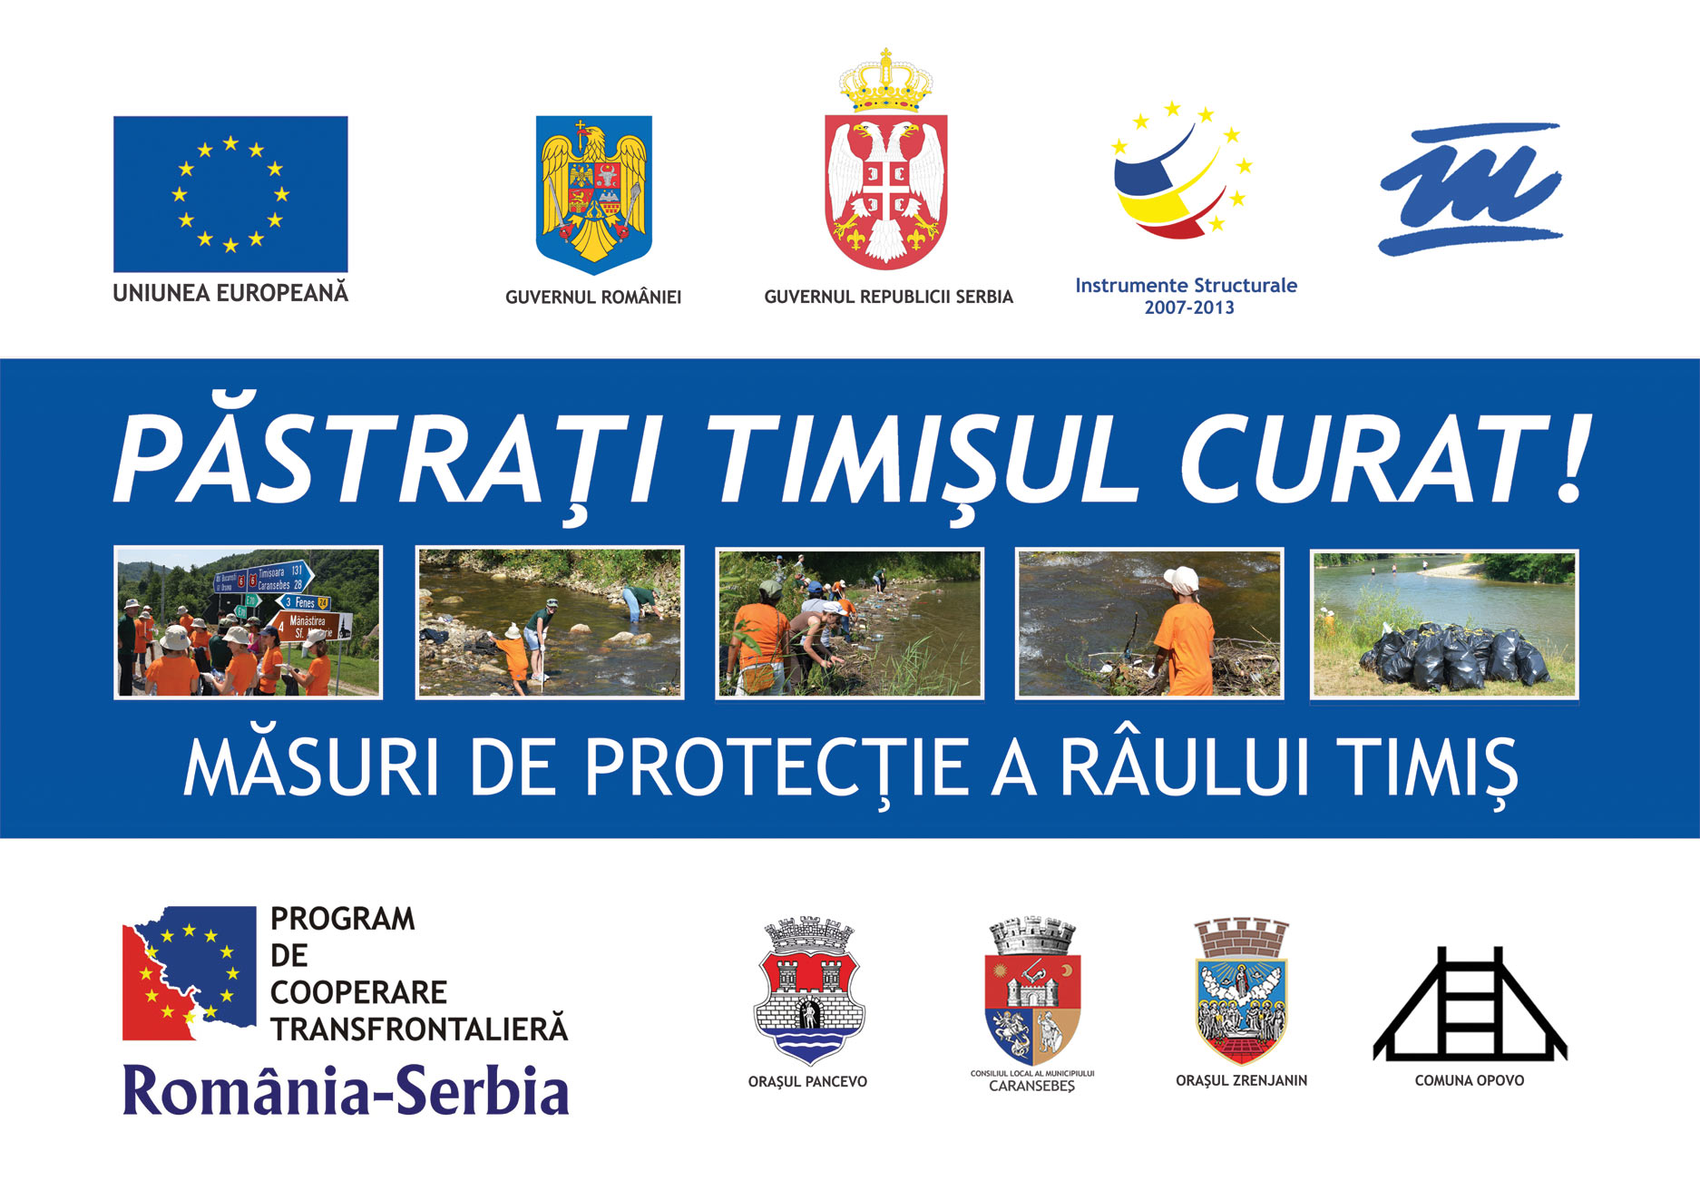

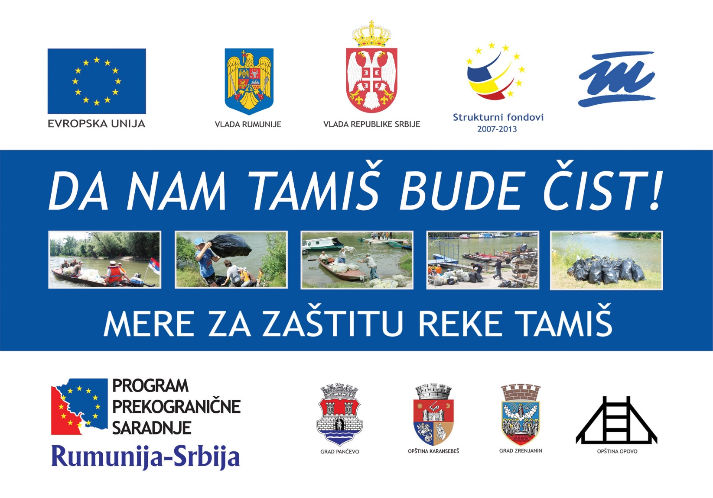

1. the implementation period (including extensions)
2. total funds spent/total funds contracted *100
3. indicators and level of achievement against targets set