Project information
CALL FOR PROPOSALS |  | 1
MIS-ETC: |  | 401
PRIORITY AXIS: |  | 1 Economic and Social Development
MEASURE: |  | 1.3 Promote SME development
PROJECT TITLE: |  | Flavours and scents of Deliblatska Peščara
ACRONYM: |  | FASOD
DURATION: |  | 17.12.2010-16.12.2011
IPA FUNDS CONTRACTED: |  | 262.586,25 €
TOTAL FUNDS CONTRACTED: |  | 308.925 €
ABSORBTION RATE (%): |  | 88,68%
PROJECT OBJECTIVE(S): |  | Increase competitiveness of the local products and services.  Exploring and identifying the most promising unique local products.  Adding value to the local products, through support to quality system, branding, packaging and promotion.  Better visibility and market presence and share of the local products.
SHORT DESCRIPTION OF THE PROJECT: |  | In Europe, the consumer demand for traditional agricultural and food products has increased and created the potential for development of niche markets. Traditional products are associated with an extensive system of production and handicraft processing implying a high rate of employment, and they can achieve good added-value, with investment in promotion. Being an effective basis for territorial management of resources, they can strengthen other activities, (especially for the tourism sector). This also contributes to promote gender equality because involves work undertaken by women.  The project represented a joint promotion of rural Banat products and services, with emphasis on the common identity: Banat. Two sides of one Banat, with common traditions. The project helps local cross-border SMEs to be able to effectively offer their products to a regional market. Euroland Banat Association, the Romanian partner transferred to Alibunar Municipality their experience regarding the EU market requirements and capacity to overcome the most frequent obstacles. The Serbian Municipality of Alibunar benefited of working with Romanian partner on the establishment of quality standards, that are compliant with the EU requirements. The project identified four of the most promising agricultural and food fields from Banat: beekeeping, fruits, medical and aromatic plants.
DEGREE OF ACHIEVEMENT OF INDICATORS: | Indicator value provisioned in the contract Present indicator value % 6= (5)/(3)*100  Output indicators (1) UM (2) Quantity (3) UM (4) Quantity (5)  Improved capacity and cross-border contacts of SMEs and in the R&D sector Number of successfully realized meetings of SMEs in the cross-border area 15 Number of successfully realized meetings of SMEs in the cross-border area 15 100%  Number of interested participants in the development of cross border cooperation in R&D sector 35 Number of interested participants in the development of cross border cooperation in R&D sector 66 190%  People in labour force with qualifications received / improved from joint training activities Number of participants in the training activities with proven qualifications improvement 25 Number of participants in the training activities with proven qualifications improvement 31 124%  Result indicators  New or improved cross-border products and joint marketing approaches/activities developed Number of new or improved cross-border products, marketing activities 4 Number of new or improved cross-border products, marketing activities 4 100%  1 1 100%  Increased importance of R&D/Innovation in the border area Number of activities focusing on promoting the importance of or dealing directly with R&D/Innovation Two months activities on research of products Number of activities focusing on promoting the importance of or dealing directly with R&D/Innovation 2 100%  8 workshops for support to products development dealing directly with innovation 11 135%  Project indicators  Number of developed products for final consummation Products 4 products for final consummation, labelled and packed Products 4 100%  Better price for unique, local agricultural and food products Price compared to prices before the project implementation Wholesale prices x 2 Price compared to prices before the project implementation Wholesale prices x 3 150%

RESULTS ACHIEVED, INCLUDING PHOTOS: | Within the support of the European Union IPA funding, the “Flavours and scents of Deliblatska peščara" project presented the rich Romanian-Serbian cross-border gastronomic heritage and brought closer the tourists to the gastronomic events and festivals dedicated to traditional food, wine and honey.  The project helped people to taste all these flavours and met the tradition, as well as contemporaneity, exploring forgotten flavours and scents of organic products, learning about traditional techniques of cooking, as well as sophisticated, trendsetting preparations from the cross-border area.  Results:  Developed 4 unique agri-food local products: honey, fruits, medical and aromatic plants.  SMEs management supported for diverse offer of unique traditional local agricultural and food products.  SMEs and key supply chain actors informed in detail of the Quality Management Systems and Quality Schemes benefits.  Local products market value and demand increased.  1 Agro-festival established and promoted  Web-based cross-border information and promotion service set up and operational.  One organization of producers/processors establishment supported.  Weak points identified, and suggestions for future improvement defined.
PROJECT WEBPAGE: | http://www.alibunar.org.rs/fsdp/en/About-us

Partnership information
 |  | COUNTRY | COUNTY/DISTRICT | BUDGET(EURO) | CONTACT DETAILS
LEAD PARTNER: | Municipality of Alibunar | Serbia | South Banat | 257.990 € | Alibunar, Trg Slobode 4  Tel. +381 13 642 105
PARTNER 2: | Euroland Banat Association | Romania | Caras-Severin | 50.935 € | Resita, Al. Galati 4/3/6  Tel. +40 745 126 876

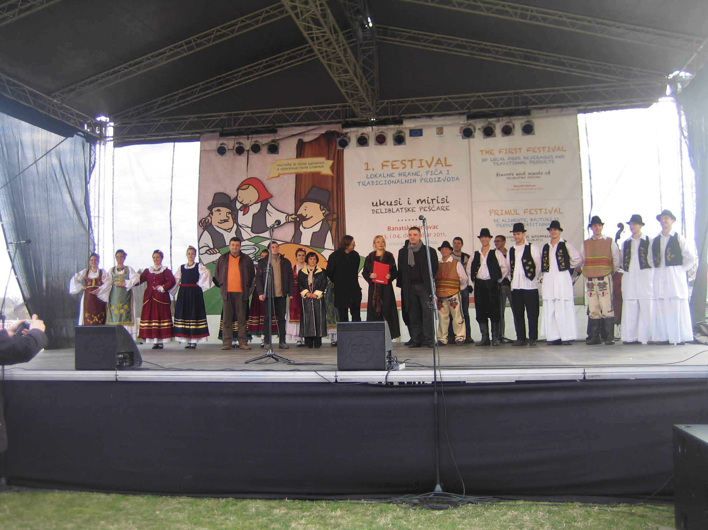
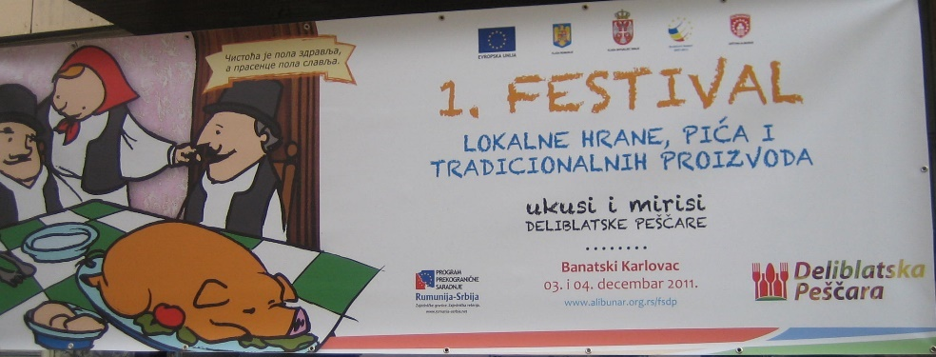

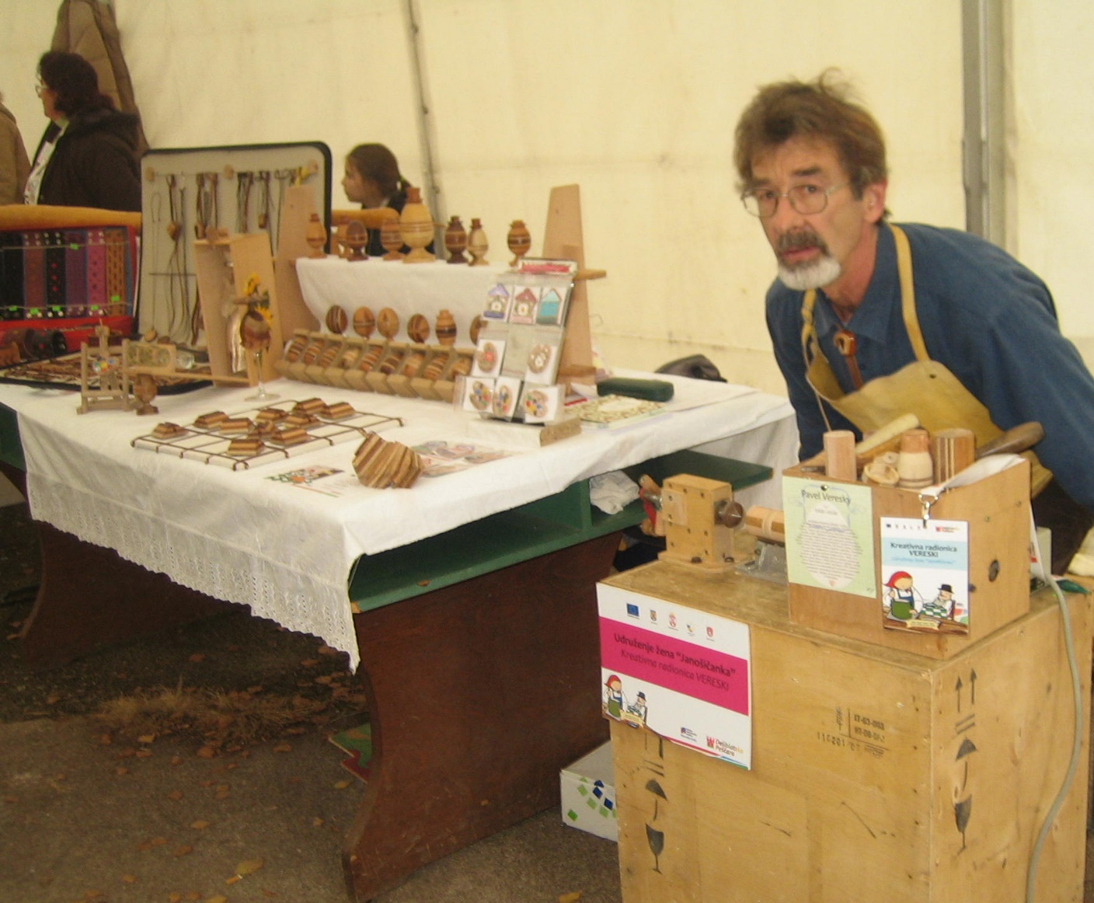
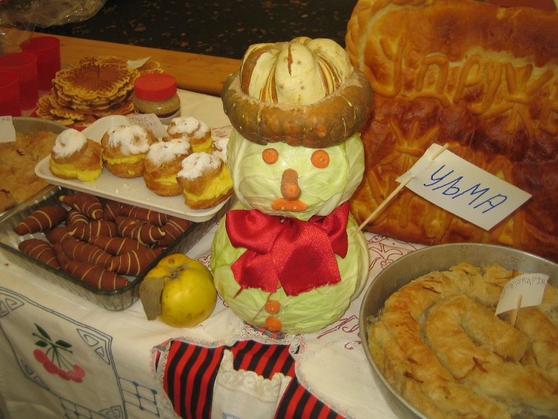
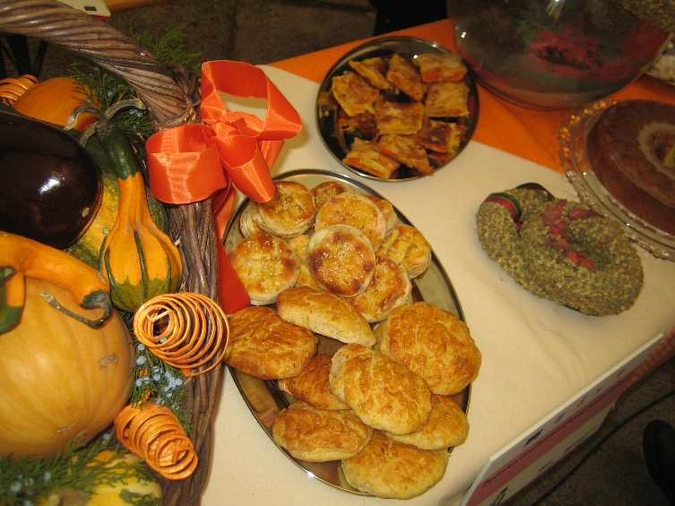

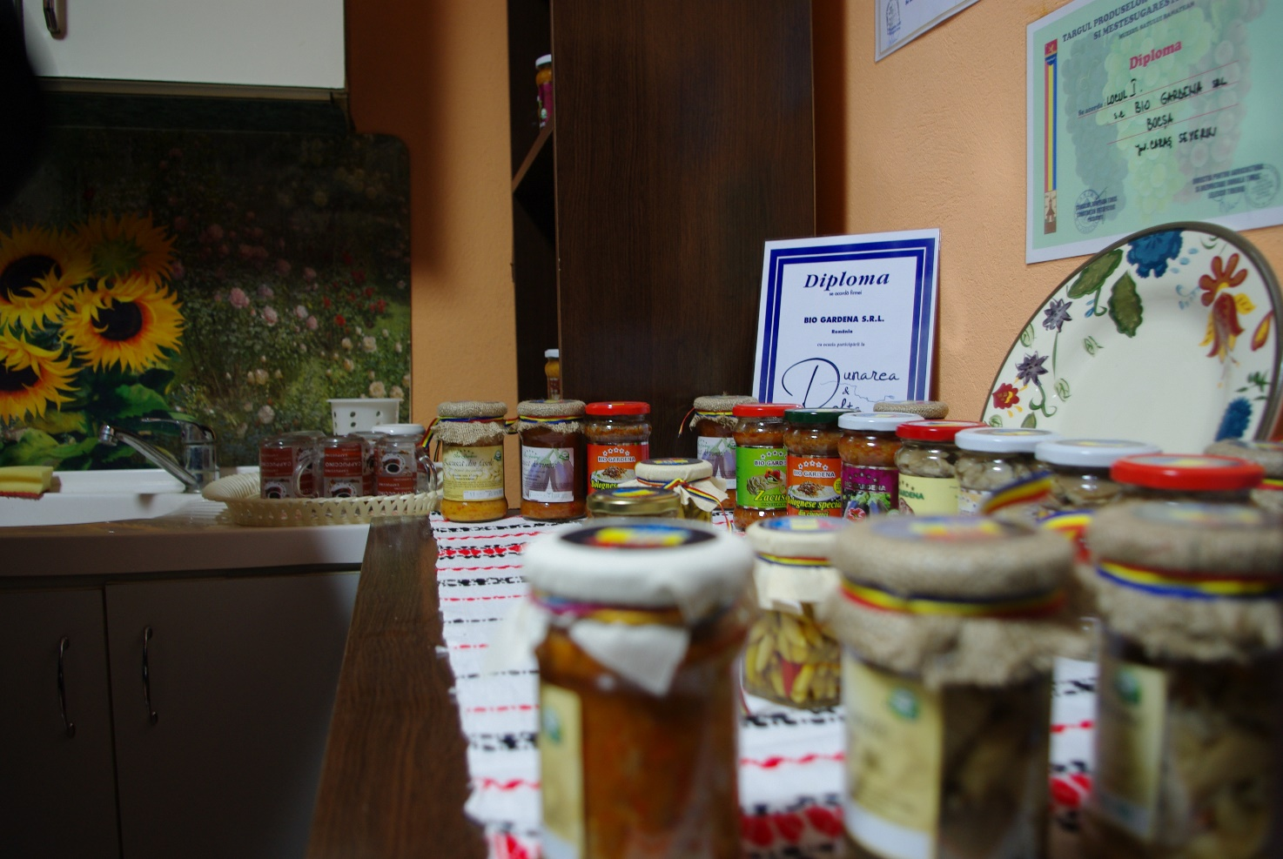
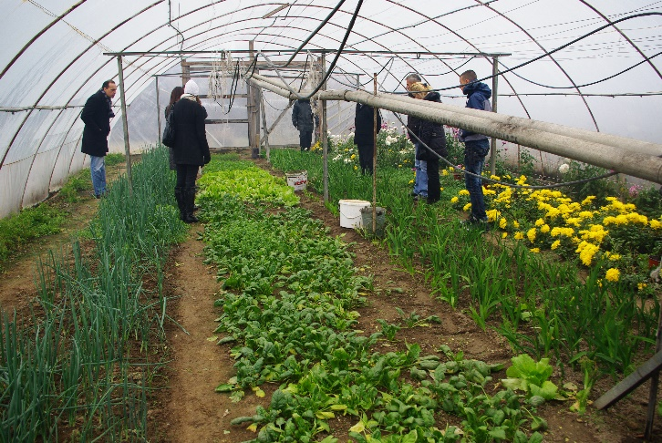
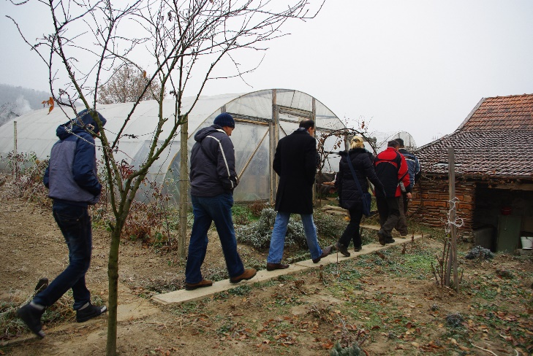

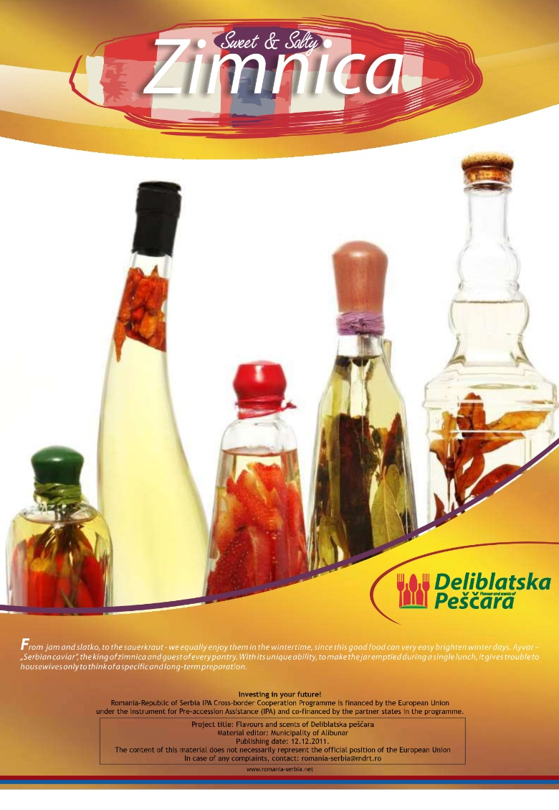
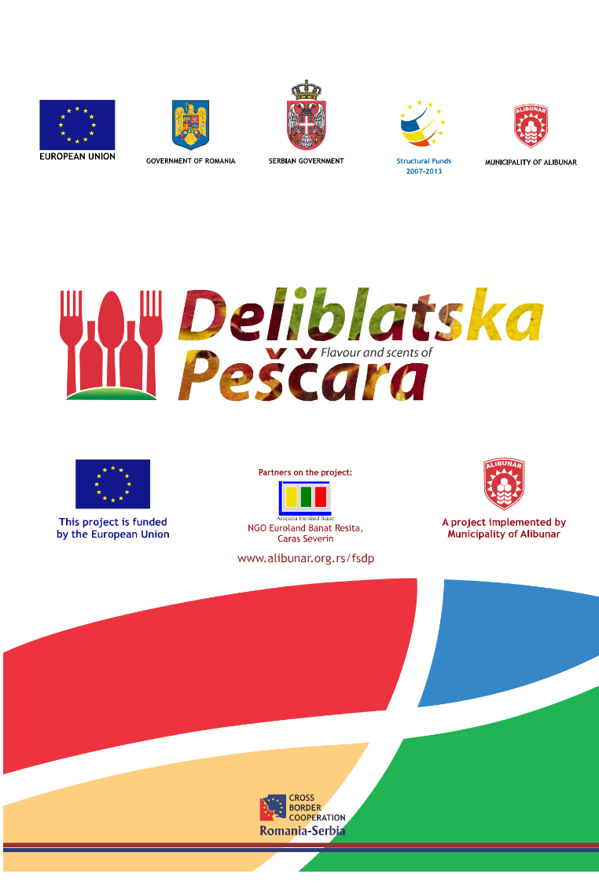

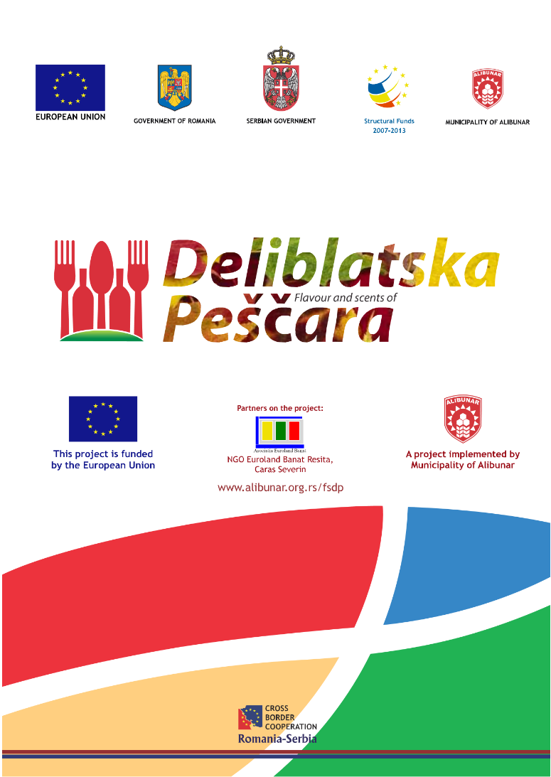
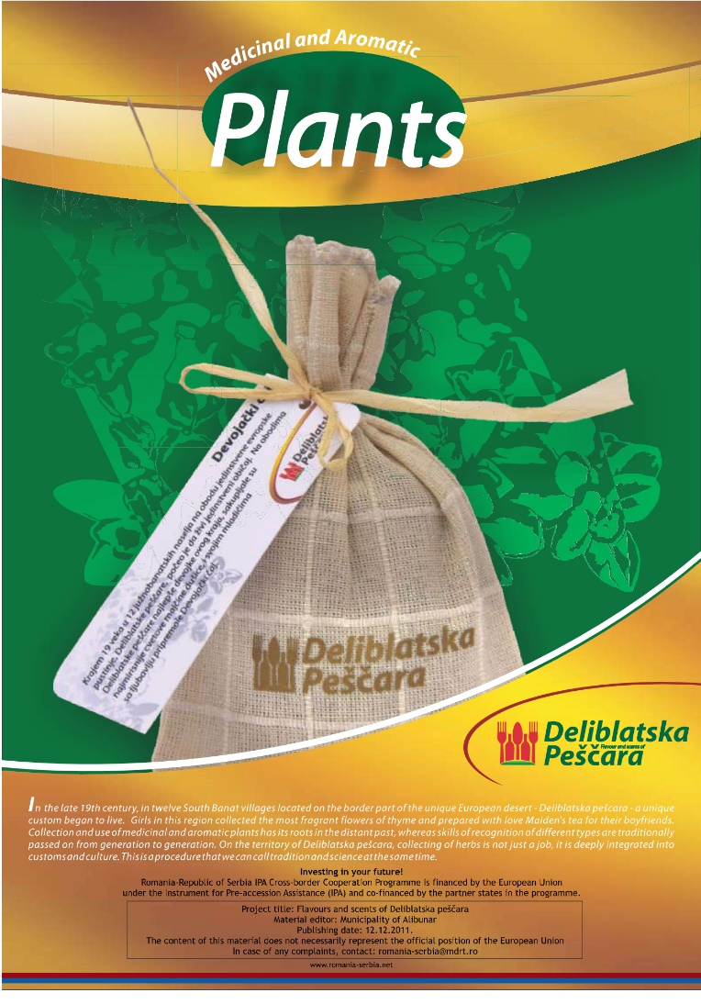

the implementation period (including extensions)
total funds spent/total funds contracted *100
indicators and level of achievement against targets set

