Project information
CALL FOR PROPOSALS | 1
MIS-ETC: | 398
PRIORITY AXIS: | 3 Promoting “people to people” exchanges
MEASURE: | 3.1 Support the development of civil society and local communities
PROJECT TITLE: | Cross border pollution on the Danube by mining wastes, reality and media bomb also.
DURATION: | 17.12.2010 – 16.12.2011
IPA FUNDS CONTRACTED: | 51.791,25 €
TOTAL FUNDS CONTRACTED: | 60.930,88 €
ABSORBTION RATE (%): | 80.27%
PROJECT OBJECTIVE(S): | The project contributes to a sustainable development in the area of Moldova Nouă, Veliko Gradište, Pojejena and Bela Crkva Municipalities by reducing mining wastes pollution.  It involves Romanian and Serbian NGOs, local administration authorities in activities of informing citizens about pollution phenomenon by mining waste from SC Moldomin SA, a Romanian mining company from Moldova Nouă. It involves Romanian and Serbian NGOs, local administration authorities in improving of management of industrial waste from the decantation pond of mine water belonging to SC Moldomin SA
SHORT DESCRIPTION OF THE PROJECT: | A joint program of volunteering, skills training for NGOs in the field of mining waste management has been implemented. Prepared for a joint local action plan to improve the management of mining waste from Moldova Noua water decantation pond, focused on priority measures proposed by NGOs, local administration authorities from the area of Moldova Noua, Pojejena, Veliko Gradište and Bela Crkva.  Development of a common communication network between local communities, NGOs in the project area, aimed at informing the population more accurately about the phenomenon of mine waste pollution from SC Moldomin SA.
DEGREE OF ACHIEVEMENT OF INDICATORS: | Indicator value provisioned in the contract Present indicator value % 6= (5)/(3)*100  Output indicators (1) UM (2) Quantity (3) UM (4) Quantity (5)  Stronger civil society of the border area No. of NGO’s 6 No. of NGO’s 6 100%  Result indicators  Improved of life quality and increased attractiveness of the border communities as a living place Number of activities, actions, initiatives destined to improving of local living conditions. 5 Number of activities, actions, initiatives destined to improving of local living conditions. 5 100%  Improved knowledge of institutional structure of the neighbouring country Number of participants gained knew knowledge in events promoting/profiling the neighbouring country 55 Number of participants gained knew knowledge in events promoting/profiling the neighbouring country 56 102%  Project indicators  Evolution of information level of the people from project area on the magnitude and consequences of the phenomenon of pollution by mining waste Survey on information level at the start and finishing of project period 60 Survey on information level at the start and finishing of project period 60 100%  Improvement of joint administrative capacity of NGOs to implement voluntary programs in environmental protection domain. Number of NGOs implementing joint volunteering program 4 Number of NGOs implementing joint volunteering program 6 150%  Improvement of professional skills of NGOs in domain of mine waste’s management. number of volunteers evaluated as positively at the end of skill training 30 number of volunteers evaluated as positively at the end of skill training 30 100%  Improvement of administrative capacity of NGOs/local administration for development of joint local strategies Number of NGOs/local administration institutions developing joint local strategies 8 Number of NGOs/local administration institutions developing joint local strategies 9 112%  Achievement of joint cross border communication network Number of NGOs/local administration institutions/media companies involving in communication network 13 Number of NGOs/local administration institutions/media companies involving in communication network 14 108%  3 publications and 7 visibility materials Survey on information level at the start and finishing of project period 60% Survey on information level at the start and finishing of project period 60% 100%  4 reports of alternative environmental monitoring Survey on information level at the start and finishing of project period 60% Survey on information level at the start and finishing of project period 60% 100%  Extended LAP – IMWM on the territories of Veliko Gradiste and Bela Crkva communes. Number of NGOs/local administration institutions developing joint local strategies 125 Number of NGOs/local administration institutions developing joint local strategies 126 101,5%
RESULTS ACHIEVED, INCLUDING PHOTOS: | Increasing the information level of the people regarding the magnitude and consequences of the cross-border phenomenon of pollution by mining waste.  Improvement of joint administrative capacity of NGOs to implement voluntary programs related to the environmental protection domain.  Improvement of institutional professional skills of NGOs from Romania and Serbia in the domain of mine waste’s management.  Improvement of administrative capacity of NGOs and local administration to develop joint local strategies.

Partnership information
 |  | COUNTRY | COUNTY/DISTRICT | BUDGET(EURO) | CONTACT DETAILS
LEAD PARTNER: | Ecological Cooperation Group -NERA Caras Severin branch | Romania | Caras - Severin | 37.723,75 | Oravita, 1 Decembrie 1918 St, 60, 2 floor  Tel. 0255 572026
PARTNER 2: | LOCAL COUNCIL OF POJEJENA COMMUNE | Romania | Caras - Severin | 5.666,53 | Pojejena, Principala St. 277  Tel. +40 255 544355
PARTNER 3: | Skola Plus Dositej Obradovic | Serbia | Youth Banat | 175.40,60 | Bela Crkva, Miletičeva St. 6  Tel. +381 63680791

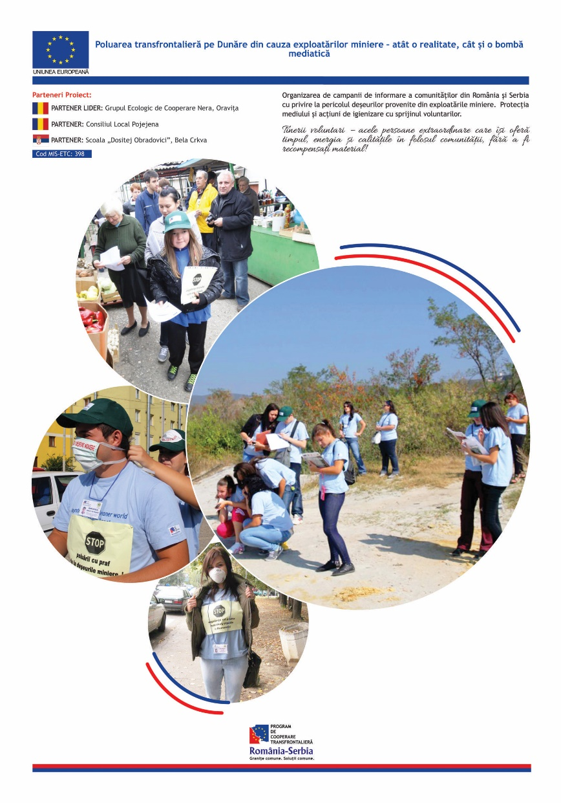

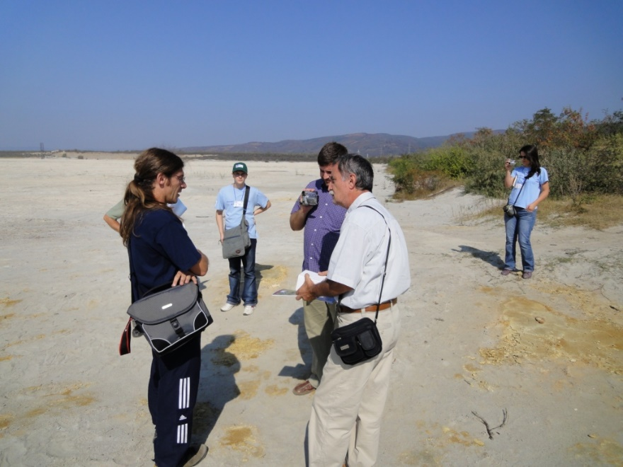
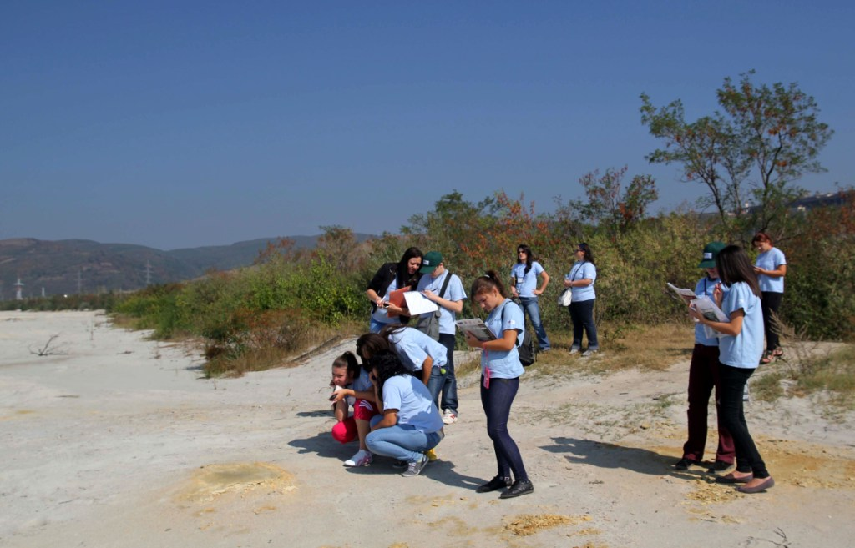

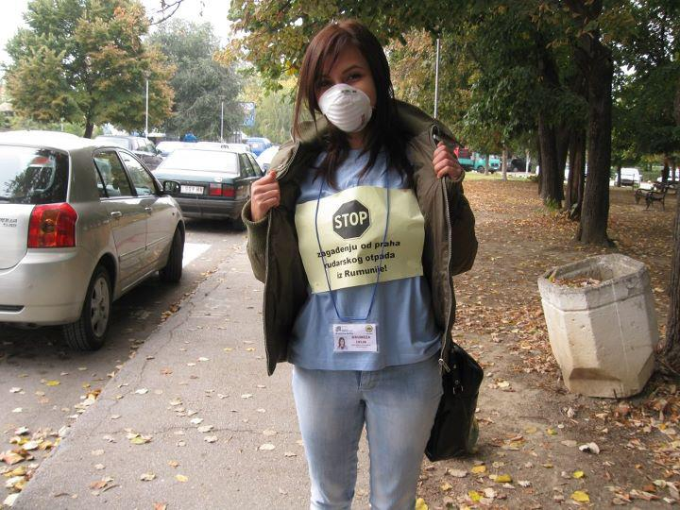
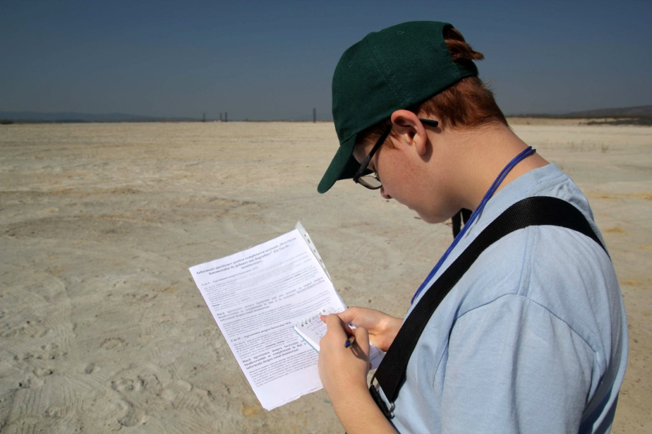

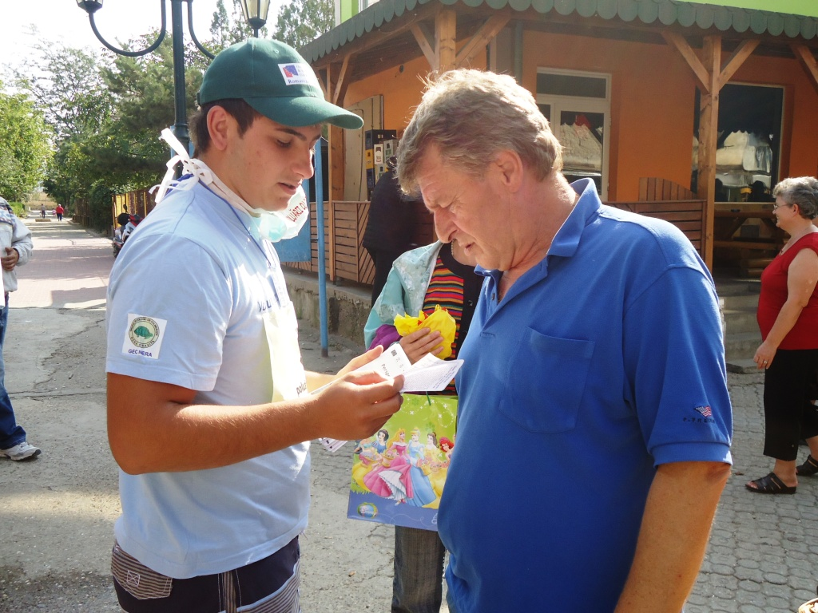
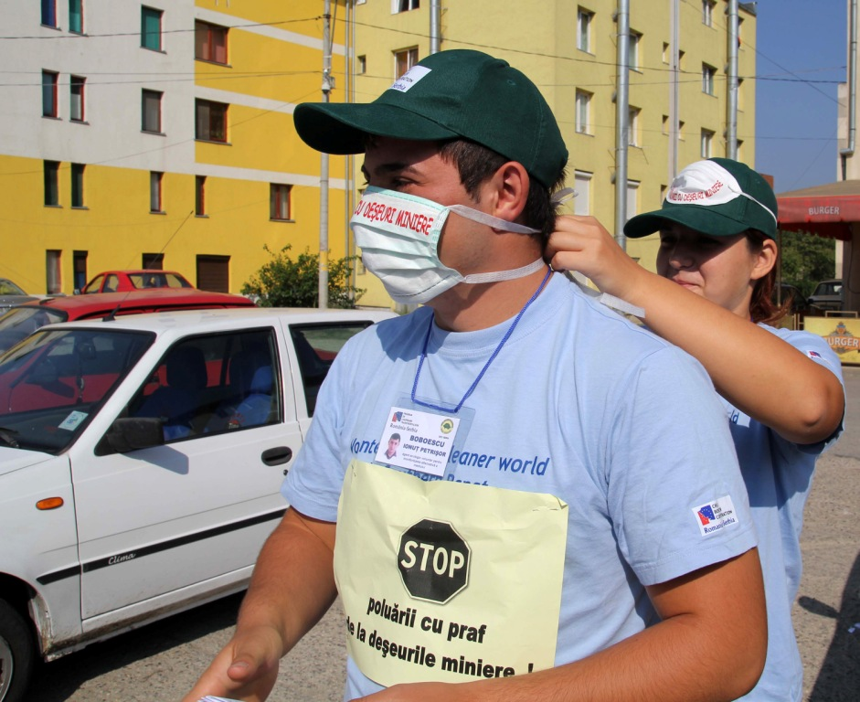

the implementation period (including extensions)
total funds spent/total funds contracted *100
indicators and level of achievement against targets set

