Project information
CALL FOR PROPOSALS |  | 1
MIS-ETC: |  | 396
PRIORITY AXIS: |  | 2. Environment and emergency preparedness
MEASURE: |  | 2.1 Improve systems and approaches to address cross-border environmental challenges, protection and management
PROJECT TITLE: |  | GREEN BANAT – cross-border environmental cooperation between the twin towns Kikinda and Jimbolia
ACRONYM: |  | Green Banat
DURATION: |  | 03.12.2010-02.05.2012
IPA FUNDS CONTRACTED: |  | 395.964,85 €
TOTAL FUNDS CONTRACTED: |  | 465.841 €
ABSORBTION RATE (%): |  | 70,66 %
PROJECT OBJECTIVE(S): |  | - Establishing cooperation between experts and institutions for environmental protection, as well as raising their technical capacity;  - Afforestation of the border area  - Raising of ecological awareness of primary school age children
SHORT DESCRIPTION OF THE PROJECT: |  | The “Green Banat” project was a joint cross-border action of the Kikinda Municipality (Serbia) and Jimbolia Municipality (Romania) in solving the problem of weak afforestation of the Romanian-Serbian cross-border area.  The main project activity was afforestation of 45 hectares of land in the municipality of Kikinda and 22.4 hectares in the municipality of Jimbolia. Positive effects of these activities are numerous and they are reflecting in reducing air pollution, decreasing speed and gust of winds, preventing erosion, reduction of extreme temperature, etc. However, while afforestation is a very important project activity, project “Green Banat” also included two very important components: raising the environmental awareness of local communities about the necessity of preserving green areas, about the need to preserve the environment and the establishment of cross-border cooperation between environmental protection experts from Serbia and Romania.
DEGREE OF ACHIEVEMENT OF INDICATORS: |  | Indicator Indicator value provisioned in the contract Present indicator value % 6= (5)/(3)*100  UM (2) Quantity (3) UM (4) Quantity (5)  Result indicators  Increased cross-border cooperation in environment protection No. activities 1 Activities 1 100%  Increased expertise and exchange of experience in the field of environment protection No. actions 6 Actions 6 100%  Increased public awareness in the field of environment protection No. informed participants 700 Informed participants 900 128%  Established cooperation between environmental experts No. meetings 6 Meetings 6 100%  Educated children No. of children 700 No. of children 820 117%  Improvement of technical capacities of the Department of Public Health No. of purchased equipment 1 No. of purchased equipment 1 100%
RESULTS ACHIEVED, INCLUDING PHOTOS: |  | - Established cooperation between the experts and services for the protection of the environment from Serbia and Romania  Under the “Green Banat” project, the partners organized six experts’ meetings. On those meetings, the experts discussed regional ecological issues and treats, as well as the opportunities for future CBC cooperation. Their conclusions are integrated in environment report where they tried to enlighten the most important ecological inputs and outputs in Kikinda and Jimbolia.  - Improved technical equipment of the relevant services for the protection of the environment  Municipality of Kikinda purchased a photometer with quality assessment tests for the Department for Public Health Kikinda which will allow more quality measurement of surface water and thus determination the exact situation in this field.  In this way, environmental risks, and risks to public health will be significantly reduced.  Also, the photometer allows fulfilment of EU standards and the possibility of quantitative data exchange among institutions from Serbia, Romania or from the region.  - Improved environmental awareness of elementary school age children  One of the most important aspects in the process of environment protection is raising awareness regarding these issues. Because children are the youngest part of the population that will, in the long run, impact the environment, the project "Green Banat", as the main target group, selected primary school age children.  This goal partners have reached in the following way. The Municipality of Kikinda and Municipality of Jimbolia, in cooperation with all primary schools in its territory, organized lectures for students of seventh grade. Lectures are designed and implemented by experts engaged within the project (this have been discussed in a previous paragraph) and it had been implemented in all primary schools in Kikinda and Jimbolia.  Regarding the Municipality of Kikinda, lectures have been conducted in all 16 elementary schools, both in town and in villages. The content of lectures was adapted to the target group, the number of students at each school, as well as the type of school (classes are also held in a special school “6th October”). Also, each lecture was followed by a Power Point presentation and to this end the project anticipated purchase of two laptops, two projectors, two screens projector, as equipment needed for successful implementation of these activities. Lectures begun on April 2011 and were held every month in all the seventh grade of primary schools (there is over 600 pupils of this generation in Kikinda municipality). After the end of the summer holidays (July and August 2011), lectures were continued with the same generation which began the education campaign. Completion of this activity was in February 2012. Totally 128 lectures have been held (eight lectures per school). Lecturers were experts from the Department of Public Health Kikinda.  In Jimbolia lectures begun on September 2011 and lasted until April 2012. Lectures were held every week in one primary school and approximately, 150 children per month attended.  In addition to lectures, which are implemented within the regular school activities, the partners have organized several after-school activities for pupils. There were two seminars (29th and 30th September 2011. – Jimbolia; 18th and 19th November 2011. - Kikinda) where the 25 students visited the partner municipality and attended workshops and lectures.  Also, two workshops were organized in Jimbolia, 31.10.2011. and in Kikinda, 19. and 20. November 2011, where around 50 pupils participated in forestation works on the field.  Also, a very important activity that the partners carried out was the production of illustrated educational brochures for all pupils who attended the classes in schools (authors of the brochure are engaged experts from Serbia and Romania). The brochure is bilingual (in Serbian and Romanian language) and it covers all eight lectures/topics. Municipality of Kikinda printed and distributed 700 copies of this brochure.  - Increased afforestation of border area  Because of the extremely poor afforestation of Banat, the significance of this project goal is very high. This is corroborated by the fact that the Kikinda Municipality has less than 1% of soil under forest, which is far from the EU standards, as well as from national strategic objectives of the Republic of Serbia. In Jimbolia situation is little bit better, but not much.  Kikinda Municipality performed afforestation on 45 hectares of soil. That surface is divided in four villages (Mokrin, Nakovo, Banatsko Veliko Selo and Rusko Selo) neighbouring the border with Romania. A total of 24.807 seedlings were planted. Kikinda Municipality planted seedlings of Poplar and Siberian Elm, because these species are recommended for this type of soil and climate. At the same time, under this forestation works, Kikinda Municipality cultivated some land fields in Nakovo to stop further soil degradation.  Jimbolia Municipality forested 22,4 hectares of soil on two locations with seedlings of ash, cypress and willow trees. At the project level, 67, 4 hectares of soil have been forested, which is very important for this agricultural area that is characterised by lack of forest land.  Sustainability of this project will be enabled by maintenance of forested soil by Kikinda and Jimbolia municipalities. Kikinda municipality already started to perform maintenance works which will be implemented in next two vegetation periods.  - Increased visibility of ecological issues  During the last implementation phase, the partner municipalities completed environmental reports (Serbian, Romanian and English language) and published it on its official web pages. They gathered all relevant ecological information under one document which can be downloaded by all interested groups, organizations or individuals.  Through educational campaigns in primary schools (lectures, brochure), the partner municipalities increased visibility of ecological problems. At the end, through constant media campaign (TV, radio, newspapers) and project promotion (website, promotional material), partner municipalities have diverted public attention to environmental issues in their local communities.
Press articles | https://www.youtube.com/watch?v=e-Q_AO0BfXw
 | http://www.tion.ro/jimbolia/colaborare-transfrontaliera-pentru-protectia-mediului-intre-orasele-jimbolia-si-kikinda-din-serbia/1077876
Brochure | http://jimbolia.ro/wp-content/uploads/documents/publicatii/2012/banatul_verde/120731_banatul_verde_raport_de_mediu.pdf
Environmental agreement | http://jimbolia.ro/wp-content/uploads/documents/publicatii/2012/banatul_verde/120731_banatul_verde_raport_de_mediu.pdf

Partnership information
 |  | COUNTRY | COUNTY/DISTRICT | BUDGET(EURO) | CONTACT DETAILS
LEAD PARTNER: | Municipality of Kikinda | Serbia | North Banat | 297.506 | Kikinda, Trg srpskih dobrovoljaca 12  Tel. +381230410157
PARTNER 2: | Municipality of Jimbolia | Romania | Timis | 168.335 | Jimbolia, Str. Tudor Vladimirescu 81  Tel. 0040256360770

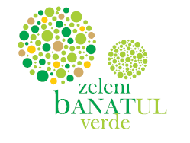

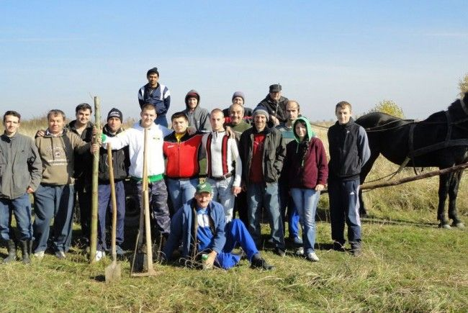
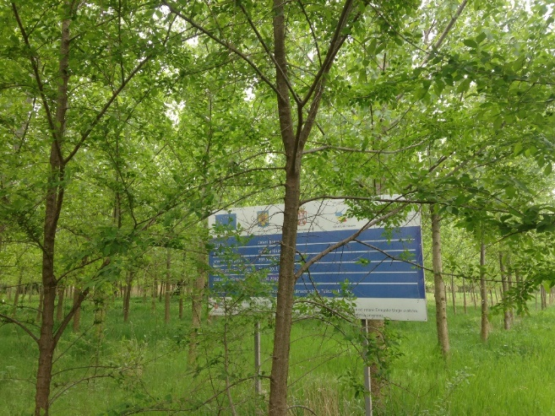
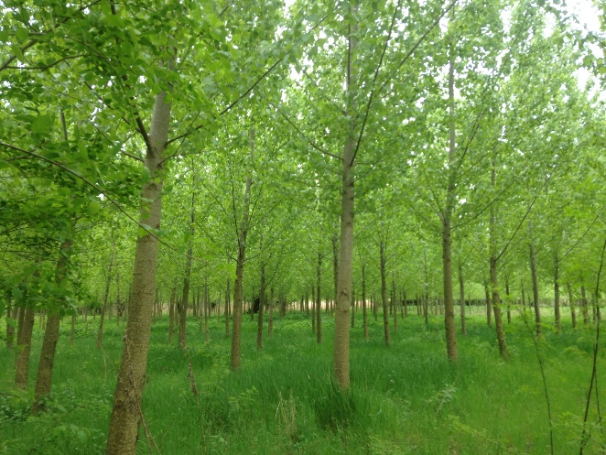

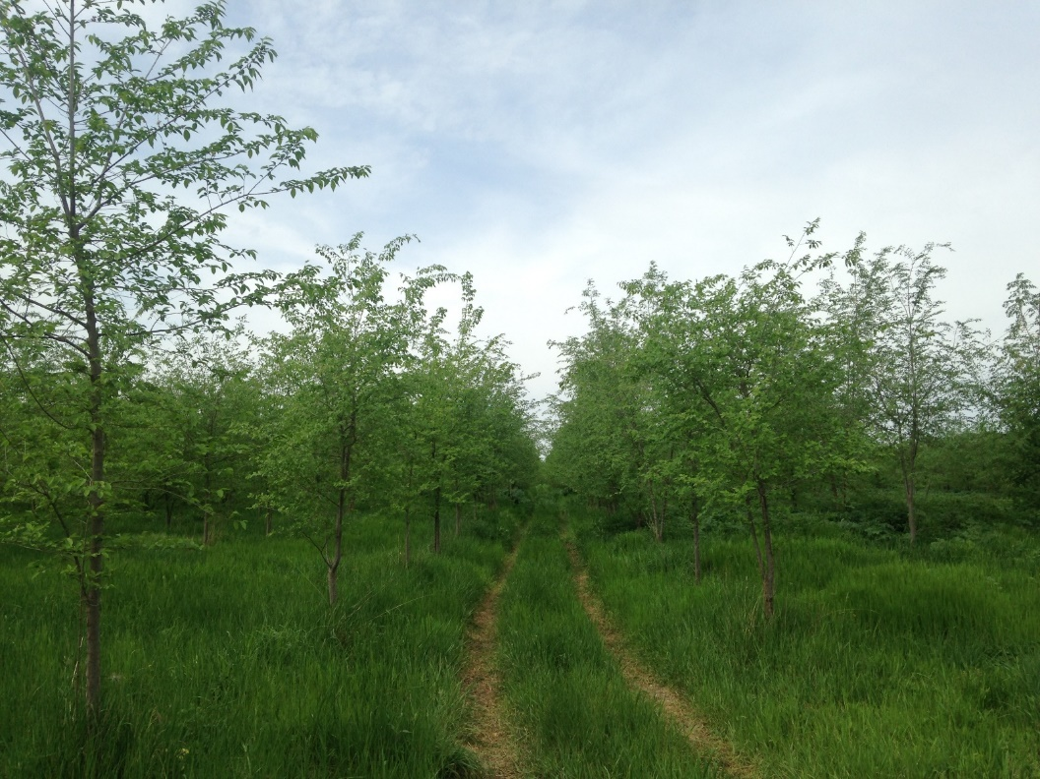
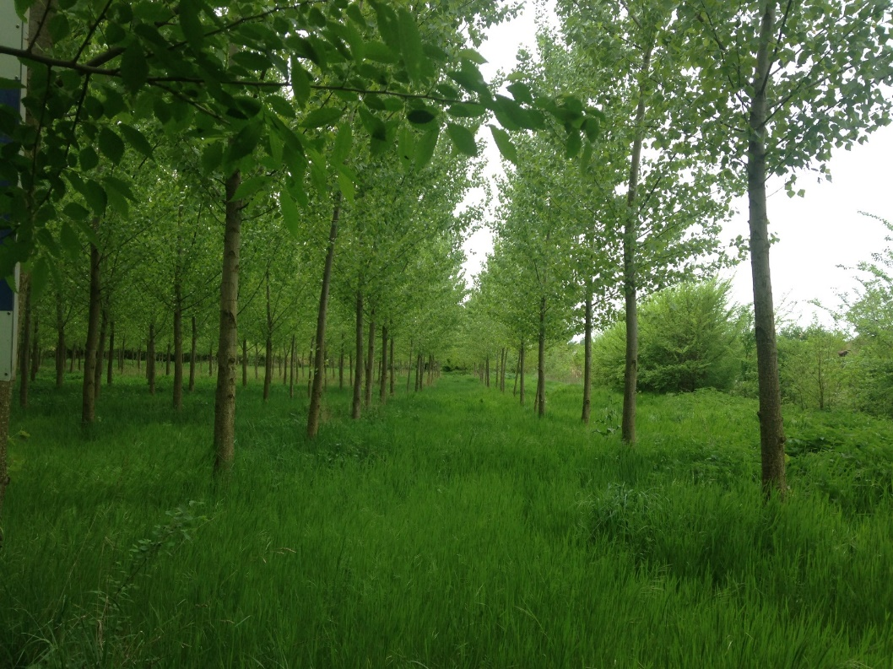

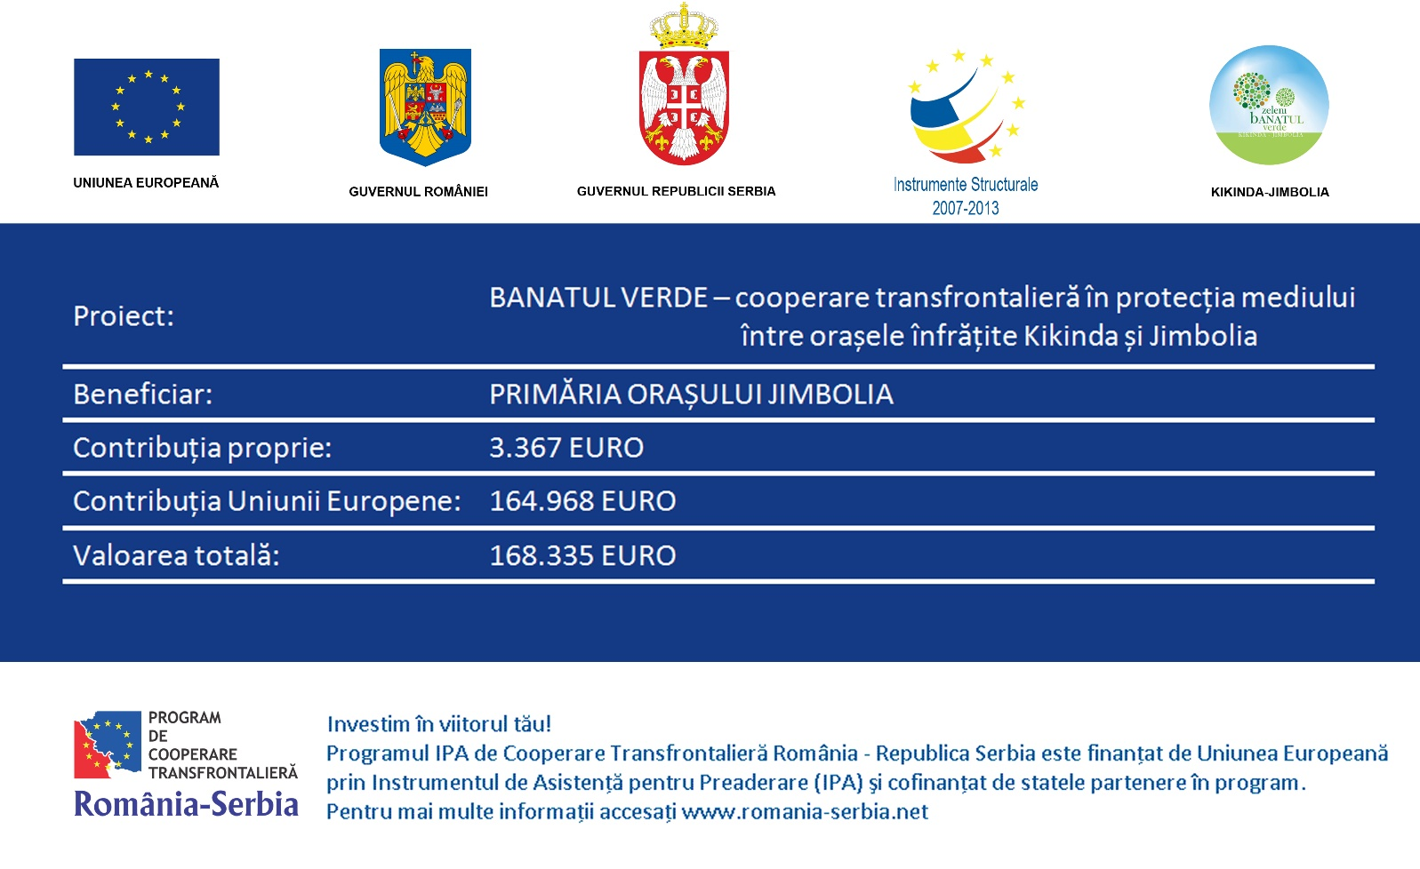

the implementation period (including extensions)
total funds spent/total funds contracted *100
indicators and level of achievement against targets set

