Project information
CALL FOR PROPOSALS | 1
MIS-ETC: | 374
PRIORITY AXIS: | 1 Economic and Social Development
MEASURE: | 1.2 Develop the tourism sector, including the strengthening of the regional identity of the border region as a tourist destination
PROJECT TITLE: | The Town of Margum
ACRONYM: | Margum
DURATION: | 29.12.2010 – 28.12.2011
IPA FUNDS CONTRACTED: | 412.590 €
TOTAL FUNDS CONTRACTED: | 485.400 €
ABSORBTION RATE (%): | 44,72%
PROJECT OBJECTIVE(S): | - Tourism development in region Timis – Branicevo through rehabilitation, protection and preservation of cultural heritage from Roman period and their inclusion in the tourism offer  - Creation of tourism site Moesia – Dacia in aim to increase cooperation in sector of tourism in border region  - Promotion of historical assets of region Timis – Branicevo and strengthening of the regional identity
SHORT DESCRIPTION OF THE PROJECT: | The partnership was formed in order to create a necessary precondition for the exploration of the opportunity for tourism development in the area, which in ancient times was a part of ancient Roman provinces Moesia (now Serbia – Branicevo area) – Dacia (Romania). During the project implementation archaeological works were carried out in Margum, Roman town, with the presence of Romanian and Serbian archaeologists. During the archaeological works fences of Roman town Margum were reconstructed, the most important pottery discovered was selected, metal artefacts were conserved, and all discovered items were marked and protected.
DEGREE OF ACHIEVEMENT OF INDICATORS: | Indicator Indicator value provisioned in the contract Present indicator value % 6= (5)/(3)*100  Output indicators (1) UM (2) Quantity (3) UM (4) Quantity (5)  Development of new tourist offer - new tourist site 4 - new tourist site 4 100 %  - exhibitions 2 - exhibitions 2 100 %  Archeological movie 1 Archeological movie 1 100 %  - Expert’s study 1 - Expert’s study 1 100 %  -Tourist offer catalogue 1 -Tourist offer catalogue 1 100 %  Promotion of new tourist offer -Number of awareness campaigns 1 Number of awareness campaigns 1 10+0 %  -promotional conference 1 promotional conference 1 100 %  -set of promotional material 1 -set of promotional material 1 100 %  - web page designed and updated 1 - web page designed and updated 1 100 %  Implementation of the awareness campaign workshops for school children 4 workshops for school children 4 100 %  trainings for tourist workers 4 trainings for tourist workers 4 100 %  trainings for tourist guides 4 trainings for tourist guides 4 100 %  people trained 180 people trained 180 100 %  Result indicators  New or improved cross-border tourism products, joint marketing approaches/activities or joint tourism information services developed - new tourist site 4 new tourist site 4 100 %  - exhibitions 2 - exhibitions 2 100 %  Archeological movie 1 Archeological movie 1 100 %  - Expert’s study 1 - Expert’s study 1 100 %  -Tourist offer catalogue 1 Tourist offer catalogue 1 100 %  New or improved cross-border tourism services and increased SME’s capacity - awareness campaign 1 awareness campaign 1 100 %  - promotional conference 1 promotional conference 1 100 %  - set of promotional material 1 set of promotional material 1 100 %  - web page designed and updated 1 web page designed and updated 1 100 %
RESULTS ACHIEVED, INCLUDING PHOTOS: | - Carried out digging and archaeological researches in new tourism site; all diggings preserved and conserved; new artefacts prepared for the exhibition  - Archaeological documentation prepared; submitted to Regional Institute for monument protection; all research result verified by Regional cultural heritage preservation Institute  - “Apulum in Pozarevac” exhibition was organized; domestic cultural population get known with Roman heritage in Timis county  - Implemented Archaeological experts seminar; Study regarding Roman history in border region prepared and published; established link Apulum – Margum  - “Margum in Timisoara” exhibition was organized; Romanian cultural population get known with Roman heritage in Branicevo county  - Study tour organized and implemented; Romanian experts introduced with new locality and artefacts from the Town of Margum  - Archaeological movie recorded, edited and produced; presented on Archaeological movie Festival  - Awareness campaign organized and implemented; promo material developed, printed and disseminated; new tourist location marked; promotional conference for tourist workers implemented

Partnership information
 |  | COUNTRY | COUNTY/DISTRICT | BUDGET(EURO) | CONTACT DETAILS
LEAD PARTNER: | National Museum Požarevac | Serbia | Branicevo | 361.000 | Požarevac, dr Voje Dulica 10  Tel. +381 12 223 597
PARTNER 2: | Timisoara Banat Museum | Romania | Timis | 124.400 | Timisoara, Piata Huniade 1  Tel. 0040 256 201321

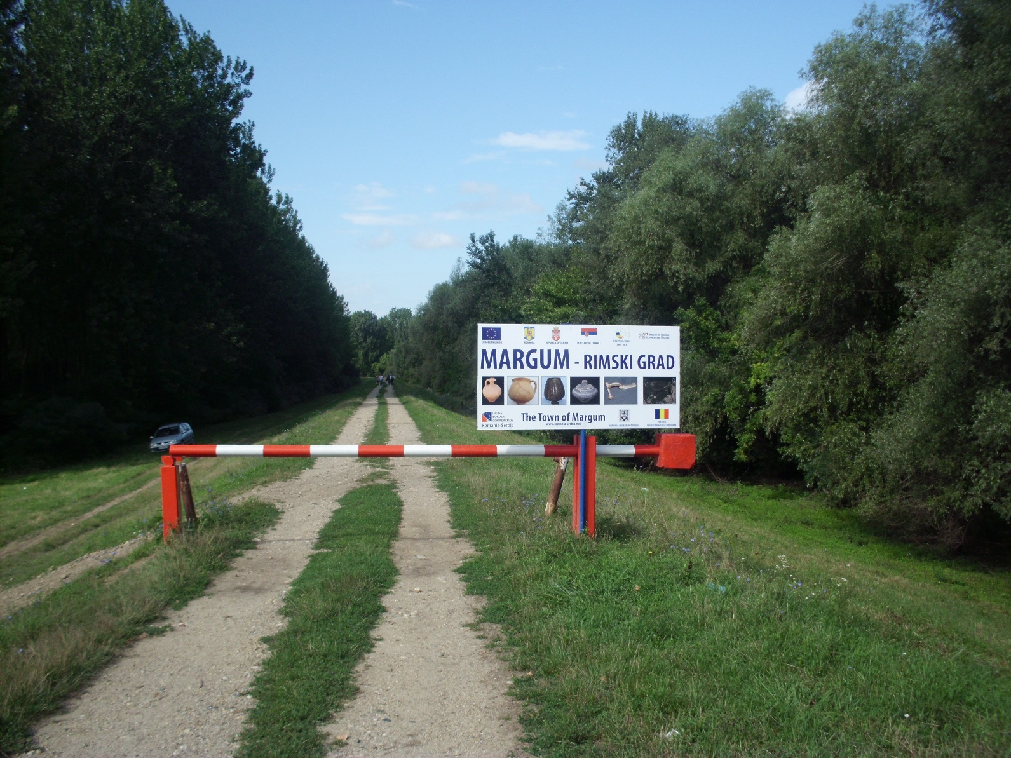

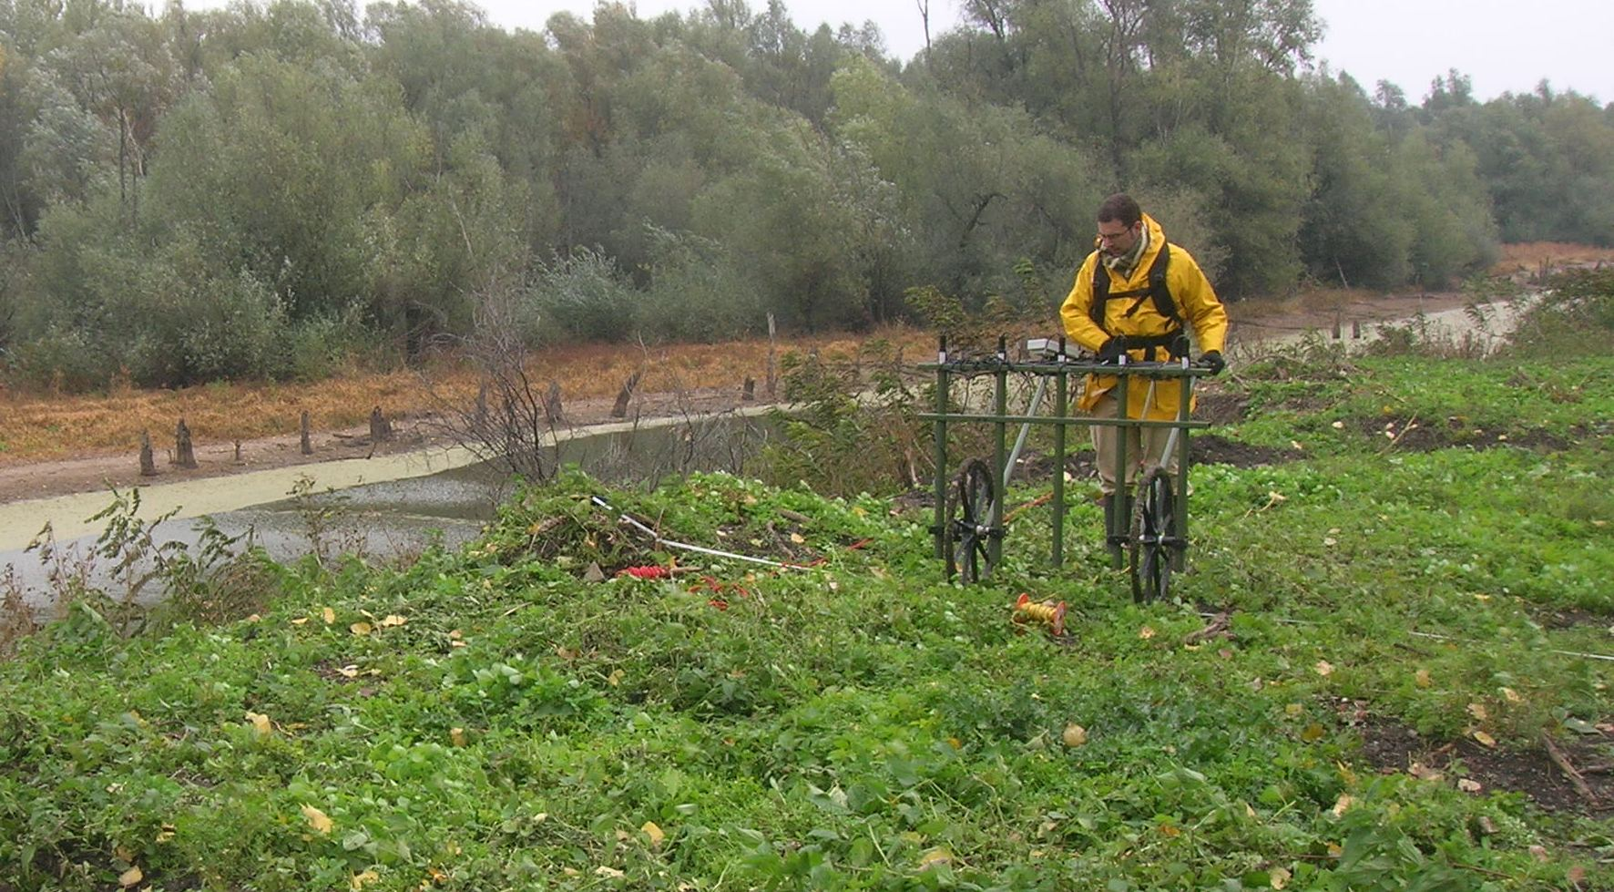

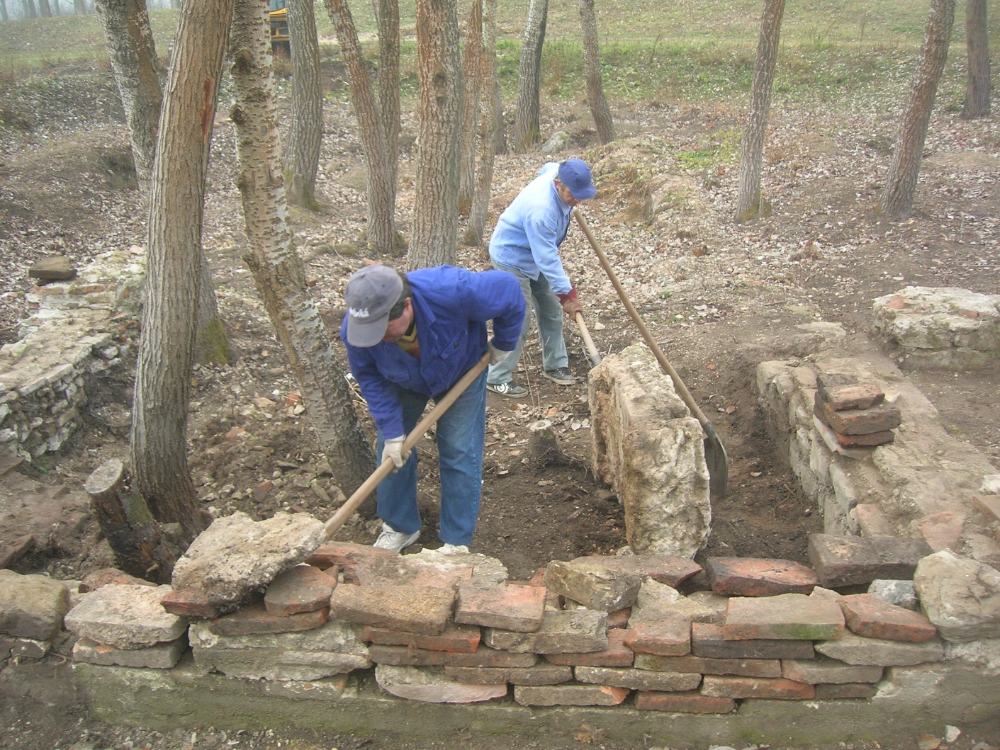

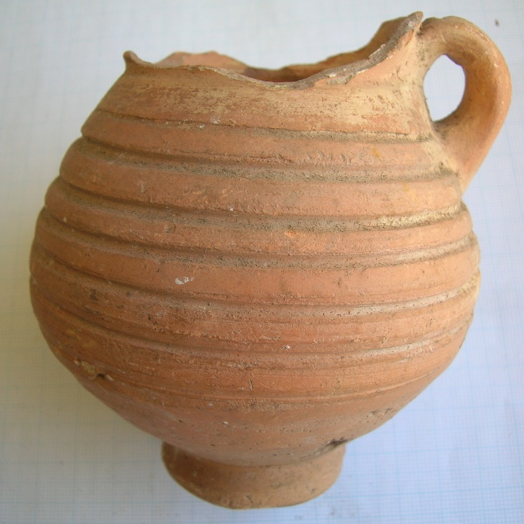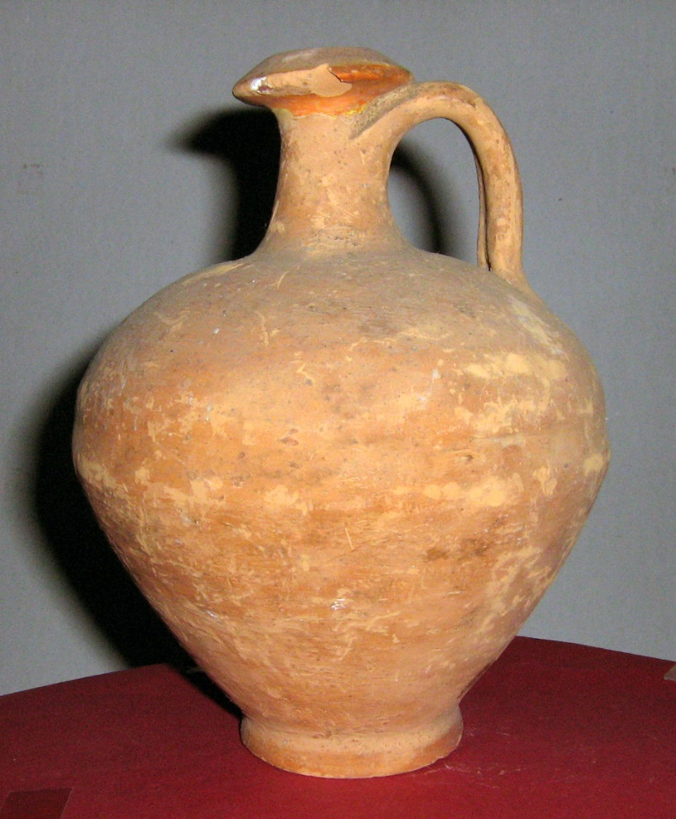

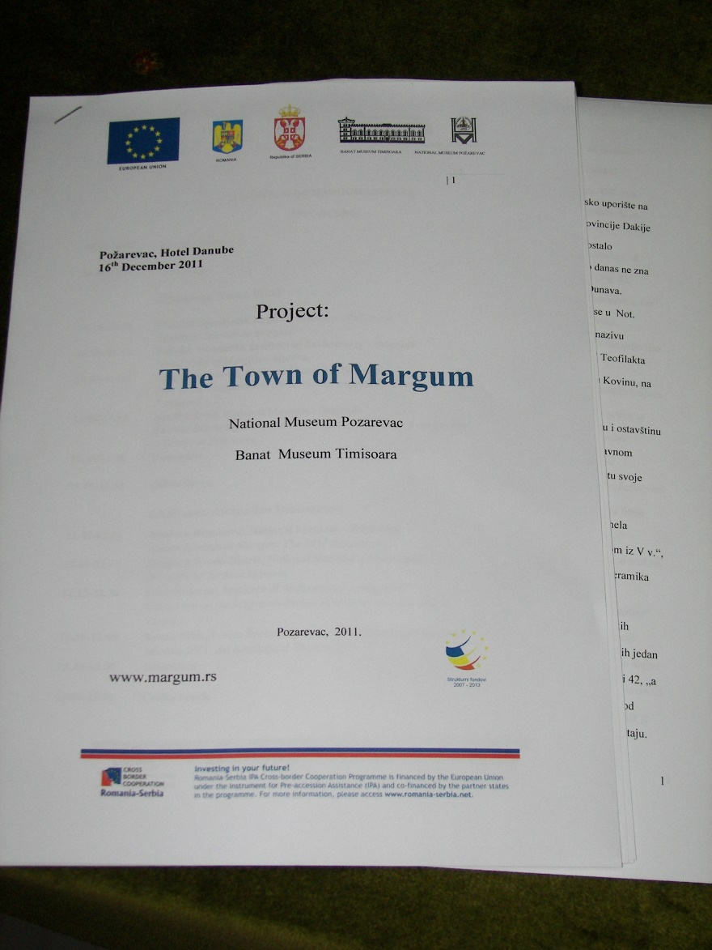

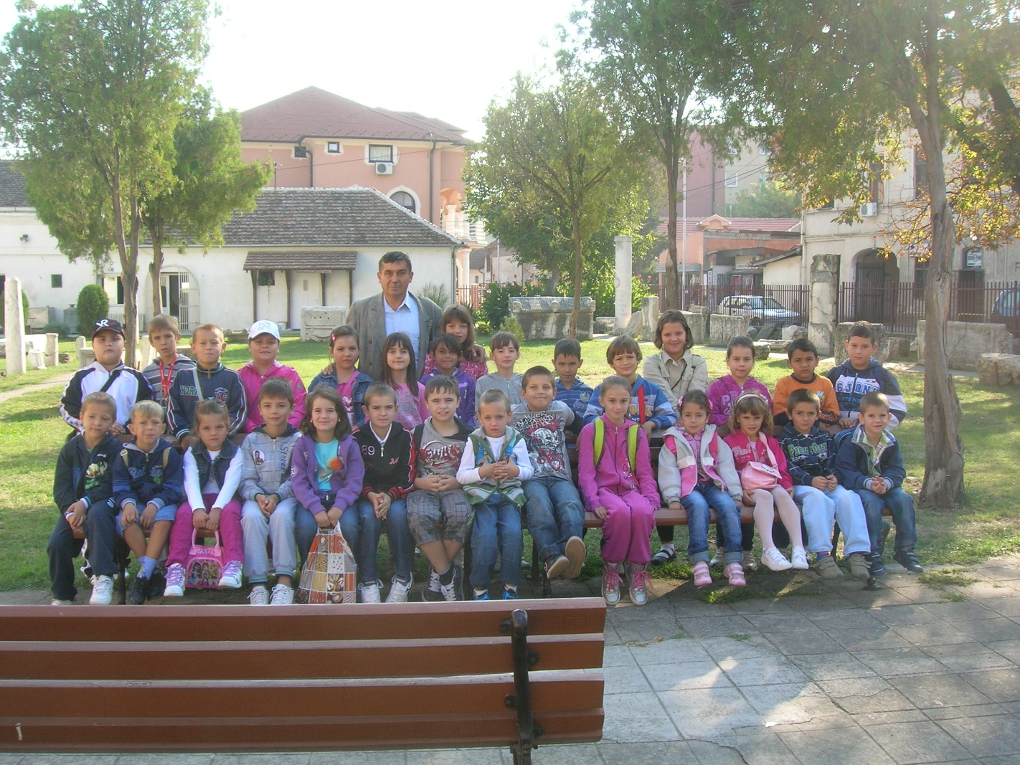

the implementation period (including extensions)
total funds spent/total funds contracted *100
indicators and level of achievement against targets set

