Project information
CALL FOR PROPOSALS | 1
MIS-ETC: | 372
PRIORITY AXIS: | 1 Economic and Social Development
MEASURE: | 1.2 Develop the tourism sector, including the strengthening of the regional identity of the border region as a tourist destination
PROJECT TITLE: | Integral development of tourism in Kladovo and Pojejena municipalities
ACRONYM: | INTEGRATIVE
DURATION: | 03.12.2010-02.03.2012
IPA FUNDS CONTRACTED: | 388.917,5
TOTAL FUNDS CONTRACTED: | 457.550
ABSORBTION RATE (%): | 76,75
PROJECT OBJECTIVE(S): | - Improved competitiveness of tourism sector in the region  - Municipalities of Kladovo and Pojejena, recognized on the market as quality regional tourist destination, whose offer is based on high level of integration of cultural, historical, natural and human resources.  - Establishing quality cooperation between Kladovo and Pojejena municipalities based on complementary tourism offer.
SHORT DESCRIPTION OF THE PROJECT: | Partnership was created in order to Improve tourism infrastructure, as well as to promote tourist offer of the Middle Danube area. In this regard, the following activities contributed to fulfilment of the objectives: mapping of cultural, historical, natural and human resources in Kladovo and Pojejena municipalities, integration of mapped resources into touristic product of the area and promotion of tourist offers in fairs, manifestations and through media.
DEGREE OF ACHIEVEMENT OF INDICATORS: | Indicator Indicator value provisioned in the contract Present indicator value % 6= (5)/(3)*100  Output indicators (1) UM (2) Quantity (3) UM (4) Quantity (5)  New or improved cross-border tourism products, joint marketing approaches/ activities or joint tourism information services development Number of new or improved cross-border tourism products, marketing activities or information services 7 Number of new or improved cross-border tourism products, marketing activities or information services 7 100  New or improved cross-border tourism services and increased SME’s capacities Number of activities, actions, initiatives focusing on promoting tourism in the border area and on promoting SME's activities 8 Number of activities, actions, initiatives focusing on promoting tourism in the border area and on promoting SME's activities 8 100  Increase of cross-border contacts between people in the border area Number of participants benefiting from the joint public cross-border events organized within the project 50 Number of participants benefiting from the joint public cross-border events organized within the project 337 674  Result indicators  Created conditions for increased cross-border cooperation regarding environment protection Number of actions, activities, initiatives protecting or preserving the environment or raising public awareness on the topic 3 Number of actions, activities, initiatives protecting or preserving the environment or raising public awareness on the topic 20 666  Created conditions for improvement of physical infrastructure in border area Number of actions, activities or initiatives contributing to improvement of physical infrastructure 3 Number of actions, activities or initiatives contributing to improvement of physical infrastructure 3 100  Increase in population with qualifications which are obtained of improved by cross-border training activities Number of participants which benefit from joint public cross-border events organized within the project. 40 Number of participants which benefit from joint public cross-border events organized within the project. 45 112
RESULTS ACHIEVED, INCLUDING PHOTOS: | Result 1: Developed 3 tourism products and marked and equipped 30 sites with the regional potential for development of tourism  Result 2: Promoted tourism potentials in the region and increased number of cross-border contacts  Result 3: Prepared technical documentation for building of cruise port and revitalisation of Fetislam fortress in Kladovo  Result 4: Realized trainings for strengthening of human resources regarding tourism and environment protection  Result 5: Successfully promoted project and increased awareness about the significance of cross-border cooperation and EU support  Result 6: Prepared action plan with proposal of follow-up activities, as a contribution to sustainability and further improvement of project’s results.

Partnership information
 |  | COUNTRY | COUNTY/DISTRICT | BUDGET(EURO) | CONTACT DETAILS
LEAD PARTNER: | Municipality of Kladovo | Serbia | Borski | 391.010 | Kladovo, Kralja Aleksandra 35  Tel. +381 19 808 066
PARTNER 2: | Municipality of Pojejena | Romania | Caras Severin | 66.540 | Pojejena, no. 277  Tel. 040255544344

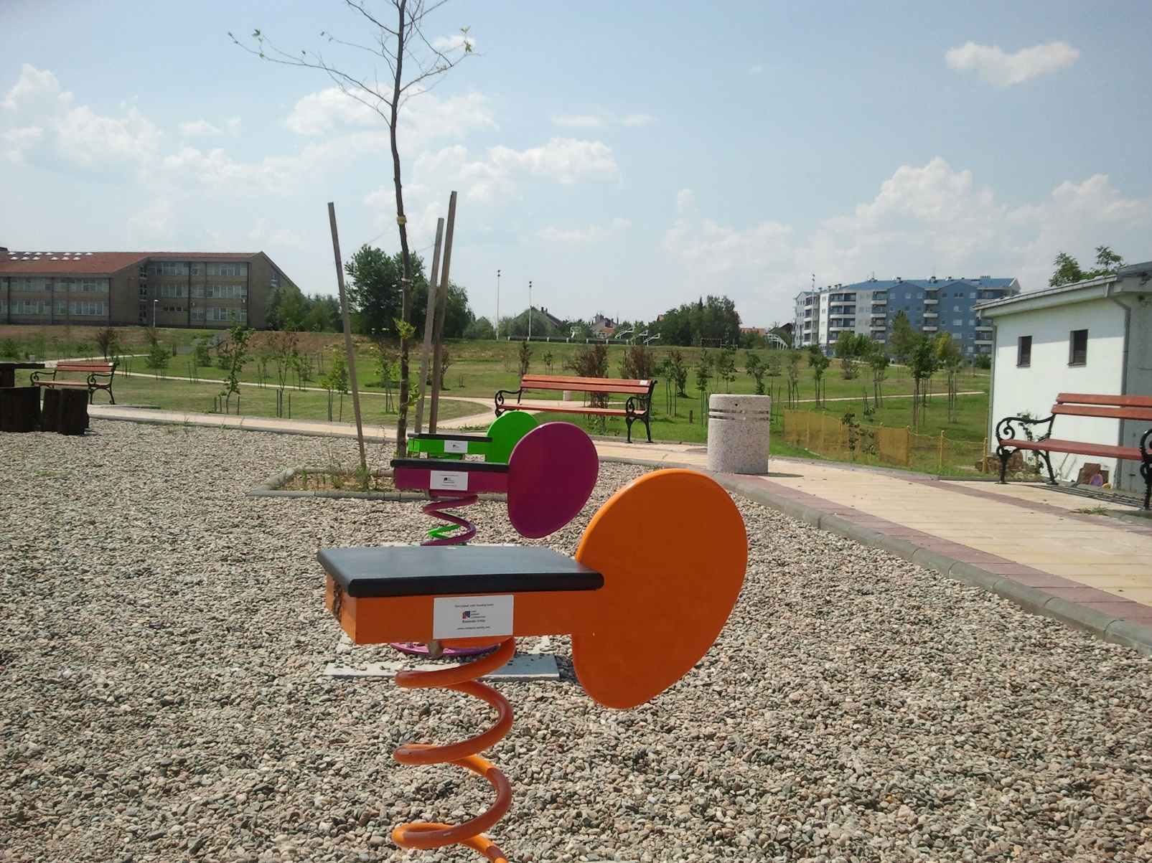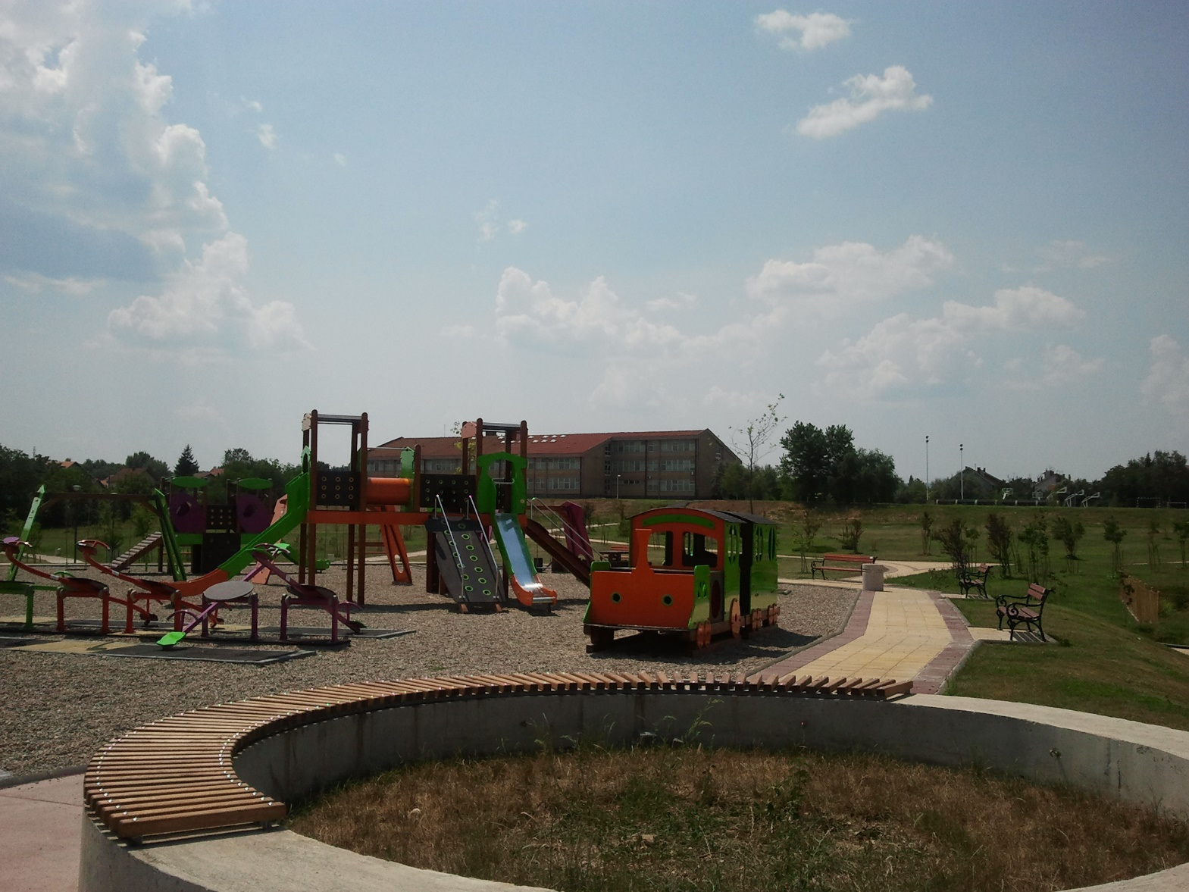

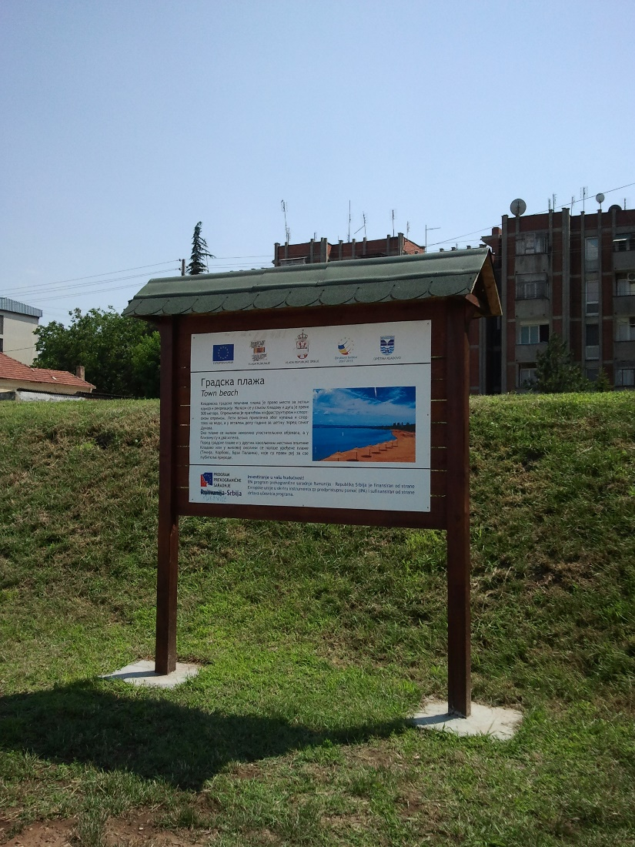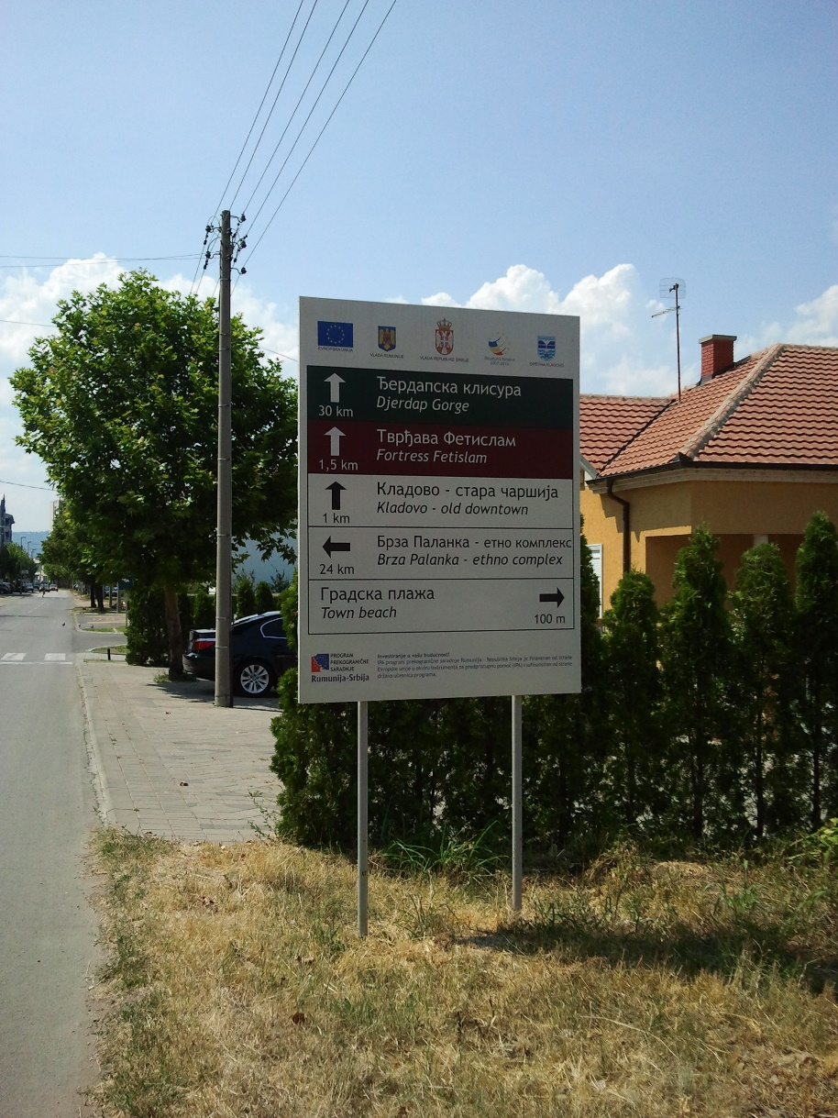

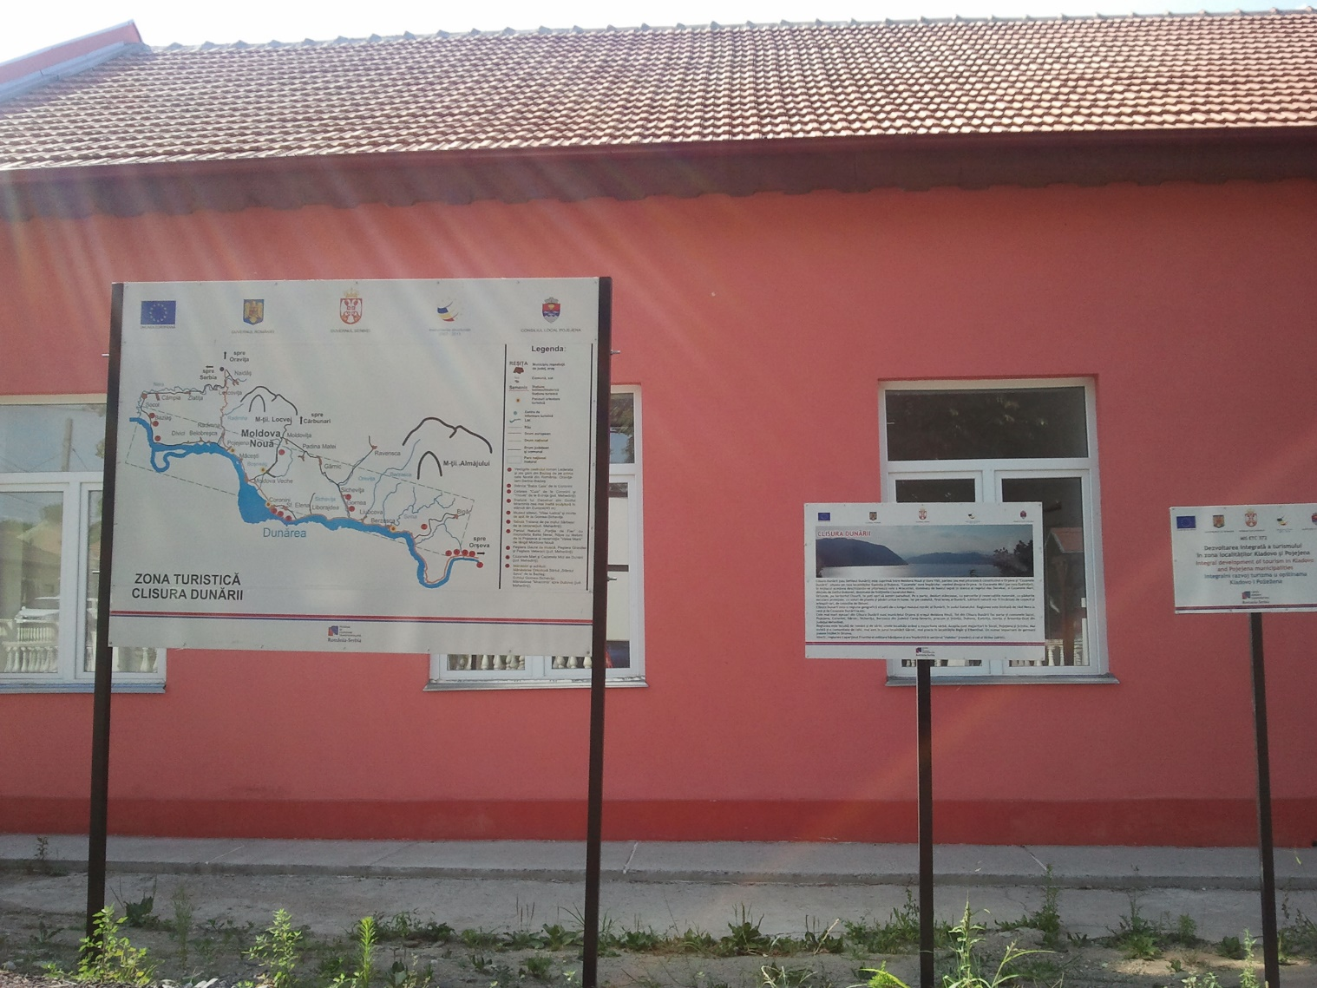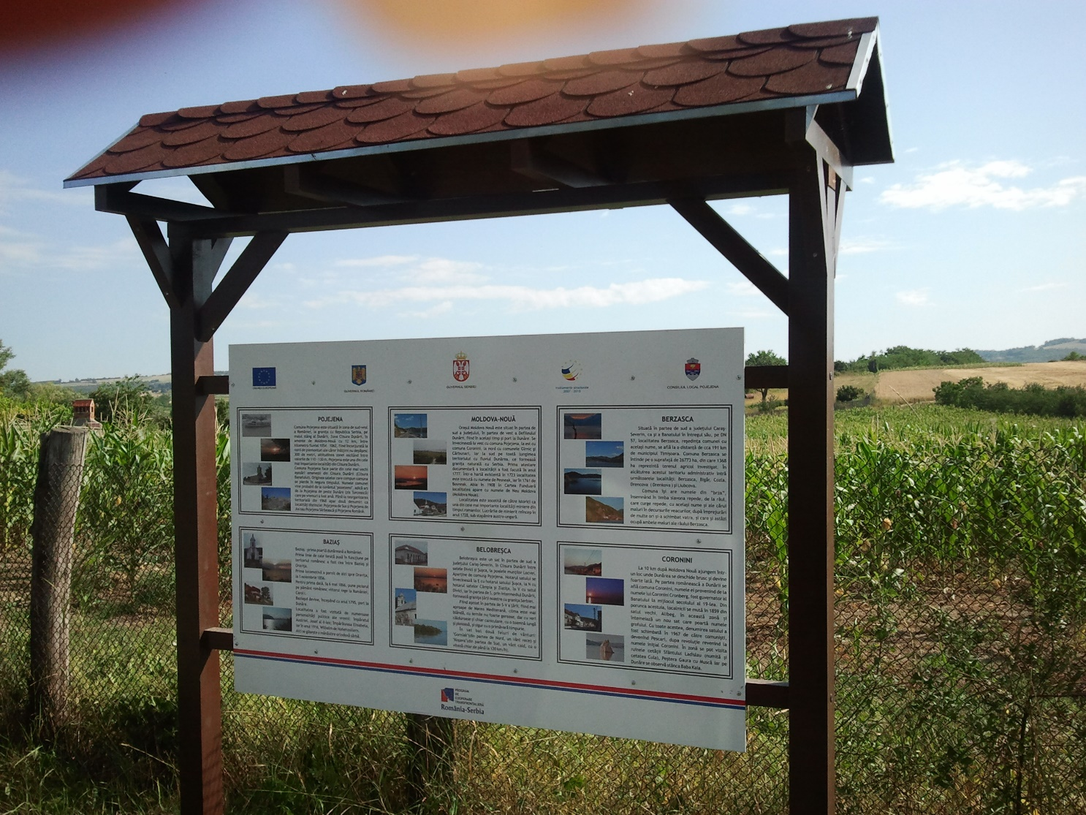

the implementation period (including extensions)
total funds spent/total funds contracted *100
indicators and level of achievement against targets set

