Project information
CALL FOR PROPOSALS | 1
e-MS Code: | RORS-8
PRIORITY AXIS: | 1 Employment promotion and basic services strengthening for an inclusive growth
OBJECTIVE: | 1.2 Health and social infrastructure
PROJECT TITLE: | Improvement of the abdominal surgery services over the cross-border area
ACRONYM: | IMASS
DURATION: | 04.05.2017 – 03.05.2019 (24 Months)
Interreg-IPA  FUNDS CONTRACTED: | €976.859,24
TOTAL FUNDS CONTRACTED: | €1.149.246,18
ABSORBTION RATE (%): | 98,74%
PROJECT OBJECTIVE(S): | Developing a network of specialists in laparoscopic surgery over the cross-border region.  Providing free high quality medical services for citizens from the cross-border area with abdominal pathologies.  Raising the awareness of the population from the cross-border area with regards to the abdominal pathologies.
SHORT DESCRIPTION OF THE PROJECT: | The project addresses the need for developing the abdominal surgery capabilities within the cross-border area. Although the advantages of laparoscopic surgery are far greater than traditional open surgery, there is a relatively low rate of laparoscopic surgeries within the total number of abdominal surgeries over the cross-border region. This is mainly caused by a deficit of capacities, both from the point of view of the available equipment and of the qualification of the medical staff. As laparoscopic surgery represents a new technique with a fast pace of development, the lack of qualification of the regional medical staff plays an important factor for the low rate of laparoscopic surgeries.  The overall objective of the project is improvement of the quality of life for the population from the cross-border area with abdominal pathologies.  Last generation surgical equipment and advanced training for expert surgeons ensured through the joint actions of the two project partners created access for the entire population of the cross – border area to modern high quality services of abdominal surgery in Timisoara and Smederevo.  Thus, throughout the entire project implementation period, high quality abdominal surgery services were available for free to all citizens from the cross-border area. As early diagnosis is of particular importance for the treatment of abdominal pathologies (especially cancers), free high quality diagnosis services were offered in Timisoara and Smederevo to patients from the entire cross-border area.  The network of specialists developed through the project around the 2 poles (Timisoara and Smederevo) managed to increase significantly and with immediate effect the access of the population from remote areas to specific healthcare services, as well as the quality of these services. More specifically, laparoscopic surgery equipment exists in hospitals from each of the 9 counties/departments of the cross-border region. Still, all hospitals are limited to a small range of simple laparoscopic surgeries, as their medical staff is only trained in basic laparoscopic surgical procedures. Through the activities of the project, expert surgeons from each county and district were trained in advanced laparoscopic surgery procedures. With immediate effect, patients will have access to advanced procedures locally, thus avoiding subjecting themselves to open surgery.  Through all its activities, the project showed particular attention to disadvantaged persons and minorities that have special tendencies of not taking medical investigations in time or cannot afford high quality medical investigations and high quality surgery services.
DEGREE OF ACHIEVEMENT OF INDICATORS: | 3865 Citizens involved in project activities in cultural, social health care services – 178,60%  1313 Disadvantaged persons involved in projects activities – 189,79%  100 Joint actions targeting vulnerable groups (youth, women, disabled, ethnic minorities) established for the prevention of early school leaving, for cultural inclusion – 169,00%  2925 Population covered by improved health services - 169,44%  3965 Participants in projects promoting gender equality, equal opportunities and social inclusion across borders - 169,00%
RESULTS ACHIEVED: | 1,800 Free medical investigations  825 Free abdominal surgery services  40 Training courses for experienced surgeons and residents  200 Training for medical students  100 Memberships to the network of specialists  200 Guides for best practices in the field of laparoscopic surgery  200 Guides for patients and family doctors concerning the costs and benefits of open and laparoscopic surgery  200 Guides for hospitals, surgeons and cost benefit analysis experts concerning the costs and benefits of open and laparoscopic surgery  200 Counselling services over the online portal ( https://imass.umft.ro )  100 Training conferences for family doctors  900 Free medical investigations for disadvantaged persons  413 Free abdominal surgery services for disadvantaged persons  100 Conferences for raising awareness for the Roma population  2,925 Improved health services  3,965.00 Citizens involved in the activities of the project  More information regarding the project can be found at: https://imass.umft.ro/project/

Partnership information
 |  | COUNTRY | COUNTY/DISTRICT | BUDGET(EURO) | CONTACT DETAILS
LEAD PARTNER: | “Victor Babes” University of Medicine and Pharmacy Timisoara | Romania | Timis | 727.032,56 | 2A Eftimie Murgu Square, 300041, Timisoara  Tel: +40 256 293 389  E-mail: rectorat@umft.ro
PARTNER 2: | General Hospital "Sveti Luka" Smederevo | Serbia | Podunavski | 422.213,62 | 51 Kneza Mihajla, 11300 Smederevo  Tel: 0038163304602  E-mail: nedadjordjevic66@yahoo.com

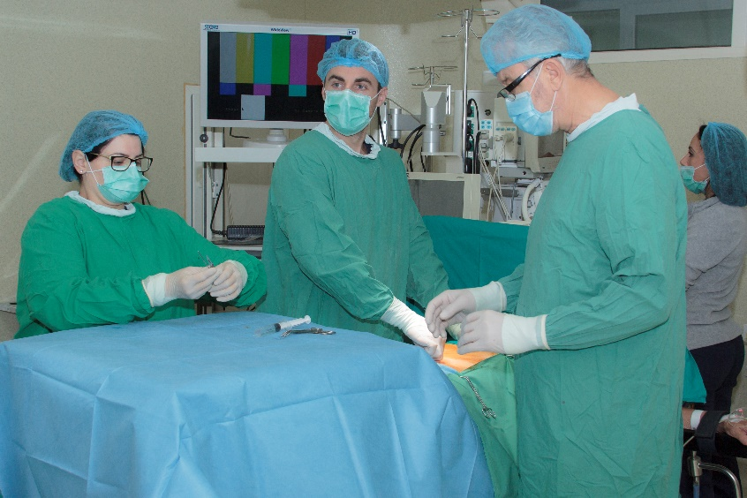
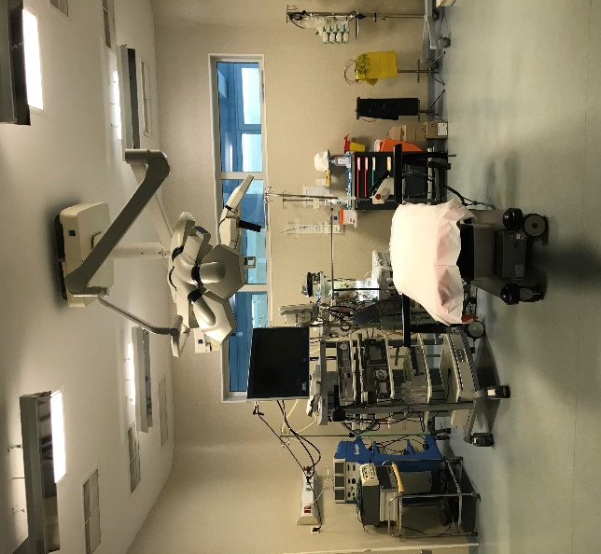

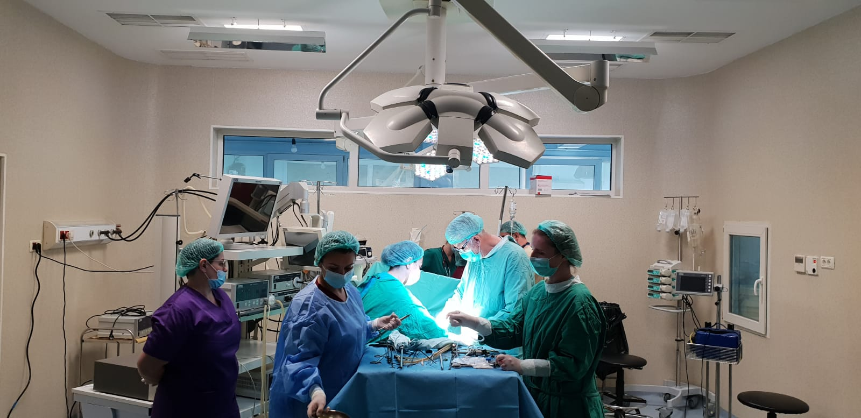
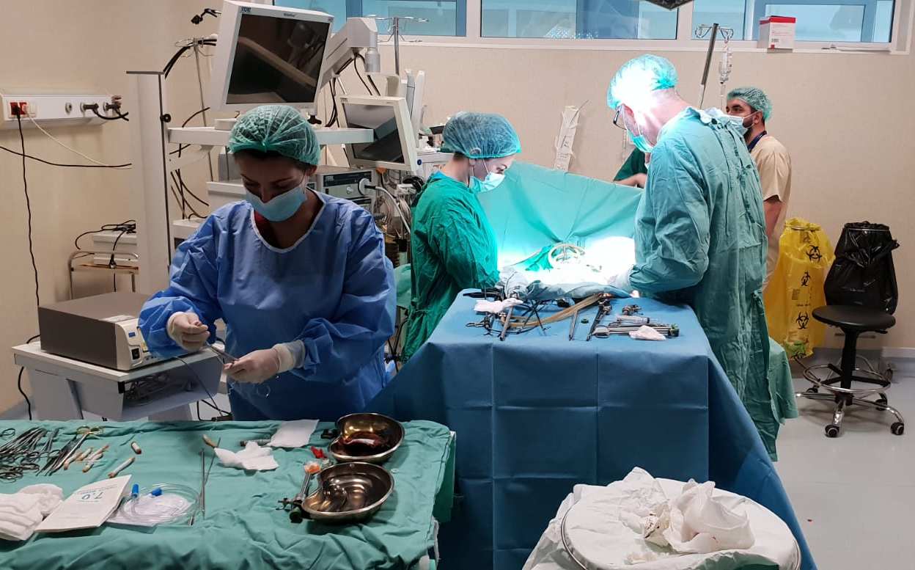

the implementation period (including extensions)
total funds spent/total funds contracted *100
indicators and level of achievement against targets set

