Project information
CALL FOR PROPOSALS | 1
e-MS Code: | RORS-6
PRIORITY AXIS: | PA 1 Employment promotion and basic services strengthening for an inclusive growth
OBJECTIVE: | 1.3 Social and cultural inclusion
PROJECT TITLE: | The Water sports - A healthy future for our youth
ACRONYM: | The Water sports
DURATION: | 16.05.2017 – 15.05.2019 (24 Months)
Interreg-IPA  FUNDS CONTRACTED: | €704.650,16
TOTAL FUNDS CONTRACTED: | €829.000,20
ABSORPTION RATE (%): | 93,52 %
PROJECT OBJECTIVE(S): | The project aims to encourage youth to lead healthier lifestyles through numerous water sports and establish the conditions for equal opportunities for developing water sports activities among the youth.
SHORT DESCRIPTION OF THE PROJECT: | The common challenge of the programme area we wanted to tackle was the need for more awareness among the youth regarding extra-curricular sports after conducting an extremely unhealthy lifestyle at a young age. Today's young people attend school because they must, not because they like it. They spend time mostly in front of televisions and computers, and there needs to be more physical activity among youth in the cross-border (CB) region between Romania and Serbia.  The project's overall objective was to improve conditions for the healthy growth and development of young people in cross-border regions through enhanced public infrastructure and the promotion of sports. The project approach was to support youth in the cross-border region through envisaged activities such as an educational event for the youth, experience exchange among teachers and decision-makers from the local community, organization of youth summer camps, the elaboration of technical documentation for the closed swimming pool in Smederevo and the construction of water centre for children in Ghilad. We raised awareness through a media campaign and promotional materials targeting youth and their parents about the benefits of water sports and a healthier lifestyle.  We organized summer camps in which the youth experienced life differently through socializing with peers in nature, sports competitions, volunteerism and cultural exchange, and experience exchanged among decision makers to review the needs of the youth and opportunities to overcome the problems.
DEGREE OF ACHIEVEMENT OF INDICATORS: | Investment in health care and social services infrastructure – 100 %  Joint actions targeting vulnerable groups (youth, women, disabled, ethnic minorities) established for the prevention of early school leaving, for cultural inclusion – 102 %  Joint actions targeting smart (green) growth opportunities – 100 %  Number of participants in projects promoting gender equality, equal opportunities and social inclusion across borders - 132 %
RESULTS ACHIEVED: | 1 Swimming Centre for children and youth in Ghilad Municipality opened.  Swimming courses offered.  1 Project technical documentation for closed swimming pool in Smederevo elaborated.  Summer camps for students organized.

Partnership information
 |  | COUNTRY | COUNTY/DISTRICT | BUDGET(EURO) | CONTACT DETAILS
LEAD PARTNER: | City of Smederevo | Serbia | Podunavski | 434.869,05 | 1 Omladinska, Smederevo, 11300, Serbia  zdravka.kovacevicvasic@smederevo.org.rs
PARTNER 2: | Ghilad Municipality | Romania | Timis | 394.131,15 | 972/A Ghilad, Timis County, Romania  aranca2003@yahoo.com

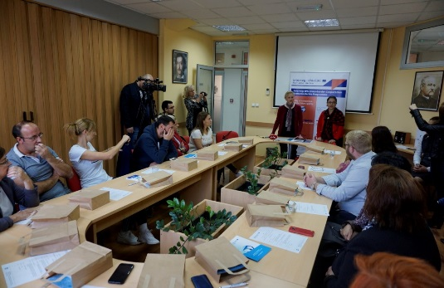
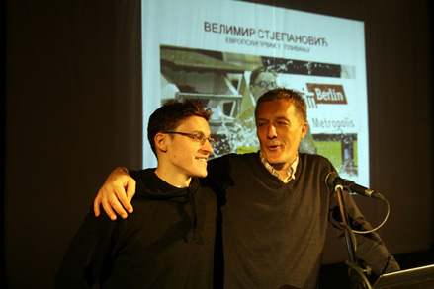
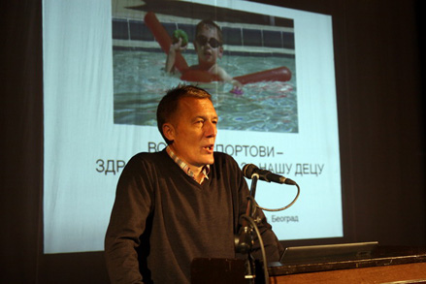
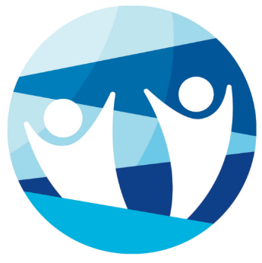
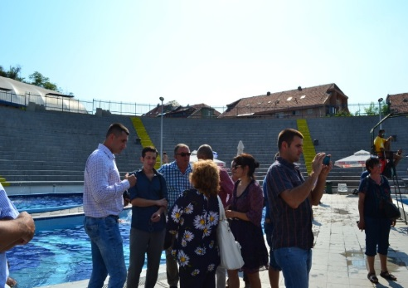

the implementation period (including extensions)
total funds spent/total funds contracted *100

