Project information
CALL FOR PROPOSALS | 1
e-MS Code: | RORS-40
PRIORITY AXIS: | 2 Environmental protection and risk management
OBJECTIVE: | 2.2 Environmental risks management and emergency preparedness
PROJECT TITLE: | Firefighters and emergency management Recas-Zagubica
ACRONYM: | F.E.M.R.Z.
DURATION: | 30.05.2017 - 29.05.2019 (24 Months)
Interreg-IPA  FUNDS CONTRACTED: | €1.201.915,30
TOTAL FUNDS CONTRACTED: | €1.414.018,00
ABSORBTION RATE (%): | 93,10%
PROJECT OBJECTIVE(S): | To clearly identify the environmental risks in the exposed areas from Recas and Zagubica through a well-documented study that would increase the effectiveness in both prevention and intervention management in case of natural disasters.  To raise awareness of the environmental risks existing in the project areas and also to inform and prepare the population on the measures that can be undertaken in order to avoid the occurrence of a disaster.  To create all the prerequisites that allows and promote an efficient intervention with adequate equipment in order to minimalize the damage made by an environmental disaster.
SHORT DESCRIPTION OF THE PROJECT: | The project was focused on implementing an effective strategy that would determine the situation at that time and identify the risk areas, a campaign to inform the inhabitants of the area and raise awareness of the environmental risks and ensuring the efficient tools to minimalize the damage in case of fires, floods, earthquakes, landslides, etc. by reducing the negative impact.  Two partners are involved in the project: Recas city from the Romanian side and Zagubica municipality, from the Serbian side. The reason that this partnership was formed was mainly because the two public entities share a lot of resemblance regarding the climate, the land and the vegetation, the protected species and the habitats, the culture, people’s willingness to protect the environment and because both are dealing with the same significant common challenge relating to the environment and the emergency situations. Taking this in consideration, the two public entities enhanced their preparedness and awareness in order to face environmental risks and emergencies together, enabling cross-border interoperability and joint actions for innovative systems of environmental protection.  The overall objective of the project was to protect the area in the cross-border region from natural disasters and also to reduce the impact in case such a disaster occurs, by enhancing awareness of the environmental risks, acting on the basis of an accurate strategy and using efficient equipment that improves the emergency reaction and result.  The end result is a clear mapping of the risk areas, a strategy that allows us to intervene efficiently and equipment that is helping to protect the environment and the firefighters who risk their lives.  The aim was also to improve the collaboration between the inhabitants of the cross border region in order to grow the capacity for emergency situations in case of natural disasters and environmental accidents. A safe and efficient procedure that deals with the natural disasters was needed in both Recas and Zagubica and in order to create it, we identified a solution in the form of a study that would determine the risks we confronted with and also the best strategy to act in case of natural disasters. As a result, our project created a documented base for a significant part of the cross border area, that determines the most vulnerable areas and best procedures to be undertaken in case of natural disasters. The main beneficiaries of this Study are the partners` inhabitants and also, indirectly, the cross-border region citizens who would have a clear mapping of the dangers in the area and a standard procedure in case of emergency.
DEGREE OF ACHIEVEMENT OF INDICATORS: | 2 Infrastructures, equipment built/ installed/ modernized in the field of cross border services for environmental protection – 100%  1 Participant to project initiatives and events for information and awareness rising – 100%  1 Study in the field of environmental protection and emergency management (technical and scientific studies, researches in the relevant fields) – 100%  1 Monitoring system established/ extended/ modernized in the eligible area in the field of environmental protection and emergency management – 100%  21200 Population benefiting from flood protection measures – 100%
RESULTS ACHIEVED: | 7 Environment monitoring devices installed.  14 Fire protection suits for members of Voluntary firefighting team procured.  40 documents/certificates attesting the training (including events costs) ensured.  New and efficient equipment that was replaced with the old one, for Recas and Zagubica  1 Study elaborated.  Dissemination in schools, dissemination in public institutions, to stakeholders and citizens ensured.  Joint training sessions organized.  Web-site: https://vatrogasci-rors40.org

Partnership information
 |  | COUNTRY | COUNTY/DISTRICT | BUDGET(EURO) | CONTACT DETAILS
LEAD PARTNER: | Recas City | Romania | Timis | 994.243,00 | 86 Cal. Timişoarei, Recas, Timis County, Romania  dezvoltare.primariarecas@gmail.com
PARTNER 2: | Municipality of Zagubica | Serbia | Branicevski | 419.775,00 | 1 Trg oslobodenja, ZAGUBICA, Serbia  milenapajic79@gmail.com

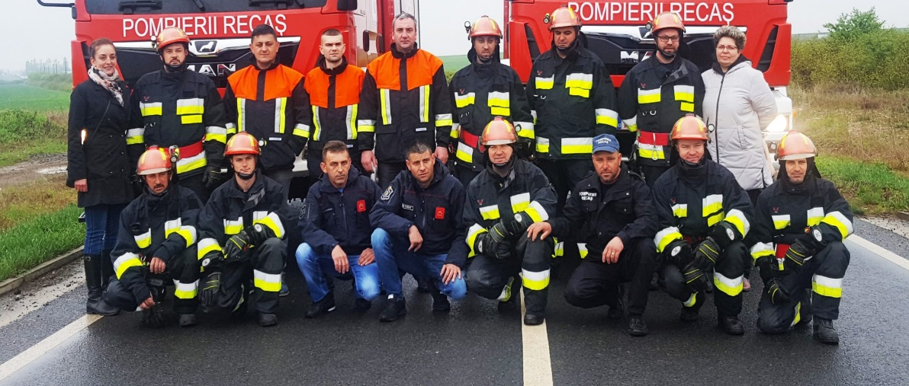
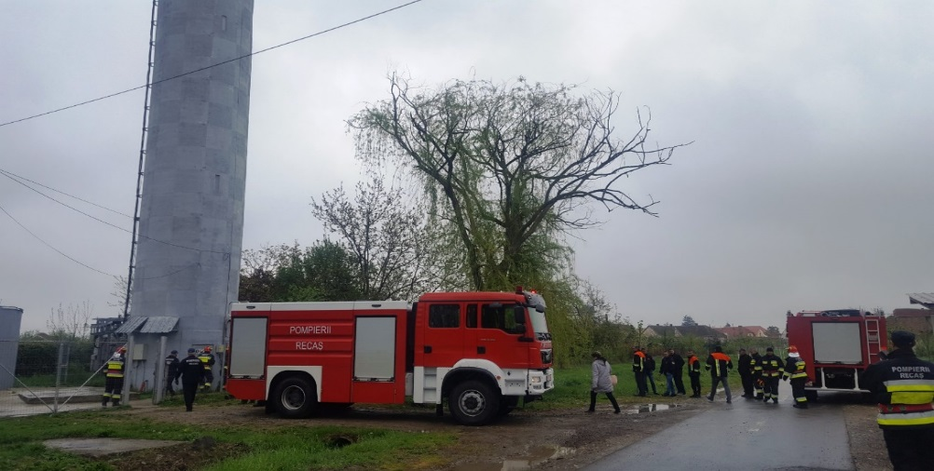

the implementation period (including extensions)
total funds spent/total funds contracted *100
indicators and level of achievement against targets set

