Project information
CALL FOR PROPOSALS | 1
e-MS Code: | RORS-38
PRIORITY AXIS: | 2 Environmental protection and risk management
OBJECTIVE: | 2.2 “Environmental risks management and emergency preparedness”
PROJECT TITLE: | Systems for emergency preparedness
ACRONYM: | SYSEP
DURATION: | 16.06.2017 - 15.12.2019 (30 Months)
Interreg-IPA  FUNDS CONTRACTED: | €800.098,57
TOTAL FUNDS CONTRACTED: | €941.292,45
ABSORBTION RATE (%): | 93,51 %
PROJECT OBJECTIVE(S): | The project is proposing to enhance capacities of relevant local/regional institutions for preparedness in emergency situations and natural disasters in the partner cities of Moldova Noua and Golubac.  Marketing for the project and publicity for the activities and events.  Enhancing preparedness and awareness to face emergency situations.
SHORT DESCRIPTION OF THE PROJECT: | The common challenges of the programme area we are jointly tackling are the lack of strategic thinking, planning and implementation (both at regional or local level), the lack of cooperation between stakeholders with common interests and prerogatives and an obvious “delay” regarding economic development due to the lack of funds for purchasing the latest technologies and equipment and training the human resources.  Regarding emergency situations preparedness and management the common challenges, the challenges are the lack of an emergency situations SWOT analysis and risk mapping analysis done by the local authorities which shall underline both the present problems and the future solutions and a decreased population awareness regarding environmental and emergency situations issues.  The project is trying to obtain a good cooperation between stakeholders with common interests and prerogatives, efficient emergency situations reactions at the local authorities’ level due to the accumulation of theoretical knowledge and practice, and due to investment in new equipment and know-how sharing, and to increase the population awareness regarding environmental and emergency situations issues.  The direct beneficiaries are the specialized departments for emergency situations. Citizens of the partners’ cities will benefit from the project implementation as they will be better protected against emergency situations and natural disasters.  The focus of the project is the active exchange of experiences and knowledge in terms of increasing the existing practice and developing new techniques which could not be possible to reach without the proposed investment in basic equipment.  Civil involvement and training for school children are the proposed approaches for the preparedness towards emergency situations, in completion to the endowing with equipment.
DEGREE OF ACHIEVEMENT OF INDICATORS: | 2 Infrastructure, equipment built/ installed/ modernized in the field of cross-border services for environmental protection.  325 Participants to project initiatives and events for information and awareness rising.  103 Participants to capacity building initiatives.  20 Monitoring systems established/ extended/ modernized in the eligible area in the field of environmental protection and emergency management.  22136 Population benefiting from flood protection measures.
ACHIEVED RESULTS: | Raising awareness among the target group, stakeholders and beneficiaries through press conferences (160), media campaigns, best practice exchanges (18), joint exercise (85), training for school children (50) and training for personal of the voluntary service (12).  Establishing of cross-border partnerships for emergency interventions during the best practice exchanges (18) and joint exercise (85).  Raised capacity of emergency intervention in the 2 cities in case of natural disasters and environmental accidents.  Acquisition of equipment for emergency reaction in case of forest fire and flooding.  Acquisition of intervention vehicles for fast reaction in inaccessible places.  Upgrading flood preparedness in terms of raising technical capacities.

Partnership information
 |  | COUNTRY | COUNTY/DISTRICT | BUDGET(EURO) | CONTACT DETAILS
LEAD PARTNER: | Territorial Administrative Unit Moldova Noua City | Romania | Caras-Severin | 603.025,50 | 26 N. Balcescu street, Moldova Noua 325500, Romania  pmn_invest@yahoo.com
PARTNER 2: | Municipality of Golubac | Serbia | Branicevski | 338.266,95 | 15 Cara Lazara, Golubac, 12223, Serbia

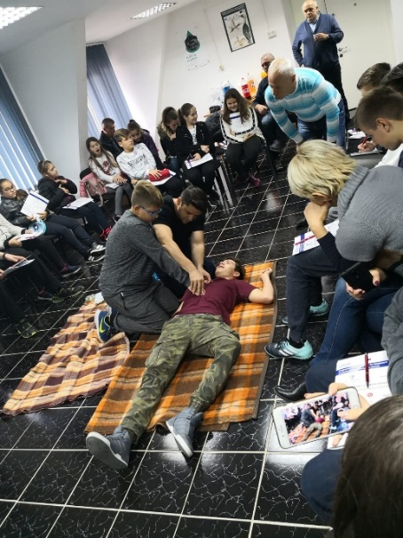
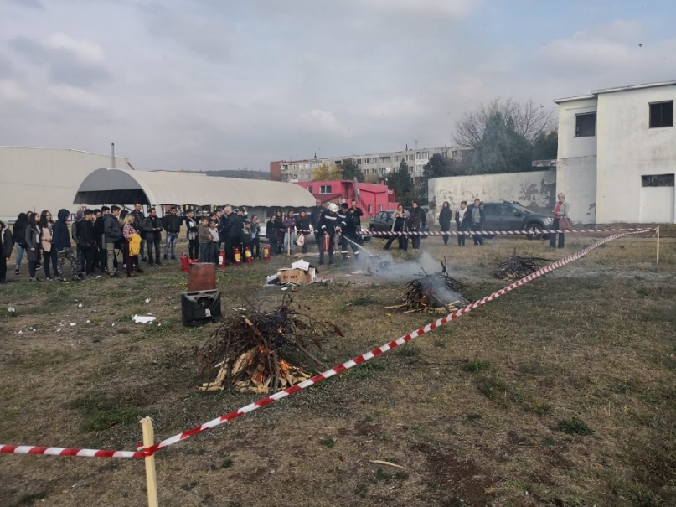
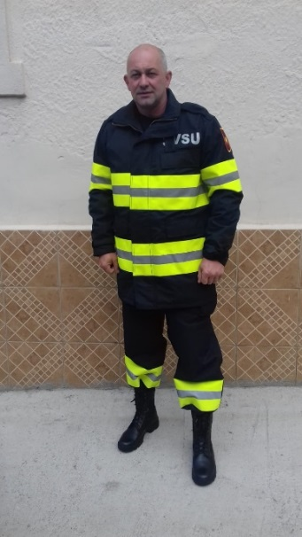
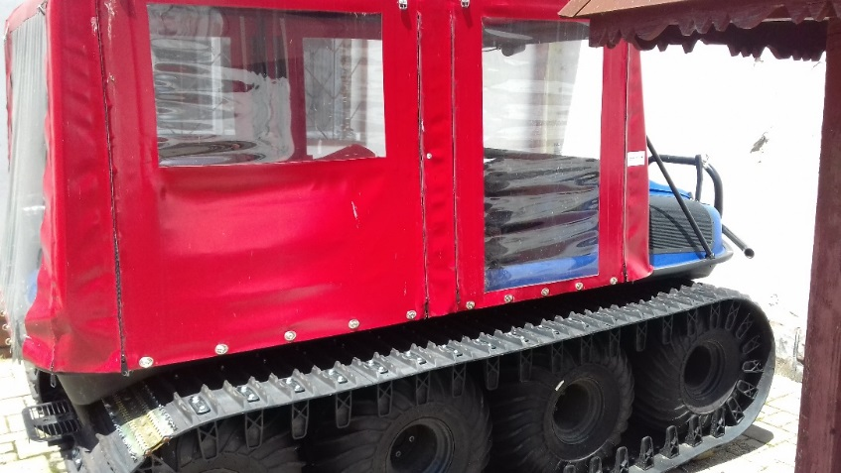
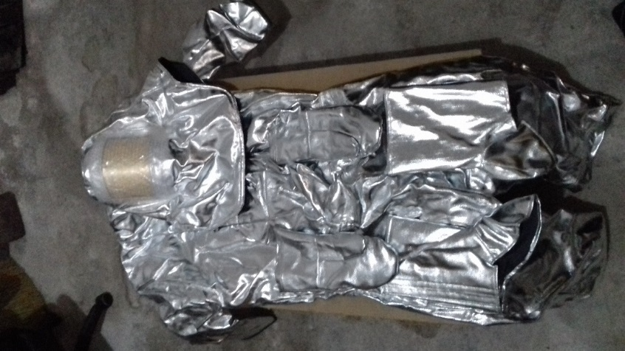

the implementation period (including extensions)
total funds spent/total funds contracted *100
indicators and level of achievement against targets set

