Project information
CALL FOR PROPOSALS | 2
e-MS Code: | RORS-372
PRIORITY AXIS: | 4 Attractiveness for sustainable tourism
OBJECTIVE: | 4.1 Investments for the growth of the demand of local tourism networks and promotion of innovative tourism activities
PROJECT TITLE: | BANAT GREENWAY CORRIDOR - Connecting People to Nature and Culture
ACRONYM: | CONNECT
DURATION: | 22.12.2020-21.09.2023 (33 months)
Interreg-IPA  FUNDS CONTRACTED: | €449.609,36
TOTAL FUNDS CONTRACTED: | €528.952,20
ABSORPTION RATE (%): | Will be updated after the final progress report is approved.
PROJECT OBJECTIVE(S): | - Establish a cross-border tourism network as a new Greenway and regional distinct tourism product with increased involvement of tourism stakeholders in the development and promotion of the new tourism asset;  - Increase the flow of tourists (domestic and international) who visit the Banat Greenway by promoting sustainable, active and quality tourism through the use of new technologies;  - Establish a cross-border tourism infrastructure for integrated innovative services and information;
SHORT DESCRIPTION OF THE PROJECT: | The project area covers the Caras-Severin County and South Banat District of the Romanian-Serbian border area through the linear green corridor that links the Banat Mountains (RO), Danube and Banat Sands (SRB). The project area includes authentic mountain villages (Cornereva), a UNESCO “World editorial centre devoted to naïve art”, galleries, ethnic houses and museums (Kovacica), “the European Sahara”, a UNESCO tentative list of Protected Natural Heritage (Dolovo) and one of the most historic viticulture regions (Vršac area). They represent significant tourism resources but with poor tourism promotion and tourist offers. There is a generalized lack of future vision of tourism in Banat, and the collective conscience of the importance of tourism for economic and social development is almost inexistent. There is no professionalization of tourism management, neither in the public sector nor in the private sector, which complicates the global development of its relevant local economy. To further develop the sector, activities such as creating complementary services, leisure activities, knowledge transfer and capacity building will strengthen the attractiveness of tourism adequate for the needs of the area and its population. The project makes the leap from local “tourism resource” to “tourism product” through the establishment of a cross-border network and the creation of `Banat Greenway`, a linear green corridor of long-distance and thematic local trails, specific tourism route reserved for non-motorized users, as a new distinct regional tourism product for leisure and cycling tourism, to connect people to nature and culture heritage, with integrated innovative services and information. The creation and promotion of Banat Greenway will help to diversify the economy in rural areas attracting visitors, but also to be used for local people. The project aims at connecting with European Greenways and the EuroVelo 6 trans-European route. Cycling is an important niche market and offers excellent opportunities for the sustainable development of the local economy for rural areas in Banat. Statistics show that European cycle tourism generates 44 billion Euros in tourism consumption and is the second largest source market for cycling tourism in the World. The project will support the establishment of a cross-border regional brand image, `Banat Greenway`, for the local touristic offer, attracting additional demand. For this purpose, the project includes actions to drive public-private collaboration and the integration of all tourism stakeholders. These changes will induce an increase in the occupancy rate of cross-border tourism infrastructure through the innovative and complementary services and information, setting of Banat Greenway cycling friendly service network and certifications according to international standards and promote new, authentic experiences through the use of new (IT) technologies in rural areas along the Banat Greenway Corridor.
TARGETED INDICATORS: | 3 Cross-border cooperation structures/ initiatives supported in the field of tourism: 1 Banat Greenway Product Club and 2 promotional events and tourism fair for the local tourist offer.  1 Study related to the implementation of selected projects or research and studies in the field of natural and cultural resources: Banat Greenway Corridor Master Plan Study.  80 participants attending training initiatives: 40 participants in workshops of knowledge transfer for tourism stakeholders and 40 participants in trainings for acquiring skills.  8 Joint actions and communication instruments created: 1 interactive website with interactive map, social media and mobile phone application with QR codes; 1 Banat Greenway Visitor Interpretation Centre (and centre for cyclists); 3 Banat Greenway Interactive digital Info-points; 4 thematic local trails.  2 Partnerships for the exchange of good practices and the promotion of joint initiatives established: 1 Banat Bike Hire Services Network; 1 ''Cyclists Welcome!'' Certification.
TARGETED RESULTS: | 1 Banat Greenway Product Club.  2 Promotional events and tourism fair of promotion of local tourist offer.  1 Banat Greenway Corridor Master Plan Study.  40 participants in workshops concerning knowledge transfer for tourism stakeholders.  40 participants in trainings for acquiring skills.  1 Interactive Website with interactive map, Social media and Mobile phone application with QR codes.  https://www.banatgreenway.com/  https://www.facebook.com/banatgreenway  1 Banat Greenway Visitor Interpretation Centre (and centre for cyclists).  2 Banat Greenway Interactive digital Info-point.  4 Thematic local trails.  1 Banat Bike Hire Services Network.  1 ''Cyclists Welcome!'' Certification.

Partnership information
 |  | COUNTRY | COUNTY/DISTRICT | BUDGET(EURO) | CONTACT DETAILS
LEAD PARTNER: | Cornereva Hall | Romania | Caras-Severin | 120.512,70 | 1 Principala Street, 327110, Cornereva Village  Tel: +40758-327-317  E-mail: primaria.cornereva@gmail.com
PARTNER 2: | Municipality of Kovačica | Serbia | Južnobanatski | 123.471,60 | 50 Marsala Tita Street, 26210, Kovačica  Tel: +381 13 661 122  E-mail: predsednik.opstine@kovacica.org
PARTNER 3: | Assoc. "Friends of Pancevo" | Serbia | Južnobanatski | 166.683,30 | 24 Bratstva i Jedinstva Street, 26227, Dolovo, City of Pancevo  Tel: +381 64 6453321  E-mail: zoranavladu@gmail.com

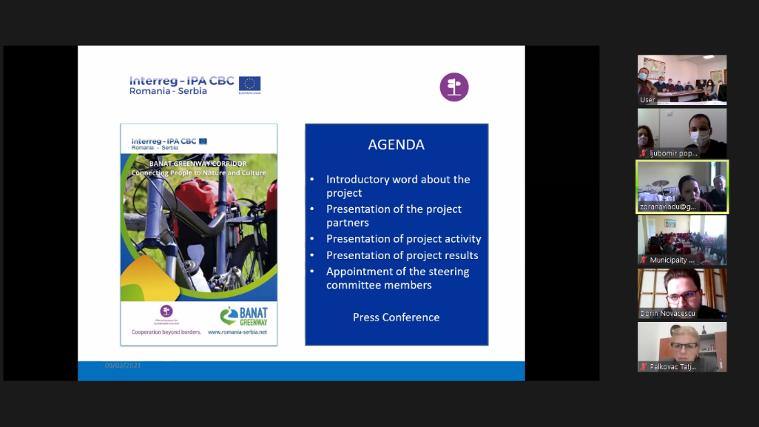
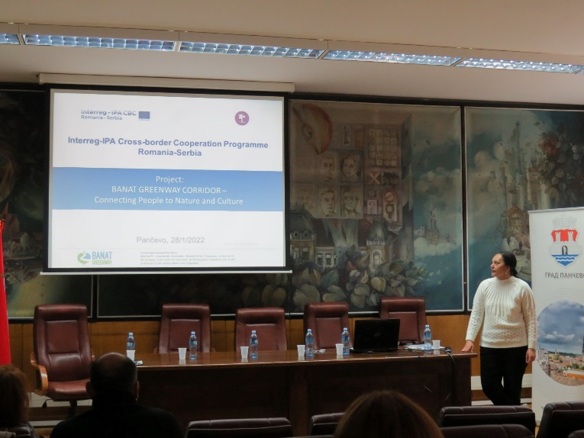

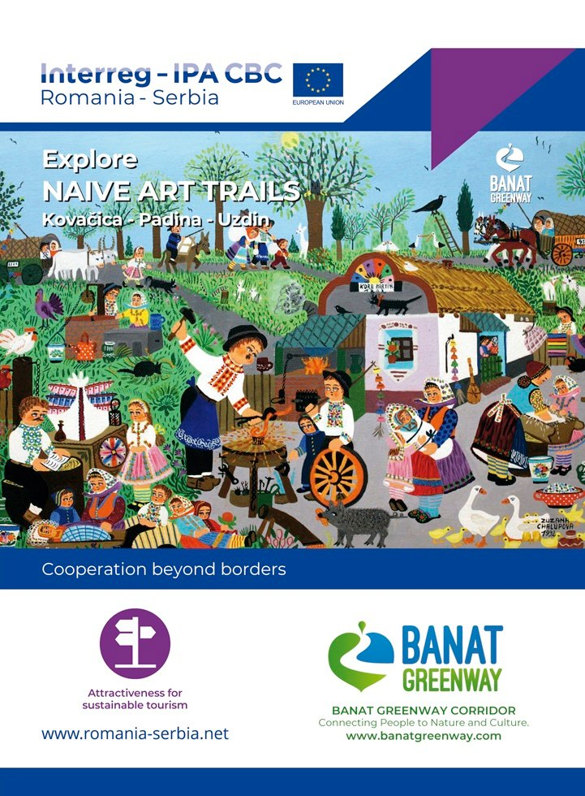
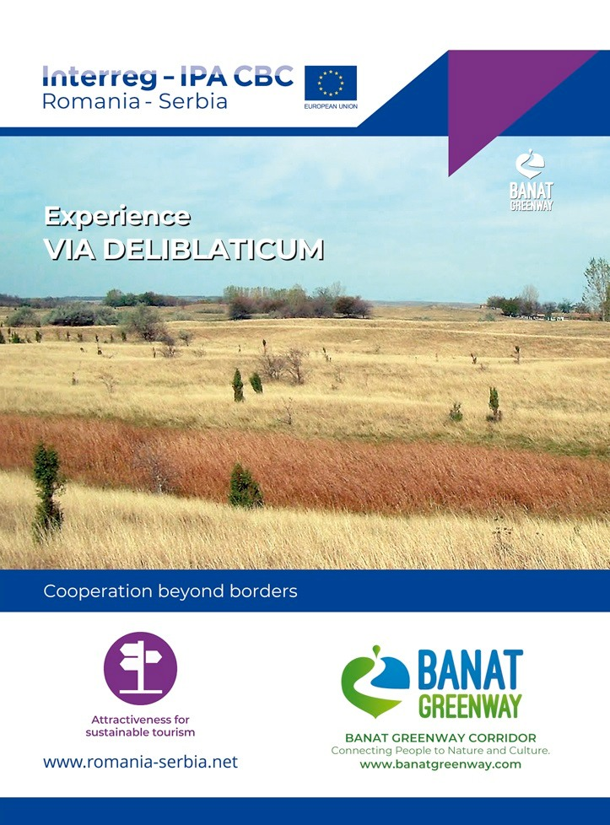
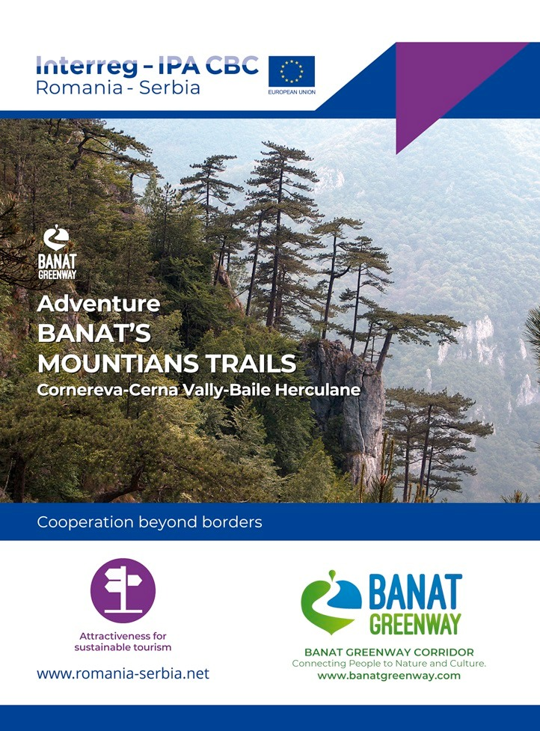

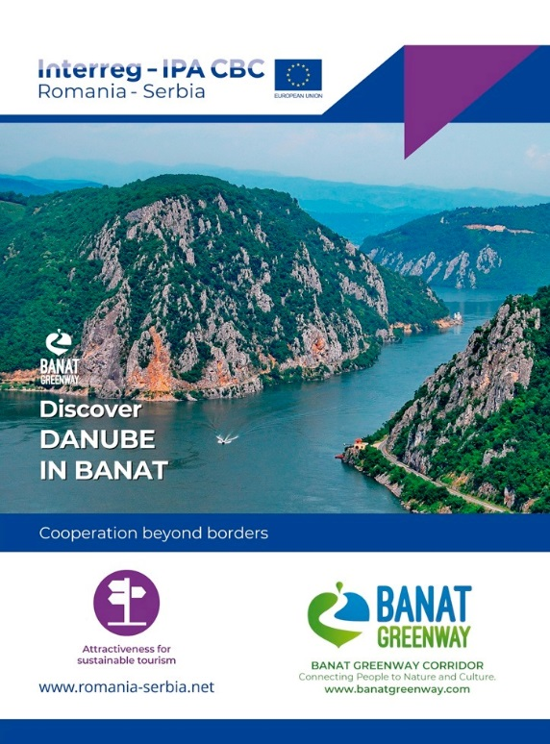

the implementation period (including extensions)
total funds spent/total funds contracted *100

