Project information
CALL FOR PROPOSALS | 1
e-MS Code: | RORS-37
PRIORITY AXIS: | 4 Attractiveness for sustainable tourism
OBJECTIVE: | 4.2 Capacity building initiatives for the improvement of quality and innovation of tourism services and products
PROJECT TITLE: | 7 Wonders of Mehedinti and Borski
ACRONYM: | 7 Wonders
DURATION: | 07.07.2017 – 06.01.2019 (18 months)
Interreg-IPA  FUNDS CONTRACTED: | €385.884,72
TOTAL FUNDS CONTRACTED: | €453.982,04
ABSORBTION RATE (%): | 79.78 %
PROJECT OBJECTIVE(S): | Increase the skills and competences of the local stakeholders involved in tourism regarding the use of natural resources available for developing niche-sectors and through this, the local economy;  Develop local cross-border structures in fields of niche-tourism sectors;  Create new instruments of research and communication tools for increasing the Mehedinti-Borski area visibility;
SHORT DESCRIPTION OF THE PROJECT: | After the successful experiences had in promoting the Iron Gates area, the partnership was pursuing a new approach that aimed to integrate the rest of Mehedinti and Borski territory in the area’s touristic offer, to present the activities that could bring and keep a visitor there for a longer period, to increase the visibility and functionality of niche-tourism attractions and to provide better knowledge for local stakeholders involved in this sector. Thus, the overall objective of the Project “7 Wonders of Mehedinti and Borski” is closely and strongly associated with one of the objectives of the Interreg-IPA Cross-border Cooperation Romania – Serbia Programme: to develop the targeted area’s tourism economy based on the sustainable use of the natural and cultural heritage, to create capacities and skills for high quality tourism services, to create all the required conditions for innovative cross border partnerships and to improve tourist informational infrastructure.  The originality and novelty of the “7 Wonders of Mehedinti and Borski” is coming mainly from its orientation to the niche-tourism sectors in an integrated, cross-border manner, targeting both districts as a whole and designing a “product” that has all the prerequisites to become a major presence in the competition for tourists at European level, greatly increasing the living standard of the region’s inhabitants. The five new structures that were developed in the region used genuine instruments of communication meant to arouse the visitors` interest and curiosity and professionally realised advertising tools, with proven efficiency in other EU financed projects.
DEGREE OF ACHIEVEMENT OF INDICATORS: | Cross-border cooperation structures/ initiatives supported in the field of tourism – 100%;  Studies related to the implementation of selected projects or research and studies in the field of natural and cultural resources – 100%;  Number of participants attending training initiatives – 100%;  Joint actions and communication instruments created – 100%;  Partnerships for the exchange of good practices and the promotion of joint initiatives established – 100%;
RESULTS ACHIEVED: | 5 cross-border cooperation structures developed in the field of tourism.  1 research in the field of natural and cultural resources of Mehedinti – Borski area elaborated.  5 new communication instruments created.  250 representatives of the stakeholders in the field of tourism attended trainings.  More details can be found by accessing:  https://promehedinti.ro/en/category/7-minuni-din-mehedinti-si-borski/

Partnership information
 |  | COUNTRY | COUNTY/DISTRICT | BUDGET(EURO) | CONTACT DETAILS
LEAD PARTNER: | Pro-Mehedinti Association | Romania | Mehedinti | 242.773,65 | 37 Plevnei Street, 220233, Drobeta Turnu Severin  promehedinti@gmail.com
PARTNER 2: | Bios fund | Serbia | Borski | 98.841,88 | 3 Milenka Stojkovica, 19220, Donji Milanovac  biosfond@gmail.com
PARTNER 3: | Tourism organization of Negotin Municipality | Serbia | Borski | 112.366,51 | 6 Kraljevica Marka Street, 19300, Negotin  toonegotin@gmail.com

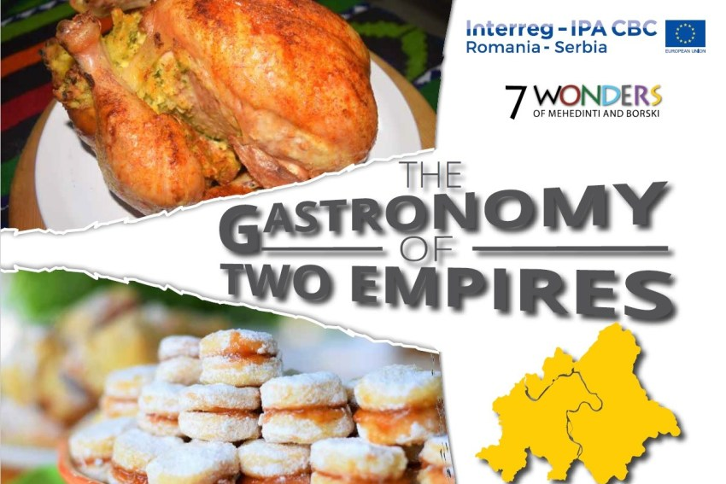
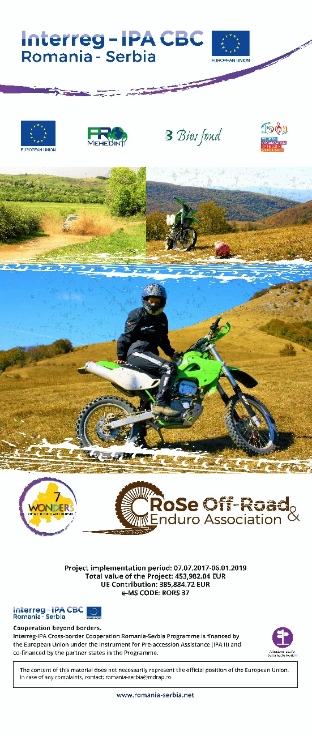
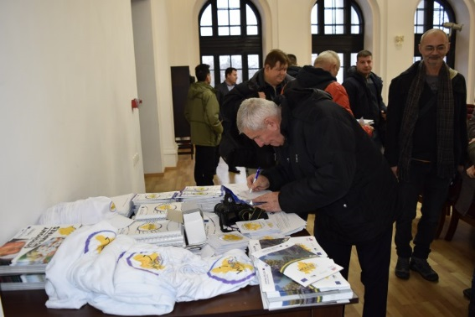
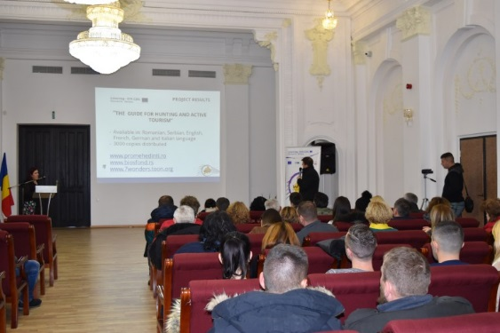
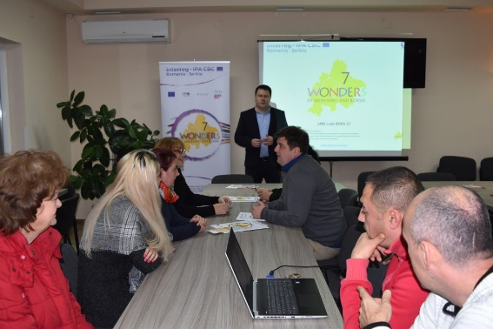
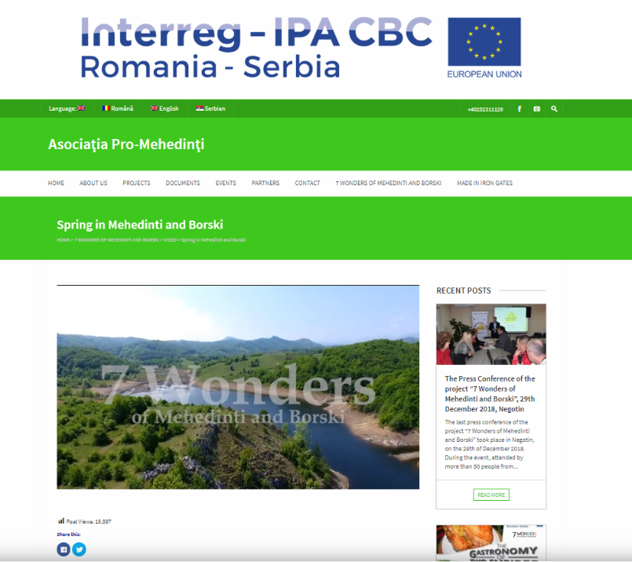

the implementation period (including extensions)
total funds spent/total funds contracted *100
indicators and level of achievement against targets set

