1

Project information
CALL FOR PROPOSALS | 1
e-MS Code: | RORS-33
PRIORITY AXIS: | 1 Employment promotion and basic services strengthening for an inclusive growth
OBJECTIVE: | 1.3 Social and cultural inclusion
PROJECT TITLE: | Rediscovering cultural traditions in Valcani - Coka border area as part of the historical Banat
ACRONYM: | The Historical Banat
DURATION: | 08.06.2017 – 07.06.2019 (24 Months)
Interreg-IPA  FUNDS CONTRACTED: | €298.960,37
TOTAL FUNDS CONTRACTED: | €351.718,10
ABSORBTION RATE (%): | 94,66 %
PROJECT OBJECTIVE(S): | Development of social and cultural relationships in the cross-border area Valcani-Coca, based on multicultural cooperation, cultural heritage and joint promotion of the multi-ethnic traditions.  Facilitating the access and participation of the Valcani (Romania) - Coka (Serbia) communities to social and cultural life by improving the local infrastructure required to host activities aimed to improve the cross-border cooperation, in general, and social inclusion, in particular.  Revival of the multicultural traditions in Valcani and Coka and promoting the cultural values by involving social groups throughout the project in activities to rediscover the values.
SHORT DESCRIPTION OF THE PROJECT: | The challenge of the project has started with identifying the common needs in the Coka-Valcani cross-border area, namely the common cultural values, but also the lack of communication, the loss of historical identity, which has led to the isolation and marginalization of the rural communities located in the border area.  To meet the identified needs, the project intended to speed-up the development of bilateral cooperation through joint cultural events by reviving the rediscovery of values, traditions and intercultural ethnic customs. In order to preserve local cultural heritage in the Coka – Valcani cross-border area it was very important to transmit the local cultural values to the young generation.  The main outcomes are the creation of a Multicultural Centre in Valcani village and the rehabilitation of the Community Centre from Banatski Monostor – Coca village. The centres hosted the project activities, cultural meetings and exchanges between Valcani - Coka, 2 sessions for cultural education, 3 groups of creative workshops (ethnographic, culinary, arts and crafts, dance classes, two visits to ethnographic museums in the cross-border area), a folklore camp in Monostur Coka, 1 culinary contest, 1 multiethnic Festival at Valcani.  As this project was about the history, the tradition, multiculturalism, the common border of the two partners, it aimed to be mainly a transfer model of experiences, knowledge and cultural practice performed over time by Coka and implemented in Valcani. Building the infrastructure represented the support for the organization of the proposed activities, providing the local population with the opportunity to have a full cultural life animated by the desire to engage in cross-border cooperation. Furthermore, the two neighbouring border communities shared strategies for solving the identified needs. The novelty of the project was to strengthen the cultural relations in the cross-border area based on the desire to save both tangible and intangible cultural values by involving all generations in their transmission and reception.
DEGREE OF ACHIEVEMENT OF INDICATORS: | 1 Investment in health care and social services infrastructure. 100%  62 Disadvantaged persons involved in projects activities. 100%  Joint actions targeting vulnerable groups (youth, women, disabled, ethnic minorities) established for the prevention of early school leaving, for cultural inclusion. 145%  Number of participants in projects promoting gender equality, equal opportunities and social inclusion across borders. 124%
ACHIEVED RESULTS: | 24 members involved in a cultural initiative group.  2 visits performed to the ethnographic museums in Romania and Serbia, with 124 participants.  37 participants at a cross cultural visit to the Ferenc Mora Cultural Organization of Coka.  321 participants at educational events.  A children’s summer camp of folk dances and music from Monostor organized.  Setting up of 3 creative workshops (ethnography, handicrafts, traditional cuisine) with 50 members, 12 volunteers.  49 participants at folk dance courses.  91 participants at a traditional culinary contest.  253 participants at a Multicultural Festival of Art and interethnic Tradition of Valcani first edition.  Elaboration of technical documentation for construction of the Multicultural Center in Valcani.  Renovation of the cultural center from Monostur.  Construction of the Multicultural center from Valcani.  1 web page created: http://ipa1.valcani.ro

Partnership information
 |  | COUNTRY | COUNTY/DISTRICT | BUDGET(EURO) | CONTACT DETAILS
LEAD PARTNER: | Valcani Commune | Romania | Timis | 252.784,35 | 222 Valcani, 307153, Romania  primaria_valcani@yahoo.com
PARTNER 2: | Municipality of Coka | Serbia | Northern Banat | 98.933,75 | 20 Potiska street, Coka, 23320, Serbia

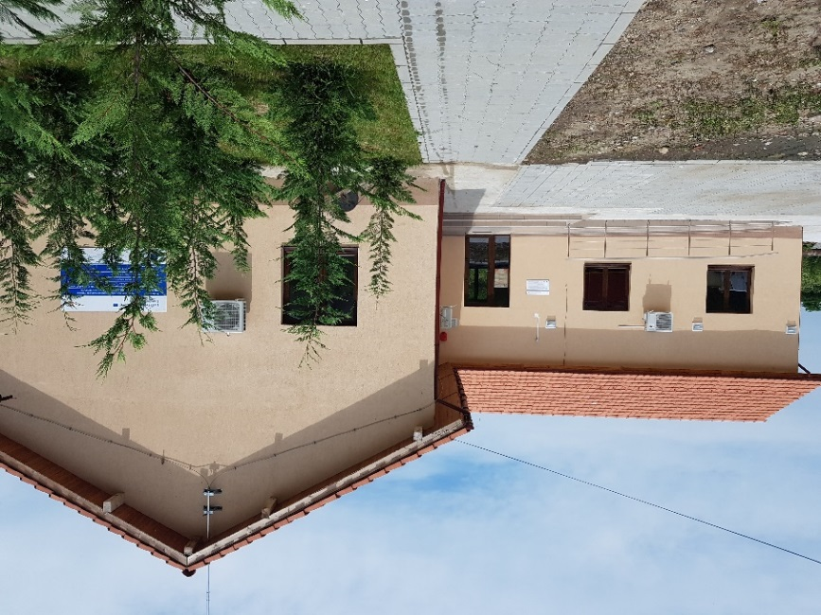
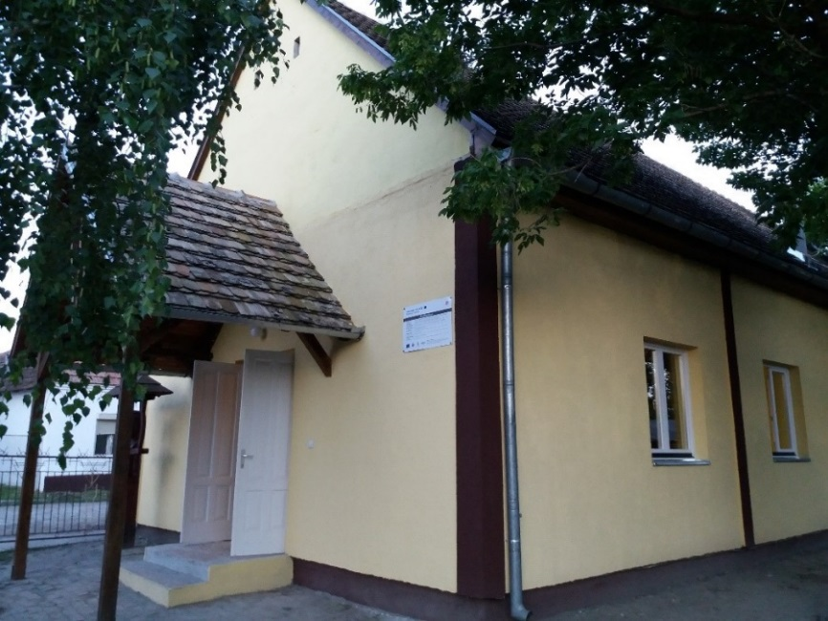

the implementation period (including extensions)
total funds spent/total funds contracted *100
indicators and level of achievement against targets set

