Project information
CALL FOR PROPOSALS | 1
e-MS Code: | RORS-32
PRIORITY AXIS: | 4 Attractiveness for sustainable tourism
OBJECTIVE: | 4.1 Investments for the growth of the demand of local tourism networks and promotion of innovative tourism activities
PROJECT TITLE: | Keepers of tradition
ACRONYM: | KOTRA
DURATION: | 13.06.2017 – 12.12.2018 (18 Months)
Interreg-IPA  FUNDS CONTRACTED: | €392.372,55
TOTAL FUNDS CONTRACTED: | €461.614,78
ABSORBTION RATE (%): | 84,47 %
PROJECT OBJECTIVE(S): | To preserve common cultural heritage.  To use the common cultural heritage for developing local tourism based economy.  To increase the visibility of the targeted area as touristic destination.
SHORT DESCRIPTION OF THE PROJECT: | The Programme area targeted through this Project, bordered by Bela Crkva (Serbia) municipality in North – West and the one of Svinita (Romania) in the South – West has the well-deserved reputation of being one of the most beautiful regions of Romania and Serbia. Known as “Clisura Dunarii” or “Banatska Klisura”, these lands amaze by many places and things, made by Nature or, since millenniums, by human hand. If the natural beauties gained certain popularity in recent years, the red thread of uninterrupted human presence – the local, common tradition – is getting more and more scattered, along with the population ageing phenomena and the youth migration to bigger, urban areas, in search for better living conditions. So, if we should use two words to describe the area envisaged through this project, these would be “beautiful” and “poor”. The touristic sector, even being on a slightly upward trend as a direct result of promotional actions, lacks some essential ingredients needed to become the main economic growth engine of the area. One of those is the poor offer of activities or attractive moments provided to the visitors: even if they can visit places, do some hiking or enjoy extraordinary meals prepared mainly from fish, they leave without truly meeting the local tradition and thus – without truly meeting the locals. This is what we tried to change through “Keepers of tradition”: by sounds, motion and colours coming from the mists of time the project gave a longer and joyful life to their memories from the area, thereby making tourists come back, stay longer and, not least of all, be appointed as ambassadors of “Clisura Dunarii” area.  Having as overall objective the preservation of cultural heritage and the use of it for developing the local tourism economy, at the end of the project 162 people were trained as tradition keepers, a new folklore dancing ensemble was set up, a Romanian – Serbian Tradition Centre was created and a network of accommodation facilities that will invite artists to perform for their visitors was established. For the first time in the area, the common Romanian – Serbian cross-border tradition and cultural life was exposed to the tourists by trained amateurs acting as professionals – without any fee – bringing this way an important contribution to the development of the touristic sector.
DEGREE OF ACHIEVEMENT OF INDICATORS: | 2 cross-border cooperation structures/ initiatives supported in the field of tourism - 100%  162 participants attending training initiatives - 100%  3 joint actions and communication instruments created - 100%  1 partnership for the exchange of good practices and the promotion of joint initiatives established - 100%
RESULTS ACHIEVED: | A tourism development association founded.  A Romanian – Serbian folklore show organized.  A documentary movie “Dancing your way through Romania & Serbia” elaborated.  A cross-border album with touristic attractions created.  A network for sustaining tourism structure attractiveness established.  A common centre for keeping the tradition created.

Partnership information
 |  | COUNTRY | COUNTY/DISTRICT | BUDGET(EURO) | CONTACT DETAILS
LEAD PARTNER: | Svinita Commune | Romania | Mehedinti | 160.646,89 | 26 2nd street, Svinita, 227440, Romania primariasvinita@yahoo.com
PARTNER 2: | Moldova Noua Tommyland Association | Romania | Caras-Severin | 113.179,00 | 11 Nicolae Balcescu street, Moldova Noua, 325500, Romania
PARTNER 3: | Bela Crkva Municipality | Serbia | South Banat | 187.788,89 | 2 Svetozara Miletica street, Bela Crkva, 26340, Serbia

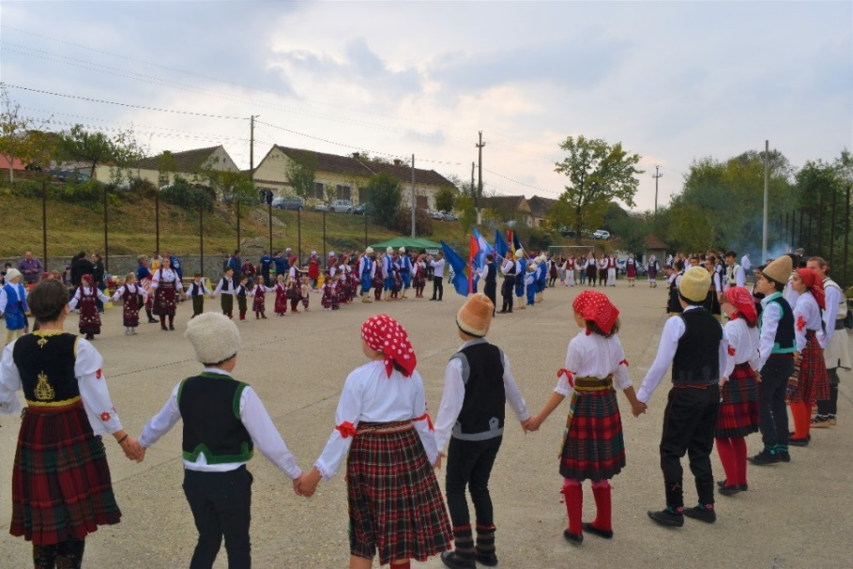
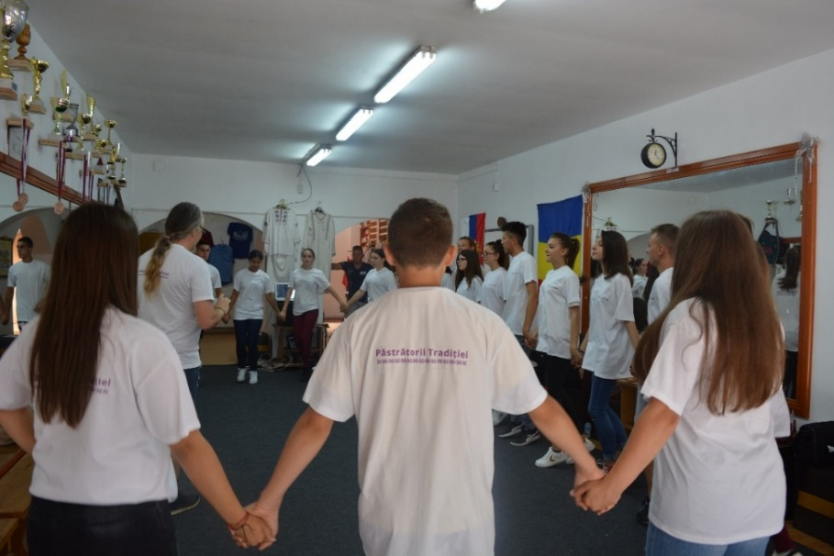

the implementation period (including extensions)
total funds spent/total funds contracted *100
indicators and level of achievement against targets set

