Project information
CALL FOR PROPOSALS | 1
e-MS Code: | RORS-31
PRIORITY AXIS: | 1 Employment promotion and basic services strengthening for an inclusive growth
OBJECTIVE: | 1.3 Social and cultural inclusion
PROJECT TITLE: | Holding alive four fields in the domain of traditions and customs
ACRONYM: | 4traditions
DURATION: | 16.05.2017 – 15.05.2018 (12 Months)
Interreg-IPA  FUNDS CONTRACTED: | €224.918,95
TOTAL FUNDS CONTRACTED: | €264.610,54
ABSORBTION RATE (%): | 90,99 %
PROJECT OBJECTIVE(S): | Increasing cultural integration in the cross-border area by joint actions focusing on folk traditions and conservation of cultural values.  Providing opportunities for cross-border communities to experiencing lively cultural life.  Increase the transfer of cultural and traditional values in the cross-border area.
SHORT DESCRIPTION OF THE PROJECT: | Having a common history, the border area between West Region of Romania and Serbia have similar characteristics, so the challenges facing the area shall be treated in a coherent and integrated manner. Cultural heritage is preserving the memory and identity of Banat area, defining the specific personality of the investigated area. In this project, 13 localities were involved: Dumbravita, Zitiste, Torak, Srpski Itebej, Torda, Banatsko Višnjićevo, Ravni Topolovac, Hetin, Banatski Dvor, Medja, Čestereg, Banatsko Karađorđevo, Novi Itebej.  The main objective was increasing cultural integration in the cross-border area by joint actions focusing on folk traditions and conservation of cultural values. 13 involved communities were being offered the possibilities to refresh the local customs in 4 tradition fields (folk dance; gastronomy traditions; folk craft traditions; and folk customs), thus increasing the cultural integration. In the above mentioned localities Tradition Points were established with the purpose of further increasing the preservation of local traditions by offering institutionalised ways of customs to be represented. The long term functioning of the Tradition Points and the cross-border cooperation between them will further give an impulse to the cultural life. The project was also contributing to cultural integration, and it was improving the situation of marginal settlements in the cross-border area. Beside the established Tradition Points, the project has other outputs too, like the 18 events: 7 folk dance festivals; 1 folk dance camp; 2 gastronomy competitions; 3 folk crafts events; 5 tradition and customs events. The recipe book of the traditional foods in the area was also created.  The newly established Tradition Points hosted the above mentioned activities. The events were organised each time with cross-border participation. For the further functioning of the Tradition Points the partners elaborated a joint cooperation action plan, in order to ensure that the priority is the conservation and preservation of traditions and customs.  This project dealt not just with one specific segment of the cultural life, but it tried to gather all the traditional elements of the involved region.
DEGREE OF ACHIEVEMENT OF INDICATORS: | 2 joint actions targeting vulnerable groups (youth, women, disabled, ethnic minorities) established for the prevention of early school leaving, for cultural inclusion. – 150%  200 participants in projects promoting gender equality, equal opportunities and social inclusion across borders. - 100%
RESULTS ACHIEVED: | 300 Participants at festivals concerning the preservation of cultural values and traditions.  A joint platform for promoting the cross-border regions programs and initiatives for the preservation of folk traditions established.  200 Participants at actions focusing on tradition conservation.  A joint initiative for preservation of traditions in the cross-border area implemented.

Partnership information
 |  | COUNTRY | COUNTY/DISTRICT | BUDGET(EURO) | CONTACT DETAILS
LEAD PARTNER: | Municipality of Dumbravita | Romania | Timis | 117.364,63 | 31 Petofi Sandor street, Dumbravita, 307160, Romania  proiectedumbravita@gmail.com
PARTNER 2: | Municipality of Zitiste | Serbia | Central Banat | 147.245,91 | 15 Cara Dusana street, Zitiste, 23210, Serbia

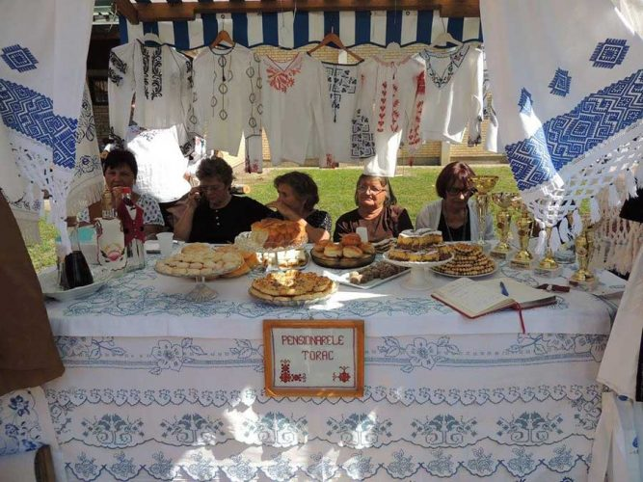
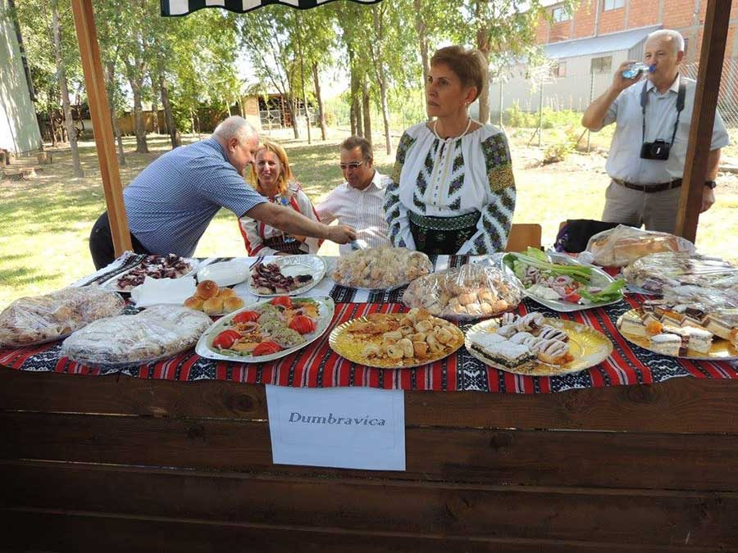
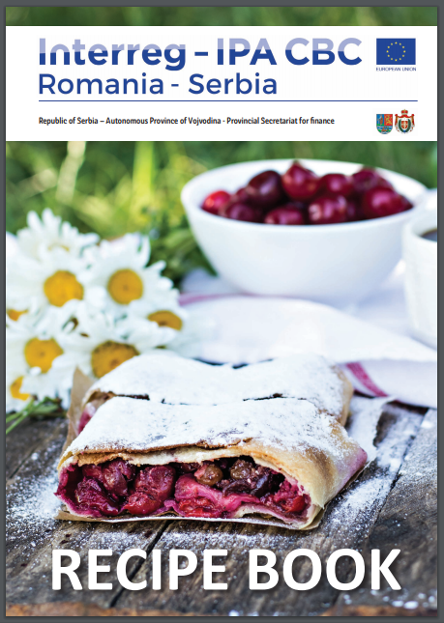
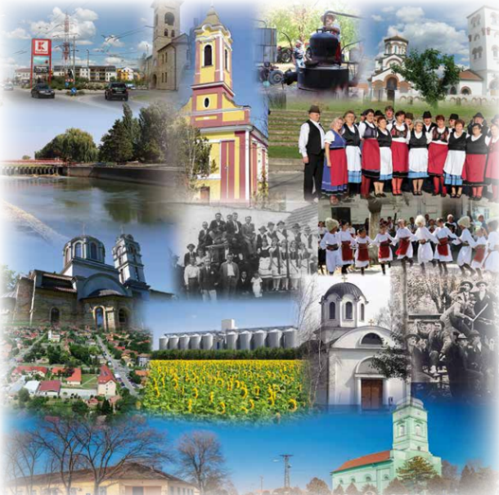

the implementation period (including extensions)
total funds spent/total funds contracted *100
indicators and level of achievement against targets set

