Project information
CALL FOR PROPOSALS | 1
e-MS Code: | RORS-26
PRIORITY AXIS: | 4 Attractiveness for sustainable tourism
OBJECTIVE: | 4.1 Investments for the growth of the demand of local tourism networks and promotion of innovative tourism activities
PROJECT TITLE: | Inheritances at the Danube Cross-border
ACRONYM: | Inheritances at Danube
DURATION: | 08.06.2017 – 07.06.2019 (24 Months)
Interreg-IPA  FUNDS CONTRACTED: | €1.969.382,73
TOTAL FUNDS CONTRACTED: | €2.316.920,87
ABSORBTION RATE (%): | 92,75%
PROJECT OBJECTIVE(S): | Improving the cross-border cooperation structures for tourism services in Borski-Mehedinti cross-border area by investments in 2 tourist products.  Development of a partnership for promotion of joint innovative actions and communication instruments in order to identify and put into value local cultural and rural inheritances in Borski-Mehedinti cross-border area.  Creation and promotion of a local brand as a joint action and communication instrument and promotion of good practice exchange in local cultural and rural tourism in Borski-Mehedinti cross-border area.
SHORT DESCRIPTION OF THE PROJECT: | In the context of the global networking and cooperation, cross-border tourism areas offers increased opportunities of attractiveness in tourist unity and cooperation of the similar natural regions and anthropogenic assets.  The Romania-Serbia cross-border area is characterized by such a similar geo-space, historical events, similar demographic features, similar religions as well as other anthropogenic factors. Both Romania and Serbia are now in the social and economic transitions stage. Romania is an EU member since 2007 and Serbia`s development is at the stage of intensive adaptations to the European Union integration.  The Romania-Serbia cross-border area and especially Mehedinti county and Borski district, which were the object of this project, have a huge touristic potential, most significant of it based on natural, historic and cultural patrimony.  Cross-border tourism potentials offer unique, attractive traditional tourism destinations (cultural, sports-recreational and weekend-picnic, religious, balneal, business, scientific) as well as potential for new forms of tourism (rural, eco, spa, medical health care and wellness, cycling, cynegetic, fishing, speo, hiking trail, cruise a.s.o.).  The partnership finds that investing in the revitalization of Fetislam fortress is one of the keys to the improvement of the touristic attractiveness in the area due to the fact that it is the most dominant monumental landmark on the territory of Kladovo, in Borski district.  This project developed “The Visitors` Center” in Kladovo, Serbia as an objective of revitalization investment, due to the fact that it is introduced immediately in tourist circuit and has a great attractiveness.  Investment in the Tourism Centre from Brosteni-Lupsa de Jos was decided as an approach for sustainable rural development of the area. This option is based on a valuable potential supported by favourable geographic location - the confluence of the plains and plateaus with the sub-mountainous area - being in the middle of an area rich in folklore with valuable traditions through consistency and variety.  This Tourism Centre consists of an assembly comprising of a building functioning as touristic centre for cultural events and a sportive platform arranged for sport events.  The present project develops a package of activities based on cross-border cooperation. The Tourism Centre have a dynamic start due to the partnership with Kladovo Municipality. The agreed activities are linked to local fests or festivals and are designed with the special purpose to ensure an annual flow of tourists in the cross-border area and to strengthen the presence of the 2 touristic products within the local market.  The partners agreed that these activities will be financed annually after the end of the project`s implementation by the Municipalities of Kladovo and Brosteni because they are addressed to young people and they are expected to be well-received.
DEGREE OF ACHIEVEMENT OF INDICATORS: | 5 cross-border cooperation structures/ initiatives supported in the field of tourism  11 joint actions and communication instruments created  3 partnerships for the exchange of good practices and the promotion of joint initiatives established
RESULTS ACHIEVED: | Building of “Visitors centre” in Kladovo  Building a Tourism Centre for Cultural and Sports Activities at Brosteni – Lupsa de Jos  Partnership that realized a professional folkloric and ethnographic research quantified in 1000 albums; 6 exhibitions, 200 Photos exposed to exhibitions; 7000 postcards; 3200 Digital Photos; 160 digital videos, 20 films, 1 website ( http://eng.nasledjanagranicidunava.rs/), 1 pilot folkloric show offer for touristic purpose, 200 tourist catalogues.  A tourist cross-border brand developed.  8 touristic events organized under the cross-border brand with participation of 800 tourists.

Partnership information
 |  | COUNTRY | COUNTY/DISTRICT | BUDGET(EURO) | CONTACT DETAILS
LEAD PARTNER: | Municipality of Kladovo | Serbia | Borski | 1.222.445,49 | Kralja Aleksandra 35, 19320, Kladovo  Tel: +38119808066  E-mail: opstina@kladovonet.com
PARTNER 2: | Municipality of Brosteni | Romania | Mehedinti | 799.428,53 | Broșteni commune, Broșteni  clbrosteni@yahoo.com
PARTNER 3: | The Bishopry of Severin And Strehaia | Romania | Mehedinti | 258.569,85 | 6 I.G. Bibicescu street  corcodelviorelmihai@yahoo.com
PARTNER 4: | Association „Sons of Lupsa” | Romania | Mehedinti | 36.477,00 | Broșteni commune, Lupsa de Jos village  cureleaion2007@yahoo.com
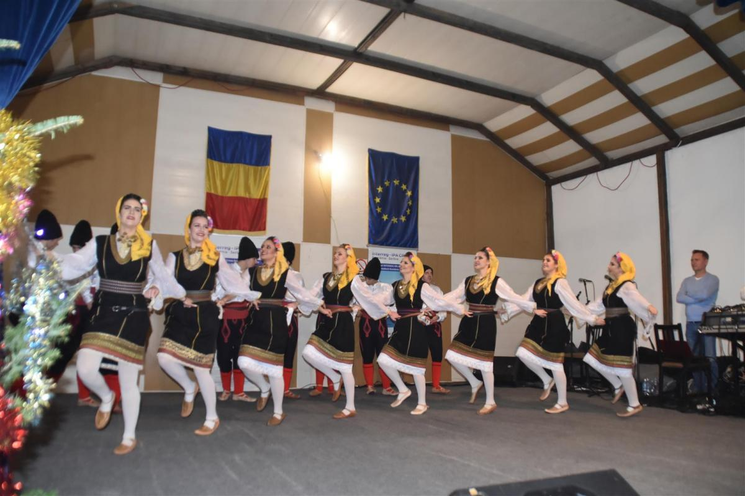
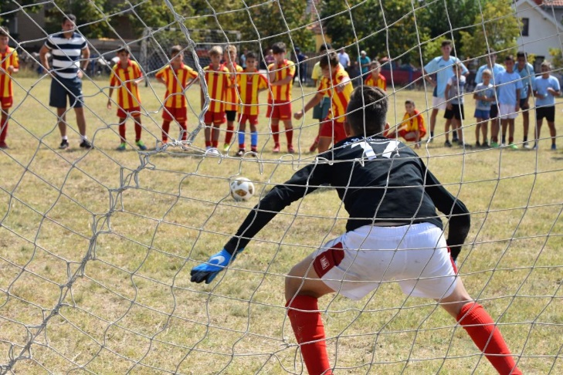

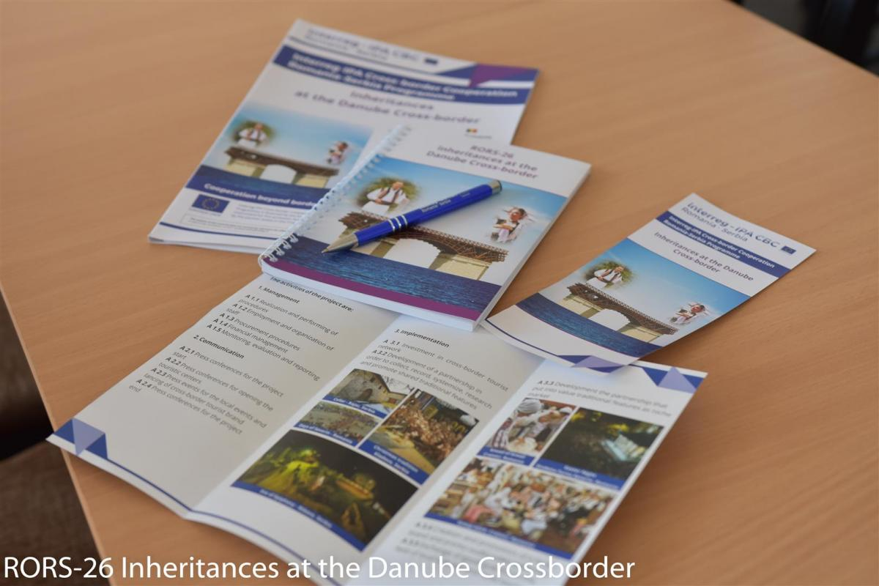

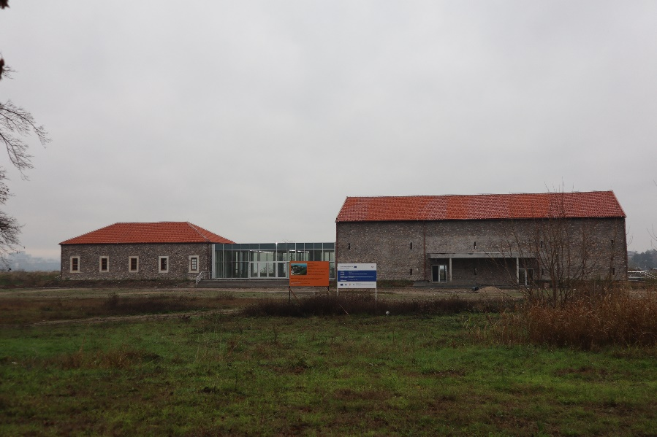
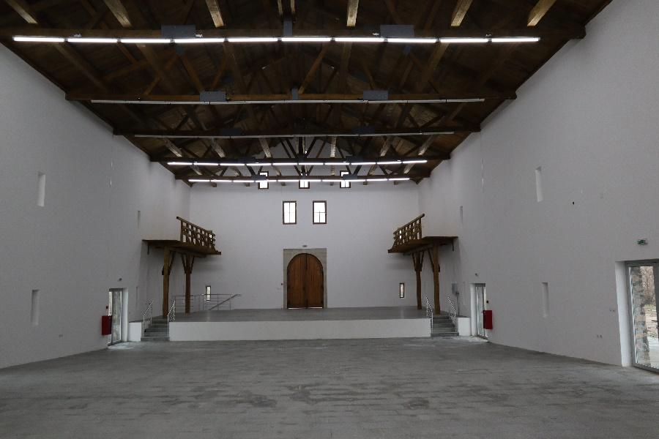
“Visitors centre” in Kladovo

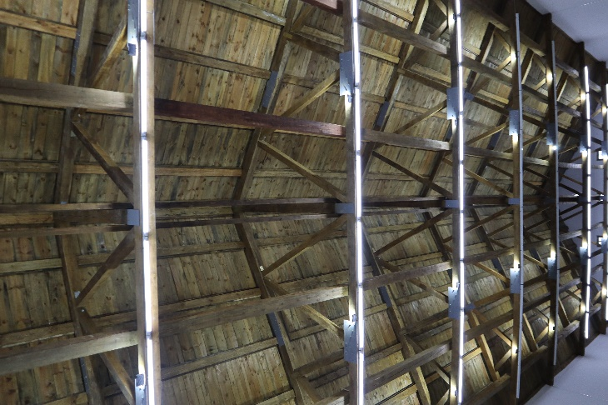
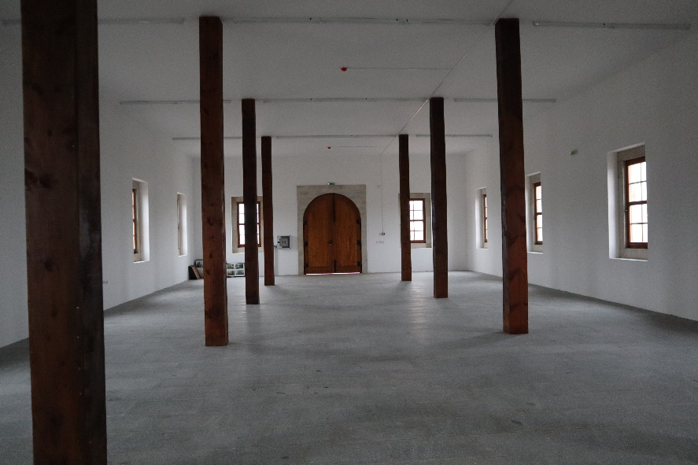
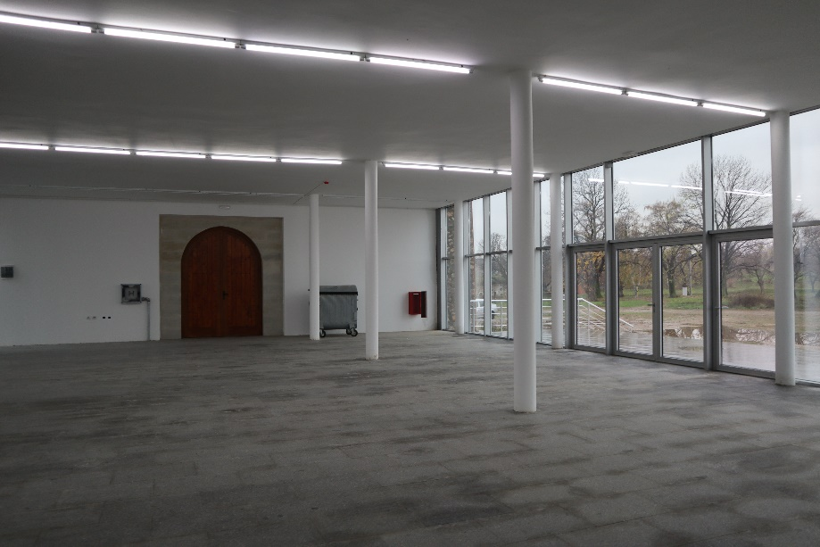
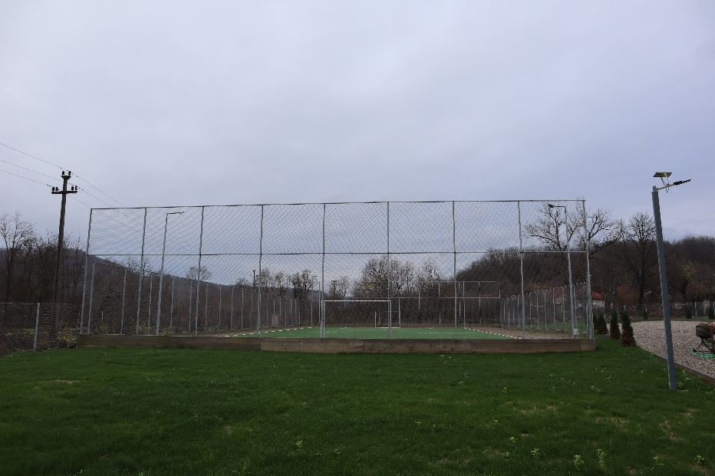
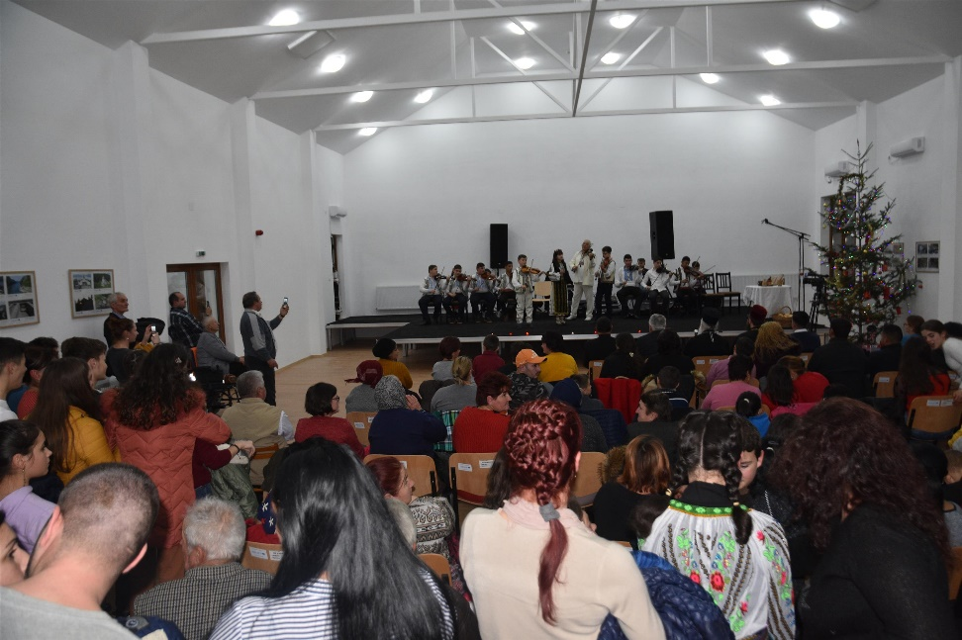
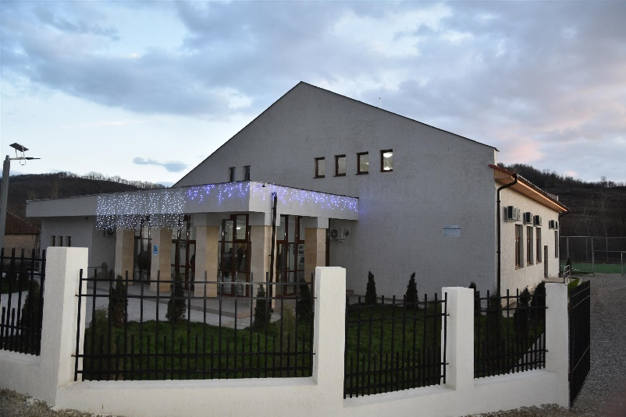
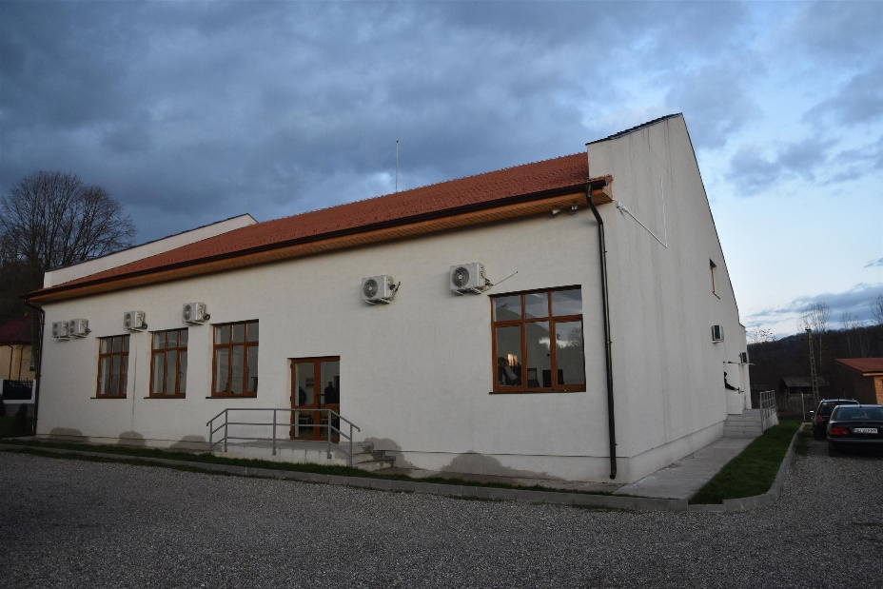
Tourism Centre for Cultural and Sports Activities at Brosteni – Lupsa de Jos

the implementation period (including extensions)
total funds spent/total funds contracted *100

