Project information
CALL FOR PROPOSALS | 1
e-MS Code: | RORS-25
PRIORITY AXIS: | 4 Attractiveness for sustainable tourism
OBJECTIVE: | 4.1 Investments for the growth of the demand of local tourism networks and promotion of innovative tourism activities
PROJECT TITLE: | “Tour de Banat”
ACRONYM: | TdB
DURATION: | 14.07.2017 – 13.10.2018 (15 Months)
Interreg-IPA  FUNDS CONTRACTED: | €455.543,04
TOTAL FUNDS CONTRACTED: | €535.933,01
ABSORBTION RATE (%): | 94.93 %
PROJECT OBJECTIVE(S): | Improvement of the attractiveness of the border area through development of cross-border institutional infrastructure and strengthening the sustainable capacity to provide quality tourism services.  Creation of cross-border partnership network and innovative package of tools and services in order to support development and promotion of cyclotourism.
SHORT DESCRIPTION OF THE PROJECT: | One of the most important criteria for tourism development in Banat is sustainability. Although Cyclotourism is a sustainable form of tourism that could contribute to the development of the cross-border region, it is a relatively new term in the Banat region, and many routes are not used for organized visits for tourists. Through this part of the Banat area, two Euro Velo routes of the European Cycling Federation pass; those are the Euro Velo 6 (Atlantic - Black Sea) and Euro Velo 13 (Iron Curtain Trail) and it is a potential that has not been utilized, primarily due to the lack of adequate cycling infrastructure (lack of bicycle tracks, institutional support, marked routes).  One of the main preconditions for development of this kind of tourism is the appropriate infrastructure and institutional support, therefore within this project the first Regional centre for development of cyclotourism in Serbia was established, under the name of “Tour de Banat”, with the headquarters in Srpska Crnja, as well as the tourist stop for cyclists in Jimbolia (Romania). This Regional centre for cyclotourism was developed as a multi-purpose facility, available to all target groups.  The project included the development of an interactive web portal, a Facebook page and a mobile application that has been offering all necessary information about new cycling routes (De Tours), as well as all tourist locations and attractions to all cyclists who want to visit this region. One of the preconditions for the valorisation of local tourist potentials is the appropriate infrastructure (traffic signalling), which would enable the cyclists to discover all the beauties and attractions of this region.
DEGREE OF ACHIEVEMENT OF INDICATORS: | 8 cross-border cooperation structures/ initiatives supported in the field of tourism - 100%  2 studies related to the implementation of selected projects or research and studies in the field of natural and cultural resources - 100%  80 participants attending training initiatives – 108,75%  3 joint actions and communication instruments created - 100%  2 partnerships for the exchange of good practices and the promotion of joint initiatives established - 100%
RESULTS ACHIEVED: | 1 Regional Centre for Cyclotourism “Tour de Banat” established.  1 Tourist Stop for Cyclist created.  1 Technical documentation for construction of the “Tourists Stop for Cyclists” elaborated.  1 Traffic tourist signalization in the cross-border region implemented.  1 Certificate of Registration of Regional Centre for Cyclotourism “Tour de Banat” created.  4 De Tours Routes (http://db.tourdebanat.com/tdb-routes) promoted.  1 Technical documentation for construction of bicycle paths along the IB-12 State Road between Nova Crnja and Border Crossing Point Srpska Crnja elaborated.  87 Participants of target groups acquired knowledge in the field of quality of tourism services and traffic safety.  1 Web portal created (http://www.tourdebanat.com/)  1 Mobile application and maps created. (https://play.google.com/store/apps/details?id=com.gavranche.tourdebanat)  1 Cyclo Fest organized.  1 Cyclo Group established.  1 Platform on the development of cyclotourism created.  1 Facebook page created (https://www.facebook.com/tourdebanat/)

Promo video about the project: https://tourdebanat.com/en/tour-de-banat-promo-movie/

Partnership information
 |  | COUNTRY | COUNTY/DISTRICT | BUDGET(EURO) | CONTACT DETAILS
LEAD PARTNER: | Municipality of Nova Crnja | Serbia | Central Banat | 282.874,70 | JNA 110, 23218 Nova Crnja  Tel: +381 23 815 030  novacrnja@gmail.com
PARTNER 2: | Municipality of Jimbolia | Romania | Timiş | 175.667,01 | T. Vladimirescu 81, Jimbolia  Tel: +40 741 190 920  primar.postelnicu@jimbolia.ro
PARTNER 3: | Regional Agency for Socio – Economic Development – Banat Ltd | Serbia | Central Banat | 77.391,30 | Čarnojevićeva 1, 23000 Zrenjanin  Tel: +381 23 510 567  irena.zivkovic@rcrbanat.rs

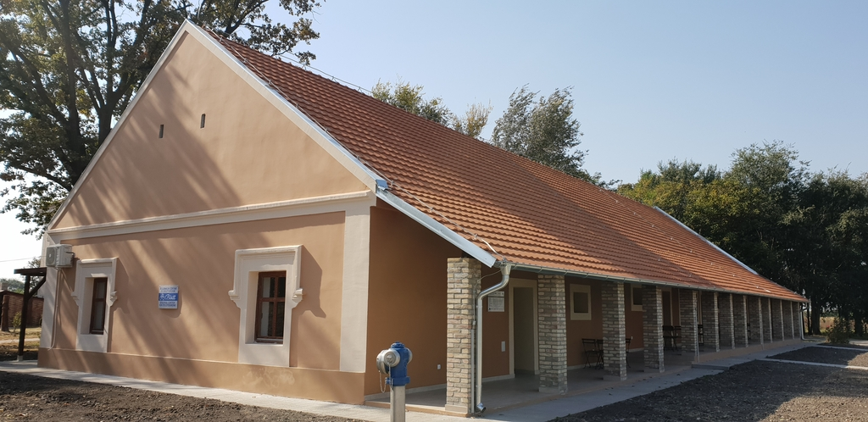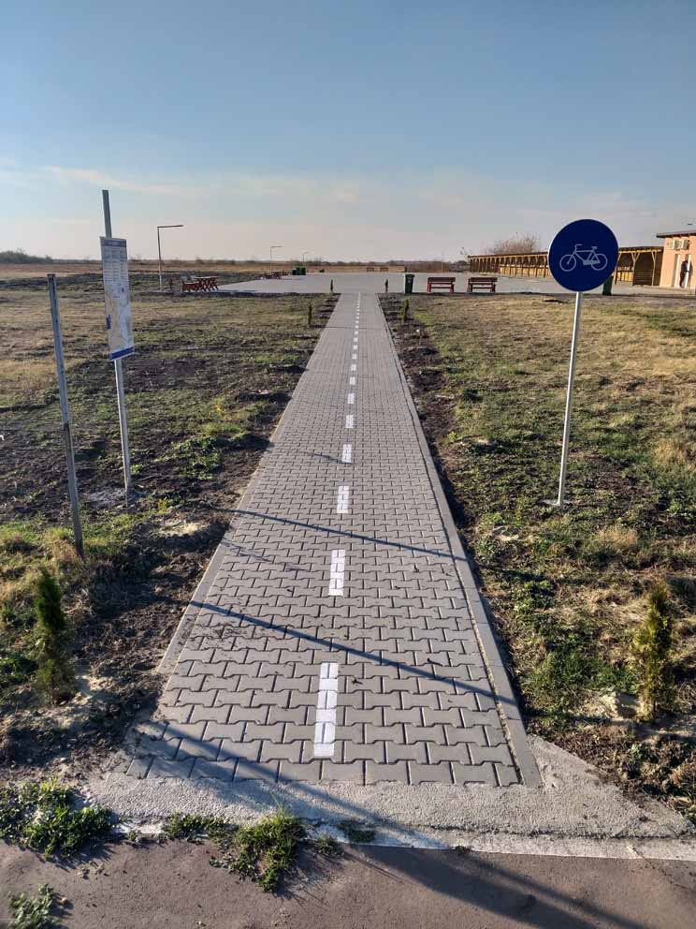

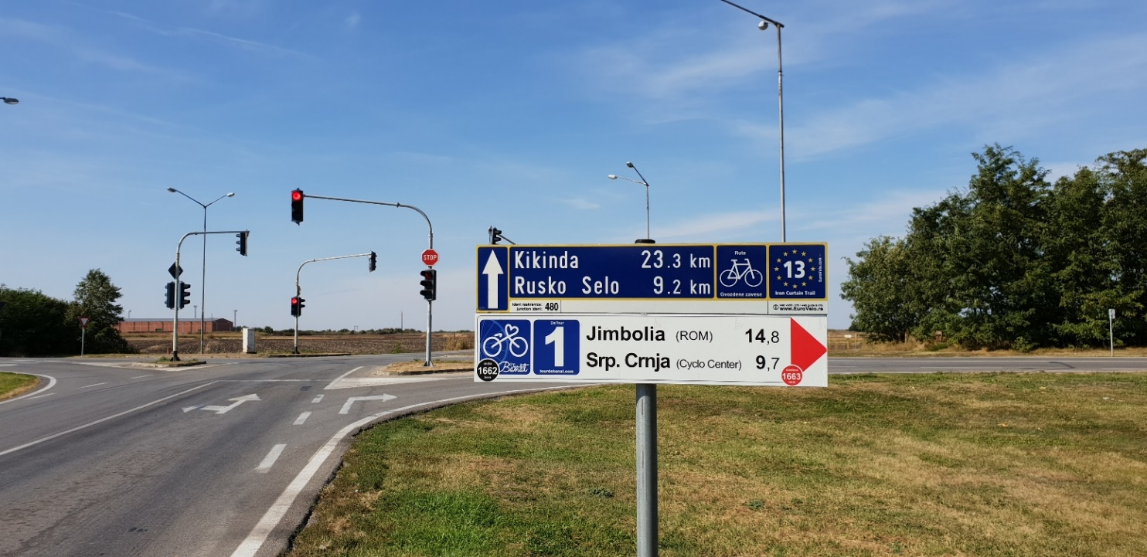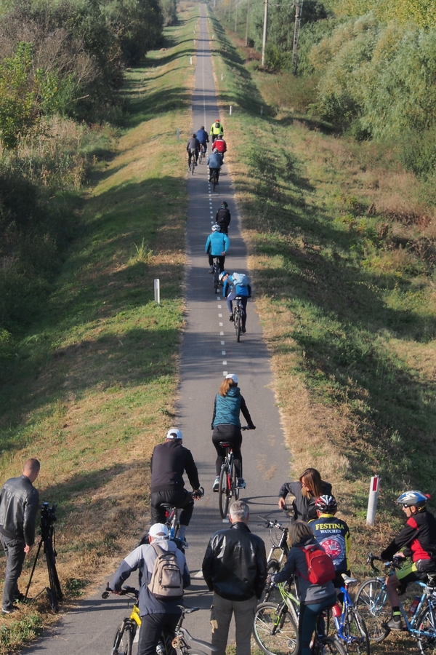

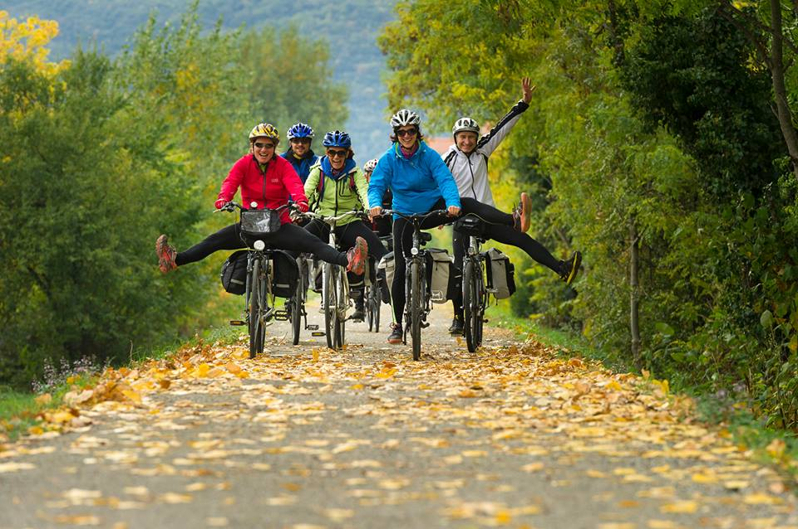

the implementation period (including extensions)
total funds spent/total funds contracted *100
indicators and level of achievement against targets set

