Project information
CALL FOR PROPOSALS | 2
e-MS Code: | RORS-248
PRIORITY AXIS: | 4 Attractiveness for sustainable tourism
OBJECTIVE: | 4.2 Capacity building initiatives for the improvement of quality and innovation of tourism services and products
PROJECT TITLE: | Lights On!
ACRONYM: | Lights On!
DURATION: | 16.07.2019-30.08.2021 (25 months and 15 days)
Interreg-IPA  FUNDS CONTRACTED: | €346.044,57
TOTAL FUNDS CONTRACTED: | €407.111,28
ABSORPTION RATE (%): | 83.23%
PROJECT OBJECTIVE(S): | Improve the system of tourism planning in the Mehedinti and Borski tourist districts in order to create an effective system of cross-border tourist services;  Improve public infrastructure for joint tourism activities – to make investments in required equipment for joint tourism activities in Cross Border Region of Romania and Serbia;  Develop a number of cross-border tourism products such as tourist routes through the territories of two countries, a guidebook, route maps, audio guidebooks, and live streaming services;
SHORT DESCRIPTION OF THE PROJECT: | Cross-border cooperation is the only way to keep the focus on small or remote destinations in the international tourism market and give them a competitive impact. In the Lights On! project, we developed the common cross-border historical and cultural heritage for its great cultural value from three perspectives: the local, the national and the international. The existing attractions are made known to a broader public on the local level. The national perspective aims at bringing cities and their attractions together to strengthen the national tourism product and offer exciting packages. Finally, the international perspective aims at the development of cross-border tourism packages.  The Romanian and Serbian cultures have been in constant interaction since prehistoric times. There are historical key sites on both sides of the Danube, from where the areas were reigned, or their control has been contested.  The Lights On! project designed and packed historical sites into attractive tourist attractions by improving the visitor experience, and on-site services, creating collaborative marketing tools and developing new creative products. We developed new products in cooperation with local entrepreneurs by using innovative service design concepts.  We created attractive new products and new marketing tools to increase visitor numbers on sites, attract new visitor groups, and attract visitors to move between the sites.  The project performed branding activities, created materials, and disseminated information online and via tourism organisations and info centres, promoting the common history, as well as the Danube region as an attractive place to see and learn more about. The project also strived to link the local attractions to a broader European context of local history.  The project's main objective was to enhance tourism in the cross-border region to promote social, economic, and territorial development. Sustainable development of the cross-border area through the effective, innovative and modern use of marketing activities reflected in improved tourism offer promoted throughout the project and created a spillover effect on tourism development in the cross-border region by increasing the share in the overall tourism.
DEGREE OF ACHIEVEMENT OF INDICATORS: | 2 studies elaborated related to the implementation of selected projects or research and studies in the field of natural and cultural resources – 100%  5 joint actions and communication instruments created – 100%  1 partnership for the exchange of good practices and the promotion of joint initiatives established – 100%
RESULTS ACHIEVED: | 1 Water screen multimedia presentation system on the Danube shore in Drobeta – 100%  1 Water screen multimedia presentation system on the Danube shore in Kladovo – 100%  3 new products and services customised for tourism needs – 100%

Partnership information
 |  | COUNTRY | COUNTY/DISTRICT | BUDGET(EURO) | CONTACT DETAILS
LEAD PARTNER: | Mod of Life Association | Romania | Mehedinti | 115.187,25 | 2 Antonini Street, 227490, Drobeta Turnu Severin  Tel: +40722-761-661  E-mail: office@modoflife.ro
PARTNER 2: | Drobeta Turnu Severin City Hall | Romania | Mehedinti | 131.796,54 | 2 Maresal Averescu Street, 220131, Drobeta Turnu Severin  Tel: +40731505742  E-mail: mihaela.vatuiu@primariadrobeta.ro
PARTNER 3: | Tourist Organization of Kladovo Municipality | Serbia | Borski | 160.127,49 | 16a Dunavska Street, 19320, Kladovo  Tel: +38169-626-991  E-mail: tookladovo@gmail.com

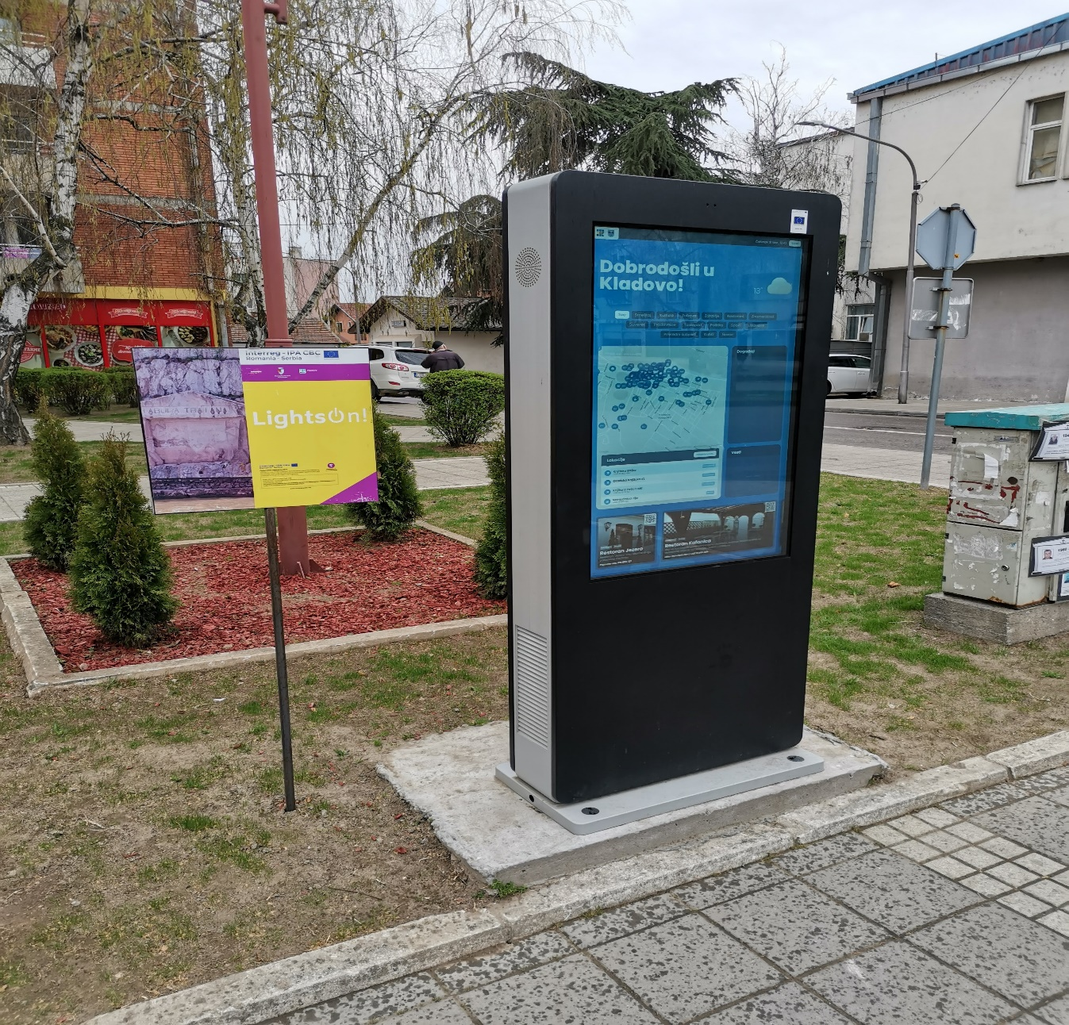
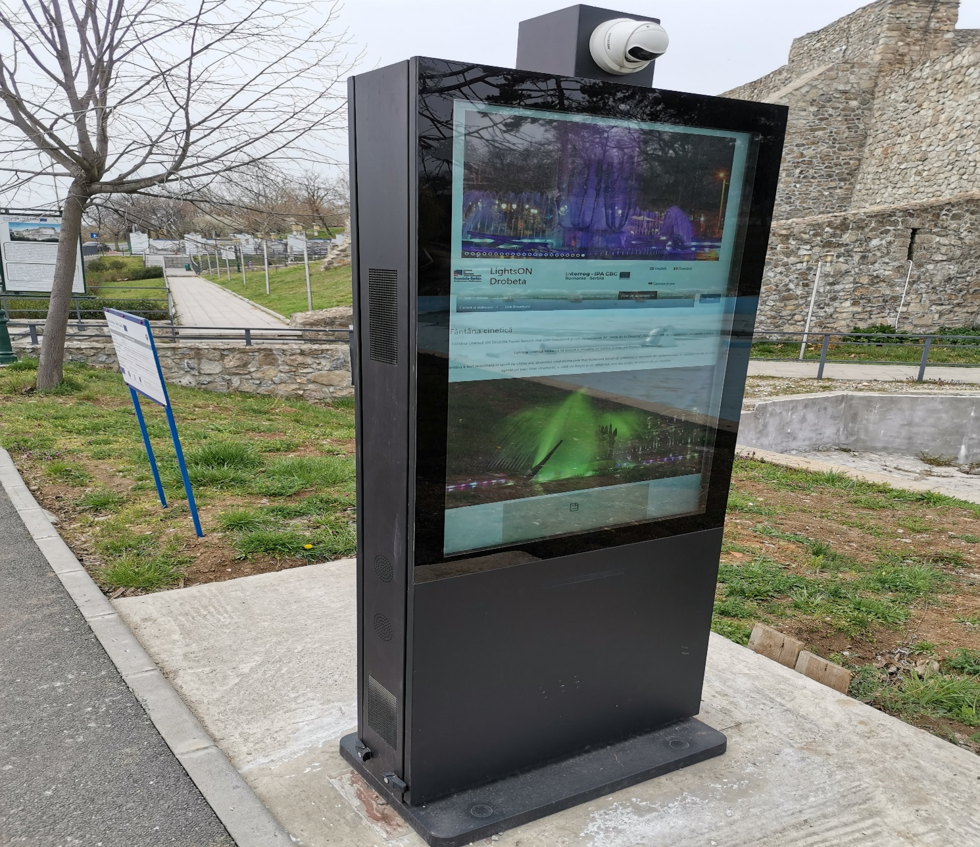

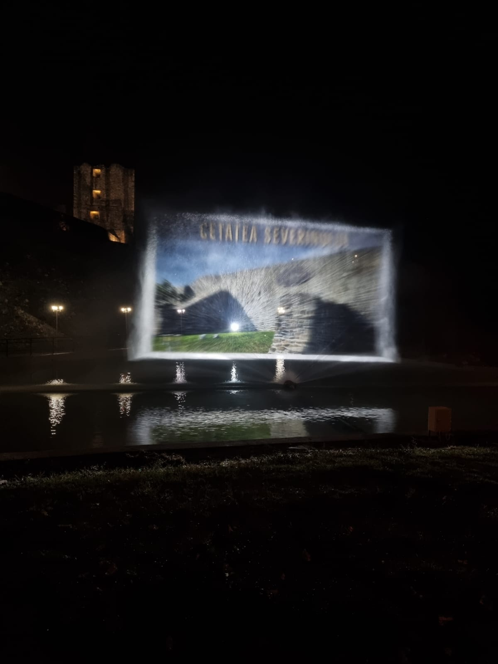

the implementation period (including extensions)
total funds spent/total funds contracted *100

