Project information
CALL FOR PROPOSALS | 1
e-MS Code: | RORS-22
PRIORITY AXIS: | 1 Employment promotion and services for an inclusive growth
OBJECTIVE: | 1.3 Social and cultural inclusion
PROJECT TITLE: | InclusiveArt – Access to Culture for Disadvantaged Children and Youth
ACRONYM: | InclusiveArt
DURATION: | 05.05.2017 – 04.11.2018 (18 Months)
Interreg-IPA  FUNDS CONTRACTED: | €393.436,30
TOTAL FUNDS CONTRACTED: | €462.866,25
ABSORBTION RATE (%): | 92,93 %
PROJECT OBJECTIVE(S): | Contribution to cultural and social cohesion of Romania - Serbia cross-border area by promoting inclusion and active participation in community development and by raising capacities.  Improvement of quality of life of children and youth from disadvantaged groups by active participation in the project activities.  Mainstreaming of the social and cultural inclusion of disadvantaged youth by organising inclusive cultural events and recommending upgrades to public policies.
SHORT DESCRIPTION OF THE PROJECT: | This project proposed to unleash the creative potential of the region. It implied a dynamic partnership formed by two NGOs, one local Public Authority and one Public cultural institution.  The project began with the transfer of knowhow and training of the project team in order to ensure good collaboration inside the project management and implementation team.  The project created the context needed and used art to make a socially inclusive intervention in disadvantaged communities.  The project was based on a good cooperation relationship between the project partners, who managed to organize several events, Banat Pavilion exhibition, training courses for artists on cultural entrepreneurship and socio-cultural animation, as well as training courses on socio-cultural animation for community stakeholders and young Roma, cultural interventions, storytelling, cultural passport, Games without frontiers, Art colonies, Terra Youth workshop, manual of socio-cultural animation, public policy research, final conference and matching event, all carried out in good conditions and directed towards the benefit of the persons involved.  Project facebook page: https://www.facebook.com/InclusiveArtEU/  Project website: https://flarom.ro/inclusiveart7
DEGREE OF ACHIEVEMENT OF INDICATORS: | 622 citizens involved in project activities in cultural, social health care services – 100%  621 disadvantaged persons involved in projects activities – 100%  11 Joint actions targeting vulnerable groups (youth, women, disabled, ethnic minorities) established for the prevention of early school leaving, for cultural inclusion – 110%  2951 participants in projects promoting gender equality, equal opportunities and social inclusion across borders – 186%
RESULTS ACHIEVED: | 12 community evaluation sheets completed  1 set of course materials for cultural entrepreneurship and labour market guidance created  1 set of course materials for socio-cultural animation created  1 set of course materials for training for facilitation of Roma community development created  40 young person’s trained in cultural entrepreneurship and art market orientation  24 young people trained in socio-educative animation  12 intervention plans drafted  1 needs analysis report completed  25 stakeholders trained in socio-cultural animation  15 young Roma trained  10 draft entrepreneurial plans created  12 artistic interventions created  360 disadvantaged children involved in the artistic interventions  12 inclusive cultural events  60 children, youth and adults from migrant communities users of cultural passports  900 children and youth involved in storytelling public reading activities  80 disadvantaged participants at games without frontiers  200 children involved in inclusive art colonies

Partnership information
 |  | COUNTRY | COUNTY/DISTRICT | BUDGET(EURO) | CONTACT DETAILS
LEAD PARTNER: | Intercultural Institute Timisoara | ROMANIA | Timis | 242.980,50 | Bd. 16 Decembrie 1989 no. 8, 300173, Timisoara  corina.raceanu@intercultural.ro
PARTNER 2: | Nevo Parudimos association | ROMANIA | Caras-Severin | 98.752,50 | 1 Bega st., 320059, Resita  ileana_rotaru08@yahoo.com
PARTNER 3: | City of Zrenjanin | SERBIA | Srednjebanatski | 78.540,00 | 10 Trg slobode, Zrenjanin
PARTNER 4: | Center for Fine and Applied Arts Terra | SERBIA | Severnobanatski | 42.593,25 | 25 Trg srpskih dobrovoljaca, Kikinda  seke.robert@gmail.com

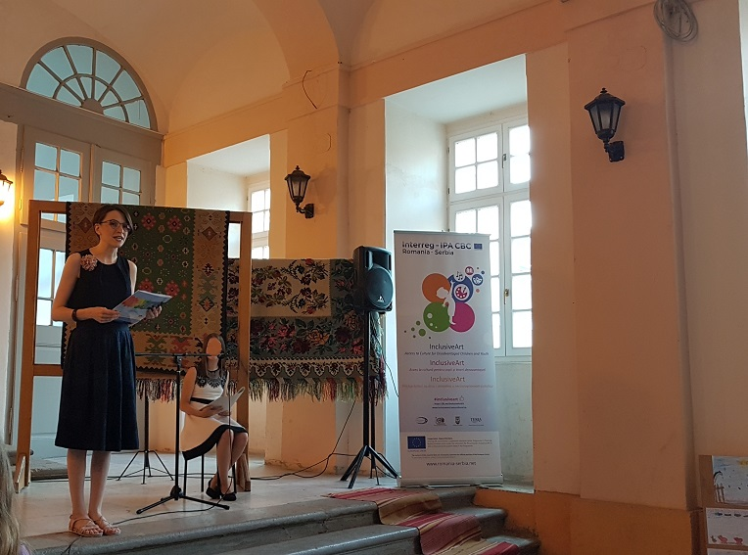
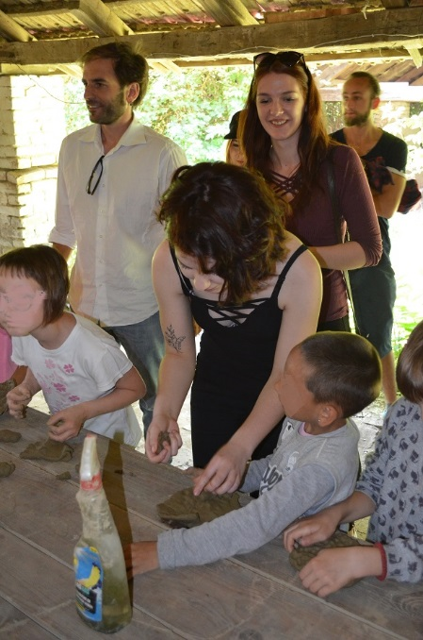
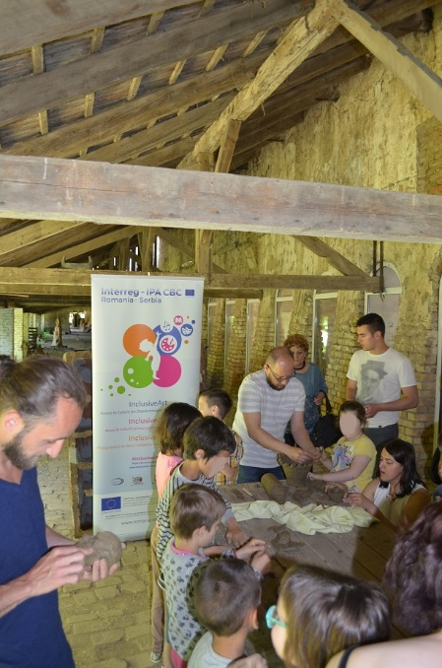

the implementation period (including extensions)
total funds spent/total funds contracted *100
indicators and level of achievement against targets set

