Project information
CALL FOR PROPOSALS | 2
e-MS Code: | RORS-215
PRIORITY AXIS: | 1 Employment promotion and services for an inclusive growth
OBJECTIVE: | 1.3 Social and cultural inclusion
PROJECT TITLE: | Educational and Networking Tools on development of Authentic Performance for professional integration
ACRONYM: | PAN
DURATION: | 29.05.2019 – 28.10.2020 (17 months*)
Interreg-IPA  FUNDS CONTRACTED: | €250.209,96
TOTAL FUNDS CONTRACTED: | €294.364,67
ABSORPTION RATE (%): | 87.85%
PROJECT OBJECTIVE(S): | Developing innovative educational tools in the field of traditional musical performance by valorising cross-border best practice examples.  Providing an educational cross-border structure to facilitate professional inclusion in the field of traditional musical performance.  Creation of a networking cross-border structure to facilitate professional inclusion in the field of traditional musical performance.
SHORT DESCRIPTION OF THE PROJECT: | The project was designed to create a cross border network for authentic traditional music performance through education and valorisation of the best practice examples in this field, as a response to the actual changing context at the level of EU policies where preserving the cultural heritage becomes a competitive advantage for societies that recognize its valuable benefits. The project continues the efforts made so far within previous projects implemented by the joint partnership in the field of cultural heritage and focused on existing challenges and opportunities in the cross-border area that are dealing with a problem related to the professional integration of authentic musical performers since the accurate manner of traditional music performance specific for Banat is fading and being replaced by the commercial way of performing so called ”traditional” music, strongly promoted by media or through other channels.
DEGREE OF ACHIEVEMENT OF INDICATORS: | 700 citizens involved in project activities in cultural, social health care services – 115%  2 cross border cooperation structures supported in the field of labour market – 100%  150 disadvantaged persons involved in projects activities – 272%  1 joint action targeting vulnerable groups (youth, women, disabled, ethnic minorities) established for the prevention of early school leaving, for cultural inclusion – 100%  20 participants in projects promoting gender equality, equal opportunities and social inclusion across borders – 100%
RESULTS ACHIEVED: | 76 participants at the Awareness campaign - joint action – 126%  76 talented and skilled cross-border individuals valorised as educational models - 126%  477 participants at the Joint education campaign – 115%  1 Educational Centre created – 100%  20 talented and skilled cross-border people identified – 100%  5 cooperation educational structures in the field of traditional music performance for professional inclusion in the cross-border area – 100%  1 archive of institutional or private musical folklore in Banat cross-border area revived and valorised – 100%  1 networking structure in the field of traditional music performance for professional inclusion in the cross-border area – 100%

Partnership information
 |  | COUNTRY | COUNTY/DISTRICT | BUDGET(EURO) | CONTACT DETAILS
LEAD PARTNER: | West University of Timisoara | ROMANIA | Timis | 160.353,27 | Bd. Vasile Pârvan no. 4, 300223, Timisoara  petru.stefea@e-uvt.ro
PARTNER 2: | City of Kikinda | SERBIA | Severnobanatski | 134.011,40 | 12 Trg srpskih dobrovoljaca, 23300 Kikinda  sasa.tanackov@kikinda.org.rs

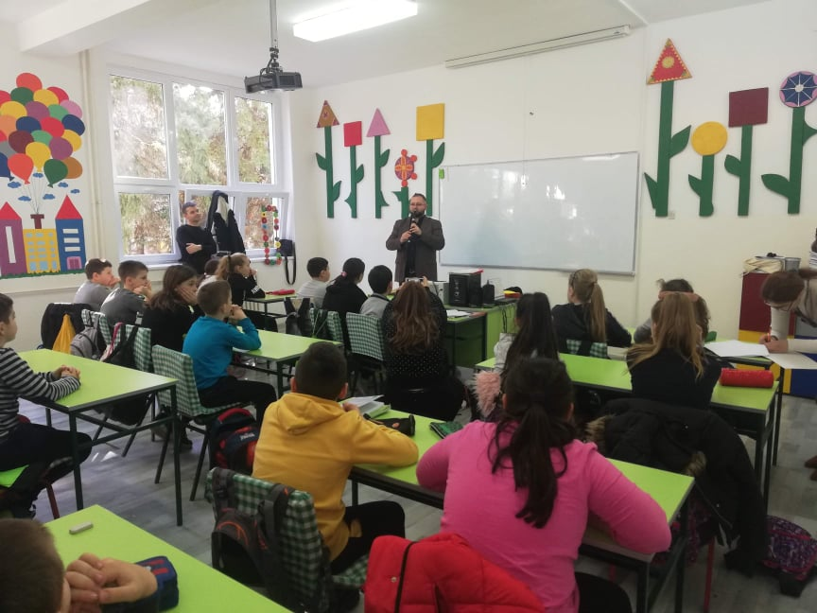
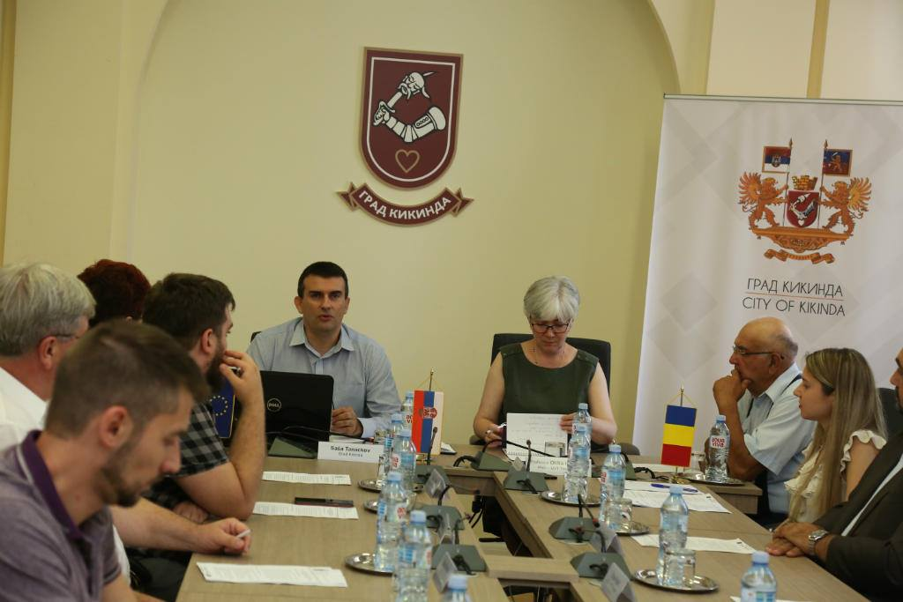
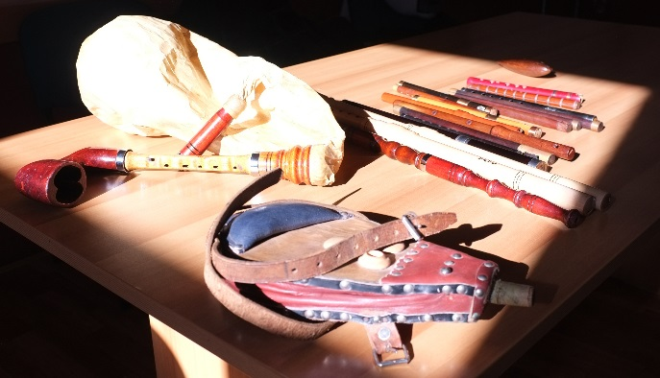
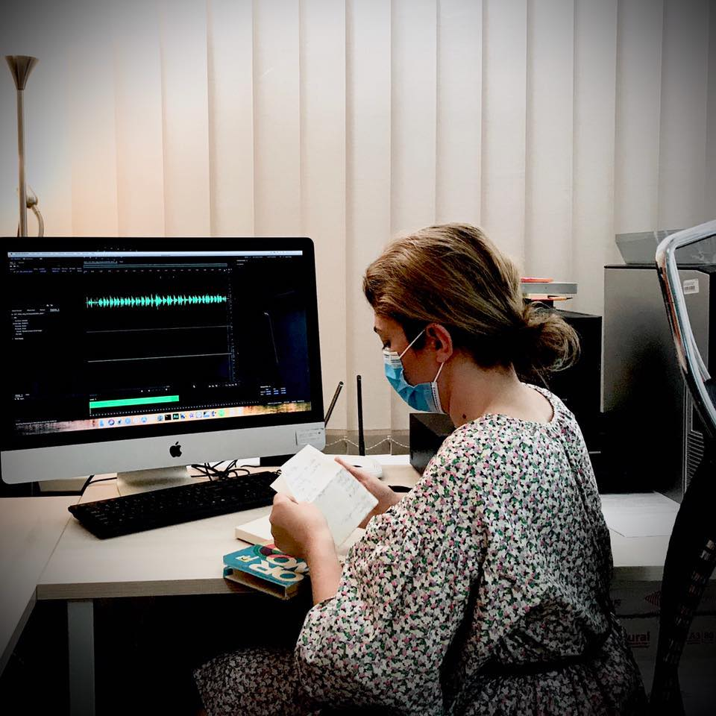
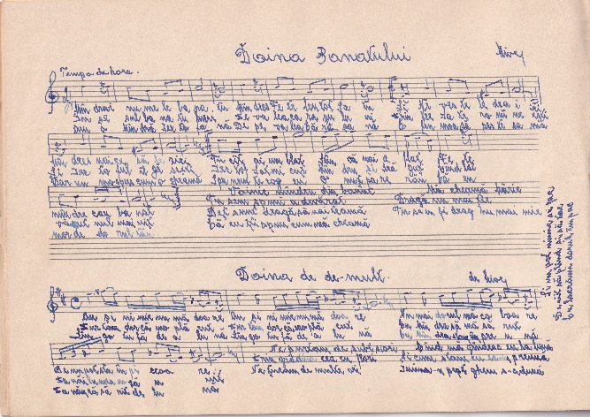
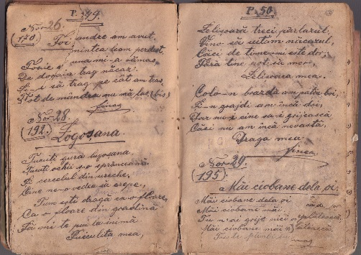

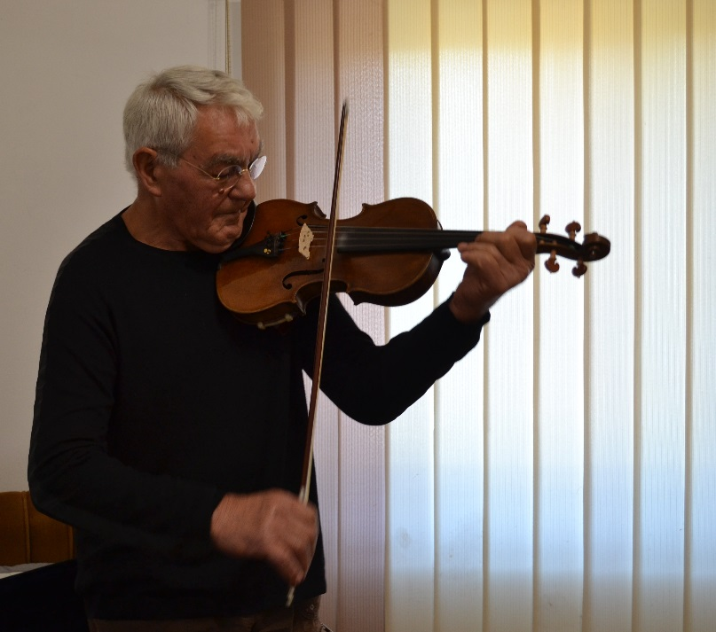
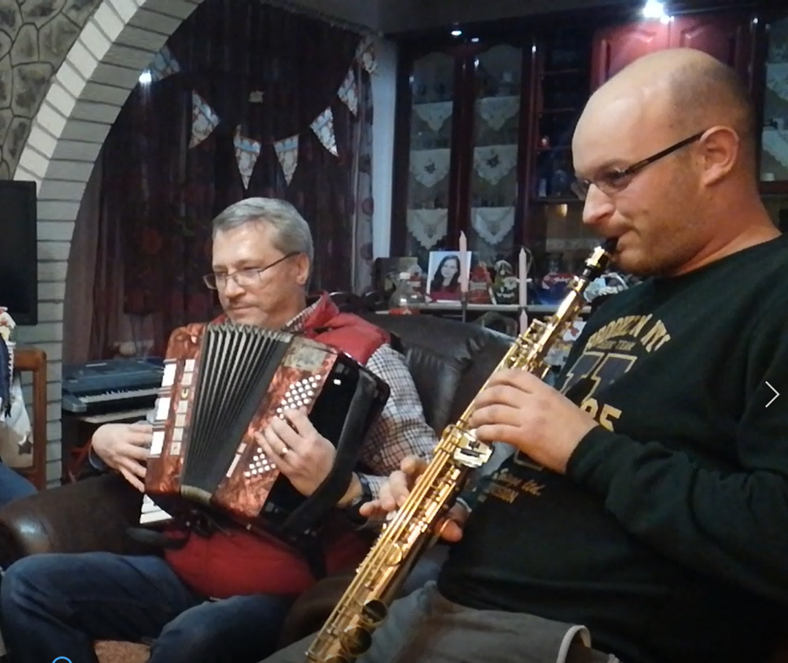

the implementation period (including extensions and *suspension)
total funds spent/total funds contracted *100

