Project information
CALL FOR PROPOSALS | 1
e-MS Code: | RORS-18
PRIORITY AXIS: | 2 Environmental protection and risk management
OBJECTIVE: | 2.1 Environmental protection and sustainable use of natural resources
PROJECT TITLE: | JOINT PROJECT FOR CONSERVATION AND SUSTAINABLE USE OF PLANT GENETIC RESOURCES FROM BORDER AREAS AS CONSEQUENCES OF CLIMATE CHANGE
ACRONYM: | GERMOSAVE
DURATION: | 21.04.2017 – 20.10.2018 (18 Months)
Interreg-IPA  FUNDS CONTRACTED: | €291.579,74
TOTAL FUNDS CONTRACTED: | €343.035,00
ABSORBTION RATE (%): | 85,16%
PROJECT OBJECTIVE(S): | To carry out one assessment study and characterization of local fruit trees and grapevine germplasm from the Romania-Serbia cross-border area, in the context of climate change.  To create a common educational and research network, concerning the protection of local germplasm by creating one local germplasm Bank.  Transfer of technology to valorising local fruit trees and grapevine germplasm from the Romania-Serbia cross-border area.
SHORT DESCRIPTION OF THE PROJECT: | In the last 100 year, European agriculture suffered significant changes. The beginning of the 21st century is marked by a global scarcity of water resources, environmental pollution and increased soil and water salinity.  In these circumstances the best solution is to identify, collect and exploit local ecotypes of fruit trees and vines grown in the border areas, which are not currently known (only by those in whose households there are grown).  Presenting a high capacity of tolerance to some abiotic stress factors, fruit trees and grapevine genotypes may represent an important source of genes, with which in the future breeding programs can create varieties with high adaptability to adverse impacts of climate change. On the other hand, local collection of these genotypes can contribute to the identification, protection, conservation, and enhancement of existing natural resources in the border area, thus preserving the identity of the Euroregion in the context of agriculture globalization.  The project proposed a theme for collaboration based on similar situations existing in the Romanian-Serbian border area. The partnership created through joint participation in project activities, by creating a Euroregion germplasm repository overcame specific issues related to the connectedness of the region, both internally - between the border regions, and externally - between the border regions and neighbouring areas.  During the project implementation a joint program for identification, collection, preservation and sustainable exploitation of local fruit trees and grapevine germplasm tree has been developed, and the resident population has been informed on quality and quantity of environmental resources in the eligible area, and on the benefits of protection actions.
DEGREE OF ACHIEVEMENT OF INDICATORS: | 1 infrastructure, equipment built/ installed/ modernized in the field of cross border services for environmental protection – 100%  190 participants to project initiatives and events for information & awareness raising – 100%  1 study in the field of environmental protection and emergency management (technical and scientific studies, researches in the relevant fields) – 100%
RESULTS ACHIEVED: | 1 Study distributed and published  1 gene bank and database created  2 trainings for farmers conducted  1 summer school organized  Increase in target groups awareness  1 web page created ( https://germosave.com )

Partnership information
 |  | COUNTRY | COUNTY/DISTRICT | BUDGET(EURO) | CONTACT DETAILS
LEAD PARTNER: | Banat’s University of Agricultural Sciences and Veterinary Medicine “King Michael I of Romania” from Timisoara | ROMÂNIA | Timiş | 258.142,50 | 119 Calea Aradului, Timisoara, Timis County, Romania  camendorin@yahoo.com
PARTNER 2: | High Techical School of Professional Studies Požarevac | SERBIA | Branicevski | 84.892,50 | 2 Nemanjina, Pozarevac, 12000, Serbia

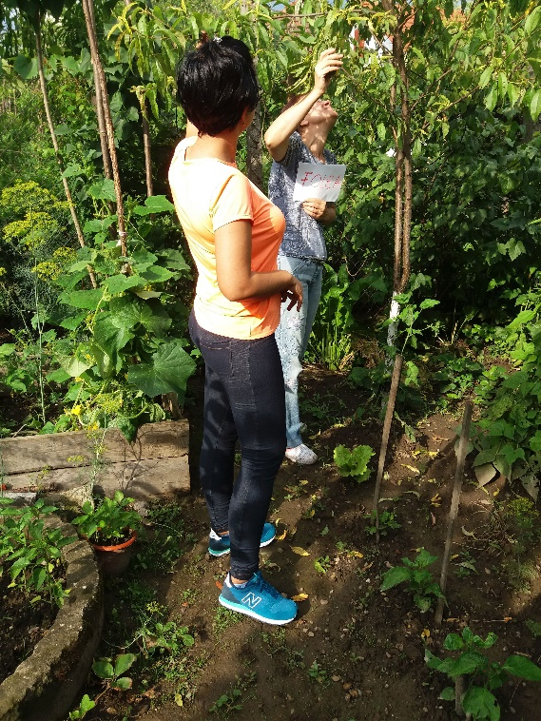
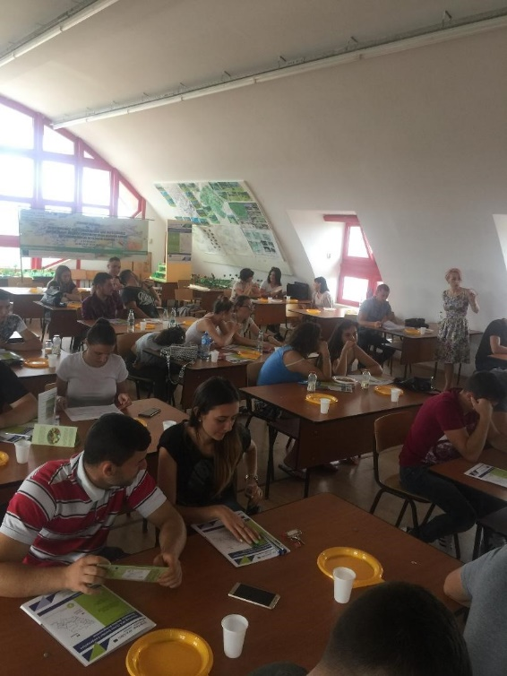
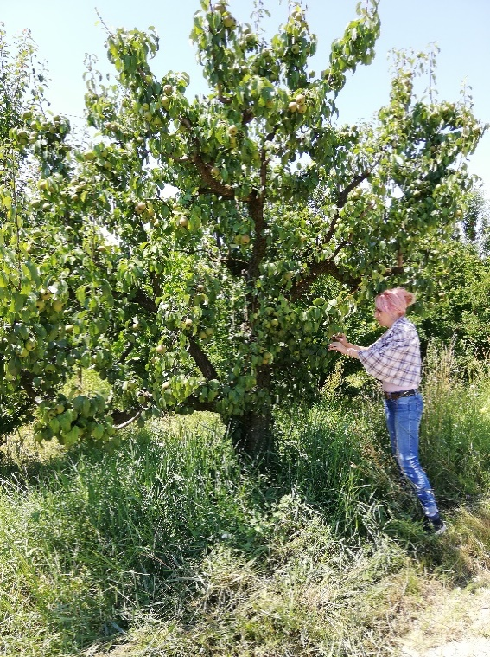

the implementation period (including extensions)
total funds spent/total funds contracted *100
indicators and level of achievement against targets set

