Project information
CALL FOR PROPOSALS | 1
e-MS Code: | RORS-13
PRIORITY AXIS: | 2 Environmental protection and risk management
OBJECTIVE: | 2.1 Environmental protection and sustainable use of natural resources
PROJECT TITLE: | Energy Efficiency - The Premise of a Better Environment in Romania – Serbia Cross-Border Area
ACRONYM: | Energy Efficiency - The Premise of a Better Environment
DURATION: | 10.06.2017 - 09.06.2019 (24 Months)
Interreg-IPA  FUNDS CONTRACTED: | €1.150.192,41
TOTAL FUNDS CONTRACTED: | €1.353.167,55
ABSORBTION RATE (%): | 93,88%
PROJECT OBJECTIVE(S): | Contribution to energy efficiency, renewable energy use and reduction of greenhouse gas (GHG) emissions.  Infrastructure, equipment built/ installed/ modernized in the field of cross-border services for environmental protection.  Installation of a bicycle rental system in order to reduce CO2 emissions.  Studies in the field of environmental protection and emergency management (technical and scientific studies, researches in the relevant fields).  Participants to project initiatives and events for information and awareness raising.
SHORT DESCRIPTION OF THE PROJECT: | The project is dealing with significant common challenges concerning specific aspects of local/regional environmental protection and sustainable use of natural resources. Also, the project is proposing to overcome the border as a perceived “division”, and promoting greater cooperation and contact between regions and communities on both sides of the border. The project aims to achieve a series of investments in infrastructure, equipment for environmental protection and sustainable use of natural resources and investment in a bicycle rental system in order to reduce CO2 emissions. The project brought a new business interest for the area, giving motivation to companies related with energy efficiency material and in general in energy efficiency to work and invest in the area.
DEGREE OF ACHIEVEMENT OF INDICATORS: | 2 Infrastructure, equipment built/ installed/ modernized in the field of cross-border services for environmental protection -100%  423 participants to project initiatives and events for information and awareness raising - 132%  1 study in the field of environmental protection and emergency management (technical and scientific studies, researches in the relevant fields) – 100%
RESULTS ACHIEVED: | 2 workshops for experience exchanges and presentation of best practices in local policies.  1 impact study concerning renewable energy innovative solutions to be applied at cross border level.  Installation of solar panels on the rooftop of the Swimming Olympic Basin in Resita.  Installation of a bicycle rental system in Resita.  Works on the dismantling/instalment the joinery, installation of insulation material and heating and cooling instalment in the Regional Sports Hall in Pancevo.  More about the project: http://www.pancevo.rs/en/energy-efficiency/

Partnership information
 |  | COUNTRY | COUNTY/DISTRICT | BUDGET(EURO) | CONTACT DETAILS
LEAD PARTNER: | Resita Municipality | ROMANIA | Caras-Severin | 560.391,30 | 1A December 1st 1918 Square, Resita  centru@primariaresita.ro
PARTNER 2: | City of Pancevo | SERBIA | Juznobanatski | 792.776,25 | 2 – 4 Trg kralja Petra I, 26000, Pancevo  grad@pancevo.rs

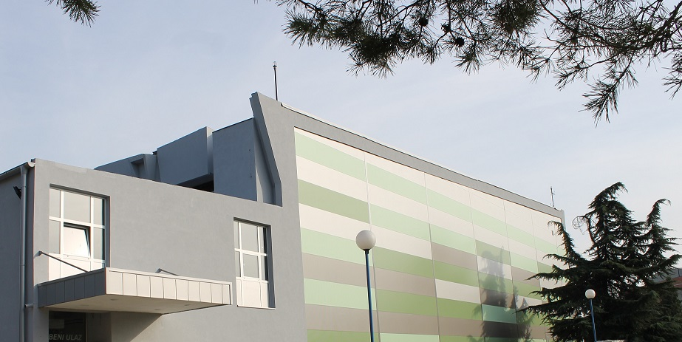

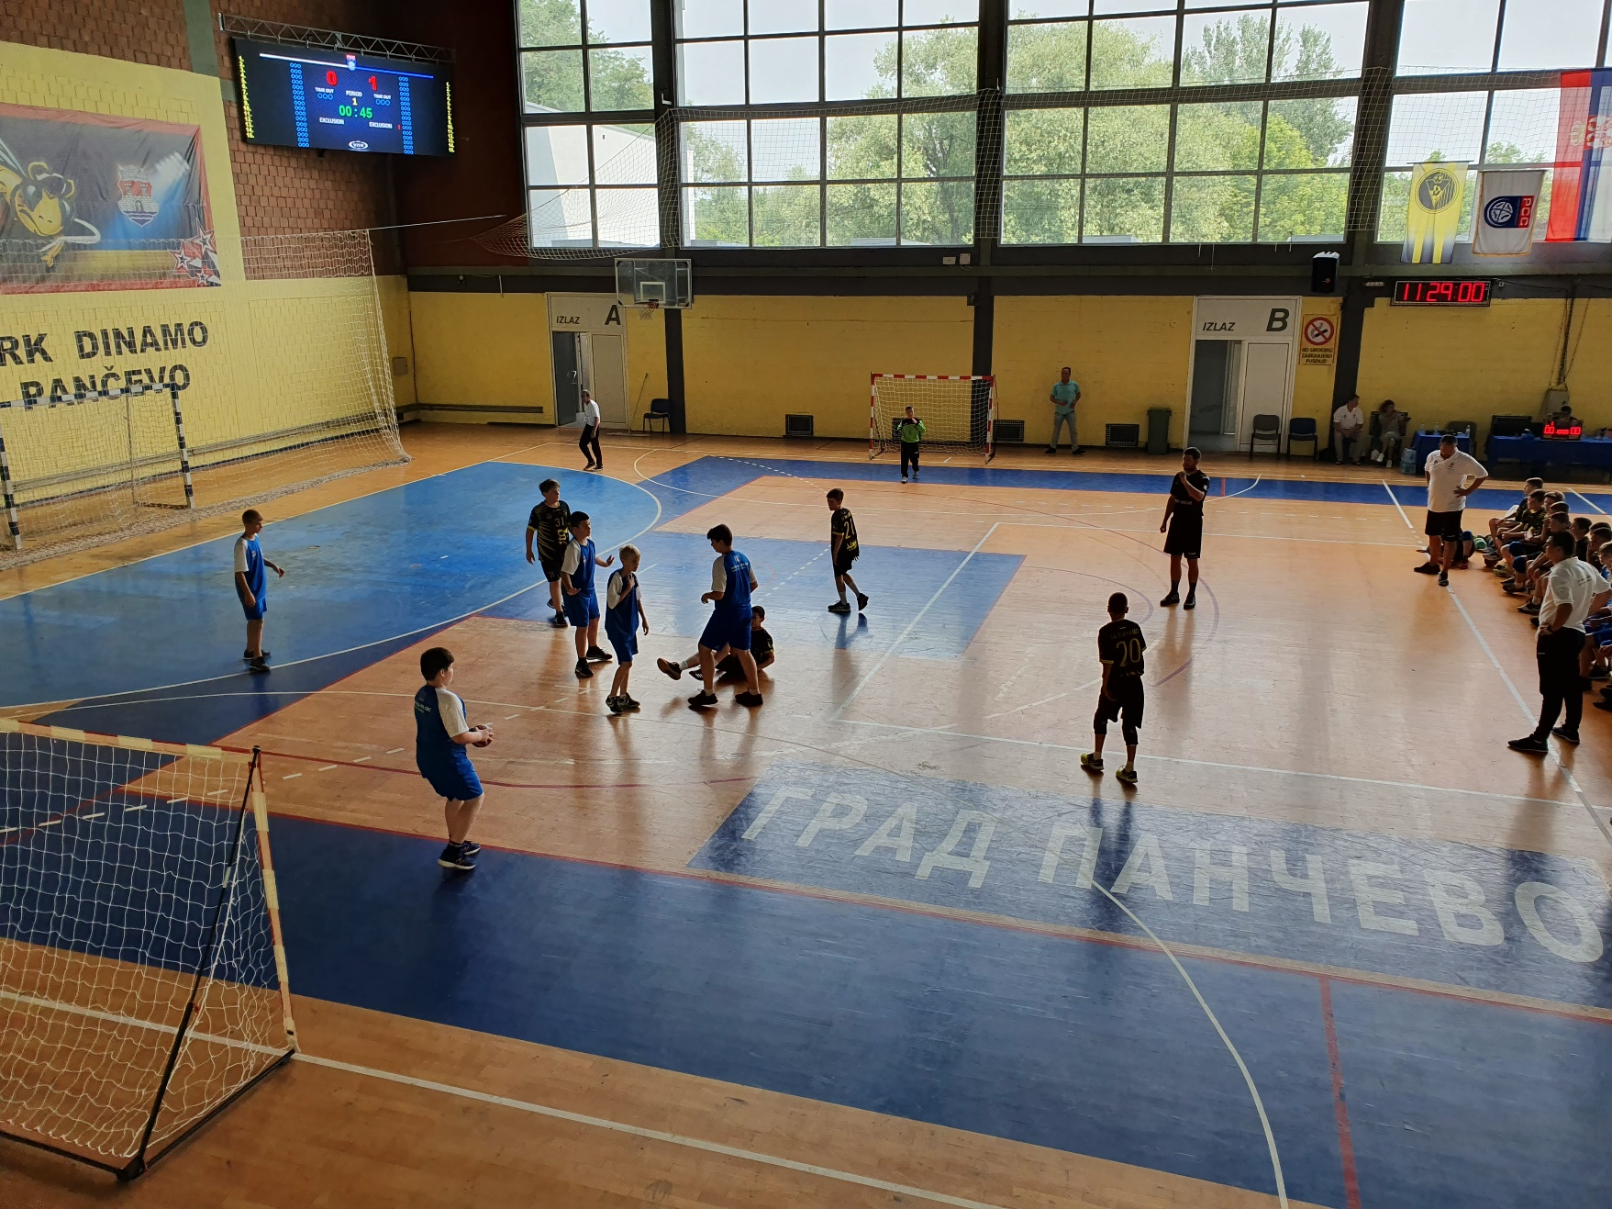

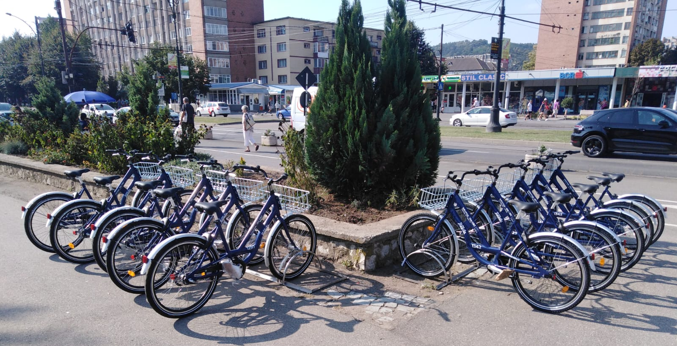
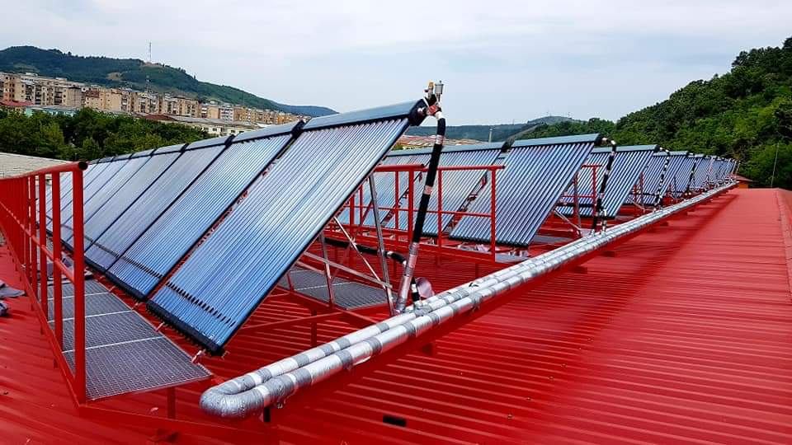

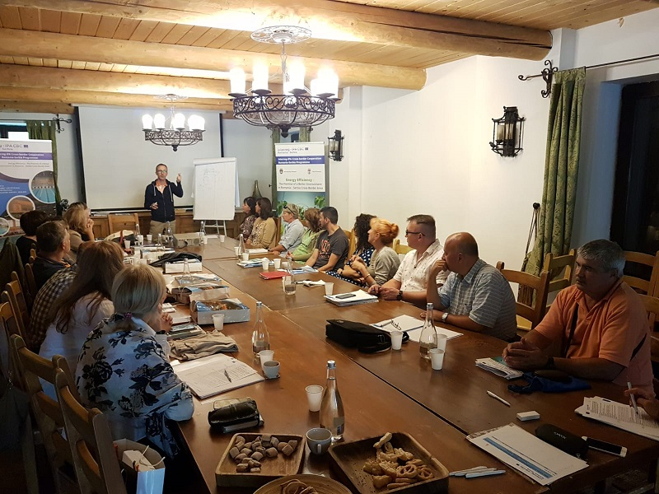
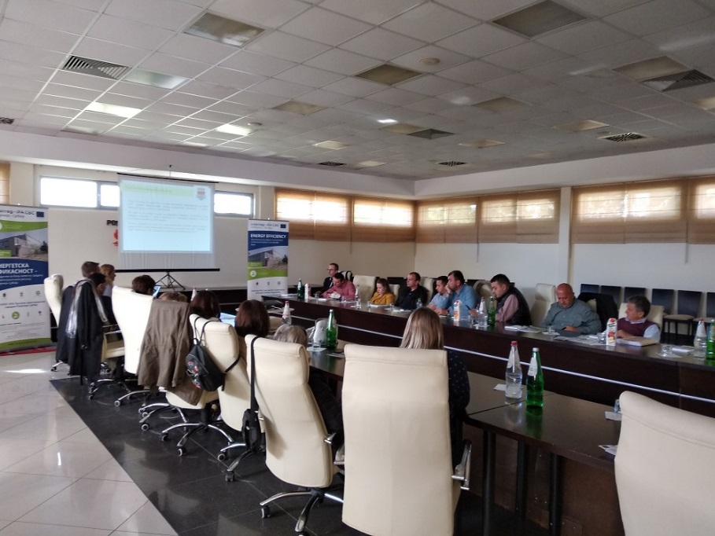

the implementation period (including extensions)
total funds spent/total funds contracted *100
indicators and level of achievement against targets set

