 | Project information
 | CALL FOR PROPOSALS |  | 2
 | MIS-ETC: |  | 1427
 | PRIORITY AXIS: |  | 1.Economic and Social Development
 | MEASURE: |  | 1.3 Promote SME development
 | PROJECT TITLE: |  | The analysis of innovation and cooperation ability and development opportunities of SMEs in the Serbian-Romanian cross border area inspired by the cultural heritage of the Serbian and Romanian people
 | ACRONYM: |  | Banat fashion
 | DURATION: |  | 24.10.2015 – 23.10.2016
 | IPA FUNDS CONTRACTED: |  | 284.733,00
 | TOTAL FUNDS CONTRACTED: |  | 334.980,00
 | ABSORBTION RATE (%): |  | 84,48
 | PROJECT OBJECTIVE(S): |  | Increased competitiveness of the industrial enterprises, networking SMEs working in the field of textile industry with scientific – research institutions and use of the knowledge economy.  Increased employment levels in the field of textile industry and combating the problem of women employment in rural areas.  Discovering the new fashion industry product which would be based on the authentic cultural heritage of the nations living in Banat region.
 | SHORT DESCRIPTION OF THE PROJECT: |  | The project created a Centre for networking textile science – research institutions working in the fields of technology (manufacturing) and arts (design) with small and medium-sized enterprises working in the field of textile processing. The project increased the technical equipment levels and ability of the faculty to use modern textile products and materials design software, created the environment that would facilitate fast development, design and technical preparation of the new products, simplified creation of the technical documentation of the products in electronic form and ensured exchange between manufacturers and purchasers of the textile and clothing products, regardless of their location in the world. Entrepreneurs from small and medium-sized enterprises were trained in how to improve their skills and how to use new technologies.
 | DEGREE OF ACHIEVEMENT OF INDICATORS: |  | Indicator Indicator value provisioned in the contract Present indicator value % 6= (5)/(3)*100  Output indicators (1) UM (2) Quantity (3) UM (4) Quantity (5)  Strengthening the economy by cultural assets Number of cultural institutions participating in the development of the economy 20 Number of cultural institutions participating in the development of the economy 20 100%  Strengthening clothing industry marketing Number of organizations included in the marketing 10 Number of organizations included in the marketing 10 100%  Creation of good ties between two universities Number of cooperating institutions 2 Number of cooperating institutions 2 100%  Result indicators  Increased importance of R&D/Innovation in the border area Number of activities, actions, initiatives focusing on promoting the importance of or dealing directly with R&D/Innovation 3 Number of activities, actions, initiatives focusing on promoting the importance of or dealing directly with R&D/Innovation 3 100%  Increased SME’s capacity in the border area Number of activities, actions, initiatives focusing on promoting SME’s activity. 2 Number of activities, actions, initiatives focusing on promoting SME’s activity. 2 100%
 | RESULTS ACHIEVED: |  | • Marketing research - Marketing Study,  • Printed catalogue of collected published works,  • Organized fashion show in Zrenjanin, realized fashion show with project partners in Timisoara, realized fashion show with project partners in Plandiste,  • Created Report from Analysis of the results achieved by the organization of the fashion show.
Partnership information
 |  |  |  | COUNTRY | COUNTY/DISTRICT | BUDGET(EURO) | CONTACT DETAILS
LEAD PARTNER: |  | University of Novi Sad, Technical Faculty "Mihajlo Pupin" Zrenjanin |  | Serbia | Central Banat | 245.790,00 | Zrenjanin, bb Djure Djakovica  Tel. +381 23 550-515
PARTNER 2: |  | “Politehnica” University of Timisoara |  | Romania | Timis | 53.810,00 | Timisoara, P-ta Victoriei nr. 2  Tel. 0256 592651
PARTNER 3: |  | Municipality of Plandiste |  | Serbia | South Banat | 35.380,00 | Plandiste, 38 Vojvode Putnika  Tel. 013861033

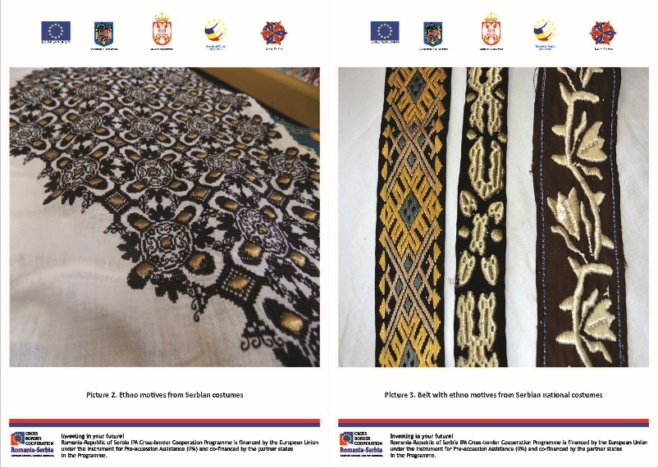
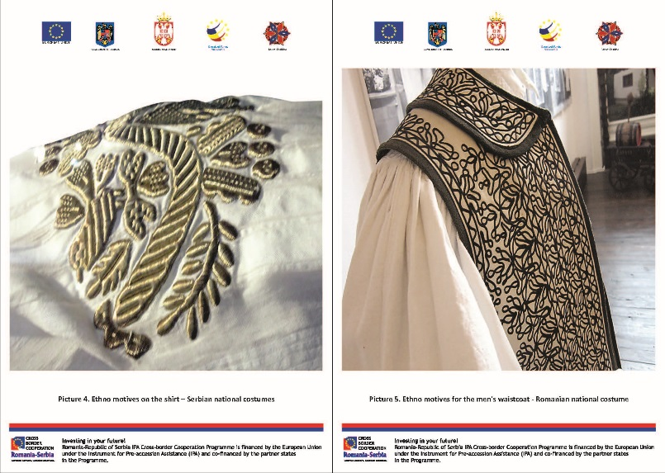
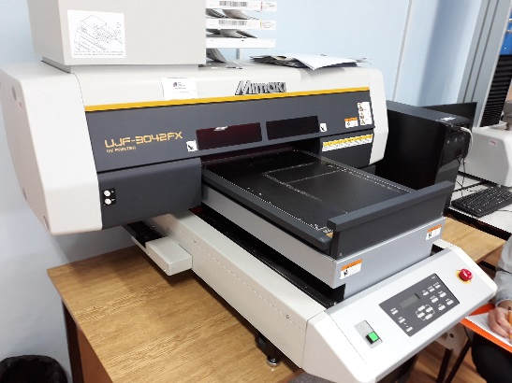
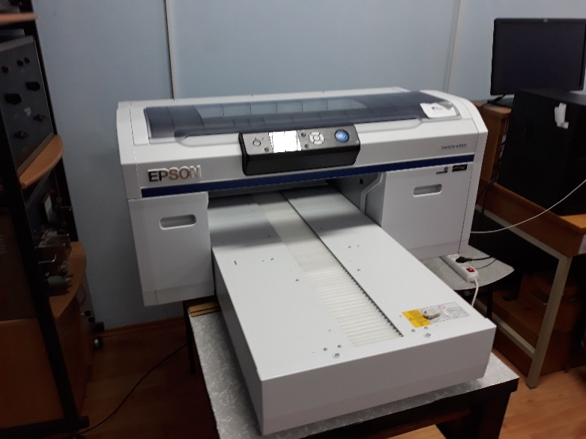
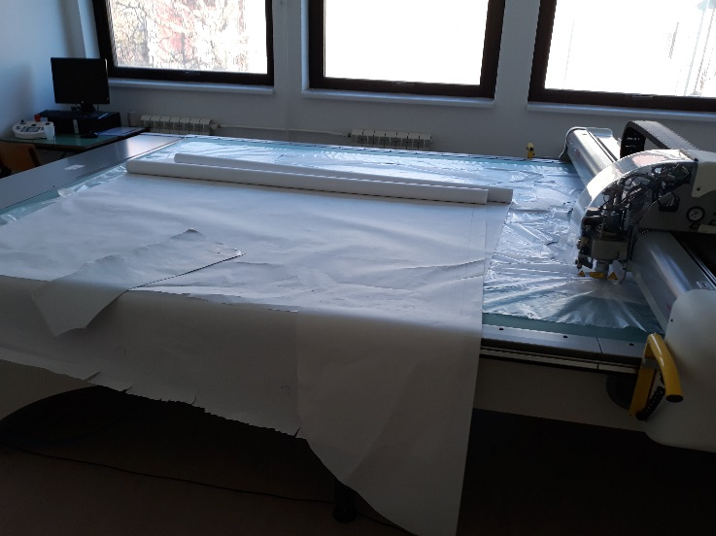

the implementation period (including extensions)
total funds spent/total funds contracted *100
indicators and level of achievement against targets set

