Project information
CALL FOR PROPOSALS | 2
MIS-ETC: | 1425
PRIORITY AXIS: | 1.Economic and Social Development
MEASURE: | 1.4 Support increased levels of R&D and innovation in the border region
PROJECT TITLE: | Sustainable development of an research center in Banat region and Danube flow area through scientific research and environmental simulation tools to assess and evaluate potential threats
ACRONYM: | ENVIROBANAT
DURATION: | 12.06.2013 – 11.06.2014
IPA FUNDS CONTRACTED: | 393.269,50€
TOTAL FUNDS CONTRACTED: | 462.670,00€
ABSORBTION RATE (%): | 68,53%

PROJECT OBJECTIVE(S): | - Strengthening the cross-border cooperation between Banat Universities for the benefit of the quality of life.  - Evaluating the environmental quality (air & water) in the Banat and Danube flow area.  - Protection of regional environment by means of a novel scientific tool consisting of identification of the pollution risk.  - Increasing the importance of R&D in cross-border area by developing a research network for environmental evaluation.  - Creation of 2D and 3D area pollutants dispersion maps for the BANAT region and Identification of the high polluted hot-spots in the Banat region and potential threats on Danube water quality.  - Dissemination of know-how to specialists, young researchers, population and authorities.

SHORT DESCRIPTION OF THE PROJECT: | The analyzed border region is unique: a hub for global trade and commerce, multicultural home to over 1 million people, beauty of the landscape, the mild climate, a richness of fauna and flora, common history and traditions, and employment and investment opportunities. For the first-time case studies in villages, in territory where natural protection area is attested, in sites with historical monuments have been realized, by on line monitoring and data base collection. Also the novelty of the iso-concentration maps for main pollutants: NOx, CO, SO2, PM will offer data for future development of the active border region.  The project activities have been structured in two stages. In the first stage the necessary data has been collected: emission factors, identification of polluted hot-spots, collection and editing of geographical maps needed for simulations and acquisition of necessary equipment. The second stage of the project has been focused on running the algorithms and obtaining the iso-concentration maps for specific pollutants for major cities, sensitive areas and Banat region followed by interpretations and scenarios for case studies of potential identified threats on Banat air and/or Danube flow quality.  Training stages (theoretical but mainly demonstration) for Serbian partners (scientists and students) have been conducted and also one scientific conference in order to present and discuss the obtained results.
DEGREE OF ACHIEVEMENT OF INDICATORS: | Indicator Indicator value provisioned in the contract Present indicator value % 6= (5)/(3)*100  Output indicators (1) UM (2) Quantity (3) UM (4) Quantity (5)  Improved physical infrastructure in the border area pc. 2 pc. 2 100  Improved capacity and cross-border contacts of SMEs and in the R&D sector pc. 2 pc. 2 100  People in labor force with qualifications received/improved from joint training activities pc. 4 pc. 4 100  Result indicators UM (2) Quantity (3) UM (4) Quantity (5)  Increased importance of R&D/Innovation in the border area Number of activities, actions, initiatives focusing on promoting the importance of or dealing directly with R&D/Innovation 2 Number of activities, actions, initiatives focusing on promoting the importance of or dealing directly with R&D/Innovation 2 100  Area covered by iso-concentration maps Entire Banat area 1 Entire Banat area 1 100  Number of studies of identification of short-range transport pattern influencing PM10 levels Number of studies of identification of short-range transport pattern influencing PM10 levels 1 Number of studies of identification of short-range transport pattern influencing PM10 levels 1 100  Knowledge transfer Number of workshops 2 Number of workshops 2 100  Public Webpage Number of webpages 1 Number of webpages (http://envirobanat.ro/) 1 100
RESULTS ACHIEVED: | • Acquisition of high resolution equipment for air and water quality monitoring and necessary software for simulations and creation of pollutants iso-concentration maps  • Intensive training of 4 Serbian scientists in use of Lagrangian and Gaussian models for air pollutant dispersion  • An academic database with all resulted iso-concentration maps for Banat region  • Dissemination workshops and book

Partnership information
 |  | COUNTRY | COUNTY/DISTRICT | BUDGET(EURO) | CONTACT DETAILS
LEAD PARTNER: | “POLITEHNICA” UNIVERSITY OF TIMISOARA | Romania | Timiş | 232.870,00 | Timisoara, P-ta Victoriei nr.2  Tel. 004.0256403000
PARTNER 2: | University of Novi Sad, Technical Faculty “Mihajlo Pupin” Zrenjanin | Serbia | Central Banat | 229.800,00 | Zrenjanin, b Djure Djakovića St.  Tel. +381 23 550-515

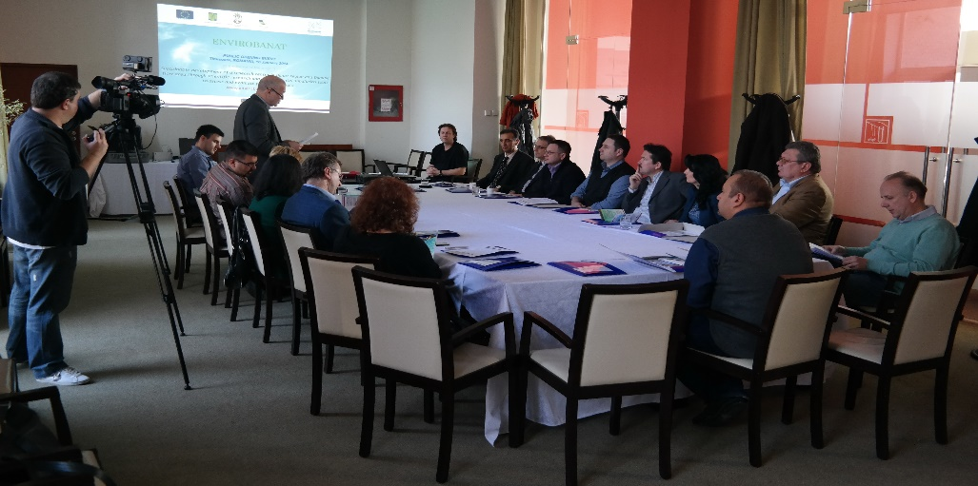
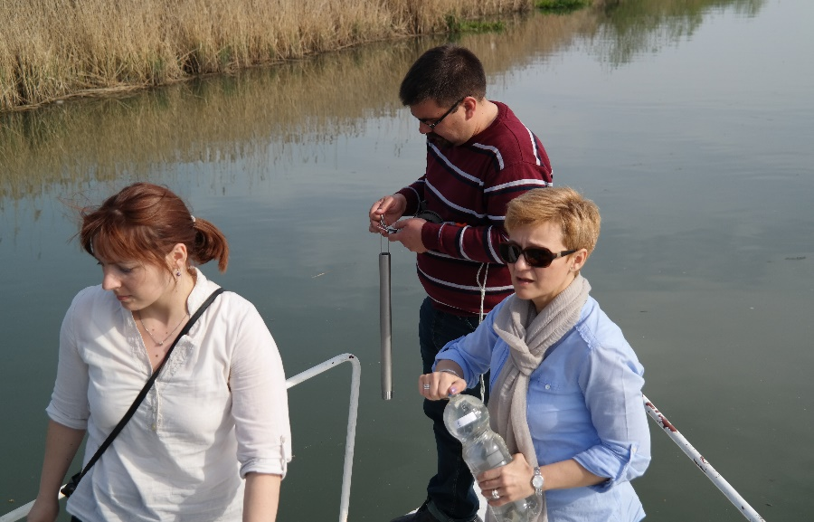
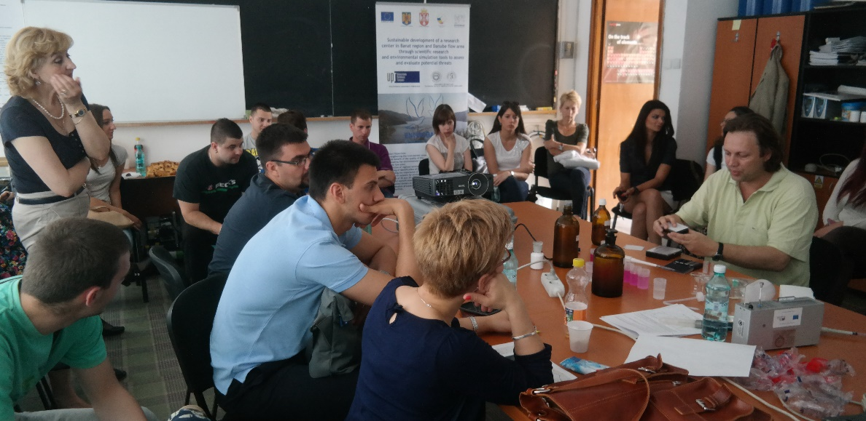

the implementation period (including extensions)
total funds spent/total funds contracted *100
indicators and level of achievement against targets set

