Project information
CALL FOR PROPOSALS | 2
MIS-ETC: | 1416
PRIORITY AXIS: | 3. Promoting “people to people” exchanges
MEASURE: | 3.3 Increase educational, social cultural and sporting exchanges
PROJECT TITLE: | Training in industrial risk management
ACRONYM: | T-IRM
DURATION: | 20.10.2015 – 19.10.2016
IPA FUNDS CONTRACTED: | 142.709,47
TOTAL FUNDS CONTRACTED: | 167.893,50
ABSORBTION RATE (%): | 73,51
PROJECT OBJECTIVE(S): | Support for better preparedness for people to find new qualified jobs in project topic: IRM - industrial risk management.  To organize two training courses in Industrial Risk Management for unemployed, young or disadvantaged people looking for a job (one training course in each side of the border).  To promote new educational services: Training in Industrial Risk Management (T IRM).  To organize four meetings on IRM topic (two events in each side of the border).  To promote people to people exchanges in industrial risk management.  To organize six partners` meetings /workshops on IRM project topics.
SHORT DESCRIPTION OF THE PROJECT: | The aim of the project was to support better preparedness for people to find new qualified jobs in Industrial Risk Management for unemployed, young or disadvantaged people looking for a job, through two workshops on IRM topic, four public events, one joint training course support on IRM, two training courses for 50 people (25 people from each side of border).
DEGREE OF ACHIEVEMENT OF INDICATORS: | Indicator Indicator value provisioned in the contract Present indicator value % 6= (5)/(3)*100  Output indicators (1) UM (2) Quantity (3) UM (4) Quantity (5)  Improved quality of life and increased attractiveness of the border communities as a living place ( 3.8.4 priority axis indicators- result indicators) Number of activities, action, initiatives developing new or existing educational services 1 Number of activities, action, initiatives developing new or existing educational services 1 100%  Improved knowledge of culture, history, society, organizational and institutional structure, and language of the neighbouring country ( 3.8.4 priority axis indicators- result indicators) Number of participants gained knew knowledge in events 50 Number of participants gained knew knowledge in events 61 122%  Project indicators  Increasing cross-border contacts between people in the border area ( 3.8.1 programme level indicator and 3.8.5 project indicators) Number of events (At least 200 participants for these events) 4 Number of events (At least 200 participants for these events) 4 100%  Increasing people to people exchange in the field of education ( 3.8.3 priority axis indicators- output indicators and 3.8.5 Project indicators) Number of people to people exchanges 24 Number of people to people exchanges 6 on the opening events 4 on the course 15 on the closing events 104%  Course support material on three languages: Serbian, Romanian and English (3.8.5 pr. ind.) Number of training course support on IRM 3 Number of training course support on IRM 3 100%
RESULTS ACHIEVED: | Two training courses on IRM (one course in each country) were organized.  Four events were organized through the project.  Project partners have jointly organized in each country two public events / workshops with total of 139 participants.  Dissemination of the project results in the frame of two closing events / workshops on IRM topic organized by both partners in Kladovo, Serbia and Timisoara, Romania.

Partnership information
 |  | COUNTRY | COUNTY/DISTRICT | BUDGET(EURO) | CONTACT DETAILS
LEAD PARTNER: | National R&D Institute for Welding and Material Testing – ISIM Timisoara | Romania | Timis | 89.633,75 | Timisoara, 30 Mihai Viteazul Blvd  Tel. +40 256 491828
PARTNER 2: | Association for the Development Kladovo | Serbia | Kladovo | 78.259,75 | Kladovo, 22 Septembar br.4, 19320 Kladovo,  Tel:+38119803338
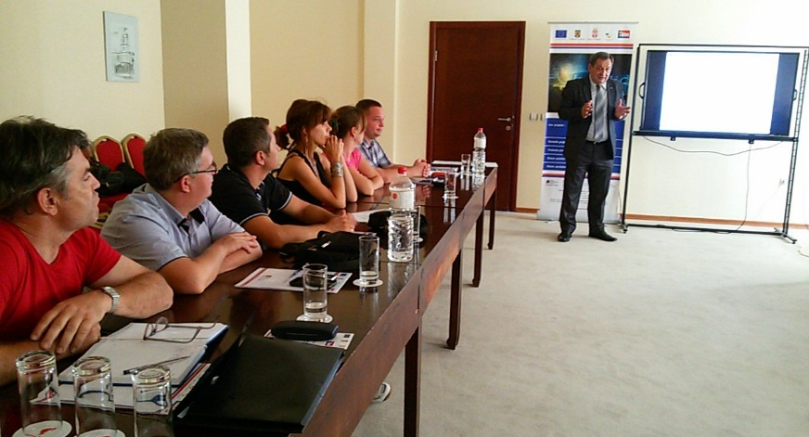
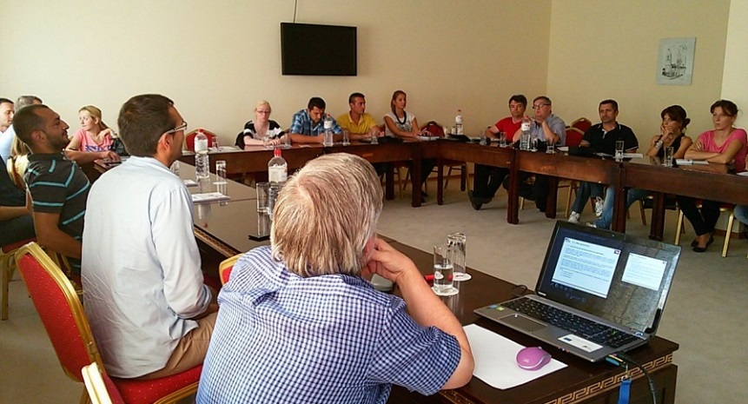
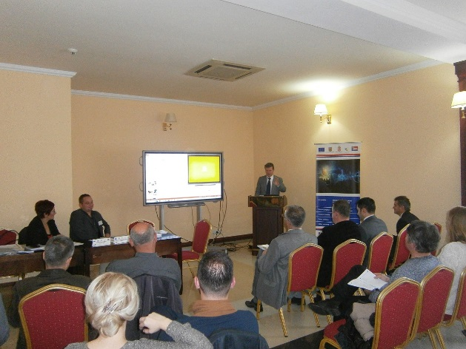
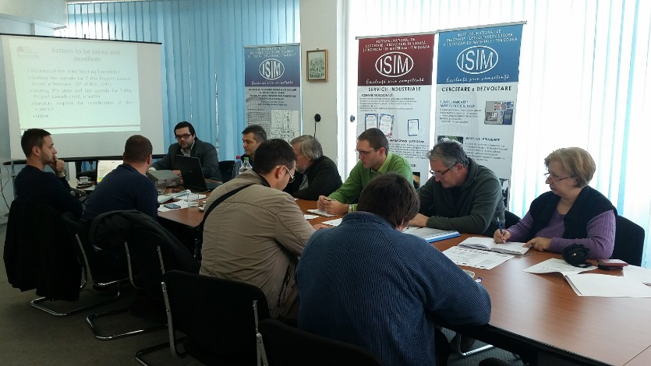

the implementation period (including extensions)
total funds spent/total funds contracted *100
indicators and level of achievement against targets set

