Project information
CALL FOR PROPOSALS | 2
MIS-ETC: | 1413
PRIORITY AXIS: | 2.Environment and Emergency Preparedness
MEASURE: | 2.3 More effective systems and approaches to emergency preparedness
PROJECT TITLE: | Joint Management of the emergency situations in Romania - Republic of Serbia cross-border area
ACRONYM: | EmSit
DURATION: | 17.04.2013 – 16.04.2015
IPA FUNDS CONTRACTED: | 1.953.876,22€
TOTAL FUNDS CONTRACTED: | 2.298.677,90€
ABSORBTION RATE (%): | 79,47%

PROJECT OBJECTIVE(S): | Increasing the quality of life for the population of the Romania-Serbia border area by strengthening the institutional and technical management capacity in case of disaster and response in emergency situations.  Strengthening the cooperation of the competent authorities of the Romania-Serbia border region, reflected in the two-way exchange of information regarding emergency situations.  Increasing the monitoring and reaction capacity of the authorities in situations of natural disasters.
SHORT DESCRIPTION OF THE PROJECT: | Through implementation of this project the partners purchased specific equipment necessary for creating an efficient Management system in case of emergency situations in the cross-border area Mehedinti – Bor.

DEGREE OF ACHIEVEMENT OF INDICATORS: | Indicator Indicator value provisioned in the contract Present indicator value % 6= (5)/(3)*100  Output indicators (1) UM (2) Quantity (3) UM (4) Quantity (5)  The institutional capacity and increased training for the reaction emergency situations in the field of environment  Technical preparation increased for emergency situations in the field of environment  Information Decision Making System for emergency situations Unit 1 Unit 1 100%  Joint actions in response to raise awareness of urgent situations Unit 2 work-shops 1 simulation exercise Unit 2 work-shops 1 simulation exercise 100%  Number of purchased equipment Unit 2 operational mobile centres 126 equipment delivered Unit 2 operational mobile centres 126 equipment delivered 100%  Result indicators (1) UM (2) Quantity (3) UM (4) Quantity (5)  Institutional qualification in response to environmental emergencies The number of new cross – border emergency plans drawn up or training events conducted on emergency planning and emergency management techniques 2 workshops The number of new cross – border emergency plans drawn up or training events conducted on emergency planning and emergency management techniques 2 workshops 100%  A wider implementation of the national and EU legislation in the field of environment The number of implementation activities, actions, initiatives and the national an EU legislative framework regarding the environment 1 action The number of implementation activities, actions, initiatives and the national an EU legislative framework regarding the 1 action 100%

 | RESULTS ACHIEVED: | 1 integrated cross-border system for management of emergency situations  The main result of the project is the implementation and operation of an integrated cross-border management system for emergency situations, which combined the state-of-the art technology in IT and field equipment.The project featured a high degree of innovation by introducing the use of latest IT technologies (hardware and software) for improving the management of emergency situations on both sides of the border.  1 implemented integrated information system  1 information system with 2 applications, as follows:  - EMS application:  - Portal for authorized users;  - Operational information module;  - Optimal route calculation module;  - Dangerous materials module;  - Intervention resources management module;  - Housing locations for evacuated persons management module;  - Risk evaluation for emergency situations module;  - Data integration module;  Equipment for emergency situations  - mobile communications centre, analysis, monitoring and coordination of interventions in emergency situations - 2 pcs;  - perimeter surveillance and security system access - 2 pcs;  - thermal infrared camera for firefighters (Thermal Imaging Camera Camera-Fire Fighting) - 2 pcs;  - ATV fire - 6 pcs;  - bags for fire extinguishers - Backpack Fire extinguisher -100 pc;  - sliding scale fire - 12 items;  - fire flashlights with batteries - 20 pieces;  boat -6 persons - 4 pcs  2 common analysis workshops with 60 participants to both workshops  1 best practice guide for emergency situations
Partnership information
 |  |  |  | COUNTRY | COUNTY/DISTRICT | BUDGET(EURO) | CONTACT DETAILS
LEAD PARTNER: |  |  | The Drobeta Inspectorate for Emergency Situations within the Mehedinti County | Romania | Mehedinți | 1.277.685,91 | Drobeta-Turnu Severin,  Str. Portului nr. 2  Tel. +40252311212
PARTNER 2: |  |  | Ministry of Interior of the Republic of Serbia | Serbia | Belgrade | 1.020.991,99 | Belgrade, Kneza Milosa 103  Tel. +381 11 3617 294
PARTNER 3: |  |  | The ”Semenic” Inspectorate for Emergency Situations within the Caras–Severin County | Romania | Caras–Severin | 0 | REŞIŢA,  Castanilor Street, no.123  Tel. +40255212639

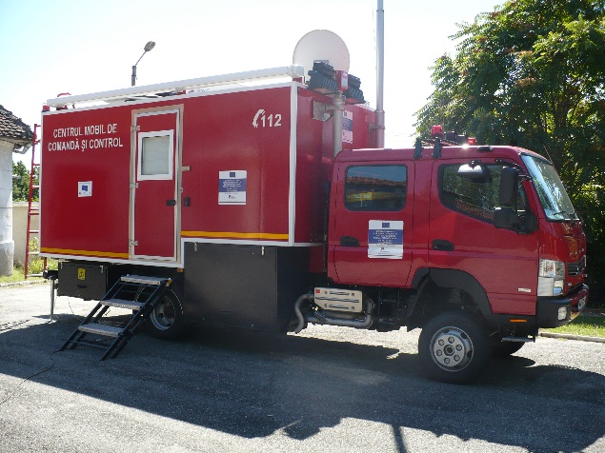
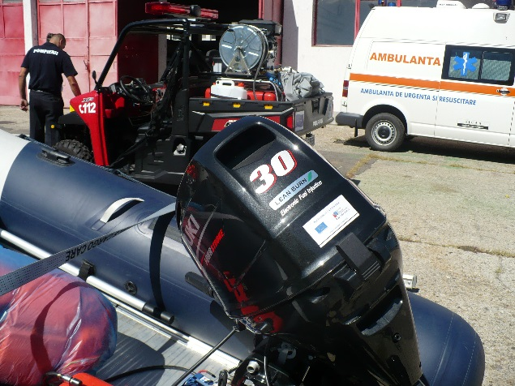
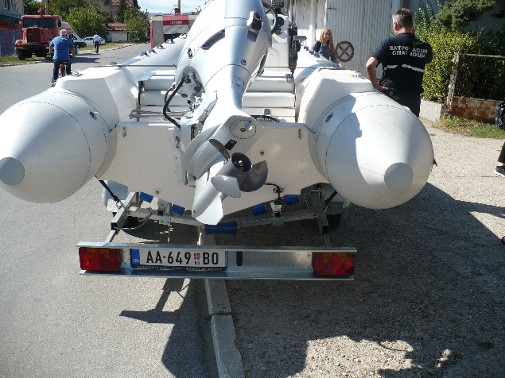
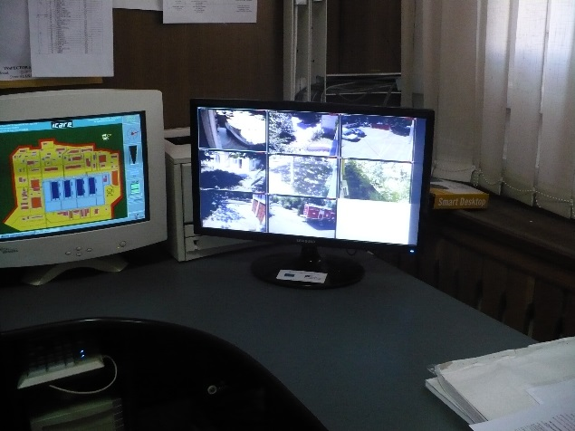
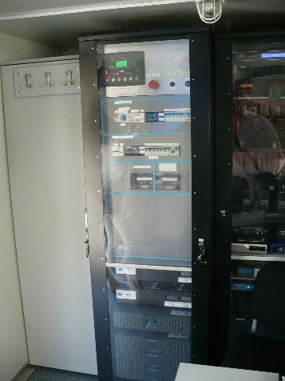
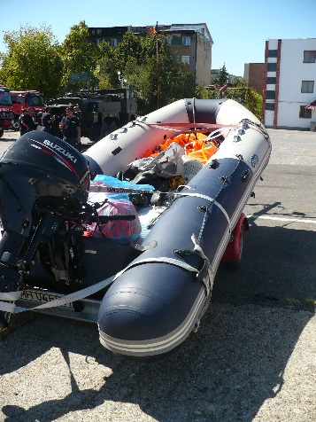
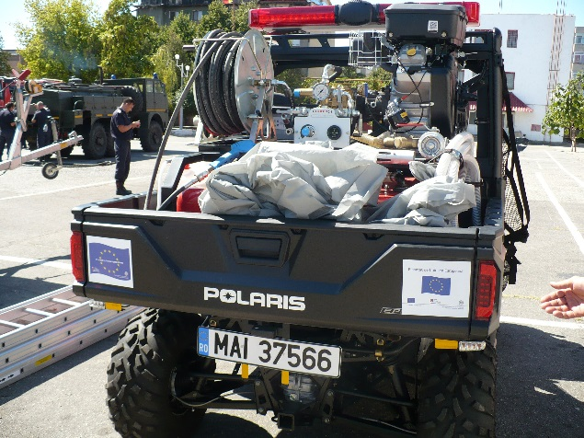
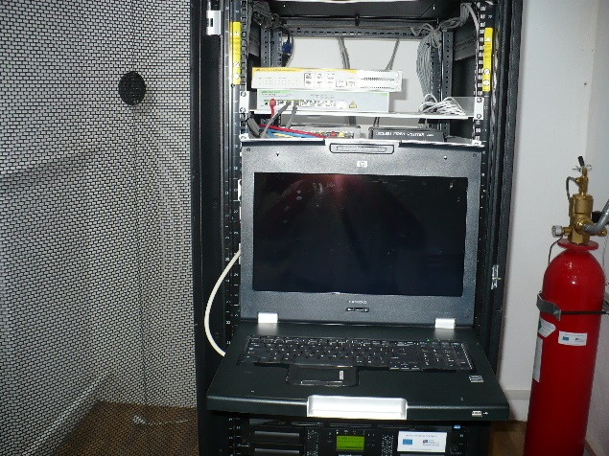

the implementation period (including extensions)
total funds spent/total funds contracted *100
indicators and level of achievement against targets set

