Project information
CALL FOR PROPOSALS | 2
MIS-ETC: | 1409
PRIORITY AXIS: | 1.Economic and Social Development
MEASURE: | 1.4 Support increased levels of R&D and innovation in the border region
PROJECT TITLE: | Promoting new ecologic filler alloys for soldering, based on the non-ferrous ore of the Romanian – Serbian cross-border area
ACRONYM: | ECOSOLDER
DURATION: | 15.06.2013 – 14.12.2014
IPA FUNDS CONTRACTED: | 187.954,81€
TOTAL FUNDS CONTRACTED: | 221.123,30 €
ABSORBTION RATE (%): | 80,74%

PROJECT OBJECTIVE(S): | Creation of a R&D cooperation network between ISIM of Timisoara and MMI of Bor, for soldering filler alloys.  Workshops for promoting the new ecologic filler alloys for soldering.
SHORT DESCRIPTION OF THE PROJECT: | The project promoted the know-how for an efficient exploitation of certain ore resources of the region and for the production of high-quality, ecologic alloys, as important products. Geology methods for discovering new resources of non-ferrous metals, up-to-date mining technologies for the extraction of these metals, processes of elaboration of the ecologic filler alloys for soldering and brazing, based on non-ferrous metals, technologies of soldering and brazing, results of the tests, that the joints made by soldering and brazing were subjected to, data of the measurements for toxic substances emissions during the soldering or brazing processes have been stored in a common and modern data base, where specialists, SMEs and other companies have access, in order to get the knowledge of developing their own business in these activities.

DEGREE OF ACHIEVEMENT OF INDICATORS: | Indicator Indicator value provisioned in the contract Present indicator value % (6) =[(5)/(3)]*100  Output indicators (1) UM (2) Quantity (3) UM (4) Quantity (5) (6)  Improved capacity and cross-border contacts of SMEs and in the R&D sector (Pct3.8.3 Priority axis indicators - Output indicators) Number of trainings/courses implemented, networks developed, fairs organized for SMEs (calculated also by type) and in the R&D sector 3 Opening Conference in Timisoara (19.07.2013) 6 200 %  Workshop no. 1 in Timisoara  (21.02.2014)  Workshop in Bor,  (01.07.2014)  Workshop in Bor,  (01.07.2014)  IT connection, web site of the project and a R&D cooperation network between ISIM Timisoara and MMI Bor (https://www.ecosolder.eu/)  Workshop no.2 in Timisoara  (26.09.2014)  Closing Conference in Timisoara (21.11.2014)  People in labor force with qualifications received/improved from joint training activities (Pct3.8.3 Priority axis indicators - Output indicators) Number of participants benefiting from training events/ courses 20 Number of participants at the Opening Conference in Timisoara (19.07.2013) 20 100 %  Result indicators  Increased importance of R&D/Innovation in the border area (Pct.3.8.4 Priority axis indicators - Result indicators) Number of activities, actions, initiatives focusing on promoting the importance of or dealing directly with R&D/Innovation 15 Number of activities finished 100% (activities no. 1,2,3,4,5,6,7,8,9, 10,11,12,13,14,15) 15 100 %  Project indicators  Number of edited and distributed promoting materials, related to the new ecologic alloys for soldering and brazing (3.8.5 Specific indicators of this project) Quantity-500 (Lead partner) Edited and distributed 500 (Leaflet 200–Ro 200 –En Flyer 100-Ro) Quantity Edited and distributed 500 (Leaflet 200–Ro 200 –En Flyer 100-Ro) 100%  Quantity-412 (Partner) Edited and distributed 412 Flyers -192 Leaflets-200 Posters -16 Banners -4 Quantity Edited and distributed 412 Flyers –192 Leaflets-200 Posters –16 Banners -4 100 %  Number of edited and distributed publications, related to the new ecologic alloys for soldering and brazing (3.8.5 Specific indicators of this project) Quantity-100 (Lead partner) Edited and distributed 100 (Newsletter no. 1 25 – En) (Newsletter no. 2 25 – En (Brochure 50 –En+Ro) Quantity Edited and distributed 100 (Newsletter no. 1 25 – En) 25 (Newsletter no. 2 25 – En) 50 (Brochure 50-En+Ro) 100 %  Quantity-1 (Partner) Monography Quantity 1 (Published in 100 copies) 100%  Number of participants at the workshops, related to the new ecologic alloys for soldering and brazing (3.8.5 Specific indicators of this project) Quantity 40 Number of participants to the Workshop No. 1 (21.02.2014) 50 467,5 %  Number of participants to the Workshop organized by MMI Bor (01.07.2014) 84  Number of participants to the Workshop No. 2 (26.09.2014) 53  Programme indicators /Programme level indicators  Increased degree/intensity of Cooperation between public services/public authorities, municipalities (3.8.1 Programme level indicators) Number of projects between public authorities with joint development, joint implementation and joint financing 1 ECOSOLDER project 1 100%  Increase in cross-border contacts between people in the border area. (3.8.1 Programme level indicators) Number of participants benefiting from the joint public cross-border events organized within the projects 20 Number of participants to the Closing Conference 59 295%  Increase in population with qualifications received or improved from cross-border training activities. (3.8.1 Programme level indicators) Number of participants benefiting from the training activities organized within projects 20 Number of participants to the Workshop no. 2 (other than member in team of the project) 43 215%  Environmental monitoring indicators  Environmental monitoring indicators (3.8.2 Environmental monitoring indicators) Number of projects on improvements of water/waste management, air quality 1 ECOSOLDER project 1 100%  Number of projects focusing on environmental emergency 1 ECOSOLDER project 1 100%

RESULTS ACHIEVED: | Result 1. Strategy for promoting the filler alloys for soldering and brazing  The results obtained at the end of the project, after experiments with filler alloys elaborated by MMI Bor, were published in international journals and they were presented to the international conference (Structural Integrity of Welded Structures – ISCS15), in order to promote the filler alloys for soldering and brazing.  The promotional materials regarding the ECOSOLDER project were distributed in the eligible cross-border area, to the events organized in the project (workshops, conferences) and other events, as well as to the companies from target groups and companies from other industrial fields where joining processes of materials are used.  The exchange of information from the database between partners continued and the database available on the website was updated (https://www.ecosolder.eu/) contributing in this way to promote the project, the ecological filler alloys and innovative processes for joining of metallic materials.  Result 2. Purchasing of equipment and goods  ISIM Timisoara purchased the following equipment: Standards and documentations, Computers-IT-software (1 computer, 1 laptop, 2 software)-, Mobile system for measurement of gas and fumes concentration: CO2, CO, H2, NO, NO2, Pb, Cr; Materials and filler alloys for soldering and brazing (budget line V.9).  MMI BOR purchased dilatometer, device for hardness measurements and devices for micro hardness measurements  Result 3. Cooperation network – The website, that is complex structured, with database, forums and live-chat, was updated with new information regarding the results obtained in the project, contribute in this way to the development of the cooperation network. The website is available at https://www.ecosolder.eu  Result 4. Data base of ISIM Timisoara includes:  - selected documentations about detecting and measuring hazardous substances of gas and fumes, by utilizing filler alloys for soldering and brazing  - selected papers of LP team members about FSW and laser techniques that are useful in the project  - documentation about furnace soldering and brazing technologies  - selected papers regarding FSW technique and process (applied on different types of similar or dissimilar materials) and methods for monitoring of the processes that are useful in the project  - documents with information regarding base materials (used in the project) and filler alloys  - selected scientifically papers regarding FSW technique and process (applied on different types of similar or dissimilar materials) and methods for monitoring of the processes that are useful in the project  - documents with technical data for base materials, filler alloys and fluxes used in the project  - documents selected by ISIM regarding base materials,  - scientific papers regarding friction stir technique,  - technical reports from the ECOSOLDER project  - scientific papers elaborated by ISIM Timisoara,  - ppt presentations from events organized in the project, regarding ECOSOLDER project  - technical reports of the ECOSOLDER project,  - technology sheets for soldering and brazing  A part of these documents can be find also on the website www.ecosolder.eu and on the web site of the MMI Bor.  Result 5. Joint innovation related studies, regarding filler alloys for soldering and brazing, in the cooperation network  The conclusions emphasize the adequate behaviour of the new ecological types of brass during the described brazing tests, as well as the adequate results by the visual examination, metallographic analysis and shear test. The new types of ecological brass can be applied to brazed joints of steel sheets, as proved by the brazing test samples made in the project.  These experiments and results were present in a workshop, and also at:  - Scientific paper presented at the National ASR Conference “SUDURA 2014”, 9th -11th April 2014, Sibiu, Romania  - Scientific paper presented at the 7th International Conference TIMA 14 “Innovative Technologies for Joining Advanced Materials”, ISI Proceedings, 19th -20th June 2014, Timisoara, Romania and published in Advanced Materials Research Volume 1029, 2: 10.  - Scientific article published in the Welding & Materials Testing Journal, No. 2/2014, http://www.bid-isim.ro/bid-rom.htm  - International Conference “46th International October Conference on Mining and Metallurgy” IOC 2014, organized by the Technical Faculty Bor, Technical University from Belgrade and Mining and Metallurgy Institute MMI Bor, 1st-4th October 2014, Bor, Serbia  - Patent request (A 00254) regarding friction stir soldering was registered with no. 1830/11.04.2014 at OSIM Bucharest.  - “Ecological lead-free solder Ag-In-Sn” in national journal “Copper”, Vol.39, No.1, pp. 9-16  - The paper titled: “Lead-free alloys for ecological solders manufacturing” by authors: Ana Kostov, Aleksandra Milosavljević, Radiša Todorović, was published in an international journal Mining and Metallurgy Engineering, No.2, 2014, pp. 117-122  Result 6. Article for a journal or newspaper and Result 7. Interviews about the project on TV or radio  - Two informative materials regarding ECOSOLDER project were prepared and published in SUDURA Journal No.2/2014 and in Welding & Material Testing Journal No. 2/2014.  - Mrs A. Kostov and Mr. V. Verbitchi gave TV interviews (regarding ECOSOLDER project) to two televisions from Serbia – RTV Bor and TV SEZAM Bor (www.dailymotion.com/video/x20m88u_vesti-rtv-sezam-01-07-2014_news ), at the workshop organized by MMI Bor on 01st July at Bor.  - advertising for the ECOSOLDER project on the first cover of the Welding and Materials Testing Journal, No.3/2014 (http://www.bid-isim.ro/bid-rom.htm )  - material regarding ECOSOLDER project, published in Banat Business Media, edited by CCIAT Timis  2 interviews were recorded and broadcasted on radio stations Radio Timisoara and Radio Oltenia Craiova, in eligible area of the project. First interview was for promote the project and the second interview was to announce the closing conference of the project.  8. Web site of the project  The website can be found at the address: www.ecosolder.eu and information regarding entire project (objectives of the project, activities and results, news and events, communication & science, etc) were uploaded.  Results 9 and Results 10. Promotional materials and publications  The promotional materials regarding the ECOSOLDER project were distributed in the eligible cross-border area, to the events organized in the project (workshops, conferences) and other events, as well as to the companies from target groups and companies from other industrial fields where joining processes of materials are used.  Result 11 – Workshops on filler alloys for soldering and brazing  The workshop no. 1 “Innovative soldering techniques using ecological filler alloys” has been organized by ISIM in Timisoara, at Hotel Central on 21 February 2014, with participation of partners from Serbia and representatives from industrial and academically fields (50 participants).  The workshop no 2 “Promoting New Ecological Solders in Romanian-Serbian Cross-Border area” has organized by MMI Bor at Hotel Albo, Bor on 1st July 2014, in the frame of the project, were Serbian partners, representatives from Lead Partner and specialists from the industrial companies from Serbia and Romania participated (84 participants).  The workshop no. 3 „Ecologic Alloys for Soldering and Brazing. Brazing and Soldering Procedures” organized by the ISIM Timisoara in the project, was organized on 26th of September 2014, at Hotel Central, Timisoara (53 participants).  The workshop no. 4 was organized during the Closing Conference „Achievements of the ECOSOLDER Project. Recommended applications for ecological filler alloys” of the project was organized by ISIM Timisoara on 21th of November 2014, at Hotel Perla, Timisoara (59 participants).  The results obtained during the project by ISIM Timisoara and MMI Bor were presented at the Closing Conference.

Partnership information
 |  | COUNTRY | COUNTY/DISTRICT | BUDGET(EURO) | CONTACT DETAILS
LEAD PARTNER: | National Research & Development Institute for Welding and Material Testing- ISIM | Romania | Timis | 121.771,30 | Timisoara, Bd. Mihai Viteazul, Nr.30  Tel. +40256-491828
PARTNER 2: | Mining and Metallurgy Institute Bor - MMI Bor | Serbia | Borski | 99.352,00 | Bor, Zeleni Bulevar 35  Tel. 00381 30 454 108

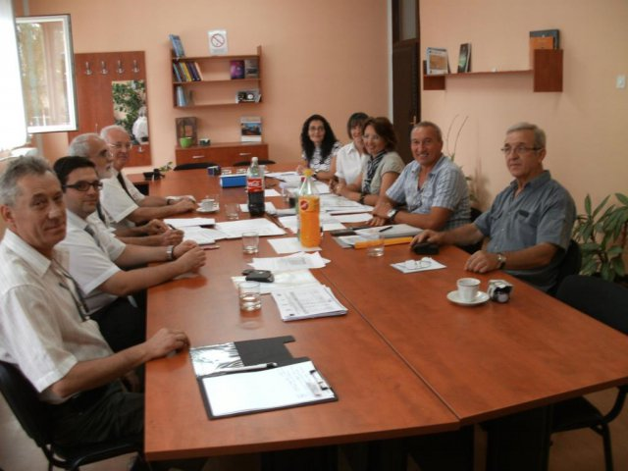
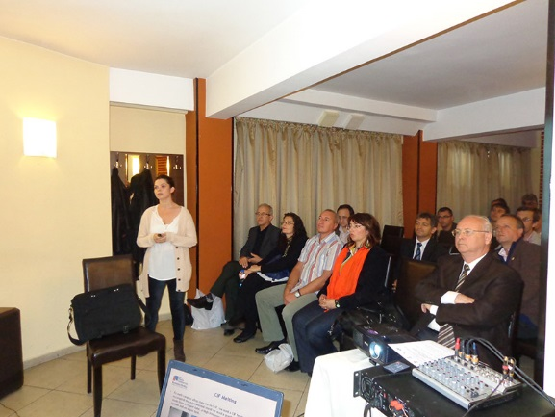
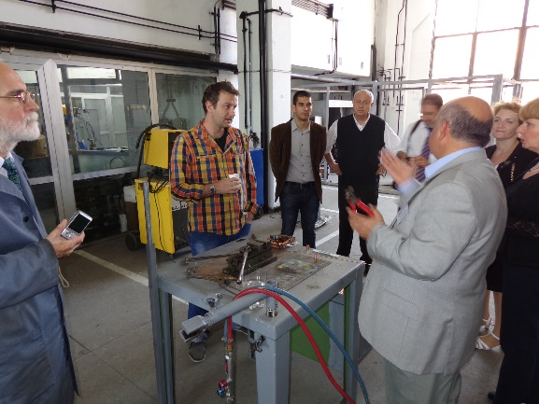
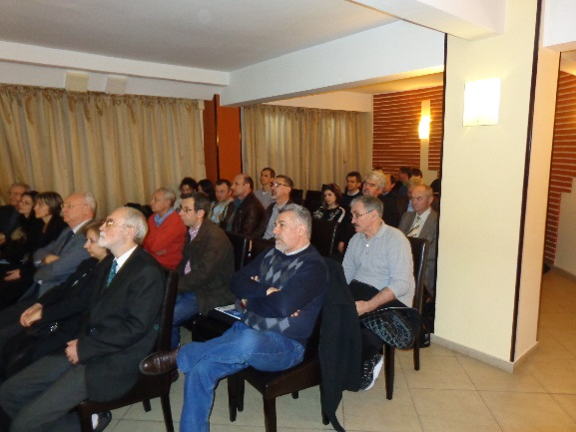
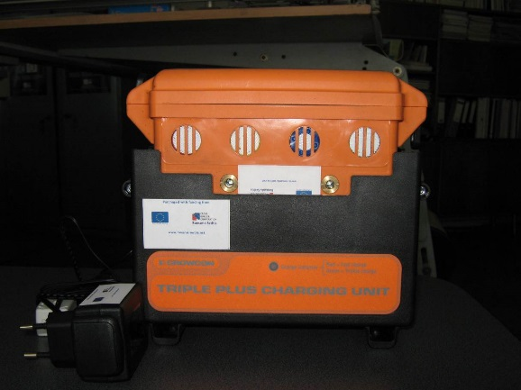
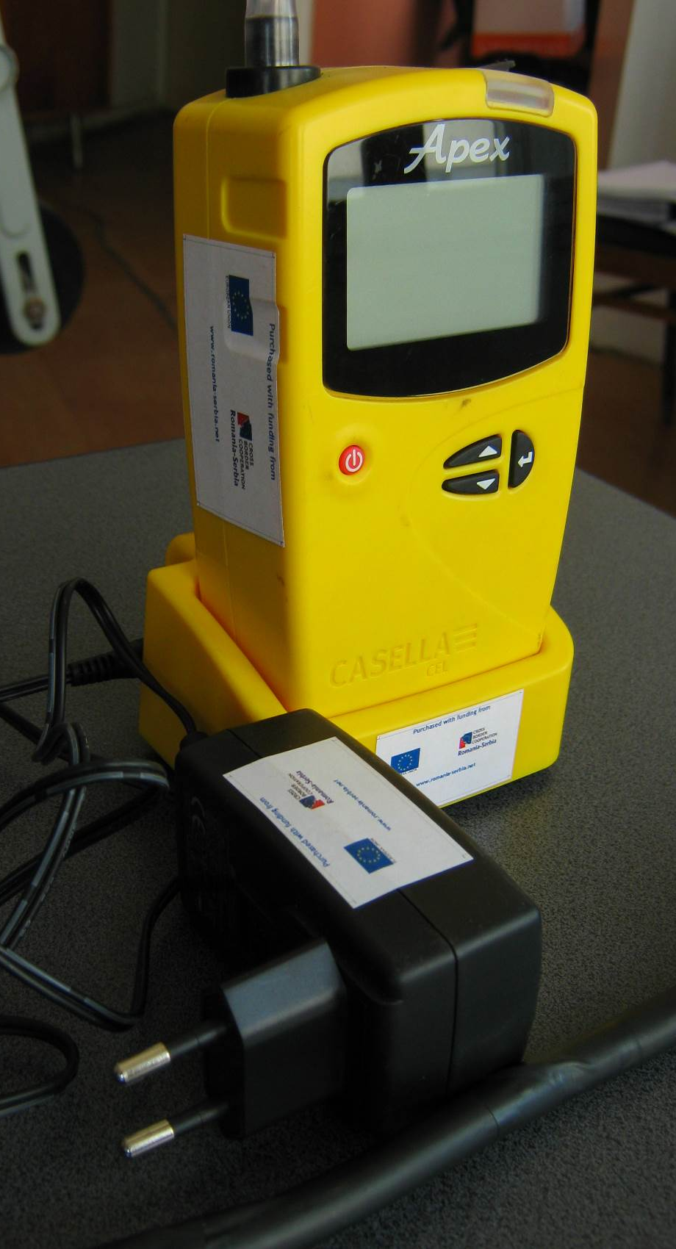
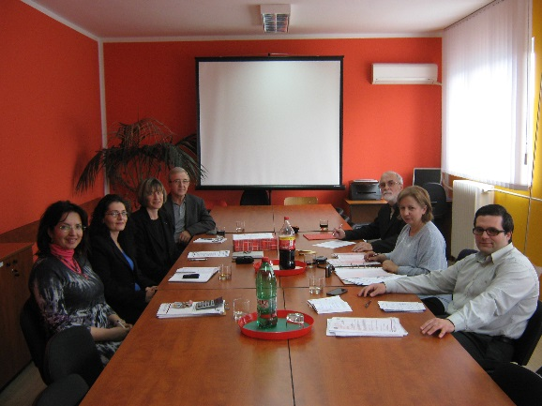

the implementation period (including extensions)
total funds spent/total funds contracted *100
indicators and level of achievement against targets set

