Project information
CALL FOR PROPOSALS | 2
MIS-ETC: | 1403
PRIORITY AXIS: | 2.Environment and Emergency Preparedness
MEASURE: | 2.3 More effective systems and approaches to emergency preparedness
PROJECT TITLE: | Improving the capability of the Romanian and Serbian authorities of reacting in emergency situations
ACRONYM:
DURATION: | 29.12.2012 – 28.12.2014
IPA FUNDS CONTRACTED: | 1.482.741,47
TOTAL FUNDS CONTRACTED: | 1.744.401,73
ABSORBTION RATE (%): | 84,79
PROJECT OBJECTIVE(S): | Consolidation of the cross-border cooperation between Romanian and Serbian authorities responsible for the management of exceptional/emergency situations.  Development a more efficient early warning and response system between Serbia and Romania, in line with EU standards.  Improving the joint response capability of the Romanian-Serbian responsible authorities for emergency situations through reduction of intervention time in such situations.
SHORT DESCRIPTION OF THE PROJECT: | The project developed and implemented a new technological platform DEWETRA and associated procedures, to support the Early Warning System and to improve the overall capacity of Serbia to mitigate the impacts of natural disasters. The system is used as an infrastructure for exchanging and sharing data, procedures, models and expertise among the Sector of Emergency Management (SEM), the Republic of Serbia Hydro-Meteorological Service (RHMSS) and the Serbian Public Water Companies (PWCs): Serbia Waters, Vojvodina Waters and Belgrade Waters. FloodPROOFS is a system designed to assist decision makers during the operational phases of flood forecasting, now-casting, mitigation and monitoring in various-sized catchments. The hydrological forecasting model FloodPROOFS was implemented in pilot basins in Serbia.  Caras-Severin County Council implemented the weather station network with the collaboration of Banat Water Regional Administration. The network is functional and fully compatible with the software used by Banat Water Regional Administration.  Partner 3 West University of Timisoara used the data obtained from the sensors installed by the Caras-Severin County Council and the weather and water consumption level station data in JSON format was made.  Based on the data provided by the systems, joint cross-border emergency reaction plans were developed.
DEGREE OF ACHIEVEMENT OF INDICATORS: | Indicator Indicator value provisioned in the contract Present indicator value % 6= (5)/(3)*100  Output indicators (1) UM (2) Quantity (3) UM (4) Quantity (5)  Joint cooperation and actions in response to raise awareness of emergency situations 1. Number of joint cross-border emergency reaction plans and actions developed. 2. Number of bilingual activities raising public awareness in the project area. - Joint emergency reaction plan prepared - At least 4 bilingual media releases - 200 brochures and 300 leaflets are distributed Number of joint cross-border emergency reaction plans and actions developed. 2. Number of bilingual activities raising public awareness in the project area. Joint emergency reaction plan prepared - 4 bilingual media releases - 200 brochures and 300 leaflets are distributed 100%  Sharing information related to emergency situations 1. Number of meetings held 2. Joint means of sharing information on floods identified and documented - At least 2 joint meetings held - At least one of means of sharing information agreed on 1. Number of meetings held 2. Joint means of sharing information on floods identified and documented - 2 joint meetings held; - one of means of sharing information agreed on 100%  Result indicators  Raising public awareness on early warning system and their role The number of actions, activities, initiatives towards increasing public awareness in the project area. - At least 40% of the local population in the project area aware - 200 brochures and 300 leaflets are distributed - 2 press conferences held and at least 4 media releases The number of actions, activities, initiatives towards increasing public awareness in the project area. - At least 40% of the local population in the project area aware - 200 brochures and 300 leaflets are distributed - 2 press conferences held and 4 media releases made 100%  Increased institutional capacity and preparedness in reacting in case of floods 1. Number of joint cross-border emergency reaction plans developed. 2. Number of trainings, study tour, meetings held. 3. Alert system functioning. 4. Manuals printed and distributed. - At least 3 active participation plans (Actions) documented. - At least 5 specific technical trainings some jointly held. - Budgeted equipment for the system procured - Data centre and alert system installed and in use. - At least 10 manuals printed and distributed 1. Number of joint cross-border emergency reaction plans developed. 2. Number of trainings, study tour, meetings held. 3. Alert system functioning. 4. Manuals printed and distributed. - 3 active participation plans (Actions) documented - At least 5 specific technical trainings. - Budgeted equipment for the system procured - Data centre and alert system installed and in use. - 10 manuals printed and distributed 100%
RESULTS ACHIEVED: | - Flood forecasting and early warning system was set up along the Danube and other rivers in the Project area. The project developed and implemented a new technological platform DEWETRA and associated procedures, to support the Early Warning System and to improve the overall capacity of Serbia to mitigate the impacts of natural disasters. Caras-Severin County Council made an early warning system based on sensors and wheatear stations installed in rivers in the County. The network is functional and fully compatible with the software used by Banat Water Regional Administration.  - Users and other stakeholders trained in the system, and use of the equipment, entry of data, analysis and interpretation - Training Activity was organized as two separated courses, the first one dedicated to system implementers and the second to end users. The training for implementers covered three weeks (November 3rd – 21st) and it contained a first period of classical frontal lectures (1 week) and a period of training on the job (2 weeks). The participants have been given the theoretical basis and practical tools in order to understand the procedures for prediction, prevention and mitigation of natural disasters, with a particular emphasis on the early warning system. The training for end users was held in Belgrade on December 15-19th 2014 and encompassed both frontal lectures and training on the job. The trainings had 6 topics: Rainfall estimation and data fusion and Hydrological modelling, Software design, Software engineering, GIS software engineering, Training on the operational use of the Dewetra platform, Standard operating procedures for early warning systems.  - Public awareness of the system: Promotional materials were printed and distributed. The closure press conference was held on 26.12.2014. in Vrsac, Municipality of Vrsac. Information regarding the project was published in the local newspaper “Vrsacka kula”, as a TV report in “RT Vojvodina”, “RT Banat Vrasac”, “RT IN Oktobar Vrasac”, and on many web portals. Caras-Severin County Council organized 2 press conferences to promote de project (one at the beginning and one at the end of the project). Also the open day event was another event to promote the projects results. The coverage in the local and regional media was assured through various press and online articles as well as a radio promotion for the final press conference. Partner 3 West University of Timisoara organized the final press conference on 22.12.2015.

Partnership information
 |  | COUNTRY | COUNTY/DISTRICT | BUDGET(EURO) | CONTACT DETAILS
LEAD PARTNER: | Ministry of Interior of the Republic of Serbia | Serbia | Belgrade | 744.401,73 | Belgrade, Kneza Milosa 103  Tel. +381 11 3617 294
PARTNER 2: | Caras-Severin County Council | Romania | Caras-Severin | 750.000,00 | Resita, P-ta 1 Decembrie 1918 nr 1  Tel. 0255 211420
PARTNER 3: | West University of Timisoara | Romania | Timis | 250.000,00 | Timisoara, Bd. V. Parvan nr. 4  Tel. 0256-592-234

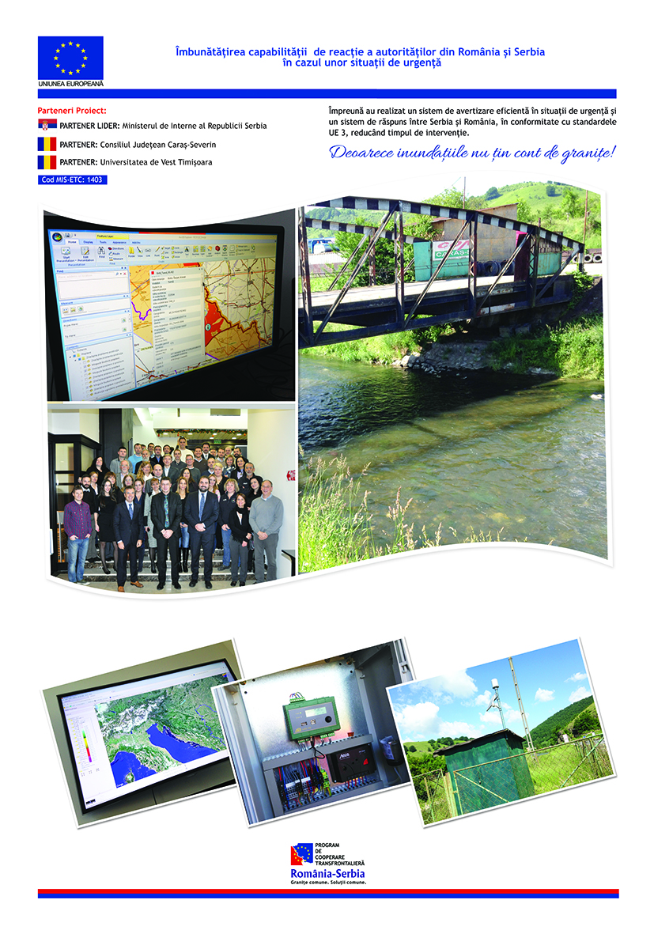

the implementation period (including extensions)
total funds spent/total funds contracted *100
indicators and level of achievement against targets set

