 | Project information
 | CALL FOR PROPOSALS |  | 2
 | MIS-ETC: |  | 1399
 | PRIORITY AXIS: |  | 3. Promoting “people to people” exchanges
 | MEASURE: |  | 3.3 Increase educational, social cultural and sporting exchanges
 | PROJECT TITLE: |  | Library as an Instrument of Building Regional Identity and Strengthening Social Cohesion
 | ACRONYM: |  | BIBLIO-IDENT
 | DURATION: |  | 18.12.2012 – 17.06.2014
 | IPA FUNDS CONTRACTED: |  | 150.002,31
 | TOTAL FUNDS CONTRACTED: |  | 176.473,31
 | ABSORBTION RATE (%): |  | 59,66
 | PROJECT OBJECTIVE(S): |  | The general objective of the project was to strengthen social and economic cohesion by the common development of abilities and knowledge concerning the highlight of patrimonial books of regional interest from libraries in the region of Banat up to year 1900, based on the premises of mutual recognition and appreciation of the common heritage.  The first specific objective of the project was for the partners to identify and highlight library documents (books, periodicals, manuscripts, etc.) having Banat region as a topic until the year 1900.  The second objective was to create a common database between the partners.  The third specific object of the project was to promote exchange of knowledge and the common development of abilities necessary to process library documents and to create the database, in order to overcome the border as a perceived “division” by promoting cross-border cooperation and creating synergies in the educational system.  Other objectives were:  - Raising the awareness of the multi-ethnic region where the tradition of historical and religious relations between ethnic groups were peaceful and leaded to cooperation and mutual tolerance.  - To facilitate contacts and communication between people over state borders from the same historical background, thus leading to the strengthening of the common identity.  - Common development of the librarians which will enrich their knowledge about cultural identity, common heritage of the 2 regions.
 | SHORT DESCRIPTION OF THE PROJECT: |  | The project addressed problems characteristic for the regions on both sides of the border, distinctive to the population which shares the same history: regional identity. Creating a multilingual bibliographic database (through bibliographic research operations, scan, document processing and display bibliographic information) contributed to the strengthening of the regional identity and provided for the benefit of researchers (historians, geographers, ethnologists, sociologists, linguists, etc.) a documentary source related to Banat which can be used to deepen their knowledge.
 | DEGREE OF ACHIEVEMENT OF INDICATORS: |  | Indicator Indicator value provisioned in the contract Present indicator value % 6= (5)/(3)*100  Output indicators (1) UM (2) Quantity (3) UM (4) Quantity (5)  The aim of this project is to increase people-to-people exchange in the field of education, culture and sport, proposing a number of 40 people who will participate in cross border people-to-people exchanges events. In this regard, the partners will organize 3 visits in each country where the participants will meet the infrastructure of the other partner, will exchange information about the project, knowledge about the common cultural heritage, subject of this project, building together a social and cultural cooperation between the regions which will lead to a sustainable social and economic development of the regions in accordance with the aim set out by the program, fulfilling also the priority axis output indicator of increase people to people exchanges in the fields of education, culture and sports. Number of participants 40 Number of participants 40 100%  Number of visits 3 Number of visits 3 100%  Result indicators  Increased social and cultural integration of people in the border areas Number of participants benefiting from cross-border social and cultural events 525 Number of participants benefiting from cross-border social and cultural events 719 136,95%  Improved knowledge of culture, history, society, organizational and institutional structure, and language of the neighbouring country Number of participants gained knew knowledge in events promoting/profiling the neighbouring country 525 Number of participants gained knew knowledge in events promoting/profiling the neighbouring country 719 136,95%  Project indicators  Number of persons benefiting from the new database Persons 500.000 Persons >500.000 100%  Number of similar project developed by other institutions Project 5 Project 5 100%
 | RESULTS ACHIEVED: |  | - Project established the cross-border cooperation in the field of education and more extended, in the field of culture and promoted a common cultural heritage.  - 3 professional visits to the Serbian partner (2 visits with project team members and 1 visit with 20 librarians for the professional and cultural exchange).  - A new database was created containing 1.000 books and relevant bibliography. The database consists of bibliographic description of the old books, the books cover, the books content and 200 full text digitized books. The database is now successfully integrated in the existing database of the lead beneficiary at http://aleph.bcut.ro/F?RN=76399525  - 7 conferences were organized in order to promote the project and its importance: 4 thematic conferences and 3 press conferences. At these events, a total amount of 719 persons participated.  - 4 workshops were organized in order to train the 40 librarians from the two partner institutions in realizing and utilizing the old book database.  - 1 professional scanner, 2 laptops, 1 Video projector + cloth screen, one audio and video conference system and related equipment were procured.  - The following promo materials were made: Roll-up, 2000 pens with EU/project sign design, 400 folders with EU/project sign design, 20.000 flyers for project propaganda, 200 brochures, 2 published articles in Romanian journals regarding the project, 2 Press conferences in Romania, one public appearance in a TV show promoting the project, 2.000 Pocket book, 2 Billboard, 1 Promo movie about the project.
Partnership information
 |  |  |  | COUNTRY | COUNTY/DISTRICT | BUDGET(EURO) | CONTACT DETAILS
LEAD PARTNER: |  | Central University Library “Eugen Todoran” Timisoara |  | Romania | Timis | 102.131,31 | Timisoara, Street Blvd Vasile Parvan no. 4A  Tel. 0040-256 490 353
PARTNER 2: |  | Zrenjanin City Public Library “Zarko Zrenjanin” |  | Serbia | Central Banat | 74.342,00 | Zrenjanin, Trg slobode 2  Tel. +381 23 566 210

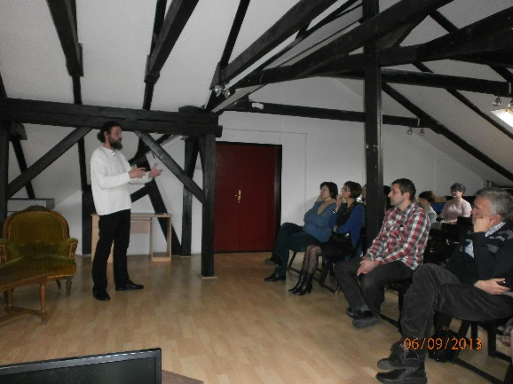
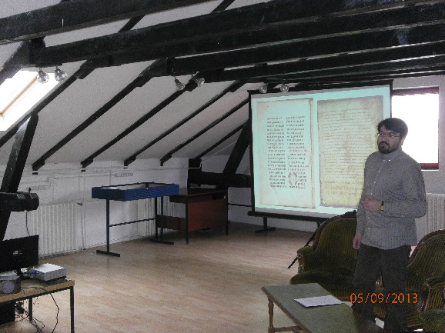
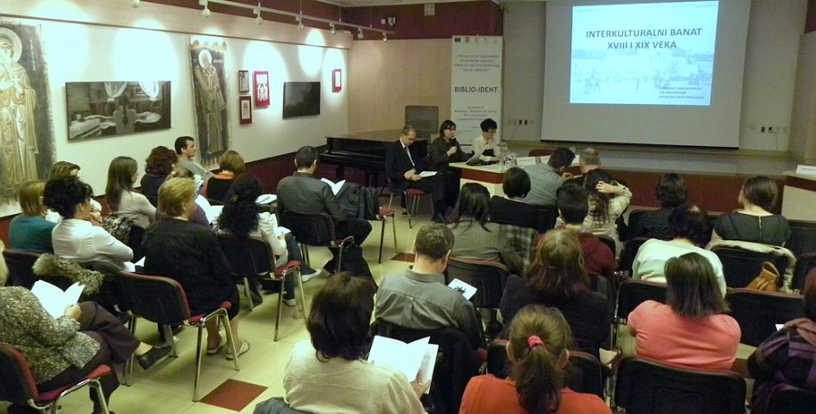
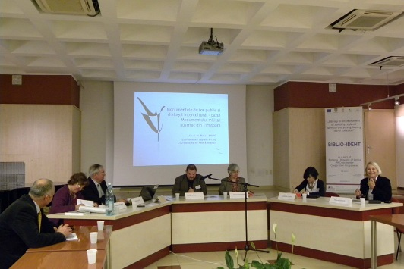
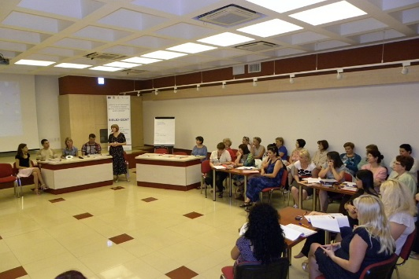
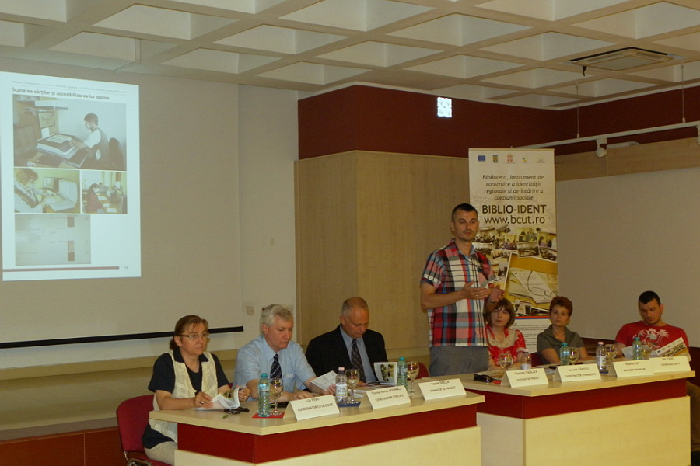
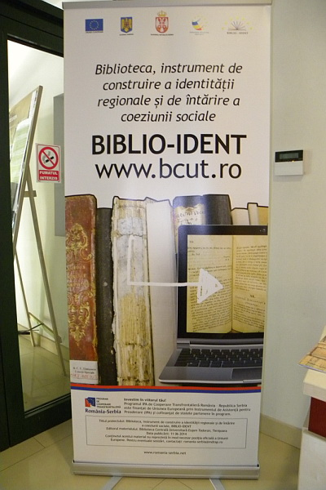

the implementation period (including extensions)
total funds spent/total funds contracted *100
indicators and level of achievement against targets set

