Project information
CALL FOR PROPOSALS | 2
MIS-ETC: | 1395
PRIORITY AXIS: | 1.Economic and Social Development
MEASURE: | 1.1 Support for local/regional economic and social infrastructure
PROJECT TITLE: | Hall of Banat Fairs
ACRONYM: | HallBF
DURATION: | 01.01.2016 -31.12.2016
IPA FUNDS CONTRACTED: | 380.771,10 €
TOTAL FUNDS CONTRACTED: | 447.966,00 €
ABSORBTION RATE (%): | 76,02%

PROJECT OBJECTIVE(S): | To contribute to the improvement of the competitiveness of Banat region as the leader of economic development.  Improvement of regional economic structure trough provision of regional fair facility.
SHORT DESCRIPTION OF THE PROJECT: | City of Zrenjanin reconstructed the old sports hall and reorganized it into Facility for organization of business networking events and regional fairs. Also, the hall was equipped with adequate furniture, installations and accompanying fittings.  Romanian partner realized a feasibility study to substantiate the technical, economic, and legal viability of the establishing the exhibit space within the Territory of Timis County in Romania.

DEGREE OF ACHIEVEMENT OF INDICATORS: | Indicator Indicator value provisioned in the contract Present indicator value % 6= (5)/(3)*100  Output indicators (1) UM (2) Quantity (3) UM (4) Quantity (5)  Increased capacity of the Exhibit/Fair facilities in the border area Area [m2] of the dedicated and equipped Exhibit/Fair facility for promotion of regional economy 3400 Area [m2] of the dedicated and equipped Exhibit/Fair facility for promotion of regional economy 3400 100%  Improved utilization of physical infrastructure for promotional activities of SME’s in the border area Number of Feasibility Studies on refurbishing of existing, non-utilized facilities as exhibition sites 1 Number of Feasibility Studies on refurbishing of existing, non-utilized facilities as exhibition / fair sites 1 100%  Result indicators  Increased SME’s capacity in the border area Number of activities, actions, initiatives focusing on promoting SME’s activity. 2 1.Provision of the facility to meet the SME’s needs for promotion at the Serbian side, and 2.Provision of the Feasibility Study for similar facility in Romanian side 2 100%
RESULTS ACHIEVED: | Facility for organization of business networking events reconstructed and equipped for organization of regional fairs.  Higher participation of businesses from Romania/Serbia as well as international companies and SMEs in business networking events organized in Zrenjanin.  Number of visitors to fairs and other business events increased.  Supervision services for execution of works, and reconstruction works on the old sports hall have been completed.  Exhibition equipment has been supplied and delivered to the Hall of Banat Fairs.  Development of opportunity and feasibility study has been completed.

Partnership information
 |  | COUNTRY | COUNTY/DISTRICT | BUDGET(EURO) | CONTACT DETAILS
LEAD PARTNER: | City of Zrenjanin | Serbia | Mid-Banat | 401.052,00 | Zrenjanin, Trg slobode 10  Tel. +381 23 315 00 94
PARTNER 2: | Timisoara Chamber of Commerce, Industry and Agriculture | Romania | Timis | 46.914,00 | Timişoara, Piata Victoriei 3  Tel. +40-374160851
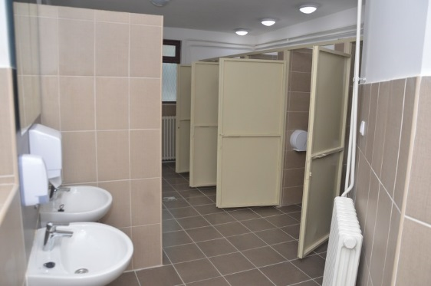
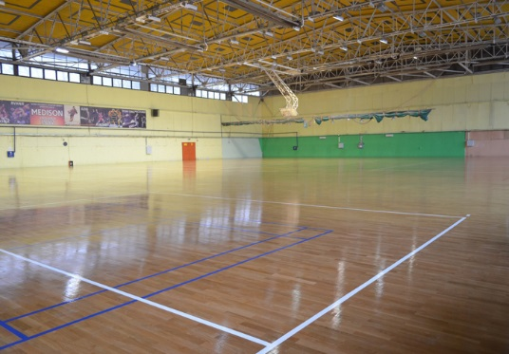
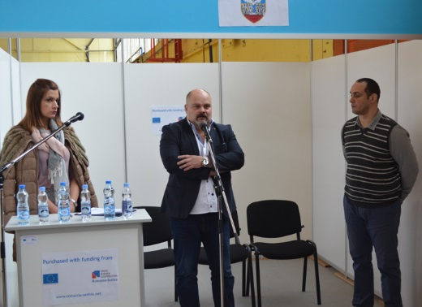

the implementation period (including extensions)
total funds spent/total funds contracted *100
indicators and level of achievement against targets set

