Project information
CALL FOR PROPOSALS | 2
MIS-ETC: | 1387
PRIORITY AXIS: | 3. Promoting “people to people” exchanges
MEASURE: | 3.1 Support the development of civil society and local communities
PROJECT TITLE: | Social Equal Opportunities
ACRONYM: | SEO
DURATION: | 05.04.2013 – 04.06.2014
IPA FUNDS CONTRACTED: | 220.915,00€
TOTAL FUNDS CONTRACTED: | 259.900,00€
ABSORBTION RATE (%): | 94,62%

PROJECT OBJECTIVE(S): | Creating conditions for the inclusion of Roma population.  Increasing the level of awareness among Roma population regarding health, education and employment.  Establishing of new working places for most vulnerable social group – Roma women.
SHORT DESCRIPTION OF THE PROJECT: | Hemofarm Foundation and Gipsy Woman Association for Our Children have jointly prepared the project in order to support the Roma population in the region by training 15 Roma women in the field of education, health and employment, visiting 500 Roma families in order to gain the opportunity to get employed, educating 30 children by raising their interest to go to school, organizing a sport tournament and a music festival.

DEGREE OF ACHIEVEMENT OF INDICATORS: | Indicator Indicator value provisioned in the contract Present indicator value % 6= (5)/(3)*100  Output indicators (1) UM (2) Quantity (3) UM (4) Quantity (5)  Project indicators  Roma women educated regarding employment, health and education Number of educated Roma women 10 Number of educated Roma women 10 100  Roma children trained on the topic of education Number of children trained 30 Number of children trained 30 100  Roma women trained by Roma women Number of trained women 50 Number of trained women 50 100  Sport tournament organized Number of organized tournaments 1 Number of organized tournaments 1 100  Music Festival implemented Number of implemented festivals 1 Number of implemented festivals 1 100  Study tour implemented Number of participants 1 Number of participants 1 100  Project promoted to a professional and wider public Number of different types of promo material 4000-flyers 2000· educational material 2-billboard, 2000·brochure 4000f·layers, 2000· educational materials 1, 2000· educational materials 2, 5000· educational materials 3, 2000·brochures, 3000-survey Number of different kinds of promo material 4000-flyers 2000· educational material 2-billboard, 2000·brochure 4000f·layers, 2000· educational materials 1, 2000 · educational materials 2, 5000· educational materials 3, 2000·brochures, 3000-survey 100  Result indicators  Increased social and cultural integration of people in the border areas Number of participants benefiting from cross-border social and cultural events 10 Roma women educated, 30 Roma children educated, 50 Roma women educated Number of participants benefiting from cross-border social and cultural events 10 Roma women educated, 30 Roma children educated, 50 Roma women educated 100
RESULTS ACHIEVED: | 10 Roma women educated;  500 Roma families visited;  30 children educated;  50 women educated;  500 hygiene packages distributed;  1 sport tournament implemented;  1 Music festival organized;  Project promotion implemented.

Partnership information
 |  | COUNTRY | COUNTY/DISTRICT | BUDGET(EURO) | CONTACT DETAILS
LEAD PARTNER: | Foundation Hemofarm | Serbia | South Banat | 145.900,00 | Vršac, Beogradski put bb  Tel. +381 13 830915
PARTNER 2: | Gipsy Women Association „For our children” | Romania | Timiş | 114.000,00 | Timisoara, Dorobantilor Street no 42,  Tel: 0256/206083

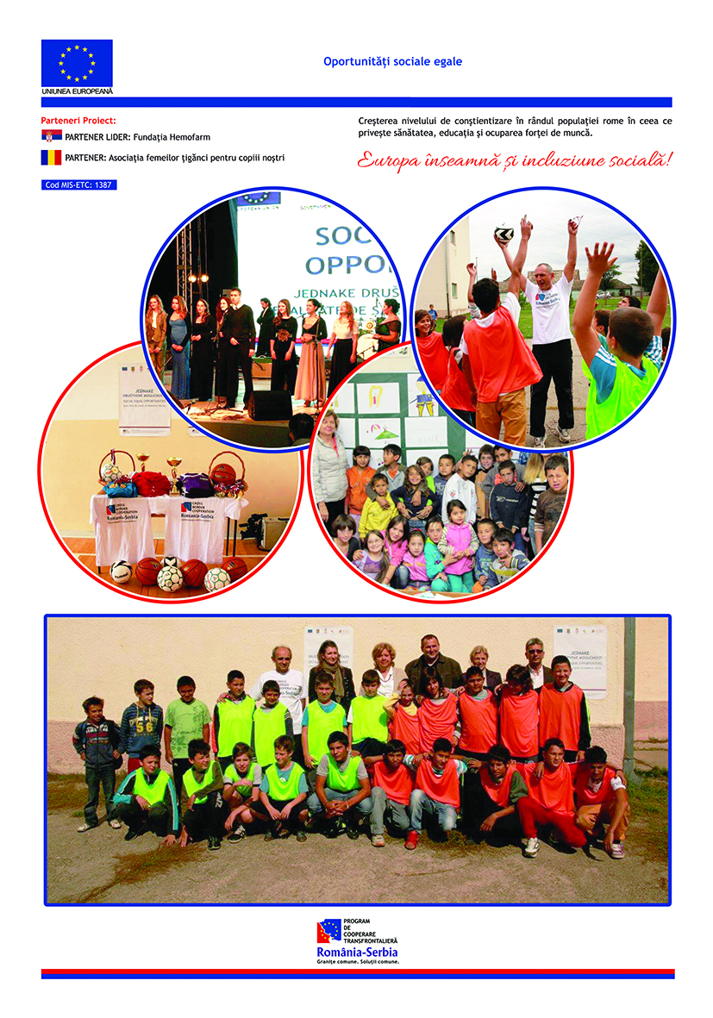

the implementation period (including extensions)
total funds spent/total funds contracted *100
indicators and level of achievement against targets set

