Project information
CALL FOR PROPOSALS |  | 2
MIS-ETC: |  | 1384
PRIORITY AXIS: |  | 1.Economic and Social Development
MEASURE: |  | 1.3 Promote SME development
PROJECT TITLE: |  | Establishing the cross-border development office
ACRONYM: |  | CBDO
DURATION: |  | 16.10.2015 – 15.10.2016
IPA FUNDS CONTRACTED: |  | 226.259,80 €
TOTAL FUNDS CONTRACTED: |  | 266.188,00 €
ABSORBTION RATE (%): |  | 86,53%
PROJECT OBJECTIVE(S): | To contribute to competitiveness of local development actors through stimulation of business-friendly environment and strengthen institutional support of border area SMEs and foreign investors through establishment of Cross border development office - CBDO – a unique location with synchronized and improved approach and service provision to business sector and investors.
SHORT DESCRIPTION OF THE PROJECT: | Cross border development office was established in Zitiste (Serbia) and Sacalaz (Romania) and it were founded in order to facilitate a better communication between the SMEs and investors from Romania and Serbia. The staff of the CBDO office had 10 training modules with the following subjects: Training in strategy development and action planning in Romania, Training in Project Management for IPA funds, Training in promotion of local investment potentials in Serbia, Training of trainers for start-up in Serbia, HR level 1 and 2 in Serbia and Training in public procurement and PRAG procedures in Romania.
DEGREE OF ACHIEVEMENT OF INDICATORS: | Indicator Indicator value provisioned in the contract Present indicator value % 6= (5)/(3)*100  Output indicators (1) UM (2) Quantity (3) UM (4) Quantity (5)  Improved capacity and cross-border contacts of SMEs and in the R&D sector Number of SMEs 15 Number of SMEs 15 100%  People in labour force with qualifications received / improved from joint training activities Number of people in labour force with qualifications received 25 Number of people in labour force with qualifications received 25 100%  Result indicators  Increased SME’s capacity in the border area Number of SMEs Up to 15 SMEs Number of SMEs 15 100%  Project indicators  Increased number of SMEs in joint work Number of contacts At least 15 % increased number of SMEs joint work in the next 3 year Number of contacts 2 100%  Increased number of investments in border area Number of investments At least 25% increased number of investments in the border area Number of investments 2 100%

RESULTS ACHIEVED: | - Cross border development office CBDO was established and 1 founding agreement was signed and 7 people was employed (5 from Serbia and 2 from Romania)  - Improved capacities of CBDO staff, through intensive capacity building trainings (10 training modules performed), 25 people from region were educated and 50 delivery services were realized.  - A business-friendly environment was created, which was achieved with equipping of 15 SMEs with wireless internet connection and providing free wireless internet connection in the centre of Zitiste for potential investors.

Partnership information
 |  | COUNTRY | COUNTY/DISTRICT | BUDGET(EURO) | CONTACT DETAILS
LEAD PARTNER: | Municipality of Zitiste | Serbia | Central Banat | 180.060,00 | Zitiste, Cara Dusana 15  Tel. +381 23 821 306
PARTNER 2: | Local Council Of Sacalaz | Romania | Timis | 86.128,00 | No.368 Sacalaz  Tel. +40 256 367101

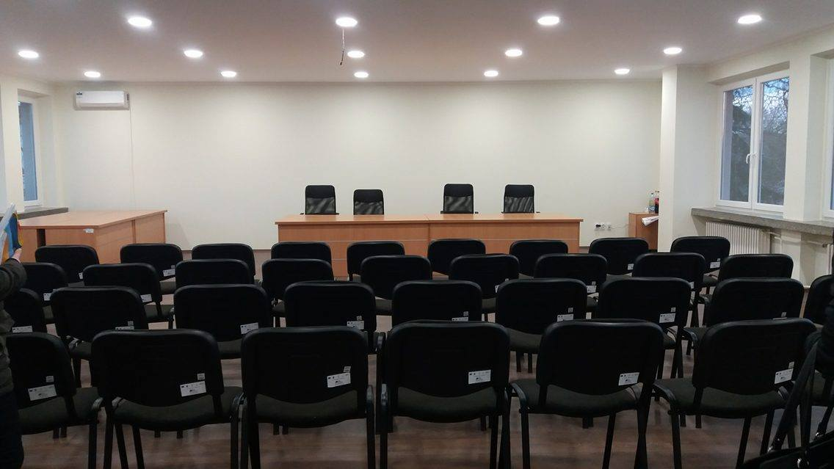
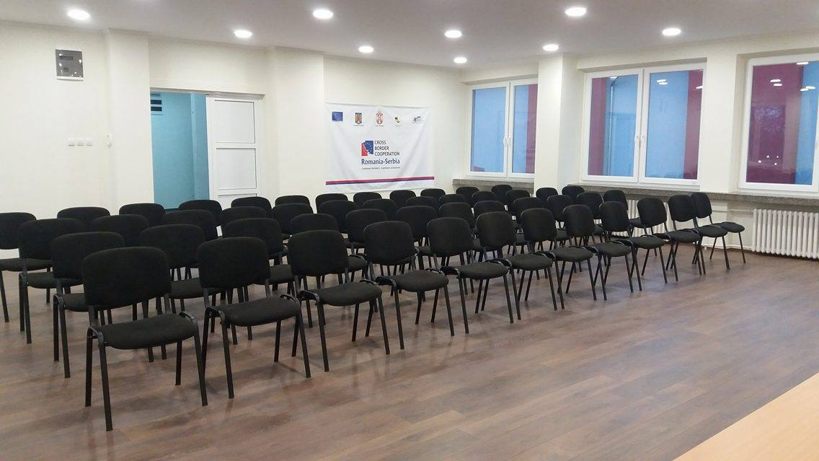
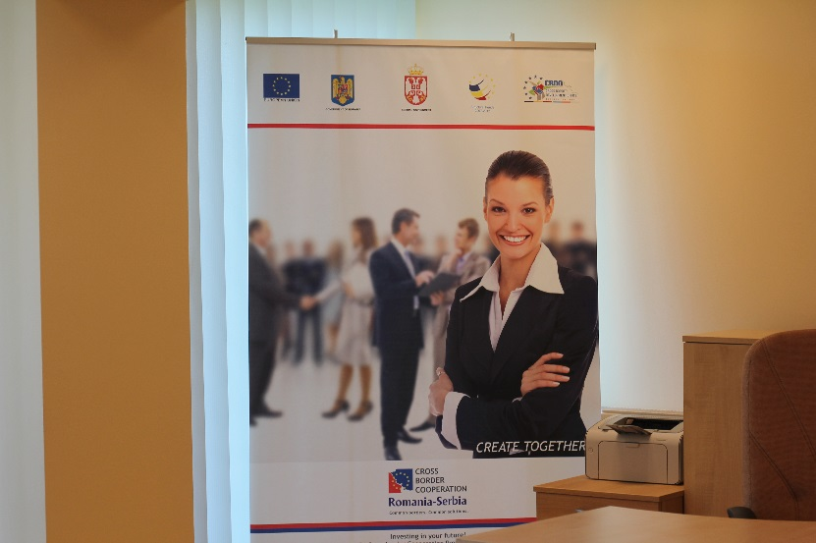
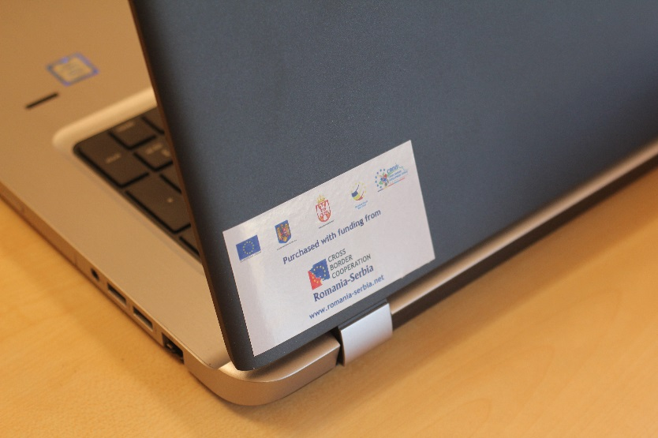

the implementation period (including extensions)
total funds spent/total funds contracted *100
indicators and level of achievement against targets set

