Project information
CALL FOR PROPOSALS |  | 2
MIS-ETC: |  | 1379
PRIORITY AXIS: |  | 3. Promoting “people to people” exchanges
MEASURE: |  | 3.3 Increase educational, social cultural and sporting exchanges
PROJECT TITLE: |  | Cross-border access infrastructure to high level education through web-casts
ACRONYM: |  | EduWebCast
DURATION: |  | 19.12.2013 – 18.06.2015
IPA FUNDS CONTRACTED: |  | 232.589,75€
TOTAL FUNDS CONTRACTED: |  | 273.635,00€
ABSORBTION RATE (%): |  | 94,80%
PROJECT OBJECTIVE(S): | - Increasing educational exchanges through a common cross-border approach in the area of technical education by implementing an Education webcast system.  - Creating a cross-border partnership between the Faculty of Automation and Computers from Timisoara and the Technical Faculty from Zrenjanin.  - Improving the quality of education for the students and pupils from the border area.  - Increasing the overall competitiveness of the economy in the border area.
SHORT DESCRIPTION OF THE PROJECT: | The project presented an innovative cooperation model based on a web portal that allows subjects from both countries to have access to common educational materials, know-how and practical applications (laboratory materials) aimed to capture the interest of students as well as pupils who are interested in following a technical education. The project included cooperation activities which could not be achieved without the partnership between the two universities and that include defining the lectures and educational material recorded and posted on the portal.

DEGREE OF ACHIEVEMENT OF INDICATORS: | Indicator Indicator value provisioned in the contract Present indicator value % 6= (5)/(3)*100  Output indicators (1) UM (2) Quantity (3) UM (4) Quantity (5)  Result indicators  Improved knowledge of culture, history, society, organizational and institutional structure, and language of the neighbouring country Number of participants gained knew knowledge in events promoting the neighbouring country 500 persons who access the Edu Webcast system Number of participants gained knew knowledge in events promoting the neighbouring country 2.076 415,2%  Improved quality of life and increased attractiveness of the border communities as a living place Number of activities, actions, initiatives developing new or improving existing educational and social services, or improving other local living conditions 1 EduWebCast system including the common portal in Romania and 1 EduWebCast system in Serbia Number of activities, actions, initiatives developing new or improving existing educational and social services, or improving other local living conditions 2 100%  Project indicators  Initiative for learning activities using ITC tools The number of EduWebCast systems used for the learning activities and hosted in Serbia 1 The number of EduWebCast systems used for the learning activities and hosted in Serbia 1 100%  Initiative for learning activities using ITC tools The number of EduWebCast systems used for the learning activities and hosted in Romania including the joint platform 1 The number of EduWebCast systems used for the learning activities and hosted in Romania including the joint platform 1 100%  Lectures available through the portal The number of materials that will be broadcasted through the portal 12 The number of materials that will be broadcasted through the portal 12 100%  Users accessing the portal The number of accesses per month 1000 The number of accesses per month 1.543 154,3%  Joint meetings between the partners Number of meetings attended by members of both teams 4 Number of meetings attended by members of both teams 5 125%  Information and publicity common events Number of conferences and announcements for promoting the project 3 Number of conferences and announcements for promoting the project 3 100%  Information and publicity common events Number of announcements for promoting the project 2 Number of announcements for promoting the project 2 100%  Information and publicity common events Number of leaflets for events 400 Number of leaflets for events 400 100%  Information and publicity common events Number of posters for events 2 Number of posters for events 2 100%  Information and publicity common events Number of months for Web promotion 3 Number of months for Web promotion 6 200%

RESULTS ACHIEVED: | - Joint meetings, multimedia content materials for proposed courses. Professional version of curricula designed, recorded, tested and finished. Joint meetings are held to support these activities and in order to make· joined efforts and expertise into creating the lectures and educational material that will be web casted and made available for all the target groups.  - Running educational web casting system. The EduWebCast System is purchased, installed and configured. The system is now in the full usage stage. The system has over 2,076 users.  Project website : http://eduwebcast.upt.ro/news.php

Partnership information
 |  | COUNTRY | COUNTY/DISTRICT | BUDGET(EURO) | CONTACT DETAILS
LEAD PARTNER: | University “Politehnica” of Timisoara | Romania | Timis | 168.255,00 | Timisoara, P-ta Victoriei no.2  Tel. 0040256403211
PARTNER 2: | Technical Faculty “Mihajlo Pupin” Zrenjanin | Serbia | Middle Banat | 105.380,00 | Zrenjanin, Djure Djakovica bb  Tel. +38123550515

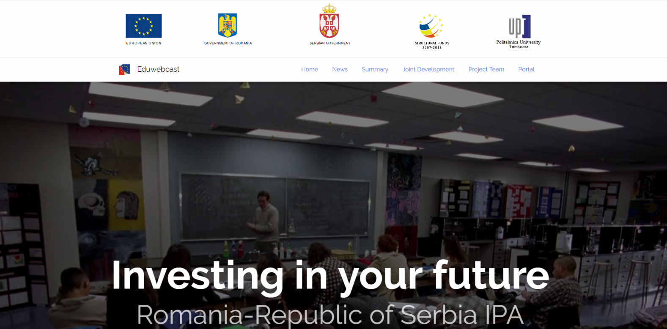
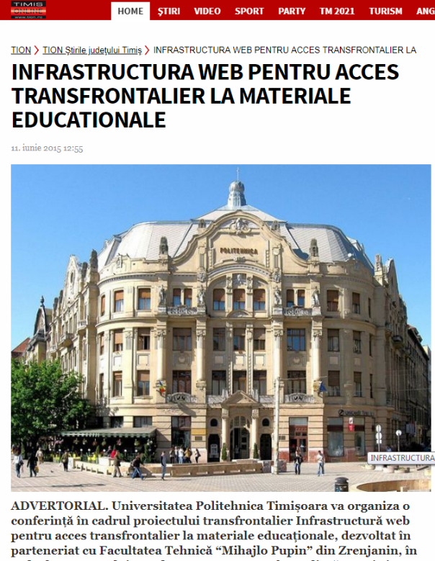

the implementation period (including extensions)
total funds spent/total funds contracted *100
indicators and level of achievement against targets set

