Project information
CALL FOR PROPOSALS | 2
MIS-ETC: | 1378
PRIORITY AXIS: | 1.Economic and Social Development
MEASURE: | 1.2 Develop the tourism sector, including the strengthening of the regional identity of the border region as a tourist destination
PROJECT TITLE: | Capitalization of the cross-border tourist potential, including bicycle lane along Bega River, downstream Timisoara
ACRONYM: | TZBL Timisoara-Zrenjanin Bicycle lane
DURATION: | 29.03.2013 – 28.03.2015
IPA FUNDS CONTRACTED: | 1.908.279,26€
TOTAL FUNDS CONTRACTED: | 2.245.034,42€
ABSORBTION RATE (%): | 98,97%

PROJECT OBJECTIVE(S): | Increase competitiveness by improving the accessibility and connectivity of the cross-border regions by alternative tourist transport infrastructure.  Improving the alternative transport connections by creating a bicycle lane between Timisoara and Zrenjanin.
SHORT DESCRIPTION OF THE PROJECT: | The main subject of the project was construction of the 37 km long bicycle trail alongside Bega River downstream Timisoara to the Serbian border, as an alternative transport infrastructure for recreation and leisure in the cross-border area  The bicycle lane starts in Timisoara, near the railway bridge Modoș from the Street Ion Românu and continues along Bega River Chanel, passing in vicinity of the villages Utvin, Sinmihaiu Roman, Uivar and Otelec, and up to the border between Romania and Serbia. The bicycle trail will be of 2.00 m width, with 2 lanes and a single cross slope of 1%.  On the Serbian side, City of Zrenjanin Feasibility study for the bicycle lane along the Bega River from RO-SER border to Klek village and the inner cycle path in the City of Zrenjanin which succeeded to obtain finance though the project RORS 15 (Interreg IPA CBC Romania-Serbia call for strategic projects).
Short video about the project | https://www.youtube.com/watch?v=l0_AyIlit-8&t=8s

DEGREE OF ACHIEVEMENT OF INDICATORS: | Indicators  Improved physical infrastructure in the border area  New or improved cross-border tourism products, joint marketing approaches/ activities or joint tourism information services developed  Result indicators Indicator value provisioned in the contract Present indicator value %  Name 1 UM 2 Quantity 3 UM 4 Quantity 5 6= (5)/(3)*100  New or improved cross-border transport links and logistics capacity in the border area Number of new transport links 1 Number of new transport links 1 100%  Increased number of passengers Number of passengers 8000 Number of passengers 8744 109.3%  Project indicators Indicator value provisioned in the contract Present indicator value %  Name UM 2 Quantity 3 UM 4 Quantity 5 6= (5)/(3)*100  Engineering design documents and execution documents for the bicycle lane done Completed technical documentation for route Timisoara border with Serbia 1 Completed technical documentation for route Timisoara border with Serbia 1 100%  Finalizing the execution works on the bicycle lane Km of lane built 37 Km of lane built 37 100%  Making the Feasibility Study on the Serbian track, Romanian border to Zrenianin Town Technical documentation for making the bicycle lane from Zrenjanin – to the border with Romania 1 Technical documentation for making the bicycle lane from Zrenjanin – to the border with Romania 1 100%

RESULTS ACHIEVED, INCLUDING PHOTOS: | Engineering design documents and execution documents for the bicycle lane, including the construction authorization.  Bicycle lane of 37 km long in Romania, Timisoara – border with Serbia.  Feasibility Study on the Serbian track, Romanian border- Zrenjanin.  Basic preconditions for movement of people and goods in cross border area established for further development of border crossing.

Partnership information
 |  | COUNTRY | COUNTY/DISTRICT | BUDGET(EURO) | CONTACT DETAILS
LEAD PARTNER: | Banat River Basin Administration | Romania | Timiş | 2.006.005,43 | Timisoara, 32, Mihai Viteazu Bvd.  Tel. 0040256/491848
PARTNER 2: | TIMIS COUNTY COUNCIL | Romania | Timiş | 5.589,77 | Timisoara, Bd. Revoluţiei din 1989, nr.17  Tel. +40-256-406 323
PARTNER 3: | City of Zrenjanin | Serbia | Middle Banat | 233.439,22 | Zrenjanin, Trg slobode 10  Tel. +381 23 315 00 94

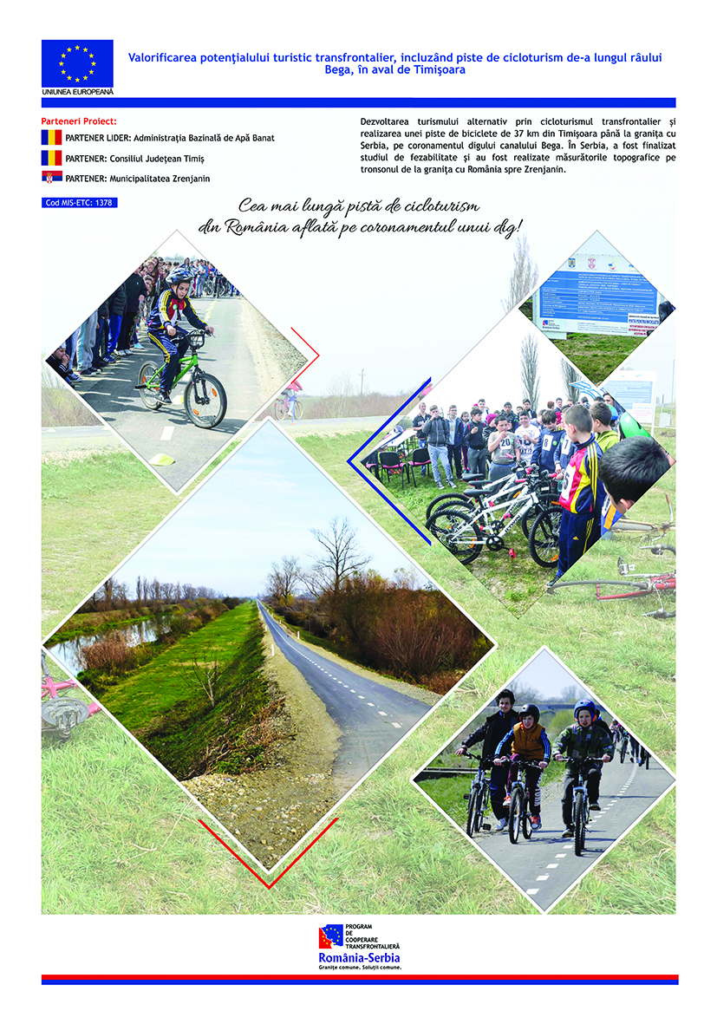

the implementation period (including extensions)
total funds spent/total funds contracted *100
indicators and level of achievement against targets set

