Project information
CALL FOR PROPOSALS | 2
MIS-ETC: | 1371
PRIORITY AXIS: | 3. Promoting “people to people” exchanges
MEASURE: | 3.3 Increase educational, social cultural and sporting exchanges
PROJECT TITLE: | Mountain Cycling Paths in Banat Area
ACRONYM:
DURATION: | 27.10.2015 – 26.10.2016
IPA FUNDS CONTRACTED: | 221.561,85 €
TOTAL FUNDS CONTRACTED: | 260.661,00 €
ABSORBTION RATE (%): | 78,48%

PROJECT OBJECTIVE(S): | Promoting MTB tourism in the Clisura Dunarii as a way of integrating 100 people from both sides of the border for an 18 months period.
SHORT DESCRIPTION OF THE PROJECT: | There is a very rich touristic common heritage between the two regions involved in the project, both a cultural and natural heritage that most of the youth living in these regions are not aware about. Consequently the project offered them the opportunity of participating in a series of youth exchanges and trainings that opened up their horizons, challenged their beliefs and prejudices, facilitated their intercultural learning and developed a series of competences in the field of environmental education. The participants became aware of the common heritage they share, of their similarities and differences and of their own cultural identity. The project invested in tourism, in youth and in their self-development, intercultural competences and civic participation, thus it contributed to the sustainable development of society.

DEGREE OF ACHIEVEMENT OF INDICATORS: | Indicator (1) Indicator value provisioned in the contract Present indicator value % 6= (5)/(3)*100  UM (2) Quantity (3) UM (4) Quantity (5)  Project indicator  Promotion campaign Number of press releases and articles published in both countries during the campaign 8 Number of press releases and articles published in both countries during the campaign 12 150 %  The increasing of the common sport and cultural events in the area of Banat Number of MTB common events in the region 5 Number of MTB common events in the region 5 100%  Improvement in the providing process of cultural and MTB tourism in the region Number of information kits available 2 Number of information kits available. 2 100%  Result indicators  Increased social and cultural integration of people in the border areas Numbers of participants benefiting from cross- border social and cultural events 120 participants Numbers of participants benefiting from cross- border social and cultural events 300 250%  Improved quality of life and increased attractiveness of the border communities as a living place. Number of activities, actions, initiatives developing new or improving existing educational and social services, or improving other local living conditions. A minimum of 5 activities Number of activities, actions, initiatives developing new or improving existing educational and social services, or improving other local living conditions. 5 100%  Improved knowledge of culture, history, society, organizational and institutional structure, and language of the neighbouring country. Number of participants that gained new knowledge in events promoting / profiling the neighbouring country. 40 participants Number of participants that gained new knowledge in events promoting / profiling the neighbouring country. 40 100%  Number of participant s benefit from the training activities 20 Number of participant s benefit from the training activities 20 100%

RESULTS ACHIEVED: | Two bilateral youth exchanges involving 20 youngsters (10 from Serbia and 10 from Romania), implemented on both sides of the frontier of the Banat Mountain region and focused on environmental and intercultural education.  20 trained Mountain Biking guides (10 from Romania and 10 from Serbia) that would act from now on as resource persons.  5 MTB trails explored and described in detail (technical and touristic information) for the interested mountain bikers.  One international event of Mountain Biking in the region of Banat Mountains – The Banat Mountain Biking Marathon 2012.  One Mountain Bike Tourist Guide for the Romanian and Serbian Region of Banat Mountains distributed in printed and digital format.

Partnership information
 |  | COUNTRY | COUNTY/DISTRICT | BUDGET(EURO) | CONTACT DETAILS
LEAD PARTNER: | Town Hall Berzasca | Romania | Caras Severin | 165.605,00 | Berzasca, 282, Main Road  Tel. 07230797768
PARTNER 2: | Municipality of Golubac | Serbia | Branicevski | 52.478,00 | Golubac, Cara Lazara 15  Tel. +38112678128
PARTNER 3: | Bike Attack Resita Association | Romania | Caras-Severin | 42.578,00 | Resita, Petru Maior, Nr.2, Bl.800, cam.321  Tel. +40 255 224033

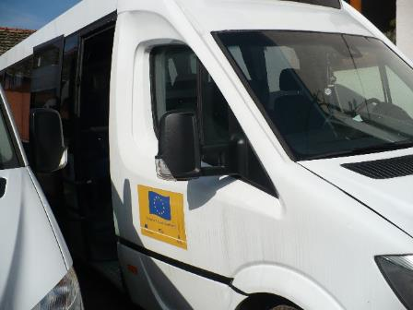
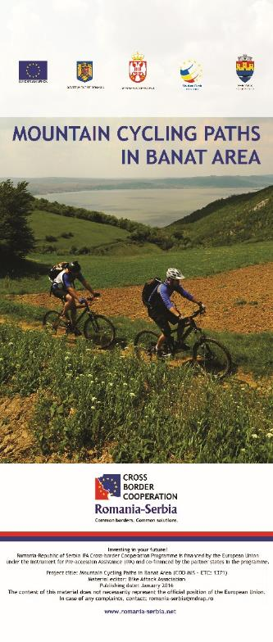
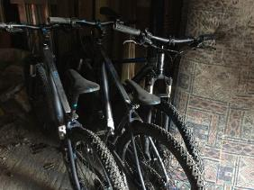
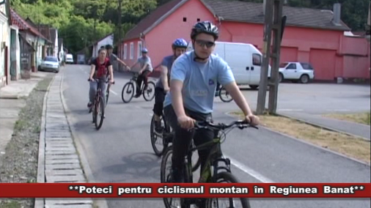
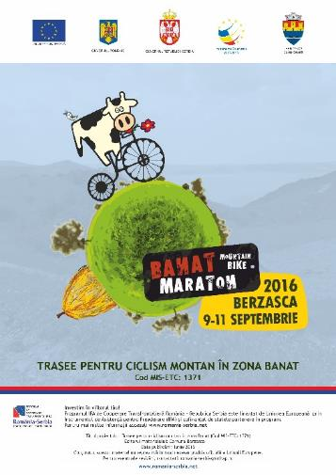
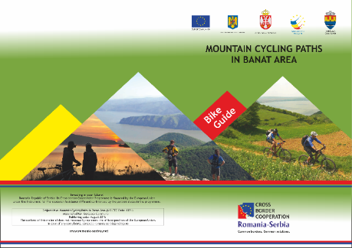

the implementation period (including extensions)
total funds spent/total funds contracted *100
indicators and level of achievement against targets set

