 | Project information
 | CALL FOR PROPOSALS |  | 1
 | MIS-ETC: |  | 1368
 | PRIORITY AXIS: |  | 1.Economic and Social Development
 | MEASURE: |  | 1.2 Develop the tourism sector, including the strengthening of the regional identity of the border region as a tourist destination
 | PROJECT TITLE: |  | Effective Measures to Promote Tourism in Banat
 | ACRONYM: |  | a week in Banat in 4 versions
 | DURATION: |  | 31.12.2013 – 30.06.2015
 | IPA FUNDS CONTRACTED: |  | 260.084,73
 | TOTAL FUNDS CONTRACTED: |  | 305.982,04
 | ABSORBTION RATE (%): |  | 70,90
 | PROJECT OBJECTIVE(S): |  | - Tourism development including strengthening the regional identity of the border region as a tourist destination and improving the quality of life of the border communities.  - Raising awareness and interest for the Banat area.  - Increasing the overall competitiveness of the economy in the border area and economic and social development.
 | SHORT DESCRIPTION OF THE PROJECT: |  | The project achieved to develop tourism on both sides of the border by creating 4 tourist routes, a regional development study, organizing tourism fairs and tourism qualification trainings for 130 persons.
 | DEGREE OF ACHIEVEMENT OF INDICATORS: |  | Indicator value provisioned in the contract Present indicator value % 6= (5)/(3)*100  Output indicators (1) UM (2) Quantity (3) UM (4) Quantity (5)  Result indicators  New or improved cross-border tourism products and services Number of activities, actions, initiatives focusing on promoting tourism in the border area 4 Proposal for four Tourism routes Rural tourist RO 1 Baile Herculane area RO 2 Urban Tourist Route RO 3 Serbia South Banat Route S1 Number of activities, actions, initiatives focusing on promoting tourism in the border area 4 100  Increased SME’s capacity in the border area Number of activities, actions, initiatives focusing on promoting SME’s activity 3 Three Tourism fairs organised Number of activities, actions, initiatives focusing on promoting SME’s activity 3 100  Increased importance of R&D/Innovation in the border area Number of activities focusing on promoting the importance of or dealing directly with R&D/Innovation 4 Proposal for four Tourism routes One route in Romania – Rural tourist RO 1 One route in Romania – Baile Herculane area RO 2 One route in Romania Urban Tourist Route RO 3 One route in Serbia South Banat Route Number of activities focusing on promoting the importance of or dealing directly with R&D/Innovation 4 100  1 Regional Development - Tourism" Study 1 100  Project indicators  Highly technique equipment for tourism promotion in the region pieces 1 pieces 1 100  promotion of the tourist routes pieces 2 pieces 2 100  tourist routes RO 1 rural Swot of the day 7 Swot of the day 7 100  tourist routes RO 2 Baile Herculane Swot of the day 7 Swot of the day 7 100  tourist routes RO 3 urban Swot of the day 7 Swot of the day 7 100  tourist routes Serbia Swot of the day 7 Swot of the day 7 100  tourism fairs RO1 Resita Participation list 1 Participation list 1 100  tourism fairs RO 2 Baile Herculane Participation list 1 Participation list 1 100  tourism fairs S1 Pancevo Participation list 1 Participation list 1 100  Trainings to improve tourism services course 7 course 7 100  Hospitality technician - COR 4222.3.1 participants 15 participants 15 100  Pension administrator - COR 512113 participants 15 participants 15 100  Waiter - COR512302 participants 23 participants 23 100  Bartender - COR 512301 participants 12 participants 12 100  Travel Guide – COR 349101 participants 20 participants 20 100  Seller - COR 522004 participants 30 participants 30 100  Hotel maid - COR 514201 participants 15 participants 15 100  "Regional Development - Tourism" Study participants 1 participants 1 100  Informational materials for the region Pieces 34270 Pieces 34270 100
 | RESULTS ACHIEVED: |  | The tourist routes were identified and tested:  Routes in Romania:  Rural tourist RO 1,  Baile Herculane area RO 2,  Urban Tourist Route RO 3  and one route in Serbia South Banat Route  The Regional Development - Tourism Study was prepared on a detailed basis documentation, made relevant in Caras-Severin – Romania and the South Banat - Serbia, in several sectors and type of tourism (cavers or cycling clubs paragliding, climbing etc.). The base for the study was the SWOT analyses made by the groups and the teams. The study contains evaluations and proposals for a forward tourism approach of the both regions.  Organizing tourism fairs - the fairs were organized in Resita, Baile Herculane and Pancevo and they were an efficient instrument to promote the tourist routes identified.  Trainings to improve tourism services. The following trainings were held:  Hospitality technician - Course type: qualification, level III,  B&B administrator- Course type: qualification, level II,  Waiter - Course type: qualification, level II,  Bartender - Course type: qualification, level I,  Travel Guide - Course type: qualification, level III  Seller - Course type: qualification, level II  Hotel maid - Course type: qualification, level I,  The following promo materials were made:  Tourist Maps (2.500 pcs),  Tourist Presentation CD (3.513 pcs.),  Postcards (14.400 pieces), Leaflets (5000), Catalogues (2500 pcs), Photo Album (500 pieces), Bags (1300 pcs), Roll-up (5 pcs), Banners (2 pcs). Leaflets (5000)
Partnership information
 |  |  |  | COUNTRY | COUNTY/DISTRICT | BUDGET(EURO) | CONTACT DETAILS
LEAD PARTNER: |  | Directorate of Public and Private Administration Domain of Caras-Severin County |  | Romania | Caras-Severin | 206.200,39 | Resita, Piata 1 Decembrie 1918, nr. 7  Tel. +4(0)255228864
PARTNER 2: |  | Turistic Club Banatia Foundation |  | Romania | Caras-Severin | 66.154,04 | Resita, Piata 1 Decembrie 1918, nr. 7  Tel. 0255-220052
PARTNER 3: |  | Tourist Organization of Pancevo |  | Serbia | South Banat | 33.627,61 | Pancevo, 2, Sokace  Tel. + 381 13 351 366

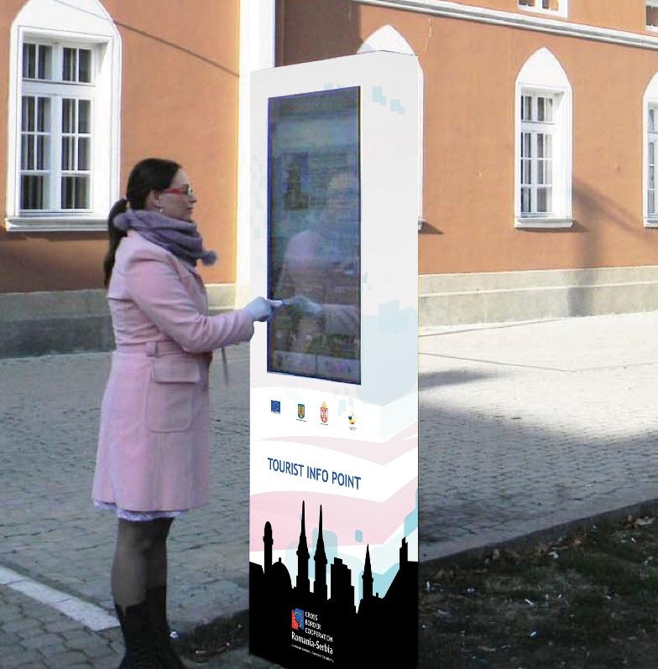
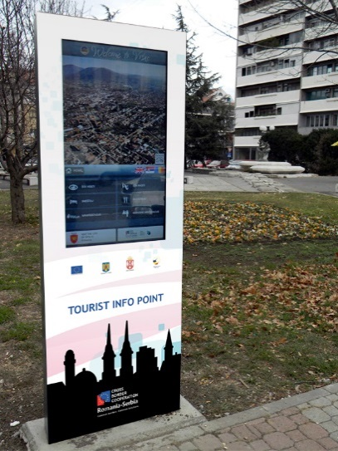
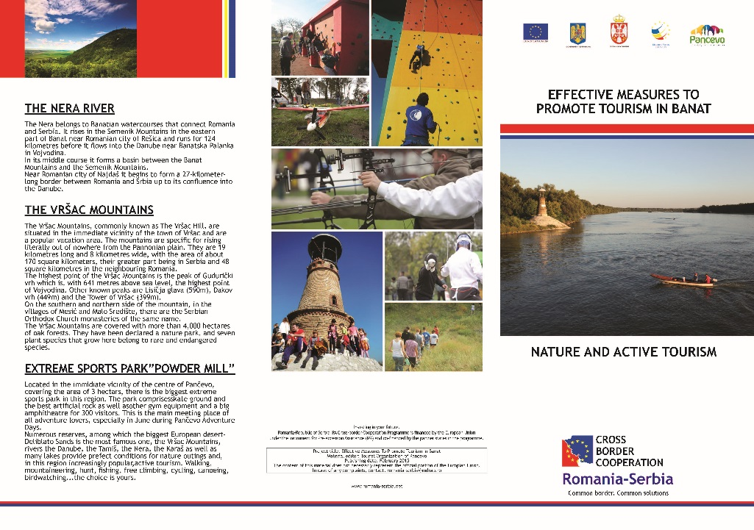
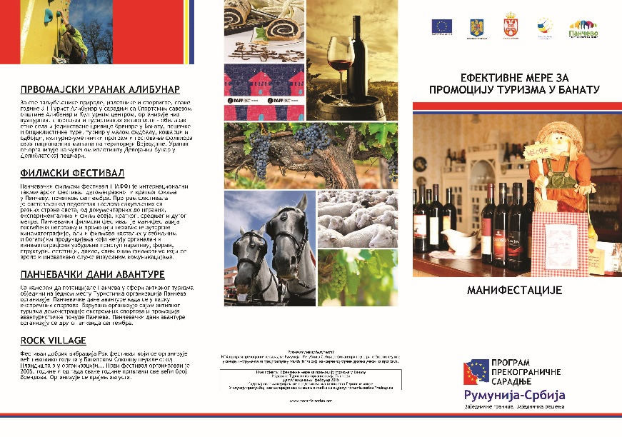
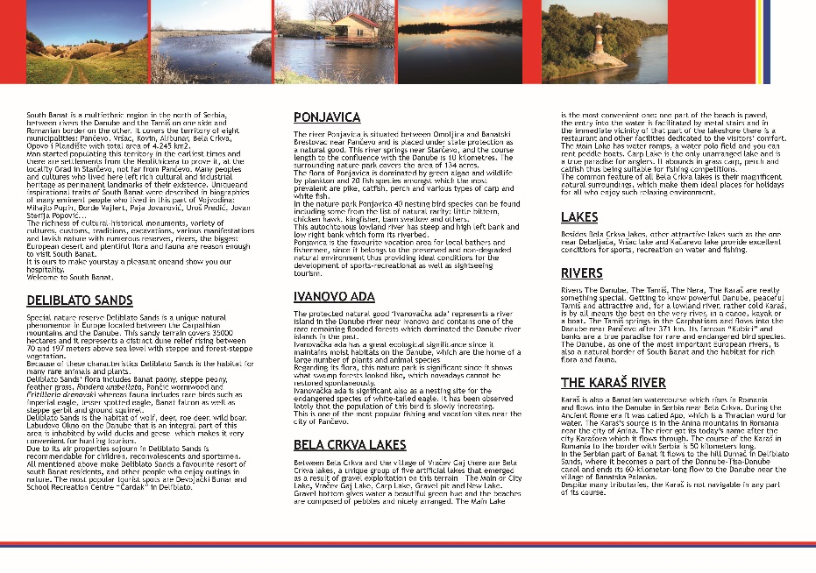
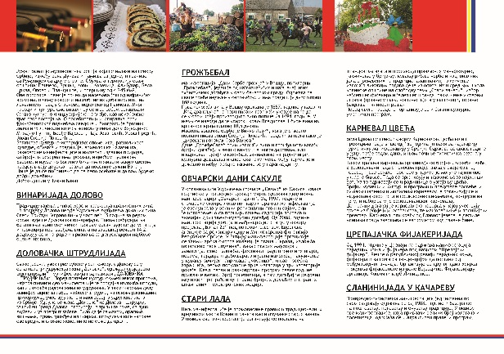

the implementation period (including extensions)
total funds spent/total funds contracted *100
indicators and level of achievement against targets set

