Project information
CALL FOR PROPOSALS | 2
MIS-ETC: | 1358
PRIORITY AXIS: | 1.Economic and Social Development
MEASURE: | 1.2 Develop the tourism sector, including the strengthening of the regional identity of the border region as a tourist destination
PROJECT TITLE: | Joint development of Romanian – Serbian Bega Channel tourism potential capitalization. Study and promotion of cross-border foreground investments
ACRONYM:
DURATION: | 15.06.2013 – 14.12.2014
IPA FUNDS CONTRACTED: | 424.319,15€
TOTAL FUNDS CONTRACTED: | 499.199,00€
ABSORBTION RATE (%): | 77,41%

PROJECT OBJECTIVE(S): | Cross–border cooperation promotion through the development of Romanian – Serbian tourism sector strategic planning.  Improving cross–border tourism development strategic framework through the institutional cross–border partnership for the formulation of the Joint Strategic Programme and promotion of joint foreground investments projects for the capitalization of Bega Channel tourism potential.  Bega Channel tourism potential capitalization through the promotion of the joint action plan, of joint projects portfolio, of partnerships and associative structures that strengthen the cooperation between the cross – border area tourism responsible actors.

SHORT DESCRIPTION OF THE PROJECT: | From more points of view, the Bega Channel is one of the key linkers of Romanian and Serbian communities.  Having a total length of 116 km (44 km on Romanian territory and 72 km on Serbian territory), the Bega Channel could be considered a living boulevard between the two countries. The aim of the project has been the collection and processing of relevant data for the tourism potential status-quo analysis (SWOT, statistical analysis, integration of existing studies), to debate and set up the Strategic Development Concept for Bega Channel - priority directions actions, targets, measures and necessary resources which define the development and exploitation of existing cross – border tourism potential, to define and agree the Bega Channel Tourism Potential Development and Exploitation Strategic Program and the Common Action Plan.  The project emphasized the joint need of revitalizing and rehabilitation of Bega Channel.  Foreseeing a joint formulation of Channel’s Development Programme alongside joint promotion of foreground investments, the project provided the necessary conditions for the sustainable development of the Channel area.  The project sustainability has been ensured through the realization of the first part of the works included in the portfolio of investments projects agreed during the project implementation.

DEGREE OF ACHIEVEMENT OF INDICATORS: | Indicator Indicator value provisioned in the contract Present indicator value % 6= (5)/(3)*100  Output indicators (1) UM (2) Quantity (3) UM (4) Quantity (5)  Project indicators  Increased degree/intensity of Cooperation between public services/public authorities, municipalities Meetings. List of Participants Project reports 24 Meetings. List of Participants Project reports (6 consolidated project reports and 22 meetings 28 116,66%  Increased tourism information and promotion within cross – border area Promotion Conferences 10 Promotion Conferences 10 100%  Promotion Materials 1355 Promotion Materials 1731 127,75%  Increased tourism joint strategic planning Strategic Planning Documentation 3 Strategic Planning Documentation (English, Romanian, Serbian) 3 100%  Increase and promotion of foreground investments projects Technical Studies and Terms of references for design and engineering 8 Technical Studies and Terms of references for design and engineering 8 100 %  Result indicators  New or improved cross-border tourism products and services Number of activities, actions, initiatives focusing on promoting tourism in the border area 1 Number of activities, actions, initiatives between local and regional public authorities in tackling joint problems, improving local service provision etc. 1 100%

 | RESULTS ACHIEVED: |  | Creation of the Bega Channel Development Strategic Programme;  Joint projects portfolio: 2 technical studies and 6 terms of references for design and engineering;  Strengthening cross – border contacts and partnerships.
Partnership information
 |  |  |  | COUNTRY | COUNTY/DISTRICT | BUDGET(EURO) | CONTACT DETAILS
LEAD PARTNER: |  | Economic and Social Development Agency Timiș |  | Romania | Timiș | 338.320,00 | Timișoara, Bv. Revoluției din 1989 nr. 17  Tel. 040/256/494131
PARTNER 2: |  | Regional Agency for Socio Economic Development – Banat Ltd. |  | Serbia | Middle Banat | 115.810,00 | Zrenjanin, Čarnojevićeva 1  Tel. +381 23 510 567
PARTNER 3: |  | Regional Chamber of Economy Zrenjanin |  | Serbia | Middle Banat | 45.069,00 | Zrenjanin, Kralja Petra I. 3/1  Tel. +381 23 535-890

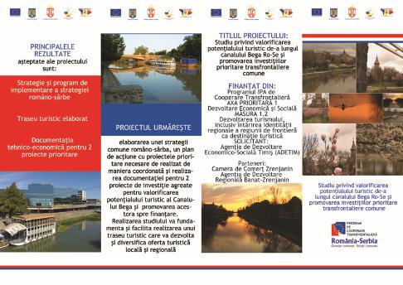
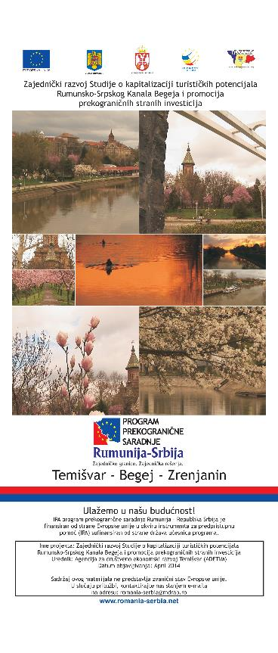

the implementation period (including extensions)
total funds spent/total funds contracted *100
indicators and level of achievement against targets set

