Project information
CALL FOR PROPOSALS | 2
MIS-ETC: | 1357
PRIORITY AXIS: | 3. Promoting “people to people” exchanges
MEASURE: | 3.3 Increase educational, social cultural and sporting exchanges
PROJECT TITLE: | Sport for tolerance
DURATION: | 11.05.2013 – 10.05.2014
IPA FUNDS CONTRACTED: | 128.690,00
TOTAL FUNDS CONTRACTED: | 151.400,00
ABSORBTION RATE (%): | 71,08

PROJECT OBJECTIVE(S): | Strengthen people-to-people connections in the border region through the improvement of sport cooperation.  Organizing football tournaments in the Romanian–Serbian border region, in order to improve the relations between youths in the cross-border communities.  Creating conditions for developing of tolerance among youths in the border region.

SHORT DESCRIPTION OF THE PROJECT: | In order to enable socializing among youth involved in the project, a Football camp has been organized in Secanj (Serbia) and Peciu Nou (Romania). In order to present to the young people the importance of tolerance and non-violence behavior, in the elementary and high schools were organized seminars where the real sport’s values have been presented to the children, especially having in mind that not all children are interested in sport.

DEGREE OF ACHIEVEMENT OF INDICATORS: | Indicator Indicator value provisioned in the contract Present indicator value %6= (5)/(3)*100  Output indicators (1) UM (2) Quantity (3) UM (4) Quantity (5)  Serbian and Romanian football team members involved in project activities Number of participants 160 Number of participants 220 137,5 %  Football coaches and teachers from Secanj and Peciu Nou educated regarding sport tolerance Number of participants 28 Number of participants 30 107%  School youth from Secanj and Peciu Nou involved in activities regarding tolerance Number of participants 1700 Number of participants 1750 103%  Result indicators UM (2) Quantity (3) UM (4) Quantity (5) %  Increased social and cultural integration of people in the border areas Number of participants benefiting from the cross-border social and cultural events 160 members of football clubs involved in trainings, seminars, football school and tournament -Serbian and Romanian coaches and teachers received consulting - Inhabitants of Secanj (16.400) and Peciu Nou (5.100) involved in actions of celebration of the jubilee -250 pupils from elementary and high schools involved in seminars and school actions Number of participants benefiting from cross-border social and cultural events - 160 members of football clubs involved in trainings, seminars, football school and tournament -Serbian and Romanian coaches and teachers received consulting -250 pupils from elementary and high schools involved in seminars and school actions - Inhabitants of Secanj (16.400) and Peciu Nou (5.100) involved in actions of celebration of the jubilee 100%

RESULTS ACHIEVED, INCLUDING PHOTOS: | 2 Sport clubs equipped  Coaches and teachers trained  Football school organized  Football tournament  Sport’s values promoted in elementary and high schools on both sides of the border

Partnership information
 |  | COUNTRY | COUNTY/DISTRICT | BUDGET(EURO) | CONTACT DETAILS
LEAD PARTNER: | Municipality of Sečanj | Serbia | Middle Banat | 94.450,00 | Sečanj, Vozda Karadjordja 57  Tel. +381-23-841-111
PARTNER 2: | Peciu Nou Town Hall | Romania | Timis | 56.950,00 | Peciu Nou, No. 189  Tel. 0256.414.500
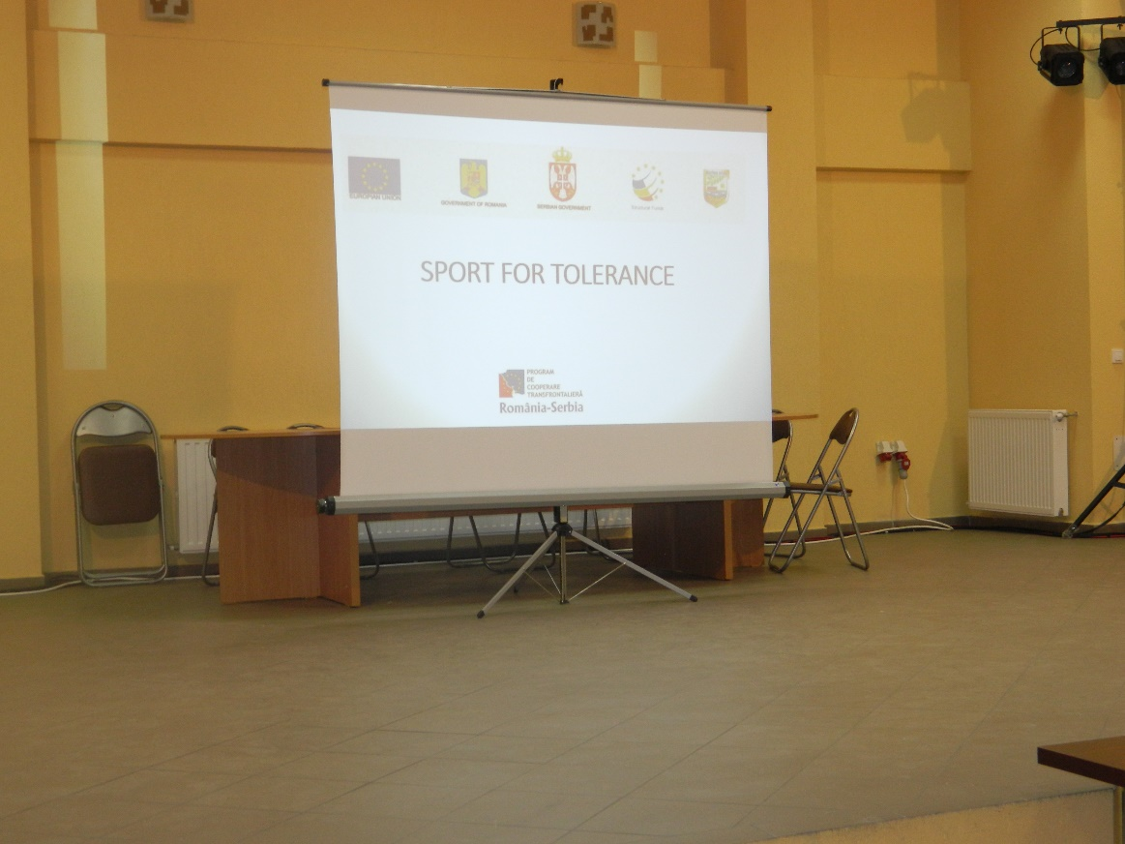
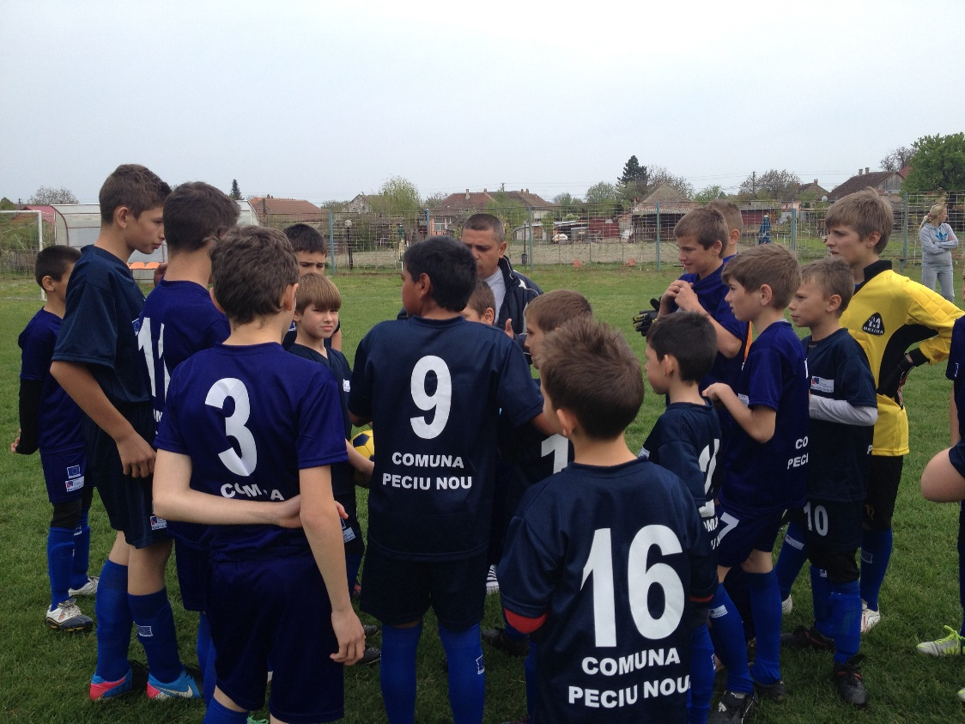

the implementation period (including extensions)
total funds spent/total funds contracted *100
indicators and level of achievement against targets set

