Project information
CALL FOR PROPOSALS | 2
MIS-ETC: | 1352
PRIORITY AXIS: | 3. Promoting “people to people” exchanges
MEASURE: | 3.3 Increase educational, social cultural and sporting exchanges
PROJECT TITLE: | Historical Banat, Romanian Serbian Intercultural Space
ACRONYM: | HiBa Ro–Se
DURATION: | 05.12.2012 – 04.06.2014
IPA FUNDS CONTRACTED: | 219.465,21€
TOTAL FUNDS CONTRACTED: | 258.194,37€
ABSORBTION RATE (%): | 80,45%

PROJECT OBJECTIVE(S): | Educational and cultural development of the cross-border regions Timiş and Južno-Banatski.  Promotion and protection of the common cultural heritage of the Romanians from the Serbian Banat and of the Serbians from the Romanian Banat.  Promoting the preservation of traditions in the historical Banat by organizing specific events.  Increase educational and cultural exchange.  Increase the cultural access of the citizens at the level of cross-border communities.
SHORT DESCRIPTION OF THE PROJECT: | Both cross-border areas, namely the Romanian Timiş County and the Serbian Južno-Banatski District, share common cultural elements as concerning local history and environment, literature and ethnography. The cultural development of both areas can be improved and developed by transforming the disadvantages of the dividing border in advantages related to the common cultural heritage and values trough specific activities. In this regard, 30 Serbian students from Timisoara and 30 Romanian students from Vršac participated in two language contests consisting of two parts: literary language and archaisms and another 25 teenagers from Romania and 25 from Serbia participated during 1 week to an educational camp.
Film of the project |  | https://www.youtube.com/watch?v=c7guejPEm1E

DEGREE OF ACHIEVEMENT OF INDICATORS: | Indicator (1) Indicator value provisioned in the contract Present indicator value % 6= (5)/(3)*100  UM (2) Quantity (3) UM (4) Quantity (5)  Project indicators  Developing civil society within border area; The number of NGOs implementing cross-border projects 3 The number of NGOs with cross-border projects implemented 3 100%  Enhance cultural exchanges between the two nations; Number of participants in cross- border exchanges events between the two nations 1000 Number of participants in cross- border exchanges events between the two nations 1000 100%  Increase cultural integrity within the border areas Timis and Južno Banatski; Number of participants to benefit by cross – border cultural events 1000 Number of participants to benefit by cross – border cultural events 1000 100%  Improving knowledge of culture, history and language of the neighboring countries; The number of participants in the language contest; 60 The number of participants in the language contest; 60 100%  Improved knowledge of culture, history and language of the neighboring countries. Number of beneficiaries of the awareness campaign. 2000 Number of beneficiary’s awareness campaign. 2000 100%  Result indicators  Increase social and cultural integration of people in the border areas; Number of participants benefiting from cross-border social and cultural events 2000 Number of participants which benefit from cross-border social and cultural events 2000 100%  Improved quality of life and increase the attractiveness of the border communities as a living place; Number of activities, actions, initiatives in developing, new or improving existing educational and social services, or improving other local living conditions 1500 Number of activities, actions, initiatives in developing, new or improving existing educational and social services, improving other local living conditions 1500 100%  Improved knowledge of culture, history, society, organizational and institutional structure and language of the neighboring country; Number of participants who obtain knowledge through promotional events / profiled on the neighbor country; 2000 Number of participants who obtain knowledge through promotional events / profiled on the neighbor country; 2000 100%
RESULTS ACHIEVED, INCLUDING PHOTOS: | 10000 flyers distributed for promoting the project;  2000 persons informed on the common cultural heritage of the two cross border regions;  100 participants in the conference “The importance of culture in Banat”;  10 cultural personalities participating in the conference “The importance of culture in the historical Banat”;  1 media campaign on the event “The importance of culture in the historical Banat”;  60 teenagers - participants in the language contest;  50 teenagers - participants to the educational camp in Romania and Serbia;  1 event, the days of Banat folklore and 1 traditional products fair in Serbia organized;  1 event, the days of Banat folklore and 1 traditional products fair in Romania;  1000 participants at the folklore event on each side of the border;  1000 participants at the fair on each side of the border;  4 arts workshops, 2 on each side of the border; 20 participants/workshop;  1 Romanian – Serbian quarterly magazine published in 10.000 copies.

Partnership information
 |  | COUNTRY | COUNTY/DISTRICT | BUDGET(EURO) | CONTACT DETAILS
LEAD PARTNER: | Banat European Union from Romania Association - UEBR | Romania | Timiş | 179.864,37 | Timisoara, 16, General Dragalina Street, ap. 2  Tel. 0040 256 247 490
PARTNER 2: | Literary Commune Vrsac | Serbia | South Banat | 26.110,00 | Vrsac, Sterijina kuca Trg Save Kovacevica nr. 11  Tel. 013839773
PARTNER 3: | The Center for Culture and Arts of the Timis County | Romania | Timiş | 10.340,00 | Timisoara, 1st. Emanoil Ungureanu Street  Tel. 0040 256 435 158
PARTNER 4: | Banat Village Museum | Romania | Timiş | 15.540,00 | Timisoara, Aleea CFR, nr. 1  Tel. 0040256 225 588
PARTNER 5: | Grammar School ”Borislav Petrov Braca” | Serbia | South Banat | 26.340,00 | Vrsac1 Mihajla Pupina Street  Tel. +381 13 836448

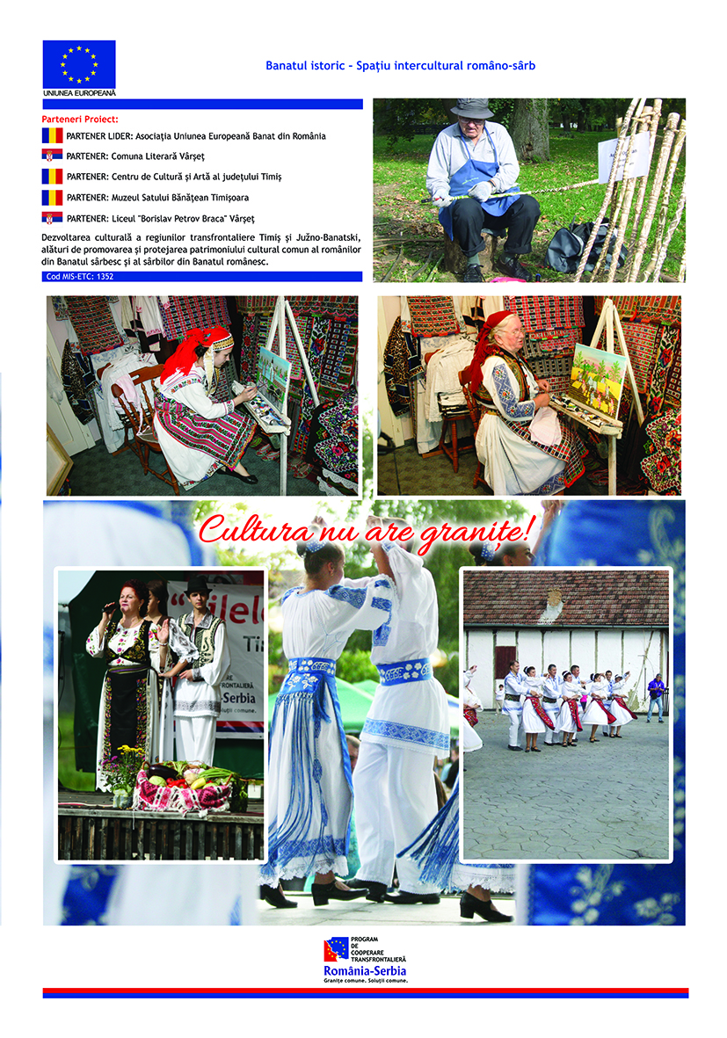

the implementation period (including extensions)
total funds spent/total funds contracted *100
indicators and level of achievement against targets set

