Project information
CALL FOR PROPOSALS | 2
MIS-ETC: | 1345
PRIORITY AXIS: | 1.Economic and Social Development
MEASURE: | 1.1 Support for local/regional economic and social infrastructure
PROJECT TITLE: | Point for Crossing the Danube by Ferry between Moldova Noua and Golubac Localities
ACRONYM: | Moldova Noua Ferry
DURATION: | 13.12.2013 – 31.12.2016
IPA FUNDS CONTRACTED: | 1.999.772,39
TOTAL FUNDS CONTRACTED: | 2.352.673,40
ABSORBTION RATE (%): | 42,07
PROJECT OBJECTIVE(S): | Balanced economic and social development of the Danube Clisura - border area between Serbia and Romania, through promoting of joint actions to stimulate cross-border economic relations, while supporting economic diversification and capitalizing the historical, cultural and natural values in the framework of joint cross-border projects aiming development of inter-modal transport infrastructure and economic services.  Increasing the overall competitiveness of the economy in Moldova Noua and Golubac areas by making inter-modal river transport infrastructure.  Stimulation of interregional cross-border cooperation by promoting economic exchanges on both Danube shores, as the main means of economic and social development.  Increasing life quality of communities from Danube Clisura cross-border area, by achieving an integrated economic and touristic offer and a program of Romanian-Serbian joint actions.
SHORT DESCRIPTION OF THE PROJECT:
DEGREE OF ACHIEVEMENT OF INDICATORS: | Immediate Result indicators (output) The value of the indicator set forth by the contract The value of the indicator reported in the previous reports The value of the indicator reported during the current period of reporting The total achievements up to date Differences compared to the values set forth in the contract  Name UM Quantity Quantity Quantity Quantity (±%)  New or improved cross-border transport links and new or improved logistics capacity in the border area The number of activities, actions, initiatives to create new transport links or improve existing transport links or addressing logistical capacity - 1 Point for crossing the Danube by ferry-boat for passengers and auto vehicles in Moldova Noua; - 1 Point for crossing the Danube by ferry-boat for passengers and auto vehicles in Usije, Golubac Municipality; - 1 Romanian border crossing point in Moldova Noua; - 1 Connection road to DN57 in Moldova Noua; - 1 Link road in Usije; Connection road Usije- Veliko Gradiste. 0 0 0 100%  Result indicators The value of the indicator set forth by the contract The value of the indicator reported in the previous reports The value of the indicator reported during the current period of reporting The total achievements up to date Differences compared to the values set forth in the contract  Name UM Quantity Quantity Quantity Quantity (±%)  Making an inter-modal river transport infrastructure and a border crossing point with direct implications on investment attractiveness, economic and social development and tourism of the Moldova Noua, Golubac and Veliko Gradiste Surface of the general platform made in the project (sqm) 2472 sqm 0 0 0 0%  Surface of the sidewalks made ​​in the project (sqm) 272 0 0 0 0%  Length of the ramp (m) 20 0 0 0 0%  Length of Danube bank protection (m) 2x60 0 60 60 50%  Length of fencing (m) 300 0 0 0 0%  Length of the rehabilitated connection road to DN57 (m) 1200 0 0 0 0%  Length of the rehabilitated connection road ferry access Usije (m) 450 0 198 0 44%  Length of the rehabilitated connection road to Veliko Gradiste (m) 7449 0 0 0 0%  number of ferries purchased 1 0 0 0 0%  Number of pontoons purchased 1 0 0 0 0%  Number of the new border crossing points opened 1 0 0 0 0%  Number of border crossings through the new point/ year 10000 0 0 0 0%  Increasing the economic and tourism interest for Moldova Noua, Golubac and Veliko Gradiste localities and their surroundings Number of new economic agents appeared in Moldova Noua, Golubac and Veliko Gradiste area 8 0 0 0 0%  Dynamics of local revenues obtained from taxes and contributions on economic activities X+n 0 0 0 0%  The turnover of the touristic services in the area X+n 0 0 0 0%  Annual number of tourists (number of nights spent in Moldova Noua, Golubac and Veliko Gradiste localities) 13000 0 0 0 0%  Annual growth in the number of tourists 5% 0 0 0 0%  Increasing life quality of inhabitants in Moldova Noua, Golubac and Veliko Gradiste localities Increasing annual income per capita in the city of Moldova Noua Y+M 0 0 0 1 0%  Increasing annual income per capita in the Golubac municipality Y+M 0 0 0 0%  Increasing annual income per capita in the Veliko Gradiste municipality Y+M 0 0 0 0%  Creation of new permanent jobs Number of newly created permanent jobs 20 0 0 0 0%  Number of persons employed in the system compared to the one proposed by the project 20+n 0 0 0 0%
RESULTS ACHIEVED: | R1: Realization of an inter-modal river transport infrastructure and of a border crossing point with direct implications on the investment attractiveness, economic and social development and tourism in the Moldova Noua-Golubac border area:  1 ferry was purchased, connection road to ferry access Usije rehabilitated and new border crossing point on the Serbian side was constructed (but it is not functional yet).  R2: Increasing the economic and tourism interest for Moldova Noua and Golubac localities and their surroundings - Not the case yet  R3: Increasing life quality of inhabitants in Moldova Noua and Golubac - Not the case yet  R4: Creation of new permanent jobs - Not the case yet

Partnership information
 |  | COUNTRY | COUNTY/DISTRICT | BUDGET(EURO) | CONTACT DETAILS
LEAD PARTNER: | Caras-Severin County Council | Romania | Caras-Severin | 1.008.383,80 | Resita, Piata 1 Decembrie No.1  Tel. 40 255 211 420
PARTNER 2: | City of Moldova Noua | Romania | Caras-Severin | 656.449,60 | Moldova Noua, Nicolae Balcescu street, no.26  Tel. 0 255 540997
PARTNER 3: | Golubac Municipality | Serbia | Branicevski | 247.071,00 | Golubac, Cara Lazara 15  Tel. +38112678128
PARTNER 4: | Veliko Gradiste Municipality | Serbia | Branicevski | 440.769,00 | Veliko Gradiste, Zitni Trg 1  Tel. +381 12 662 120

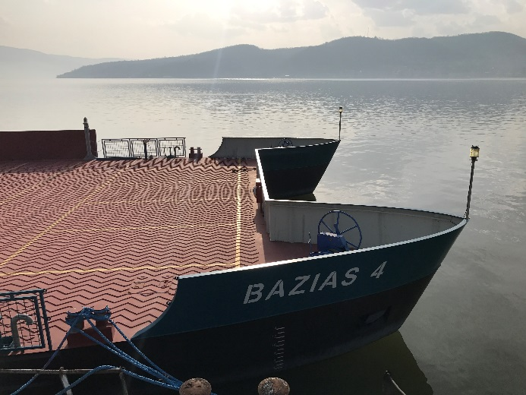
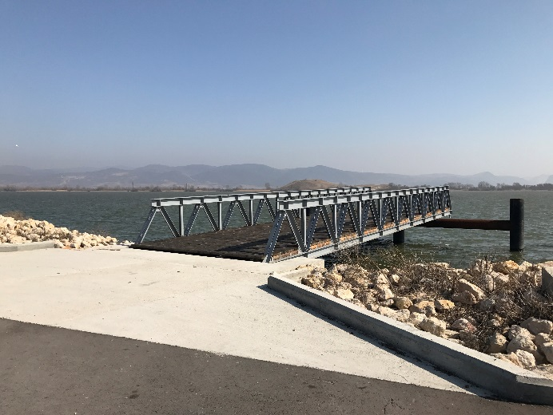
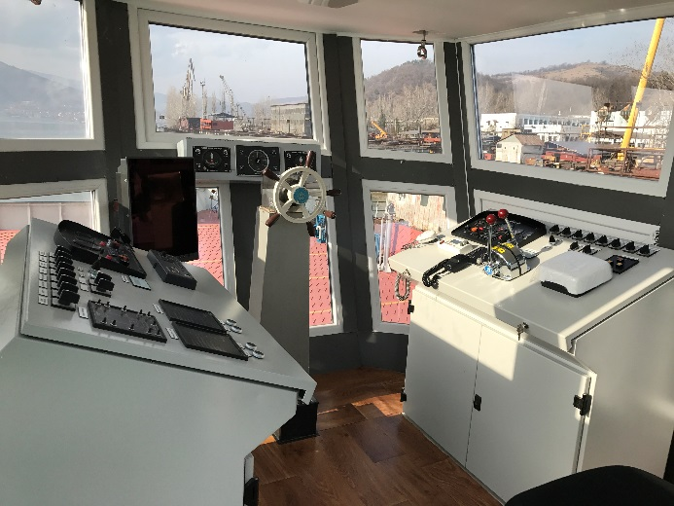
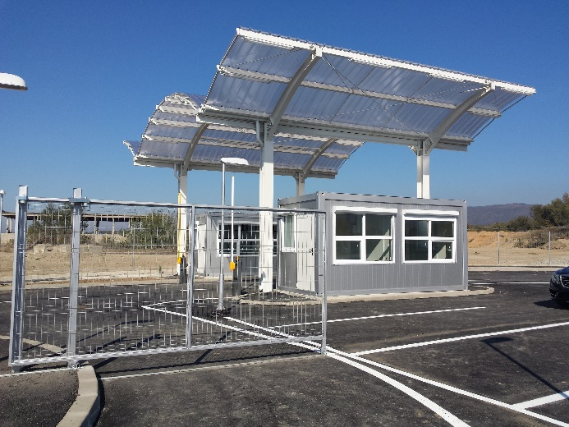

the implementation period (including extensions)
total funds spent/total funds contracted *100
indicators and level of achievement against targets set

