 | Project information
 | CALL FOR PROPOSALS |  | 2
 | MIS-ETC: |  | 1341
 | PRIORITY AXIS: |  | 3. Promoting “people to people” exchanges
 | MEASURE: |  | 3.3 Increase educational, social cultural and sporting exchanges
 | PROJECT TITLE: |  | Guiding pupils through cross-border careers
 | ACRONYM: |  | CAREER
 | DURATION: |  | 26.03.2016 -31.12.2016
 | IPA FUNDS CONTRACTED: |  | 70.550,00
 | TOTAL FUNDS CONTRACTED: |  | 83.000,00
 | ABSORBTION RATE (%): |  | 88,61
 | PROJECT OBJECTIVE(S): |  | Create added value for the cross-border socio-economic environment by training adequate human resources.  Counselling for cross-border business career at secondary education level.  Formation of future cross-border managers by creating their own simulated firms in which they would have internships.  Cross-border cultural harmonization as a basis for sustainable cross-border socio-economic development.
 | SHORT DESCRIPTION OF THE PROJECT: |  | The main issue pursued in this project was the professional counselling for future cross-border economic careers before entering the actual practical period within the simulated firms.  Students received career guidance hours, various tests of professional self-awareness, but at the same time participated in scientific events like conferences and workshops, aiming at stimulating the desire for knowledge, life-long learning. They have been determined by the interaction of events to continue their higher education studies and to access jobs in accordance with their educational level.  The project achieved to develop a cross-border business e-platform, to provide counselling for cross-border business careers and lifelong learning, to train pupils in simulated cross-border firms, to ensure cultural harmonization for a cross-border sustainable cooperation.  The project included new solutions and different original ways of satisfying target group needs. For example, practical periods in simulated and innovative start-up and spin-off firms and the creation of the specialized software for counselling and professional testing.
 | DEGREE OF ACHIEVEMENT OF INDICATORS: |  | Indicator Indicator value provisioned in the contract Present indicator value % 6= (5)/(3)*100  Output indicators (1) UM (2) Quantity (3) UM (4) Quantity (5)  Result indicators  Increased social and cultural integration of people in the border areas No. of participants 50 No. of participants 50 100%  Increased cooperation between NGOs across the border in order to develop civil society capacity on border area Cooperation between NGOs 2 Cooperation between NGOs 2 100%  Improved quality of life and increased attractiveness of the border communities as a living place No. of activities 10 No. of activities 10 100%  Improved knowledge of culture, history, society, organizational and institutional structure, and language of the neighbouring country No. of participants 30 No. of participants 30 100%  Project indicators  Number of visits between partners for best practice exchange PC 10 PC 10 100%  Number of methodologies developed in the partnership PC 6 PC 6 100%  Number of work-shops, round tables, simulated business meetings, networking meetings between other secondary education institutions for best practice dissemination PC 6 PC 6 100%  Number of interactive information website regarding cross-border extracurricular activities within the project PC 1 PC 1 100%
 | RESULTS ACHIEVED: |  | Joint actions (2 press conference, 2 conferences, 1 Caravan, 2 joint workshops, 1 local workshop, 6 joint staff meetings, 6 E – workshops, 2 job - shops).  The creation and registering of 5 simulated firms.  2 Competitions between pupils: „The best business plan”, „The best essay” (Lead Partner).  1 database updated.  Courses with pupils’ involvement.  Cooperation with the NGO and local government.  Organized visits to academic institutions and companies.  6 Methodologies developed in partnership.  2 guides and one career manual.
Partnership information
 |  |  |  | COUNTRY | COUNTY/DISTRICT | BUDGET(EURO) | CONTACT DETAILS
LEAD PARTNER: |  | “Ioan Slavici” Secondary School |  | Romania | Timis | 49.800,00 | Timisoara, 144 Dr. A. Paunescu-Podeanu street  Tel. +40720909836
PARTNER 2: |  | School Centre “Nikola Tesla” |  | Serbia | South Banat | 33.200,00 | Vrsac, Sterijina 40-44  Tel. 0038113830668
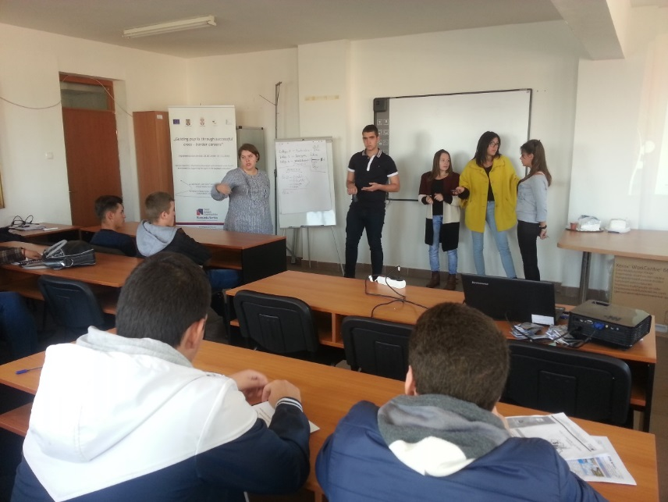
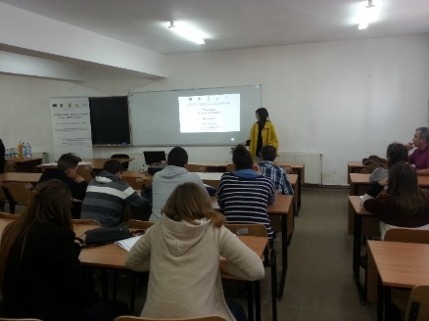
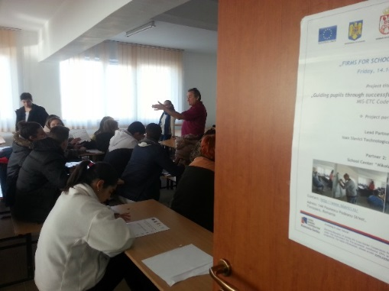
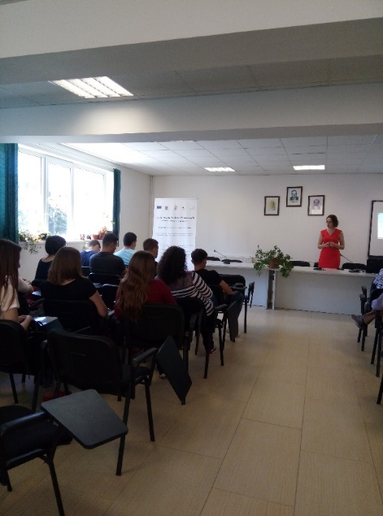
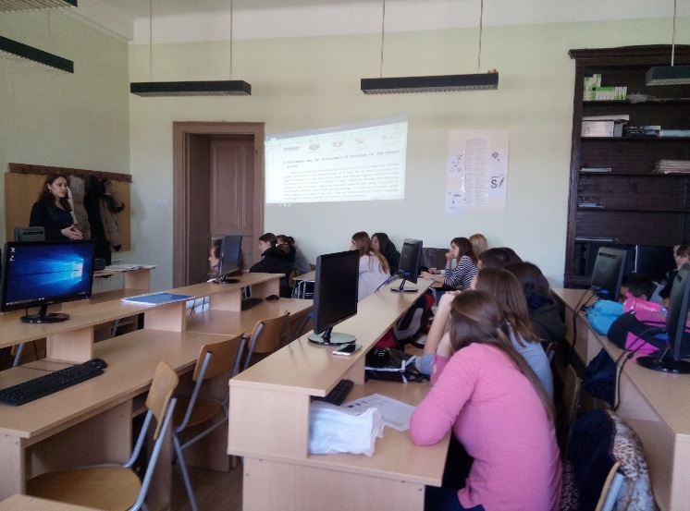

the implementation period (including extensions)
total funds spent/total funds contracted *100
indicators and level of achievement against targets set

