Project information
CALL FOR PROPOSALS |  | 2
MIS-ETC: |  | 1340
PRIORITY AXIS: |  | 1.Economic and Social Development
MEASURE: |  | 1.2 Develop the tourism sector, including the strengthening of the regional identity of the border region as a tourist destination
PROJECT TITLE: |  | Reconfiguration and promoting methods regarding rural tourism in Banat
ACRONYM: |  | BANATUR
DURATION: |  | 01.01.2016 -31.12.2016
IPA FUNDS CONTRACTED: |  | 351.440,01 €
TOTAL FUNDS CONTRACTED: |  | 413.458,84 €
ABSORBTION RATE (%): |  | 90,73%
PROJECT OBJECTIVE(S): | Increasing the overall competitiveness of the economy in the border area. Developing rural tourism in the border region. Identification and promotion of new procedures regarding rural tourism.  Increasing regional identity and development of mutual understanding.
SHORT DESCRIPTION OF THE PROJECT: | The project suggested a new approach of the topic concerning the rural tourism. Collaboration is needed among the factors, which can work together to elaborate and efficiently promote projects of rural tourism. The project created Tourism Development Centres in Dumbrava and Kanjiza, 1 database containing three domains of interest: Mansions, castles, fortresses (ruins); Traditional trades – persons who activate in the domain; Gastronomy – culinary habits, traditional food and customs, training sessions in Timis and Kanjiza. Through its activities, the project revealed and described touristic values and cultural heritages both from Romania and Serbia.

DEGREE OF ACHIEVEMENT OF INDICATORS: | Indicator Indicator value provisioned in the contract Present indicator value % 6= (5)/(3)*100  Output indicators (1) UM (2) Quantity (3) UM (4) Quantity (5)  Establishing Tourism Developing Centres Number of Centres 2 Number of Centres 2 100  Elaborating promotional products Number of products 21.000 Number of products 21.000 100  Events promoting tourism in the cross-border region Number of events 6 Number of events 6 100  Result indicators  New or improved cross-border tourism products and services Number of activities, actions, initiatives focusing on promoting tourism in the border area 10 Number of activities, actions, initiatives focusing on promoting tourism in the border area 10 100

RESULTS ACHIEVED: | 2 training session, 20 trained local tourism promoters, a seminar organized in Kanjiza, 1 conference organized in Remetea Mare, Timiş County, 7 Info Points, 2 thematically touristic routs and were distributed 1.000 albums, 5.000 maps, 15.000 flyers, 1000 promotional materials.  Were founded foundation of the two Tourism Development Centres, by finalizing the rehabilitation works and furnishing the Centres.

Partnership information
 |  | COUNTRY | COUNTY/DISTRICT | BUDGET(EURO) | CONTACT DETAILS
LEAD PARTNER: | Diaspora Foundation | Romania | Timis | 48.493,82 | Timisoara, Putna nr. 7  Tel. +40-356-44.65.16
PARTNER 2: | Dumbravita Local Council | Romania | Timis | 223.735,02 | Dumbravita, 336  Tel. 0040 256 325553
PARTNER 3: | Municipality of Kanjiza | Serbia | Northern Banat | 141.230,00 | Kanjiža, Glavni trg 1.  Tel. +381(0)24 /875-166
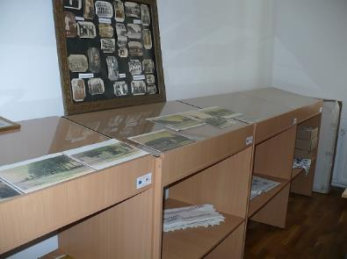
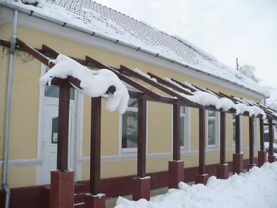
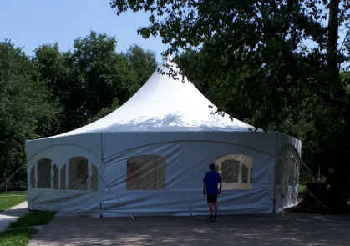
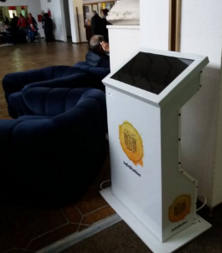

the implementation period (including extensions)
total funds spent/total funds contracted *100
indicators and level of achievement against targets set

