Project information
CALL FOR PROPOSALS | 2
MIS-ETC: | 1338
PRIORITY AXIS: | 1.Economic and Social Development
MEASURE: | 1.3 Promote SME development
PROJECT TITLE: | Training to the Romanian-Serbian cross-border labour market
ACRONYM: | TRAININGLAB
DURATION: | 22.01.2014 – 21.01.2015
IPA FUNDS CONTRACTED: | 251.472,50 €
TOTAL FUNDS CONTRACTED: | 295.850,00 €
ABSORBTION RATE (%): | 90,65%

PROJECT OBJECTIVE(S): | - Supporting the SMEs to increase their competitiveness through trainings.  - Surveying and assessing the training-needs of local and regional SMEs.  - Elaborating accurate curricula of the training courses.  - Training of workers and job seekers.  - Providing the opportunity of e-Learning.  - Organizing informational days and workshops making companies and job seekers to meet
SHORT DESCRIPTION OF THE PROJECT: | The “Training to the Romanian-Serbian cross-border labour market” project was implemented in order to give support for small and medium sized businesses in the border region and especially in the two applicant organizations’ settlements and region by establishing cross-border information facilities for the business environment, by capacity building and strategic partnership building through joint workshops, trainings and eLearning courses for better economic cooperation in the labour market of the Romanian-Serbian border area. The project offered several training possibilities for long term unemployment persons after surveying the SME sector labour needs, promoting professional re-training, job search facilities, counselling activities through local informational points, providing labour market consultation services for job seekers, supporting the local employment of disadvantaged groups as well.  An E-learning platform system was developed, the E-learning training had 84 participants. Also, the classroom trainings had 129 participants
DEGREE OF ACHIEVEMENT OF INDICATORS: | Indicator Indicator value provisioned in the contract Present indicator value % 6= (5)/(3)*100  Output indicators (1) UM (2) Quantity (3) UM (4) Quantity (5)  Number of trained people person 180 person 222 123,33  SMEs and firms reached piece 100 piece 112 112  Accredited training syllabus piece 1 piece 3 300  Workshops and info days participant 1400 participant 1400 100  Database piece 3 piece 4 133,33  Result indicators  Increased SME’s capacity in the border area Number of activities, actions, initiatives focusing on promoting SME’s activity 12 Number of activities, actions, initiatives focusing on promoting SME’s activity 12 100  Revealing the problems of the SME sector Number of databases elaborated 3 Number of databases elaborated 4 133,33  Amending the situation of the SMEs in the border region Number of business firms reached by the action 100 Number of business firms reached by the action 112 112  Increasing knowledge of the people in the cross border area Number of participants successfully trained 180 Number of participants successfully trained 222 123,33  Strengthening the cooperation between the public and the private sector Number of entities involved in new contacts 300 Number of entities involved in new contacts 300 100  Helping the spread of modern knowledge Number of equipment purchased 2 Number of equipment purchased 2 100  Promotion of the Romanian-Serbian cross-border cooperation. Number of information materials 3000 Number of information materials 5000 166,66
RESULTS ACHIEVED: | Elaborated training syllabi created for three modules that will remain and stay available within the e-learning system.  Three accredited training syllabi.  2 servers purchased  7 information days and 5 workshops held.

Partnership information
 |  | COUNTRY | COUNTY/DISTRICT | BUDGET(EURO) | CONTACT DETAILS
LEAD PARTNER: | Centre for Information and Development of the Tisza region | Serbia | North Banat | 154.000,00 | Kanjiza, Doža Đerđa 4  Tel. +381 24 873 151
PARTNER 2: | Timis Chamber of Commerce, Industry and Agriculture | Romania | Timis | 141.850,00 | Timisoara, Piata Victoriei nr.3  Tel. +40.374160832

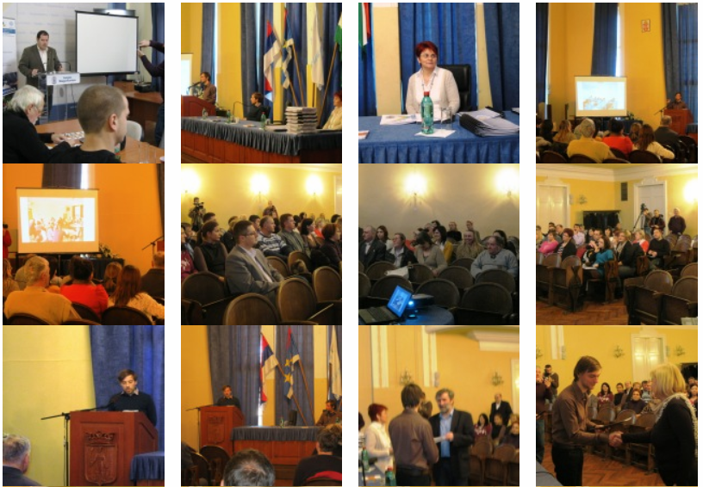

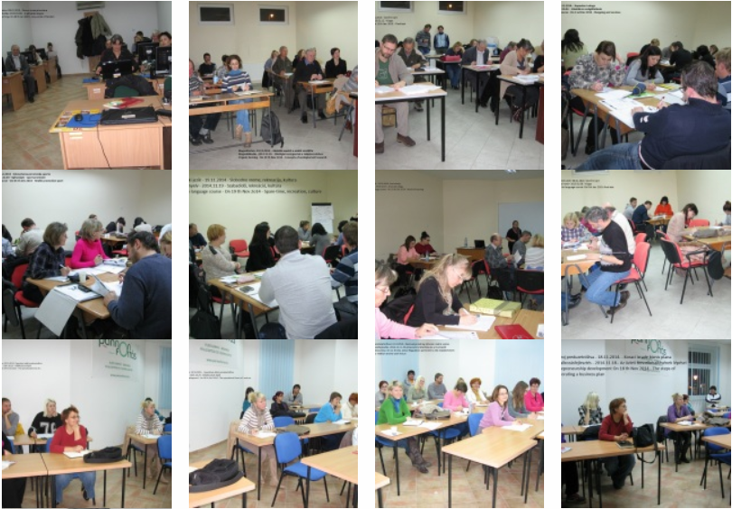

the implementation period (including extensions)
total funds spent/total funds contracted *100
indicators and level of achievement against targets set

