 | Project information
 | CALL FOR PROPOSALS |  | 2
 | MIS-ETC: |  | 1336
 | PRIORITY AXIS: |  | 3. Promoting “people to people” exchanges
 | MEASURE: |  | 3.3 Increase educational, social cultural and sporting exchanges
 | PROJECT TITLE: |  | Recover and rehabilitation. Centre for children with deficiencies
 | ACRONYM:
 | DURATION: |  | 15.10.2015 – 14.04.2015
 | IPA FUNDS CONTRACTED: |  | 119.068,00
 | TOTAL FUNDS CONTRACTED: |  | 140.080,00
 | ABSORBTION RATE (%): |  | 91,04
 | PROJECT OBJECTIVE(S): |  | - Support social integration measures for disadvantaged groups from Moldova Noua (Romania) and Zrenjanin (Serbia) areas for an 18 months period.  - Satisfying some specific physical recovery needs and training of 40 children with disabilities from Moldova Noua until the middle of the year 2013.
 | SHORT DESCRIPTION OF THE PROJECT: |  | Through the implementation of this project the partners purchased medical equipment necessary for the physical recovery of 40 children who had physical deficiencies and who could not participate in activities of integration in schools and kindergartens because of their physical handicap.
 | DEGREE OF ACHIEVEMENT OF INDICATORS: |  | Indicator Indicator value provisioned in the contract Present indicator value % 6= (5)/(3)*100  Output indicators (1) UM (2) Quantity (3) UM (4) Quantity (5)  Project indicators  Increased in cross border contacts between people in the border area Number of participants benefits from the joint public cross-border events organized within the projects 80 Number of participants benefits from the joint public cross-border events organized within the projects 80 100  Result indicators  Improved quality of life and increased attractiveness of the border communities as a living place Number of activities, actions, initiatives, developing new or improving existing educational and social services, or improving other local living conditions 1 Number of activities, actions, initiatives, developing new or improving existing educational and social services, or improving other local living conditions 1 100
 | RESULTS ACHIEVED: |  | Individual recovery programs were formed and successfully implemented for 40 children with disabilities from Moldova Noua by the psychologists, kineto-therapists and social workers.  1 recovery centre fully functional in Moldova Noua – procured equipment such as: laptop and soft printer, copy machine, magnetodiaflux machine, medical equipment, office, book shelves, chairs, little tables, shelves with 2 doors, metallic bed, massage bed, video-camera.  In Zrenjanin, the Institute purchased: combined closet for didactical means, table for four people, shelf for toys, children's kitchen, children's chair, projector, projector screen, universal kitchen machine, dishwasher, potato peeler, tower with a hanging bridge.
Partnership information
 |  |  |  | COUNTRY | COUNTY/DISTRICT | BUDGET(EURO) | CONTACT DETAILS
LEAD PARTNER: |  | Association Rainbow Moldova Noua |  | Romania | Caras-Severin | 104.610,00 | Pojejena, No 159  Tel. 0040 769287141
PARTNER 2: |  | Preschool Institute Zrenjanin |  | Serbia | South Banat | 35.470,00 | Zrenjanin, Karadziceva 3a  Tel. +38123510538

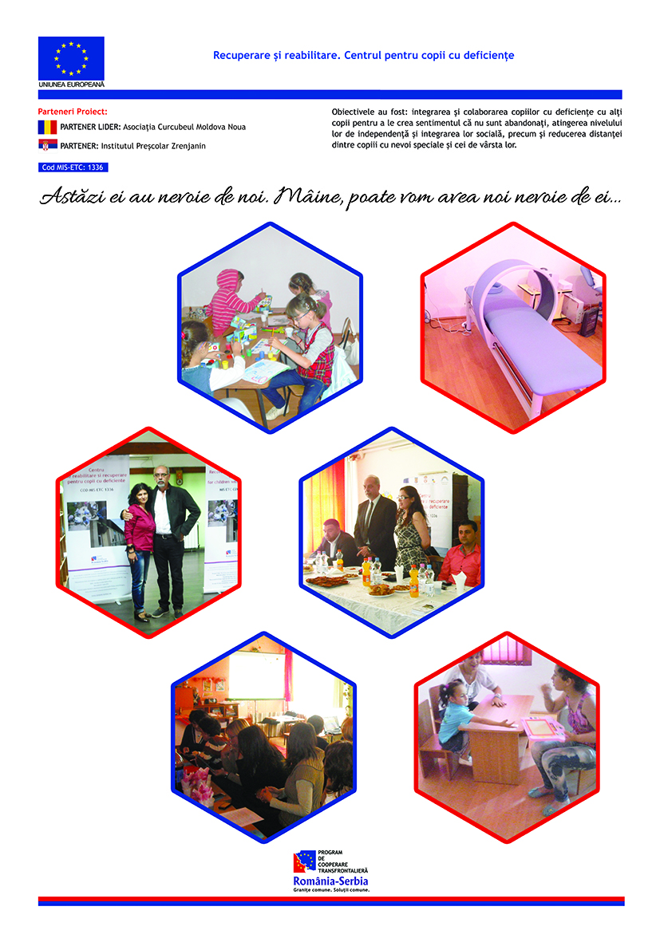

the implementation period (including extensions)
total funds spent/total funds contracted *100
indicators and level of achievement against targets set

